



# Building an Accessible Activity in Storyline 360

Revised: April 2022

Table of Contents

Building an Accessible Activity in Storyline 360 1

Storyline Accessibility Basics 3

Accessibility Tool Visibility 3

Keyboard Accessibility 4

Keyboard Focus Indicator 5

Focus Order 6

Layers 7

Images and Alternative Text 8

Decorative Images 9

Informative Images 9

Groups of Images 9

Other Best Practices for Images 9

Complex Charts 10

Video Players 11

Closed Captioning 11

Audio Descriptions 11

Transcripts 11

Other Best Practices for Video Players 11

Using Text Boxes to Add Semantic Structure 13

Headings 13

Page Title 13

Best Practices for Semantic Structure 14

Font Attributes 14

Tables 14

Menus 15

Forms 15

Links 16

Color 16

Color Contrast 16

Use of Color 17

Instructions for Accessibility 17

Timing 18

Accessible Assessments 19

Quick Checklist 19

How-to Articles and Resources from Articulate 20

## Storyline Accessibility Basics

Storyline 360 can be a great tool to create engaging, interactive content that is also accessible to users with disabilities. This guide will help you create accessible Storyline 360 courses as well as alert you to existing accessibility issues in the platform and offer some possible workarounds to consider.

Once your designs are complete, make sure you conduct comprehensive testing. This should include testing for all user groups – including low vision testing, keyboard testing and screen reader testing among others.

### Accessibility Tool Visibility

Accessibility tool visibility defines whether an object can receive keyboard focus and be read by a screen reader. This is an essential accessibility feature in Storyline and is defined through the **Object is visible to accessibility tools** setting within the Accessibility tab of the Size and Position panel of the object.

Note that elements that appear decorative and even elements that are not visible due to having a 100% transparent fill can still be visible to accessibility tools if this setting is not set correctly. As a result, this setting needs to be checked for all objects in Storyline.

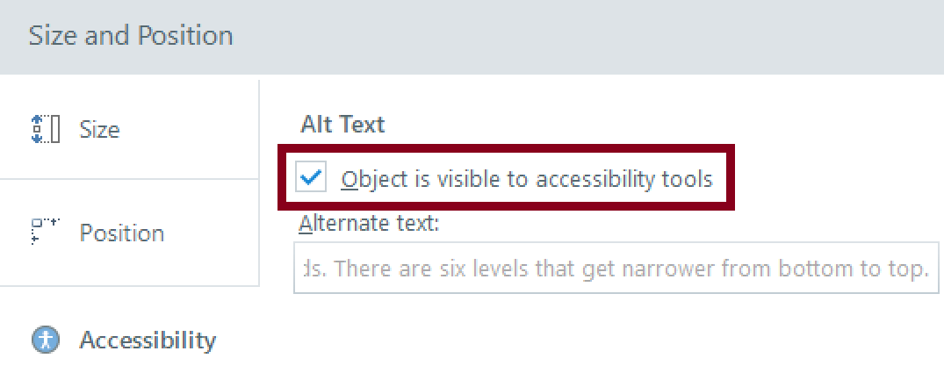

*Figure 1: Accessibility Tool Visibility Setting*

Examples of elements that **should not** be made visible include callout boxes, page separators, or other graphical elements that are decorative in nature.

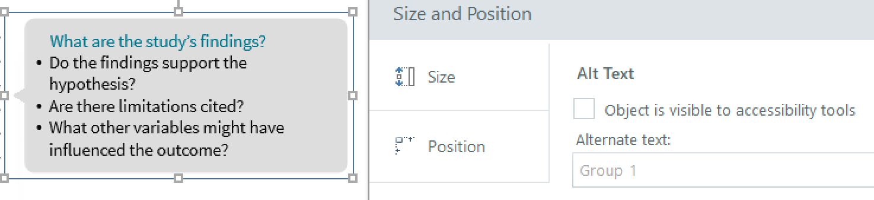

*Figure 2: Accessibility Tool Visibility Setting - Decorative Elements*

Examples of elements that **should** be made visible include images of historical figures, charts, graphs, or other information that helps learners understand the material being presented.

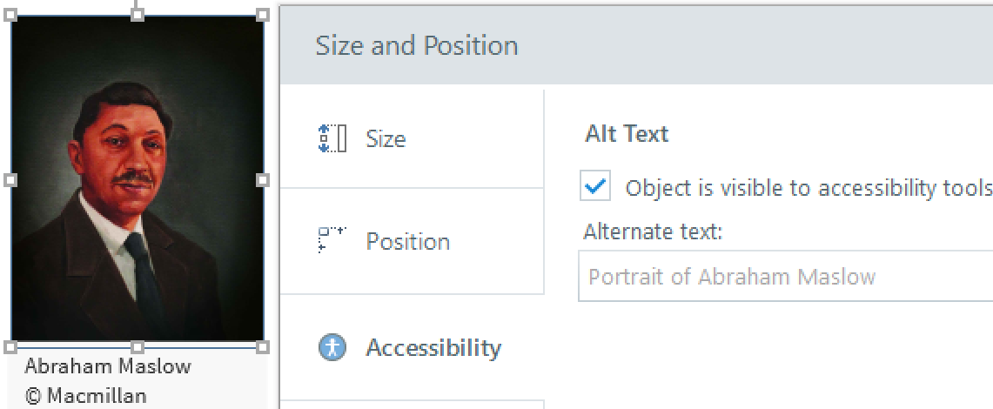

*Figure 3: Accessibility Tool Visibility Setting - Informational Images*

### Keyboard Accessibility

In Storyline, elements that are in the Focus Order and are visible to accessibility tools (as described in “Accessibility Tool Visibility”) will be keyboard accessible with the Tab key (users can also press Shift + Tab to navigate backwards).

Prior to 2020, screen reader users and keyboard-only users tabbed to every object on each slide which was a very tedious way of interacting with Storyline content. Now, the focus order that you define for each slide in Storyline 360 controls the reading order for screen readers as well as the tab order for interactive elements, such as buttons, hotspots, and data-entry fields. Here’s how screen readers and keyboard users can interact with slide content:

|  |  |
| --- | --- |
| **Screen reader users** | **Keyboard-only users** |
| Screen reader users use navigation keys (e.g., Down and Up arrows) to move through all text and interactive objects on the slide.  Tab and Shift+Tab can also be used to move from one interactive element to another, skipping text and images.  Users can press the spacebar or the Enter key to activate an interactive object, such as a button or hotspot. | Keyboard-only users press Tab and Shift+Tab to move from one interactive object to another on the slide and press the spacebar or the Enter key to activate an item.  Since keyboard-only users can see text and images, these objects get skipped when tabbing through the slide content. |

### Keyboard Focus Indicator

Traditionally, keyboard focus is indicated in Storyline with a yellow highlight around an object. This technique works well when the background is dark but if a yellow highlight on a white background is use the contrast ratio won’t meet the requirements for WCAG 1.4.11 Non-Text Contrast which requires a 3:1 contrast ratio. There is now an option to change the color when the focus indicator is on a light background to ensure that it has sufficient contrast. This option is only available in the new “modern player” within Storyline and can be accessed via the Properties tab. Refer to the Storyline Reference page to learn more about [Using the Two-Color Focus Indicator](https://articulate.com/support/article/Storyline-360-Two-Color-Focus-Indicator).

Some good color combinations to consider for focus indicators include the following:

|  |  |
| --- | --- |
| **Background Color** | **Focus Indicator Color** |
| White | Black or Dark Blue |
| Black | Yellow or White |
| Red, Dark Beige | White is probably the best color. Test with the [Colour Contrast Anayser](https://www.tpgi.com/color-contrast-checker/) to ensure that the contrast is at least 3:1 between the focus indicator and the background. |

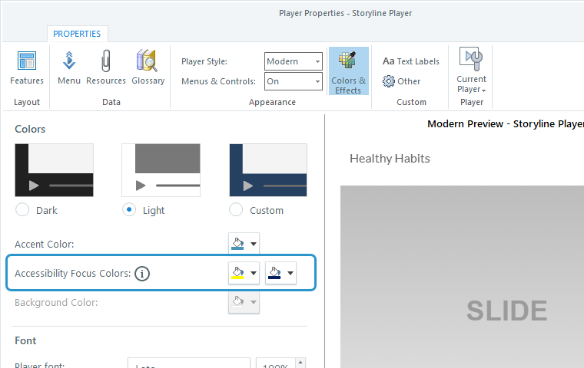

*Figure 4: Screenshot of the properties window in Storyline 360 highlighting the accessibility focus colors options*

### Focus Order

The Focus Order is the order in which elements will be exposed to accessibility tools within a slide. Content should be ordered in the sequence you expect it to be read. Appearing in order is not the same as the actual ordering.

By default, objects are ordered top to bottom, left to right, layers then base layer. Review the focus order of each slide to make sure that the reading order is logical and intuitive. Focus order on each slide is available from the Home Tab: Focus Order Dialog. Use this Storyline resource to ensure that your course has a meaningful and intuitive reading order: [Customizing the Focus Order of Slide Objects](https://community.articulate.com/series/articulate-storyline-360/articles/storyline-360-customizing-the-focus-order-of-slide-objects).

When setting the order, consider how you would want to encounter those elements when using a screen reader. In general you can use simple logic where the title would come first, buttons should go after whatever introduces them, layer elements come after whatever activates the layer, and the Next Slide button is at the end of the slide’s focus order as this should be the last item users encounter.

Notes:

1. Objects that are positioned outside of a slide and accessible to screen readers may not show keyboard focus highlighting. However, these objects may still be accessible to screen readers.
2. Web Objects embedded into Storyline such as videos, web pages, and HTML tables will always be last in the slide focus order due to cross-domain limitations. If you have a Next slide button it will not be at the end of the content and you should provide instructional text to alert users to this order.

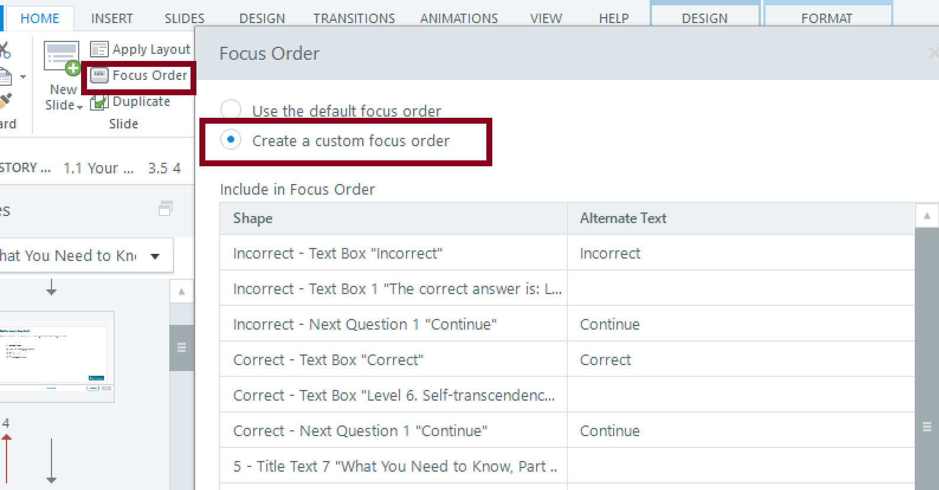

*Figure 5: Screenshot of the Focus Order Dialog*

### Layers

In most situations, it’s best to hide the base layer or slide layer content from accessibility tools when a new layer opens. If this is not done, assistive technology users may encounter elements from background layers that are not currently accessible. This can also impact decorative elements (e.g., background shapes, active state indicators, etc.) and can impact the Slide Master and Feedback Master. For example, in a tab interaction slide, you don’t want a user to be able to read a previously opened tab’s contents when a new tab is opened. Or, in an interactive slide, you don’t want a user to be able to continue engaging with the interactive in the base layer if an error message has popped up in another slide layer.

Manage layer visibility by using the Edit Properties for a selected Slide Layer and then open the Slide Layer Properties dialog. You can change the visibility of other slide layers when the selected slide layer is shown by using the **Hide other slide layers setting**. You can also enable the option to **Prevent the user from clicking on the base layer** to hide objects on the base layer 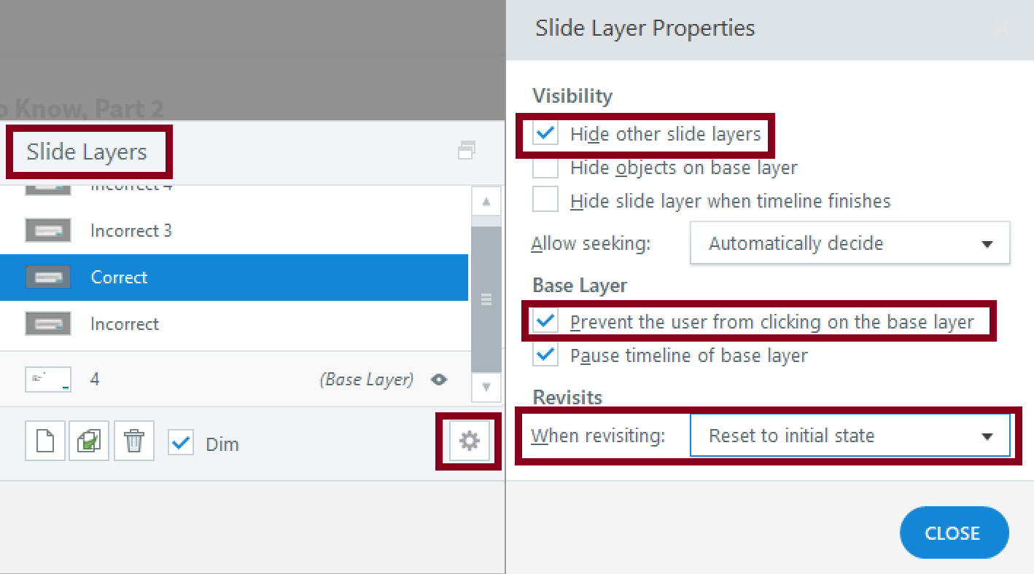from assistive technology. Note, however, that this feature will not hide them visually.

*Figure 6: Screenshot of the Slide Layer Properties Dialog*

### Images and Alternative Text

**A Note About Storyline “Alternative Text”:**

If the image you are describing is to be delivered to the user via Storyline slides or modules, all the above applies to your image. The place in the Storyline interface where you'll put the description is referred to as "Alternative Text."

Most elements in Storyline have an opportunity for you to include alternative text. Use this feature with extreme caution. If the element is inherently text, such as a paragraph or a heading, there is rarely any reason to use alternative text. This feature replaces the text when it is presented to the screen-reader user, and so the user will not be able to read your paragraph or heading. Besides the potential to confuse users, this makes your presentation much more difficult to update-- each time you make an edit to a paragraph, you'll need to make sure the alternative version of the text is updated as well... and there is some likelihood this will not get done.

Additionally, it is extremely easy and common for creators of Storyline modules to copy a slide from one set of content to use in another. If alternative text is not replaced or removed, the screen reader user will read the content from the previous course, and not your content.

Alternative text gives screen reader users descriptions of images. In Storyline, the default for alt text is the image’s filename. DO NOT USE THE IMAGE FILE NAME AS THE ALT TEXT.

#### Decorative Images

If the image is decorative, uncheck the checkbox “Object is visible to accessibility tools” and leave the alternate text blank.

#### Informative Images

If the image is not decorative, ensure that the checkbox “Object is visible to accessibility tools” is checked, then create meaningful alternate text.

* Describe images to the best of your ability.
* Avoid repeating information or being too verbose, but make sure the user understands the pedagogical implications of the image.
* Do not include any analysis or additional information that sighted users do not receive.
* If the image is decorative or adequately described in the surrounding text, remove it from the focus order and do not add alt text.
* More information is available in the Macmillan Learning Alt Text Guidelines.

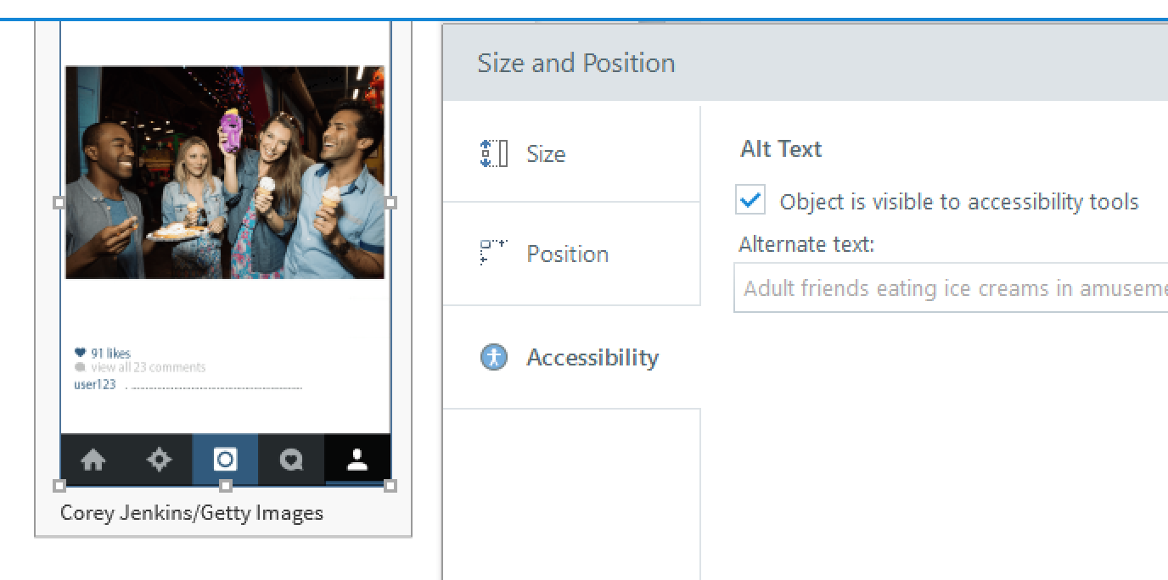

*Figure 7: Image Accessibility Options*

#### Groups of Images

* If you’re creating a visual out of several images or shapes such as a diagram you’ve drawn with rectangles and other shapes, add alt text to one of the objects that summarizes the meaning and context of the whole group and the other images by unchecking the “Object is visible to accessibility tools” checkbox.

#### Other Best Practices for Images

* Never Use Images of Text (Except Logos)
  + Images of text are not accessible to screen readers.
  + Resizing or enlarging images of text can cause pixelation, which may make it more difficult for low vision users.
  + Images of text are not accessible to text spacing tools.
  + Long alt text for images of text can be frustrating to listen to. Instead use plain text.
  + Images, figures, etc. should be numbered or labeled for easy reference.

#### Complex Charts

* + If you need to add complex graphs or charts to Storyline 360, make sure that these are designed for accessibility, including accessible colors, accessible legends, etc.
  + For very complex charts, you may want to consider embedding [HighCharts](http://www.highcharts.com) (www.highcharts.com) charts which offer an accessible alternative to traditional charts and graphs.

### 

### Video Players

#### Closed Captioning

Ensure all videos are captioned for users who are deaf or hard-of-hearing. Captions include all audible sounds including speech and sound effects. Changes of speakers should also be indicated.

#### Audio Descriptions

Audio descriptions are typically included within the audio of any videos. However, they can also be provided as a separate file which describes what is happening on screen for users who are blind or visually impaired.

Transcripts   
Transcripts should be included as a separate file or window that includes all audible sounds (speech and/or sound effects) as well as any on-screen text or descriptions of pertinent on-screen visuals. The audio description script should be used as the descriptive text transcript.

#### Other Best Practices for Video Players

* Use the SAVI Brightcove Player – always
* Do not use YouTube
* Do not use the native Storyline video player
* Do not use videos or animations that flash or blink more than three times per second.

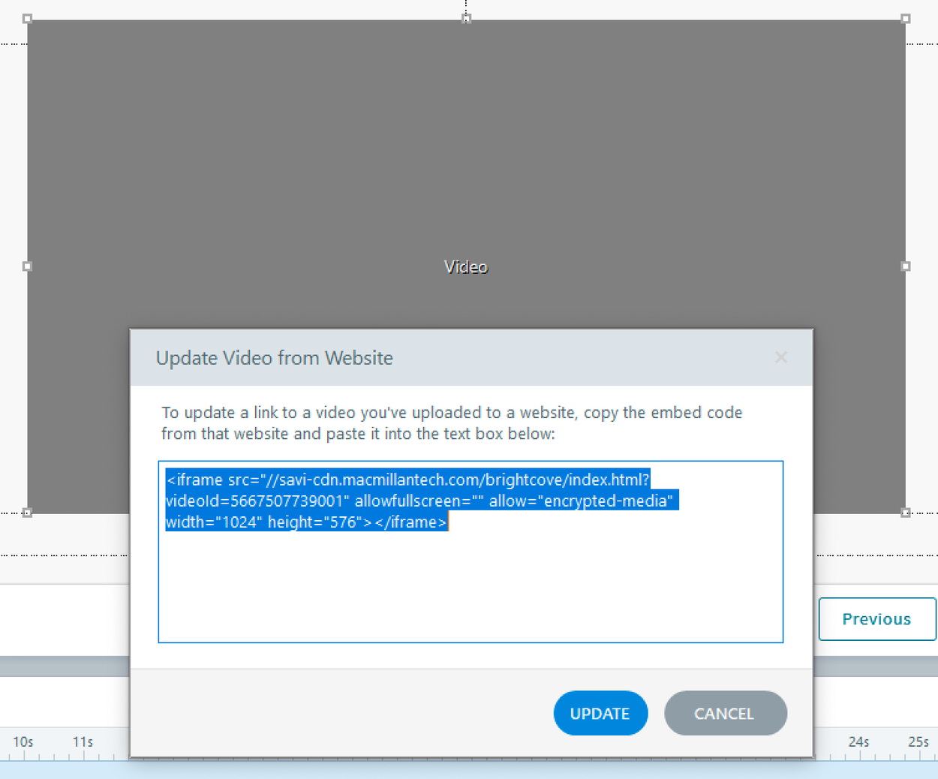

*Figure 8: Update Video from Website Dialog*

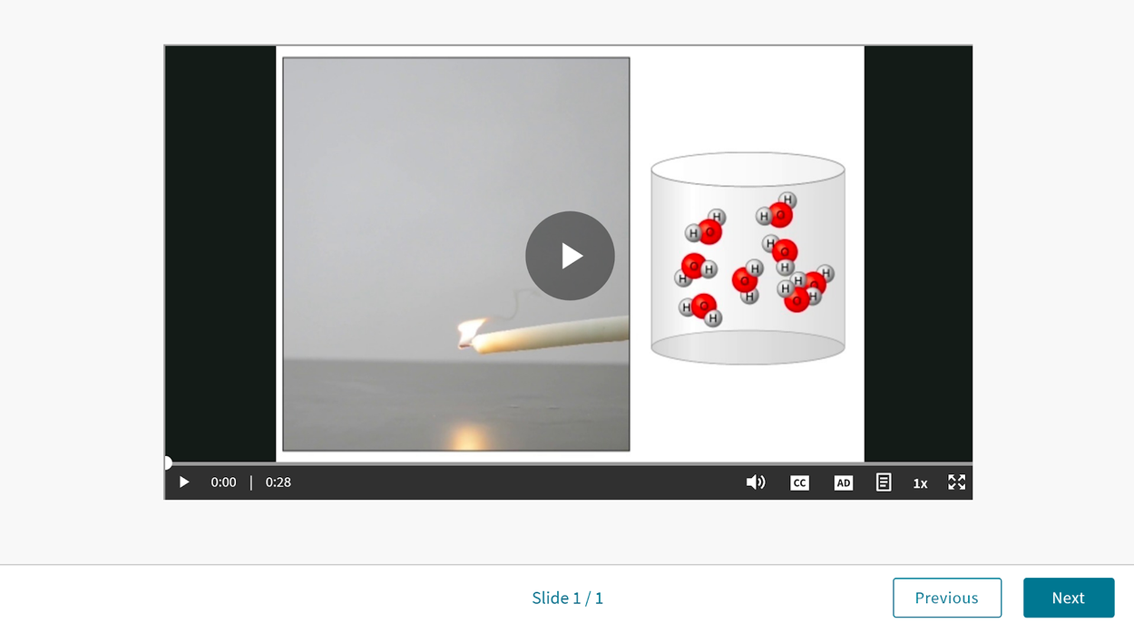

*Figure 9: Screenshot of the Brightcove Video Player*

### Using Text Boxes to Add Semantic Structure

Use Textbox styling to add semantic structure. Styling within textboxes allows you to add headings, lists, etc. Be sure to use the built-in styling features to make this accurate.

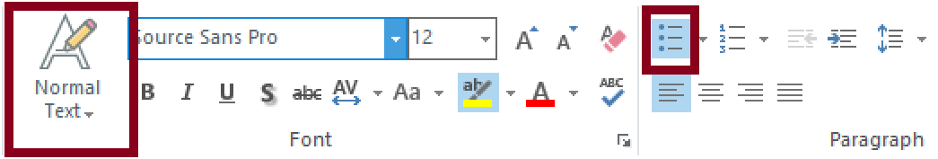

*Figure 10: Text Box Options Toolbar*

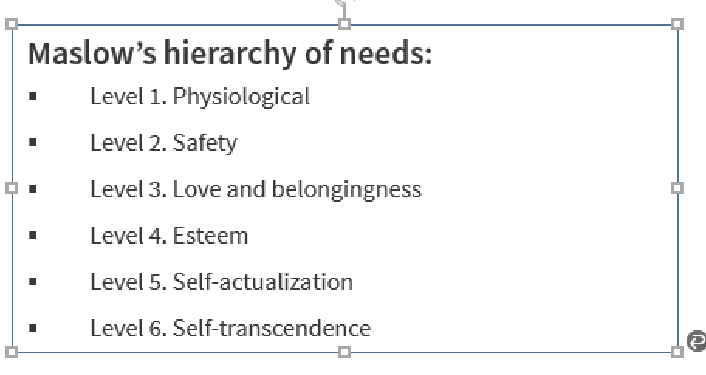

*Figure SEQ Figure \* ARABIC 7: Screenshot of adding bullet points using the styling features*

*Figure 11: Example of text box structured for accessibility with a heading and list.*

#### Headings

Headings should be meaningful and unique. It is not helpful to use the same heading repeatedly. Consider numbering slides that have the same name or add “continued.” Screen reader users can use slide headings to quickly navigate through each course. Headings and Titles should provide information about what content will follow.

Heading Hierarchy**:** When using multiple headings on a single page, ensure that headings follow a logical hierarchy. For example: h1, h2, h3. Do not use headings for stylistic purposes only. Note: If your Storyline 360 learning module will be integrated into another platform such as Achieve, you should start the first heading with h2 as there will already be an h1 present on the Achieve page.

#### Page Title

Storyline 360 automatically uses the course title as the page title that appears on the browser tab. Ensure that the course title is meaningful as screen readers announce the course title (i.e., the page title) to users. Page title is set when publishing your course.

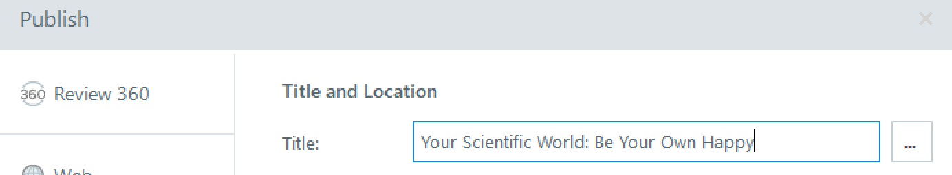

*Figure 11: Screenshot of the Course Title field from the Publish Dialog*

#### Best Practices for Semantic Structure

* Refer to the Using Text Styles Storyline resource to ensure that your visible headings are marked as headings: [Using Text Styles](https://community.articulate.com/articles/storyline-360-using-text-styles).
* Ensure that list items are enclosed within ordered or unordered lists. Use the bulleted or numbered list feature within Storyline to ensure that content is marked properly for screen reader users.
* **CAUTION:** Recent updates in 2020 added the ability to add headings to Storyline 360 projects. If making edits to a previously created Storyline 360 project you may need to recreate your styles and headings to make sure they are rendered correctly with a screen reader. The best way to test whether this is needed is to use a screen reader to see if the headings are properly identified.

#### Font Attributes

Note that since Storyline is using SVGs instead of real text, font attributes and styling (bold, underline, highlighting, etc.) are not accessible to assistive technology users. As a result, you will need to make sure that font attributes and styling you use are supplemental and not used to convey critical information. For example, using strikethrough text to indicate that something has been deleted or using an underline to highlight a phrase that a learner needs to use to respond to a test question would be inaccessible to assistive technology users.

### Tables

Storyline does not fully support accessible tables. There are some workarounds – see the following support article: [Setting a Custom Focus Order for Table Cells](https://community.articulate.com/series/articulate-storyline-360/articles/storyline-360-adding-tables#custom-focus-order). Due to the limitations within Storyline, limit your tables to simple tables that are 2 columns wide as screen readers won’t have access to column and row header information nor can they use screen reader table reading commands to access the content in tables. It is also recommended that merged cells be avoided. If your data can be presented as a list, this is a good alternative.

If you must use a table larger than two columns, you must also provide a link to either an accessible PDF or an HTML page with the table in an accessible format. One additional technique is to insert an HTML table as a web object. Select Insert>Web Object and then past the URL in the address field and select either view in slide or view in a separate browser window.

### Menus

Use the built-in menu or create your own custom menu to convey the structure of your course. Ensure that menus have an appropriate reading and tab order as well. Note: Menus in Storyline 360 are not fully accessible as users must navigate backwards to access the content in menus (this is a reported Storyline 360 bug).

When you use menus, you should add an accessibility statement that includes tips for navigating menus with a statement such as “Keyboard users must press Shift+Tab to navigate to the menu once the menu is opened”.

Skip Navigation is automatically enabled. Do NOT disable skip navigation. This feature can be helpful for keyboard-only users who prefer to skip the menu.

### Forms

Storyline 360 automatically associates labels with form elements. However, there are some limitations to be aware of as well as additional ways you can convey information and relationships to learners with assistive technologies:

* Forms *can* be labeled but not grouped with a fieldset and legend in Storyline, which is problematic for assistive technology users. Ensure all forms are labeled as accurately as possible. If multiple questions are on the same slide with the same option (i.e., multiple Yes or No questions) add alternate text to the label to distinguish between the 2 options by selecting the option and opening the Accessibility options.
* Edit Boxes: Since visible labels can often be missing from edit boxes, create this effect by adding a text label above the form and updating the alternate text to include the text label. You can also choose to add placeholder text if you prefer but remember that this is only supplemental as it will disappear after someone enters their data.
* Dropdown Labels: Storyline does not allow for fully accessible labels for dropdown menus. Due to this, JAWS will read the labels, but NVDA will identify these as unlabeled forms. However, the use of dropdown menus in Storyline is intuitive. For full accessibility, consider other form types.
* Placeholder Text: While placeholder text provides guidance for many users, placeholder text is not a replacement for labels. Assistive technologies, such as screen readers, do not treat placeholder text as labels and is not broadly supported across assistive technologies. Placeholder text disappears from form fields when users start entering text. If the placeholder text contains instructional information or examples that disappear, it can make it more difficult for users to check their responses before submitting the form.
* Use form elements appropriately. When users should select one item between a group of items, use radio buttons. When users can select multiple items use checkboxes. In the example below, buttons were used instead of radio buttons so screen readers may not understand that only one option is allowed.

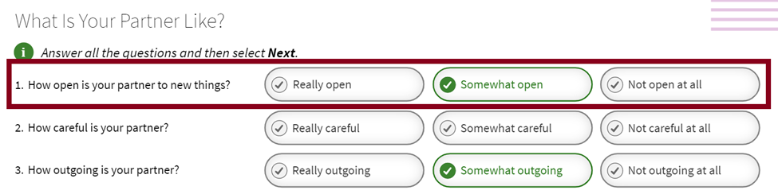

*Figure12: Screenshot of sample radio buttons structured as buttons vs. radio buttons*

### Links

* Avoid the use of “device dependent” language on links such as “Click here”. This implies that only people using a mouse can activate this link. Instead use “Select.”
* Link names should tell you where the link is going.
* Use appropriate link styling – typically blue text with an underline. This is a universally recognizable way of presenting links. Example: [www.macmillanlearning.com](http://www.macmillanlearning.com).

### Color

#### Color Contrast

Check your color contrast. The Colour Contrast Analyser is a simple to use free tool – refer to [Color Contrast Analyser](https://www.tpgi.com/color-contrast-checker/) to allow you to use an eyedropper to test colors in Storyline or enter hex codes. Your goal is AA compliance. Text below 14-point bold or 18-point regular font should provide at least a 4.5:1 color contrast ratio. Text above this threshold should provide at least a 3:1 color contrast ratio.

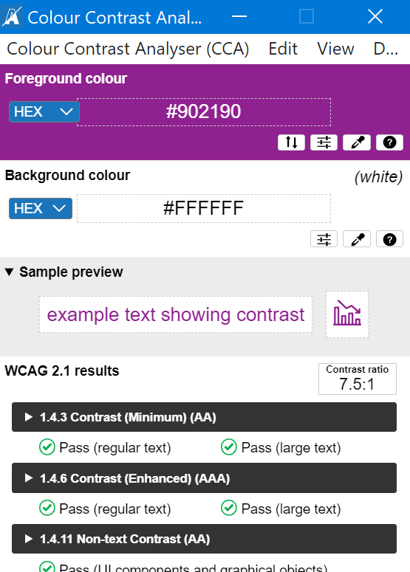

*Figure 13: Screenshot of the Colour Contrast Analyser*

#### Use of Color

Don’t Use Color to Convey Meaning!

* Avoid statements like “select all elements that are red”.
* Avoid using just color to distinguish a hotspot or link text – add a secondary attribute such as an underline.
* Ensure graphs have accessible legends that don’t rely solely on color.

### Instructions for Accessibility

* Course Developers must give learners instructions when they need to interact with slide content. For example, provide on-screen instructions when learners need to type information in a data-entry field, so they know what’s expected of them.
* Never assume that the action or sequence of actions is obvious. While we aim for the user flow to be intuitive, leave room for different types of users and experiences.
  + Hot spot Example: In the example shown below, the hot spots are all numbered and the tab order aligns with the numbers making the activity intuitive. However, the instructions don’t call out 4 hot spots so some users may miss one by mistake. (Note: one issue with the example below is that the color contrast of the hotspot numbers is below the required minimum of 3:1 for large text). 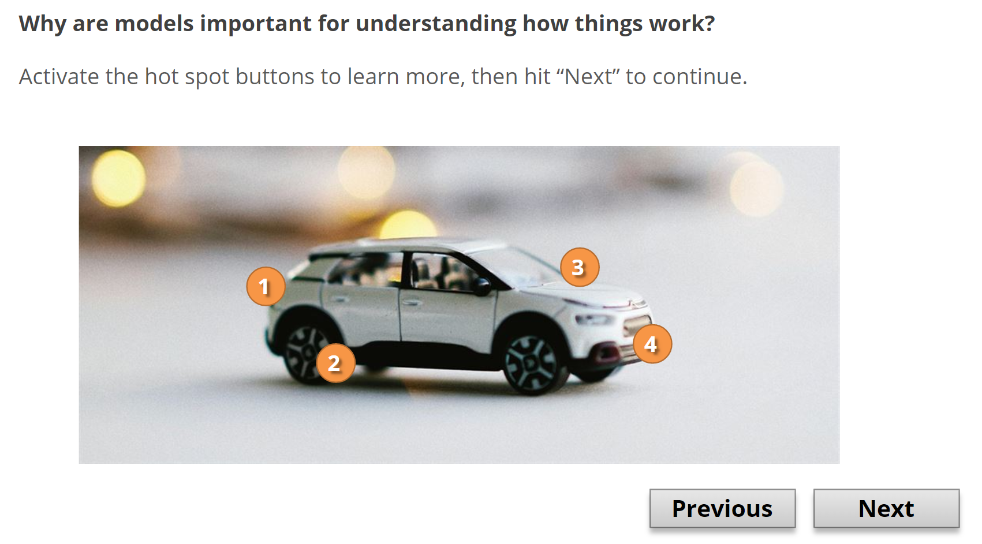

*Figure 14: Screenshot of a hotspot activity*

* Track Directional Language
  + Images are not below, above, to the right or left for a screen reader user.
  + Image placement reflows when the screen size or zoom changes so location can change whereas language will not.
* Images, figures, etc. should be numbered or labeled for easy reference.
* Provide additional text-based instructions for content that can only be understood by shape, size, visual location, orientation, or sound. For example, if you asked users to fill in the edit box in the upper left corner of the page, assistive technology users may have difficulty completing this exercise. However, if a secondary attribute was added such as “fill in your name in the First Name edit field in the upper left corner of the page” this would not present an accessibility barrier.
* Error Prevention and Error Messages: Course developers can use triggers, states, and layers to create custom validation and error messages. Ask users to confirm their responses before submitting them. For example, when users are required to enter text in a data-entry field, ask them if the information they entered is correct and give them the opportunity to change it before moving on. You can also display a Yes/No confirmation question on a separate layer. If users select Yes to confirm that the information is correct, proceed to the next slide. If learners select No, close the layer, and allow them to change their responses before continuing. Refer to the resource articles [Working with Layers](https://community.articulate.com/series/articulate-storyline-360/articles/articulate-storyline-360-user-guide-how-to-work-with-slide-layers); [Working with Triggers](https://community.articulate.com/series/articulate-storyline-360/articles/storyline-360-working-with-triggers); and [Adding and Editing States](https://community.articulate.com/series/articulate-storyline-360/articles/articulate-storyline-360-user-guide-how-to-add-and-edit-states).

### Timing

* Don’t add time limits to activities unless the time limit is essential to the functionality.
* Don't advance slides automatically. Allow learners to read the content at their own pace and advance when they're ready.
* Don’t animate text to make it disappear after a certain amount of time (such as scrolling text off the slide). Some learners with vision, mobility, or cognitive disabilities might need more time to read the text.
* Do not use videos or animations that flash or blink more than three times per second.

## 

## Accessible Assessments

Not all Storyline 360 assessment types are accessible! Make sure that you avoid inaccessible question types such as the examples listed below and that you provide clear instructions on answering assessment questions. It is also recommended that you test any assessment items with both a keyboard and screen reader to verify accessibility.

The following activities are not fully accessible and should not be used:

* Drag and drop activities.
* Sort and match activities.
* Activities requiring color identification (i.e. “count the number of red and blue balls”).

The following assessment types are accessible:

* Multiple choice questions with radio buttons
* Multiple select questions with checkboxes
* Sliders

## Quick Checklist

* Check your alternate text for accuracy
* Always use the SAVI Brightcove player
  + Include Captioning, Audio Description, and a transcript
* Use Unique and Informative Headings
* Check the Logical Reading Order
* Ensure Links Make Sense
* Check Color contrast
* Avoided inaccessible question types. Matching and drag and drop activities are NOT accessible assessment types in Articulate Storyline 360.
* Don’t Use Color to Convey Meaning
* Give instructions when interaction is expected
* Do not use images of text
* Track (and avoid) directional language
* Usability Testing: Make sure you test your course for use with assistive technology:
  + Keyboard Testing: Make sure to test courses using only the keyboard by pressing the Tab key to move forward and Shift + Tab to move backward. Ensure all aspects of the course can be accessed via a keyboard.
  + Screen Reader Testing: Make sure to test courses with a screen reader such as JAWS to ensure the focus order is accurate and no hidden content is exposed to screen readers.

## How-to Articles and Resources from Articulate

Links to how-to articles from Articulate covering common processes for adding and customizing accessibility in Storyline 360 (Control + click or CMD + Click on a Mac on the following links to open in a new tab).

* [Adding Alternate Text for Screen Readers](https://community.articulate.com/series/articulate-storyline-360/articles/articulate-storyline-360-user-guide-how-to-add-alternate-text-for-screen-readers)
* [Importing Closed Captions for Narration and Videos](https://community.articulate.com/series/articulate-storyline-360/articles/articulate-storyline-360-user-guide-how-to-add-closed-captions)
* [Creating and Editing Closed Captions with the Built-In Editor](https://community.articulate.com/series/articulate-storyline-360/articles/storyline-360-user-guide-how-to-closed-captions-editor)
* [Customizing the Focus Order of Slide Objects](https://community.articulate.com/series/articulate-storyline-360/articles/articulate-storyline-360-user-guide-how-to-customize-tab-order)
* [Working with Layers](https://community.articulate.com/series/articulate-storyline-360/articles/articulate-storyline-360-user-guide-how-to-work-with-slide-layers)
* [Using the Two-Color Focus Indicator](https://articulate.com/support/article/Storyline-360-Two-Color-Focus-Indicator)
* [Articulate Storyline 360 Accessibility Conformance Report (VPAT)](https://articulate.com/support/article/Storyline-360-Accessibility-Conformance-Report-VPAT)