Session 2019-20
100%Result of Cambridge International School, Nakodar*
Brilliant performance shown by the students of Cambridge International School, Nakodar in the first CBSE 10th Board Examination, as school got 100% result. Navreet secured first position by scoring 91.6% marks, second position is grabbed by Mehtab Sidhu by scoring 85.8% marks, whereas Shreyansh Kumar secured third position with 84.6% marks. Principal Mrs. Sandhya Dewan and the Managment extend heartiest congratulations to all the students who have shown excellence in exams and have got through final exams with flying colors. She also congratulated all the cambridge members for their support.

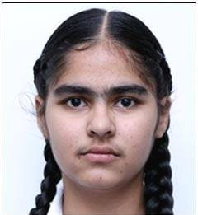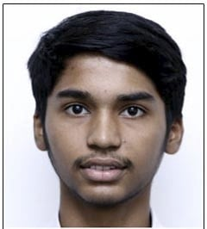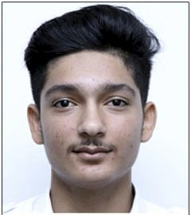

Session 2021-22

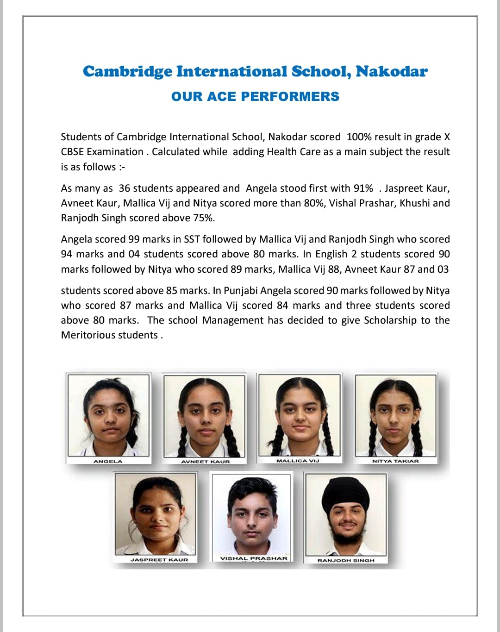
Session 2021-22
Our GLITTERING STARS of XII std.
The CBSE Term I result of grade XII of Cambridge International School, Nakodar has been remarkably outstanding. Manveer Kaur, Taranpreet Singh, Manraj Singh, Manan, and Prince of Non Medical stream bagged highest positions by scoring 94.8%, 92.8%, 91.6% 91.6%, 89.2%marks respectively. Khushi, Simranpreet Kaur, Amardeep Kaur, Prabhjeet Kaur, Arman Sindh of Medical stream scored 91.2%, 89.2%, 89.2%, 88.8%, 88% marks respectively. Prabhjot Kaur, Navneet, Kirandeep Kaur, Harpinderjot Kaur, Sahibpreet Singh, Samleen Kaur, Navjot Kaur of Commerce scored 96.4%, 94.3%, 92.4%, 90.8%, 90.8%, 90.8%, 90.4% marks respectively. Prabhjot Kaur and Kiranjeet Kaur of Humanities scored 93.6% and 90% marks respectively.
Principal Mrs. Sandhya Dewan applauded the students and congratulated the highly dedicated teachers for these spectacular results and wished for the bright future of the 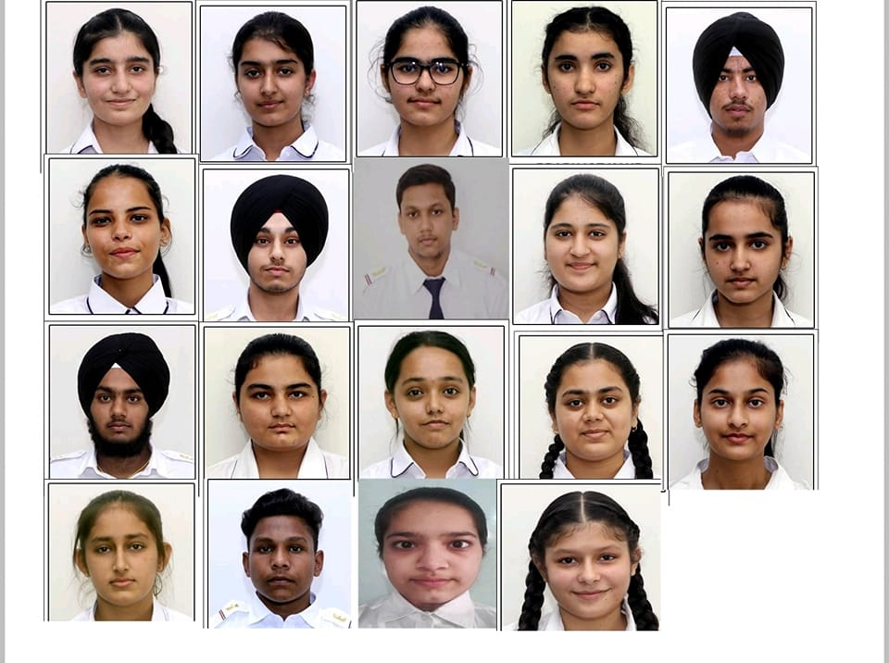students.

