SAP (statistical analysis plan)
Pooled RESULTS:
DEMOGRAPHICS SUMMARY REPORTS:
Table 1: Age Analysis
Category | Mean | Std
Recipient | XX | XX
Donor | XX | XX

Table2: Relationship of recipient with donor
mother, father-:Related
wife-:Spousal
Other-:Unrelated
Category | Number of Records
Related | XX
Spousal | XX
Unrelated | XX
Total | XX

Table 3: Gender Analysis
Category | Total
Recipient | XX  XX
Female | XX  XX
Male | XX
Donor | XX  XX
Female | XX  XX
Male | XX

LAB SUMMARY REPORTS:

Table 4: Analysis of Serum Creatinine on Different Days
Day | no of records | Mean | Std | Range
day3 | XX | XX | XX | XX
day7 | XX | XX | XX | XX
day15 | XX | XX | XX | XX
day30 | XX | XX | XX | XX
day90 | XX | XX | XX | XX
day180 | XX | XX | XX | XX
day360 | XX | XX | XX | XX
day720 | XX | XX | XX | XX

Plot1: Analysis of Serum Creatinine on Different Days
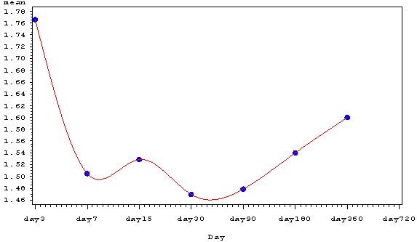

TABLE 5: ANALYSIS OF HB IN DIFFERENT DAYS

Day | N | Mean | Std | Range
day0 | XX | XX | XX | XX
day3 | XX | XX | XX | XX
day7 | XX | XX | XX | XX
day14 | XX | XX | XX | XX
day30 | XX | XX | XX | XX
day90 | XX | XX | XX | XX
day180 | XX | XX | XX | XX
day360 | XX | XX | XX | XX
day720 | XX | XX | XX | XX

PLOT 2: ANALYSIS OF HB IN DIFFERENT DAYS
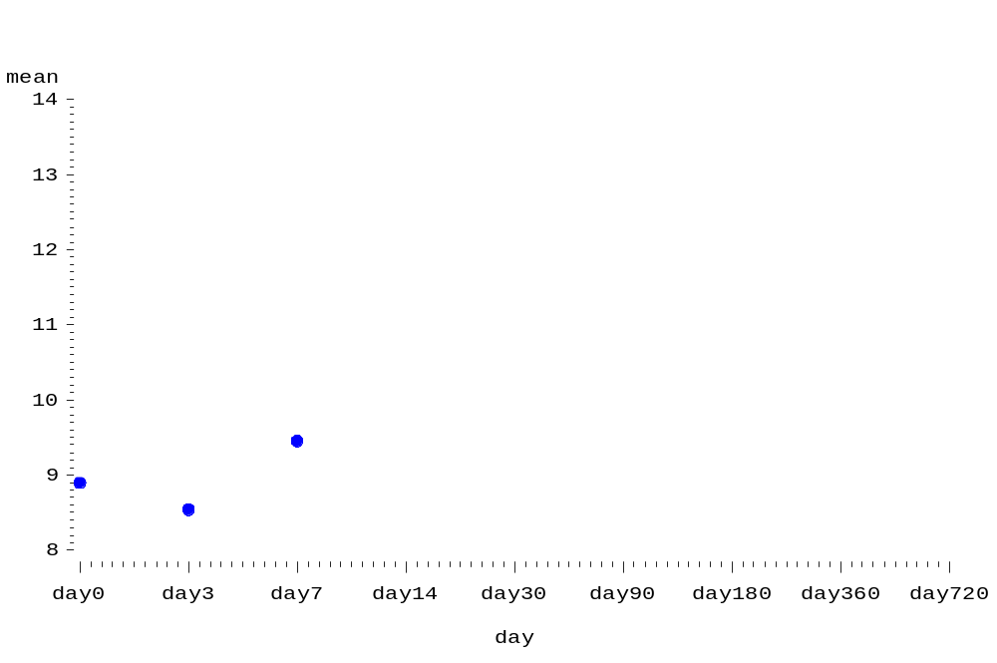

TABLE 6: ANALYSIS OF PLATELETS IN DIFFERENT DAYS

Day | N | Mean | Std | Range
day0 | XX | XX | XX | XX
day3 | XX | XX | XX | XX
day7 | XX | XX | XX | XX
day14 | XX | XX | XX | XX
day30 | XX | XX | XX | XX
day90 | XX | XX | XX | XX
day180 | XX | XX | XX | XX
day360 | XX | XX | XX | XX
day720 | XX | XX | XX | XX

PLOT 3: ANALYSIS OF PLATELETS IN DIFFERENT DAYS
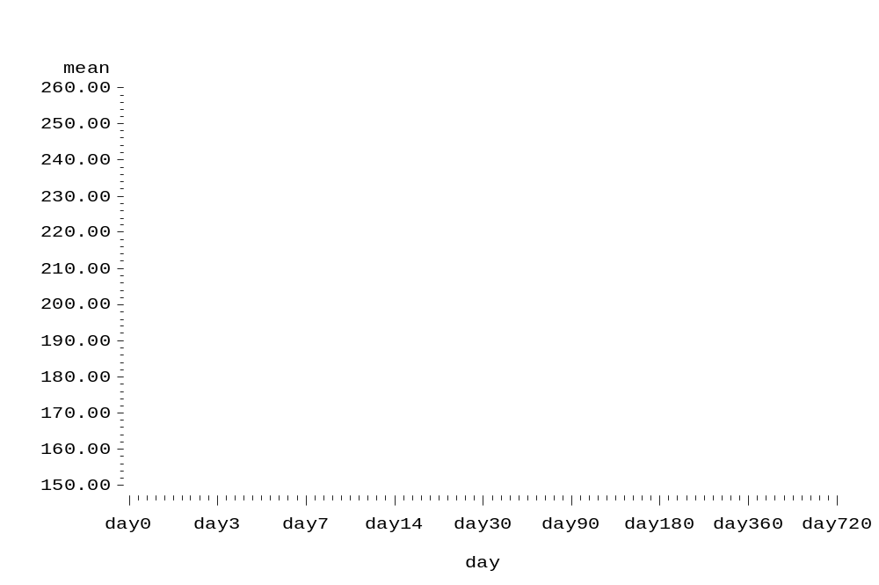

Table 7: ANALYSIS OF URINE TEST

Day | No of records observed
day0 | XX
day3 | XX
day7 | XX
day14 | XX
day30 | XX
day90 | XX
day180 | XX
day360 | XX
day720 | XX

Table 8: Analysis of CD3 in different days
Day | no of records | Mean | Std | Range
Day0 | XX | XX | XX | XX
Day3 | XX | XX | XX | XX
Day7 | XX | XX | XX | XX
Day14 | XX | XX | XX | XX
Day30 | XX | XX | XX | XX
Day90 | XX | XX | XX | XX
Day180 | XX | XX | XX | XX
Day360 | XX | XX | XX | XX
Day720 | XX | XX | XX | XX

PLOT 4: ANALYSIS ON CD3 IN DIFFERENT DAYS
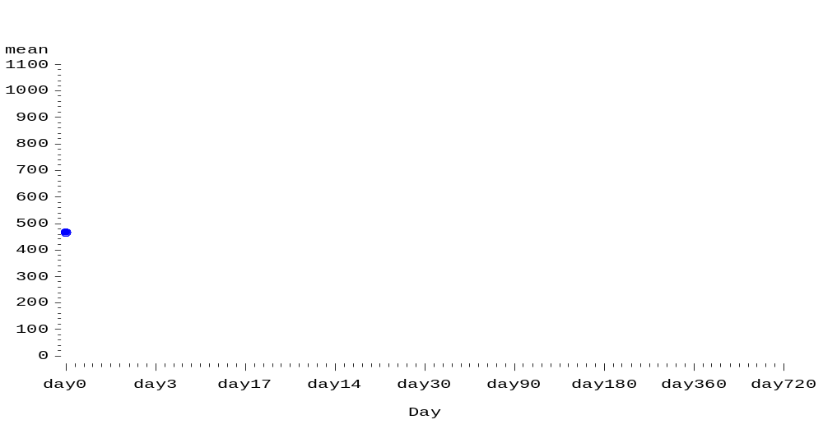

TABLE 9 : ANALYSIS ON CD4 IN DIFFERENT DAYS
day | no of records | Mean | Std | Range
day0 | XX | XX | XX | XX
day3 | XX | XX | XX | XX
day7 | XX | XX | XX | XX
day14 | XX | XX | XX | XX
day30 | XX | XX | XX | XX
day90 | XX | XX | XX | XX
day180 | XX | XX | XX | XX
day360 | XX | XX | XX | XX
day720 | XX | XX | XX | XX

PLOT5: ANALYSIS OF CD4 IN DIFFERENT DAYS
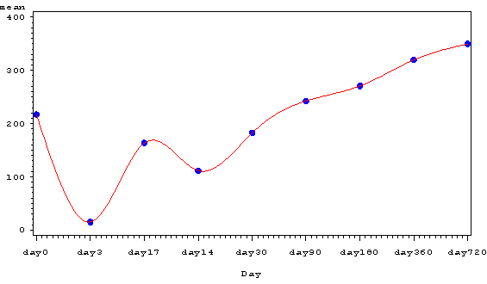

TABLE10 :ANALYSIS ON CD8 IN DIFFERENT DAYS
day | no of records | Mean | Std | Range
day0 | XX | XX | XX | XX
day3 | XX | XX | XX | XX
day7 | XX | XX | XX | XX
day14 | XX | XX | XX | XX
day30 | XX | XX | XX | XX
day90 | XX | XX | XX | XX
day360 | XX | XX | XX | XX
day720 | XX | XX | XX | XX

PLOT6: ANALYSIS OF CD8 IN DIFFERENT DAYS

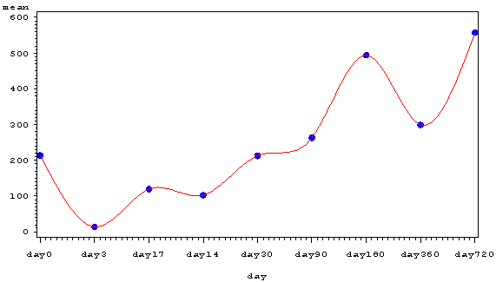

TABLE 11: HLA MATCHING

rec_a_hla | don_a_hla | rec_b_hla | don_b_hla | rec_dr_hla | don_dr_hla | hlm
2 | 2,3 | 57 | 57,63 | 9,14 | 10,13 | 2
1,3 | 19,11 | 23,37 | 44,3 | 10,11 | 10,17 | XX
2,30 | 2,3 | 5,35 | 7,66 | 2 | 11 | XX
3,2 | 3,11 | 18,37 | 18,14 | 11 | 11,7 | XX
2,28 | 2,26 | 17,56 | 55,44 | 7,- | 2,7 | XX
1,24 | 1,11 | 5,57 | 62,37 | 7 | 2,10 | 1
2,33 | 1,31 | 35,61 | 8,61 | 3,7 | 3,15 | XX
1,26 | 1,11 | 51,55 | 51,57 | 4,2 | 4,13 | XX
1,13 | 11,32 | 62,37 | 49,37 | 10 | 10,13 | XX
68 | 1,3 | 52,15 | 60,57 | 4,1 | 14,7 | XX
1,2 | 26,32 | 37,50 | 8 | 3,10 | 3 | XX
26,28 | 23,33 | 70 | 41,44 | 4,15 | 4,7 | XX
32,28 | 2,11 | 21,44 | 18 | 7,13 | 7,15 | XX
23,1 | 28,3 | 44,55 | 18,39 | 10,11 | 14,1 | XX
11,32 |  | 13,18 | 11 | 4,7 | 21,35 | XX
2,10 | 2,11 | 44,35 | 35,40 | 7,4 | 13,14 | XX
24,2 | 24,2 | 5,40 | 5,44 | 4,14 | 4,11 | XX
1,24 | 30,32 | 5,35 | 22,12 | 15 | 7,14 | XX
2,24 | 2,24 | 44,35 | 44,8 | 14 | 14,7 | XX
1,3 | 28,32 | 35, | 37,8 | 7,10 | 3, | XX
24,28 | 2,31 | 5,60 | 2,31 | 4,14 | 15, | XX
33 | 33,11 | 17,35 | 15,35 | 13,15 | 13,12 | XX
29,33 | 29,11 | 7,58 | 7,52 | 10,3 | 10,4 | XX
3,24 | 2, | 5,22 | 60, | 14, | 15, | XX
2,11 | 2,29 | 5,22 | 7,13 | 13,15 | 14,15 | XX
28,24 | 28,11 | 35,62 | 35,18 | 4,12 | 4,15 | XX
2,26 | 32,26 | 8,27 | 8,39 | 3,14 | 3 | XX
2,33 | 2,9 | 16,35 | 40,35 | 15,3 | 15 | XX
11,10 | 11,9 | 7,5 | 7,50 | 13 | 13,7 | XX
2,28 | 11,32 | 50,60 | 35,38 | 12,15 | 11 | XX
1,24 | 28,24 | 13,37 | 52,40 | 10,11 | 4,15 | XX
1,33 | 1,11 | 17,40 | 5 | 13,15 | 8,15 | XX
1,33 | 32,33 | 17,53 | 17,44 | 3,14 | 3,7 | XX
2,24 | 2,24 | 17,35 | 17,50 | 3,11 | 3 | XX
2,3 | 2,3 | 7,50 | 7,52 | 3,7 | 3,5 | XX
 |  |  |  |  |  | XX
3,24 | 1,2 | 7,18 | 15,35 | 15,8 | 15,13 | XX
2 | 24,32 | 5,17 | 40,44 | 3,4 | 7,14 | XX
1,26 | 1,11 | 40 | 40 | 15,14 | 15 | XX
1,33 | 1,33 | 44 | 44,35 | 7 | 7,15 | XX
24,2 | 24,33 | 40,44 | 17,44 | 7,14 | 7,3 | XX
24,31 | 24,28 | 8,44 | 5,35 | 3,4 | 15,4 | XX
2,3 | 11,3 | 5,7 | 7 | 7,11 | 7 | XX
 |  |  |  |  |  | XX
1,33 | 1,2 | 5,22 | 7,22 | 13,15 | 13,7 | XX
11,28 | 2,28 | 22,44 | 22,35 | 13,7 | 13,11 | XX

TABLE I2: ANALYSIS OF TLC ON DIFFERENT DAYS

DAY | no of records | Mean | Std | Range
day0 | XX | XX | XX | XX
day3 | XX | XX | XX | XX
day7 | XX | XX | XX | XX
day14 | XX | XX | XX | XX
day30 | XX | XX | XX | XX
day90 | XX | XX | XX | XX
day180 | XX | XX | XX | XX
day360 | XX | XX | XX | XX
day720 | XX | XX | XX | XX

MEDICATION SUMMARY REPORTS

TABLE 13: ANALYSIS OF MMF DOSE IN DIFFERENT DAYS

Day | no of records | Mean | Std | Range
day0 | XX | XX | XX | XX
day3 | XX | XX | XX | XX
day7 | XX | XX | XX | XX
day14 | XX | XX | XX | XX
day30 | XX | XX | XX | XX
day90 | XX | XX | XX | XX
day180 | XX | XX | XX | XX
day360 | XX | XX | XX | XX
day720 | XX | XX | XX | XX

]

PLOT 7 : ANALYSIS OF MMF DOSE IN DIFFERENT DAYS
*
TABLE 14: ANALYSIS OF WYS DOSE TEST ON DIFFERENT DAYS
day |  | No of records |  | Mean |  | Std |  | Range
day0 | XX |  | XX |  | XX |  | XX
day3 | XX |  | XX |  | XX |  | XX
day7 | XX |  | XX |  | XX |  | XX
day14 | XX |  | XX |  | XX |  | XX
day30 | XX |  | XX |  | XX |  | XX
day90 | XX |  | XX |  | XX |  | XX
day180 | XX |  | XX |  | XX |  | XX
day360 | XX |  | XX |  | XX |  | XX

PLOT 8: ANALYSIS ON WYSDOSE IN DIFFERENT DAYS
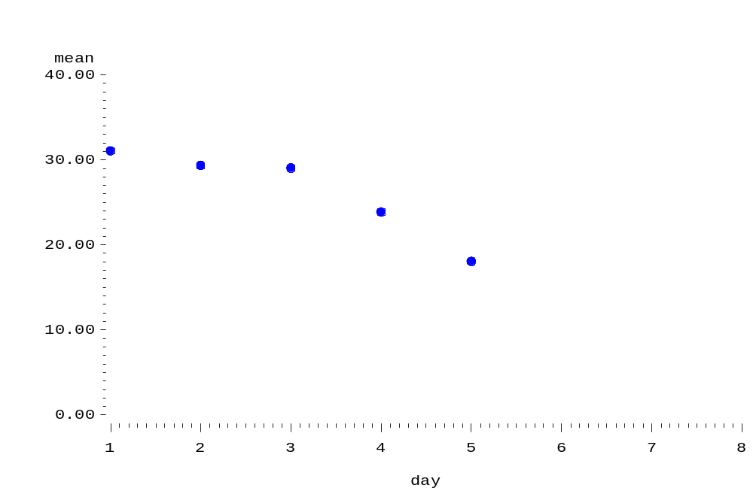
TABLE 15: ANALYSIS OF ATG DOSE TEST IN DIFERENT DAYS
rec_atg_doses | Avg_dose
100mg*3 | XX
not known | XX
50mg*3 | XX
50mg*3 | XX
 | XX
50mg*3 | XX
50mg*3 | XX
50mg*3 | XX
75mg*2,50mg*1 | XX
100mg*3 | XX
100mg*3 | XX
50mg*2 | XX
50mg*2 | XX
100mg*3 | XX
 | XX
50mg*3 | XX
50mg*2 | XX
50mg*2 | XX
50mg*2 | XX
75mg*2 | XX
50mg*2 | XX
50mg*1,75mg*1 | XX
50mg*2 | XX
50mg*2 | XX
75mg*2 | XX
75mg*1,50mg*3 | XX
75mg*2 | XX
50mg*2 | XX
50mg*2 | XX
50mg*6,75mg*1 | XX
50mg*2 | XX
50mg*2 | XX
50mg*4 | XX
75mg*2 | XX
50mg*2 | XX
50mg*3 | XX
50mg*1,75mg*1 | XX
50mg*3 | XX
50mg*2 | XX
50mg*4 | XX
75mg*1,50mg*1 | XX
75mg*2 | XX
50mg*2 | XX
75mg*2 | XX
75mg*1 | XX
 | XX

TABLE 16: VIRUS EFFECT

LabTestName | Count
HCV | XX  XX
+ve | XX  XX
-ve | XX
HIV | XX  XX
-ve | XX  XX
HBS | XX  XX
+ve | XX  XX
-ve | XX

TABLE17: ADVERSE EFFECTS ON ATG DRUG

Infection category | No of records
Viral | XX
Bacterial | XX
Fungal | XX
Others | XX

TABLE18: ANALYSIS OF ORGAN S INVOLVED

Organ Infected | No of records
UTI | XX
LUNG | XX
CNS | XX
OTHERS1 | XX

TABLE19: ANALYSIS OF INFECTION

Category | no of records
Nodm | XX
dyslipidemia | XX
dyselectrolytemia | XX
Cosmetic | XX

CONTROL GROUP RESULTS:
DEMOGRAPHICS SUMMARY REPORTS:

AGE ANALYSIS:
TABLE 1:

Categeory | Mean | Std
Recipient | XX | XX
donors | XX | XX

Table 2: Relationship of recipient with donor
Category | No of records
Related | XX
Unrelated | XX
Total | XX

Table 3: Gender Analysis
Category | TOTAL
Recipient | XX  XX
Female | XX  XX
Male | XX
Donors | XX  XX
Female | XX
Male | XX

LAB SUMMARY REPOTS:

Table 4: Analysis of SERUM in different days
day | no of records | Mean | Std | Range
day3 | XX | XX | XX | XX
day7 | XX | XX | XX | XX
day15 | XX | XX | XX | XX
day30 | XX | XX | XX | XX
day90 | XX | XX | XX | XX
day180 | XX | XX | XX | XX
day360 | XX | XX | XX | XX
day720 | XX | XX | XX | XX

PLOT 1: Analysis of SERUM in different days
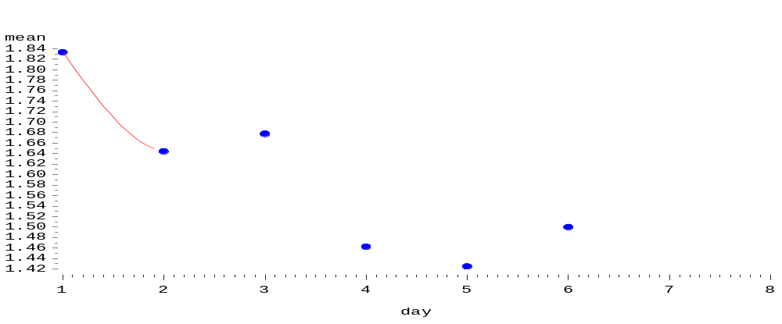

Table 5: Analysis of CD3 in different days

day | no of records | Mean | Std | Range
day3 | XX | XX | XX | XX
day7 | XX | XX | XX | XX
day14 | XX | XX | XX | XX
day30 | XX | XX | XX | XX
day90 | XX | XX | XX | XX
day180 | XX | XX | XX | XX
day360 | XX | XX | XX | XX
day720 | XX | XX | XX | XX

PLOT 2:CD3 PLOT
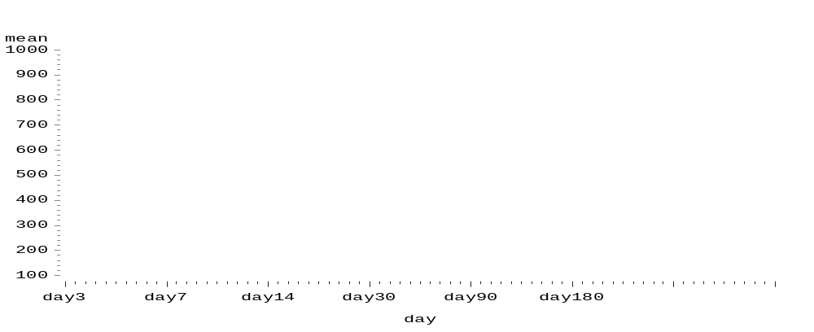

TABLE 6: ANALYSIS OF CD4 IN DIFFERENT DAYS

Day | no of records | Mean | Std | Range
day3 | XX | XX | XX | XX
day7 | XX | XX | XX | XX
day14 | XX | XX | XX | XX
day30 | XX | XX | XX | XX
day90 | XX | XX | XX | XX
day180 | XX | XX | XX | XX
day360 | XX | XX | XX | XX
day720 | XX | XX | XX | XX

PLOT 3:CD4
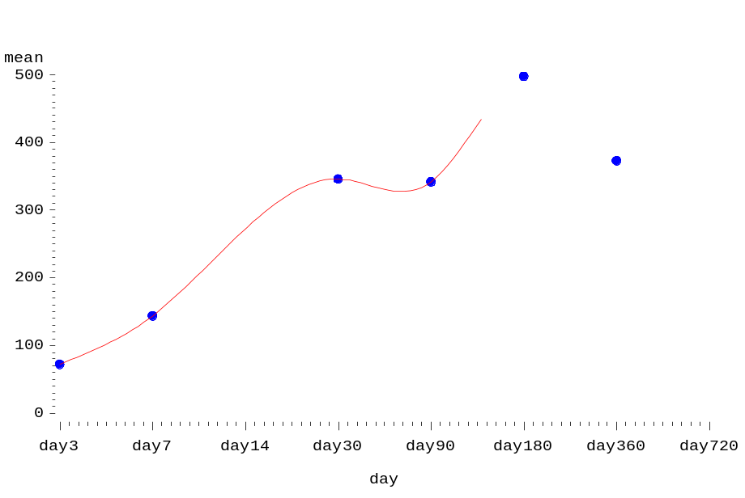

TABLE 7:
day | no of records | Mean | Std | Range
day3 | XX | XX | XX | XX
day7 | XX | XX | XX | XX
day14 | XX | XX | XX | XX
day30 | XX | XX | XX | XX
day90 | XX | XX | XX | XX
day180 | XX | XX | XX | XX
day360 | XX | XX | XX | XX
day720 | XX | XX | XX | XX
ANALYSIS OF CD8 ON DIFFERENT DAYS

PLOT 4:CD8 PLOT
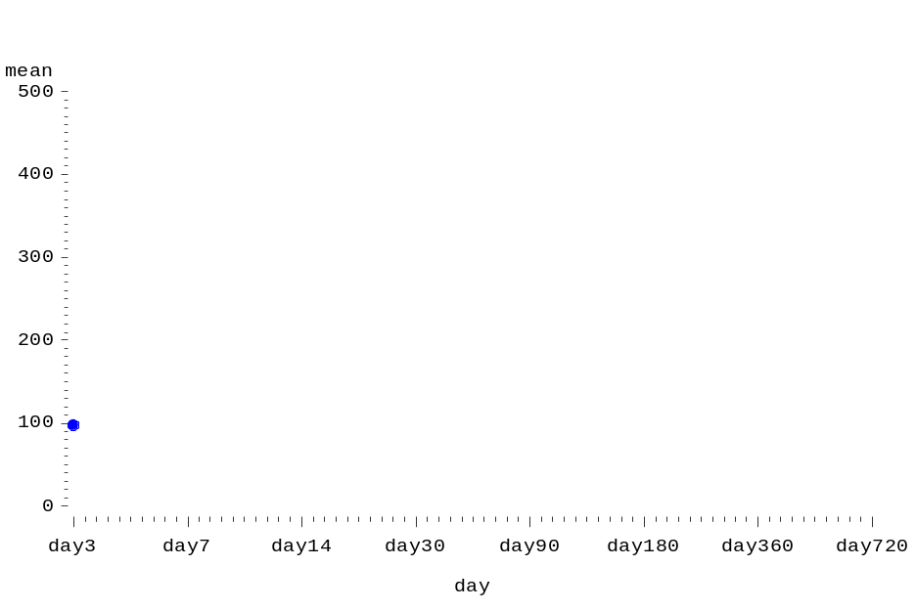

TABLE 8 : ANALYSIS OF HB ON DIFFERENT DAYS
day | N | Mean | Std | Range
day0 | XX | XX | XX | XX
day3 | XX | XX | XX | XX
day7 | XX | XX | XX | XX
day14 | XX | XX | XX | XX
day30 | XX | XX | XX | XX
day90 | XX | XX | XX | XX
day180 | XX | XX | XX | XX
day360 | XX | XX | XX | XX
day720 | XX | XX | XX | XX

PLOT5:HB PLOT
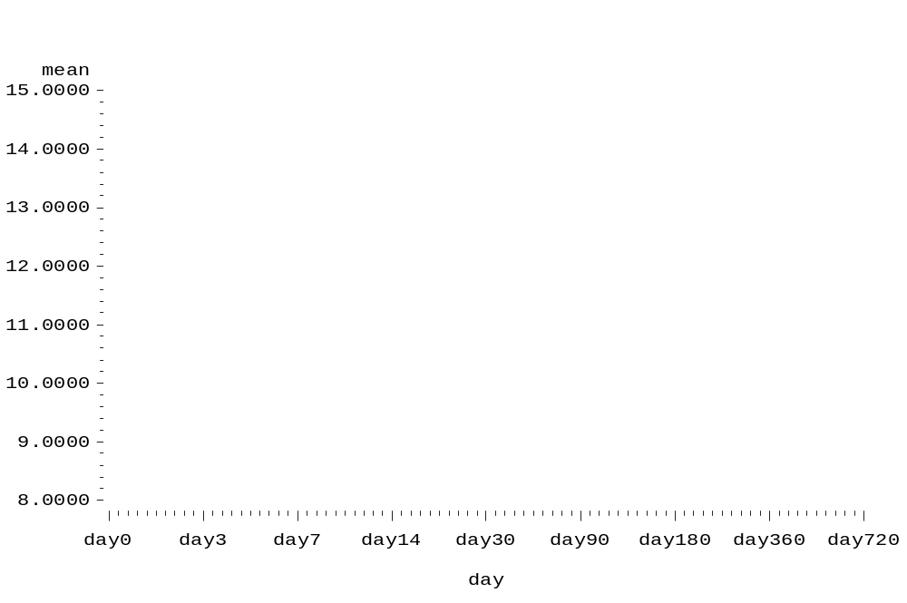

TABLE 9: Analysis of urine test

day | No of Records Observed
day0 | XX
day3 | XX
day7 | XX
day14 | XX
day30 | XX
day90 | XX
day180 | XX
day360 | XX
day720 | XX

TABLE 10: ANALYSIS OF PLT TEST ON DIFFERENT DAYS
day | N | Mean | Std | Range
day0 | XX | XX | XX | XX
day3 | XX | XX | XX | XX
day7 | XX | XX | XX | XX
day14 | XX | XX | XX | XX
day30 | XX | XX | XX | XX
day90 | XX | XX | XX | XX
day180 | XX | XX | XX | XX
day360 | XX | XX | XX | XX
day720 | XX | XX | XX | XX

PLOT 6: PLT PLOT

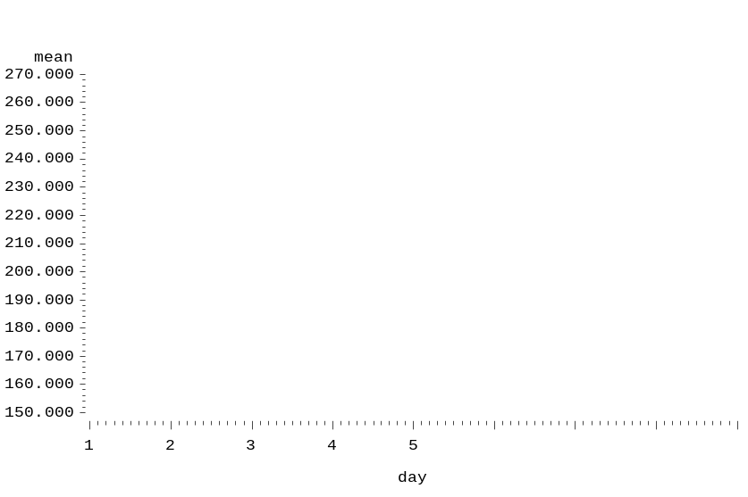

VIRUS EFFECTS
TABLE 11: Analysis of HIV HCV HBS
 | COUNT
HCV | XX  XX
-ve | XX  XX
HIV | XX  XX
-ve | XX  XX
HBS | XX
-ve | XX

MEDICATION SUMMARY REPORTS

TABLE 12: ANALYSIS OF MMF DOSE IN DIFFERENT DAYS
Day | No of Records | Mean | STD | Range
day0 | XX | XX | XX | XX
day3 | XX | XX | XX | XX
day7 | XX | XX | XX | XX
day14 | XX | XX | XX | XX
day30 | XX | XX | XX | XX
day90 | XX | XX | XX | XX
day180 | XX | XX | XX | XX
day360 | XX | XX | XX | XX
day720 | XX | XX | XX | XX

PLOT 7: MMF PLOT
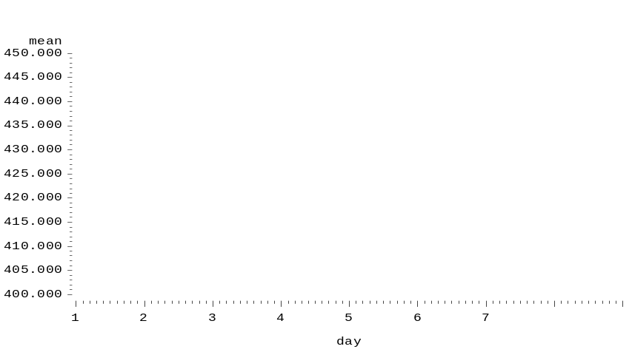
TABLE 13: ANALYSIS ON WYS DOSE FOR DIFFERENT DAYS
Day | No of Records | Mean | STD | Range
day0 | XX | XX | XX | XX
day3 | XX | XX | XX | XX
day7 | XX | XX | XX | XX
day14 | XX | XX | XX | XX
day30 | XX | XX | XX | XX
day90 | XX | XX | XX | XX
day180 | XX | XX | XX | XX
day360 | XX | XX | XX | XX

PLOT 8: WYS PLOT

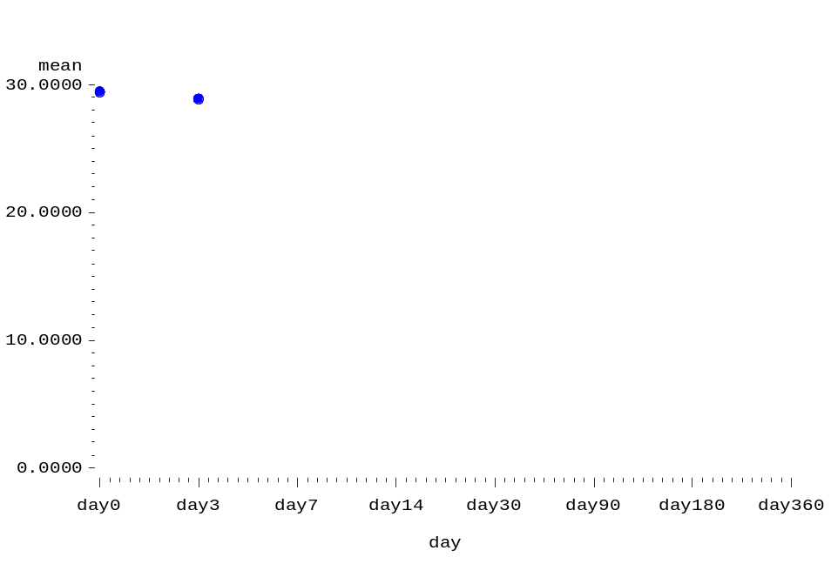

TABLE14: ADVERSE EFFECTS ON ATG DRUG

Day | No_of_records_observed
Viral | XX
bacterial | XX
Fungal | XX
Others | XX

TABLE 15: ANALYSIS OF ORGAN S INVOLVED
day | No_of_records
UTI | XX
lung | XX
CNS | XX
Others1 | XX

TABLE 16: ANALYSIS OF INFECTION TEST

Day | No_of_records
Nome | XX
dyslipidemia | XX
dyselectrolytemia | XX
cosmetic | XX

﻿

COMPARISION RESULTS:
PLOT 9: CD3 Plot
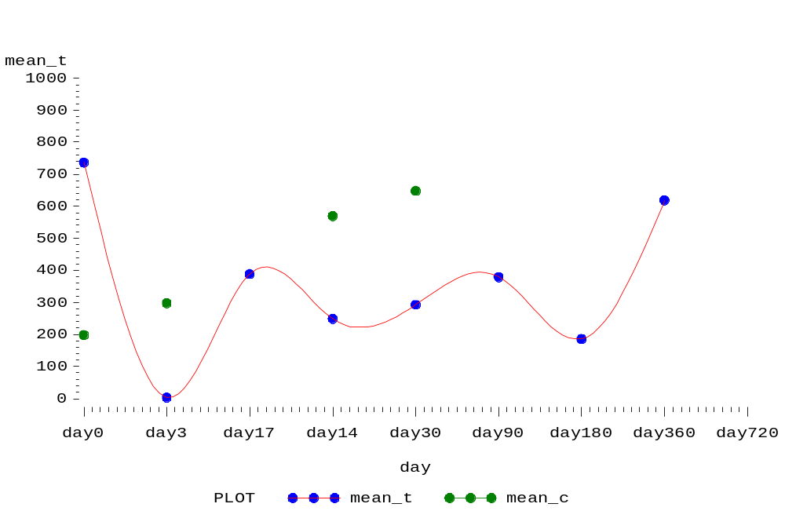

TABLE 17: T-TEST FOR CD3

T-Tests
Variable | Method | Variances | DF | t Value | Pr > |t|
mean | Pooled | Equal | XX | XX | XX
mean | Satterthwaite | Unequal | XX | XX | XX

PLOT 10: CD4 FINAL
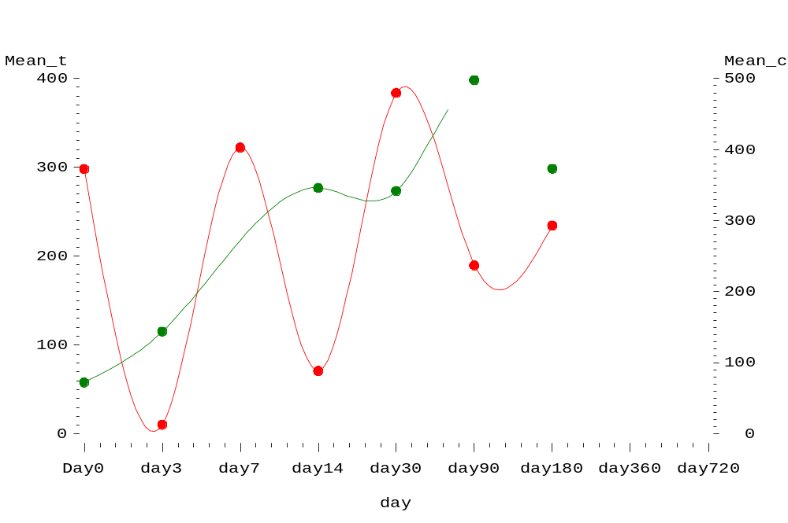

TABLE 18 :T-TEST FOR CD4 FINAL
T-Tests
Variable | Method | Variances | DF | t Value | Pr > |t|
mean | Pooled | Equal | XX | XX | XX
mean | Satterthwaite | Unequal | XX | XX | XX

PLOT 11 : CD8 FINAL
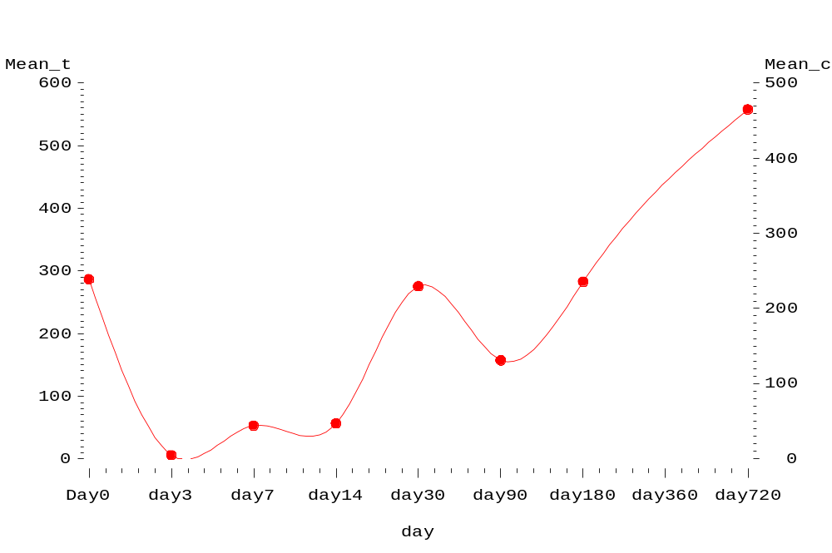

TABLE 19 :T-TEST FOR CD8
T-Tests
Variable | Method | Variances | DF | t Value | Pr > |t|
mean | Pooled | Equal | XX | XX | XX
mean | Satterthwaite | Unequal | XX | XX | XX

PLOT 12: HBTEST FINAL
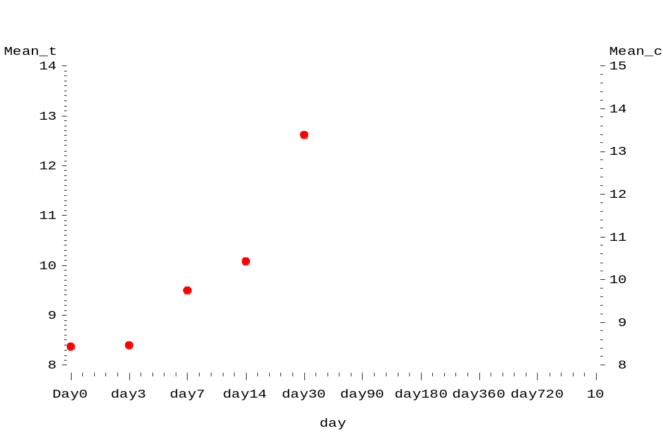
TABLE 20: T-TEST FOR HB TEST
T-Tests
Variable | Method | Variances | DF | t Value | Pr > |t|
mean | Pooled | Equal | XX | XX | XX
mean | Satterthwaite | Unequal | XX | XX | XX

PLOT 13: PLT TEST FINAL
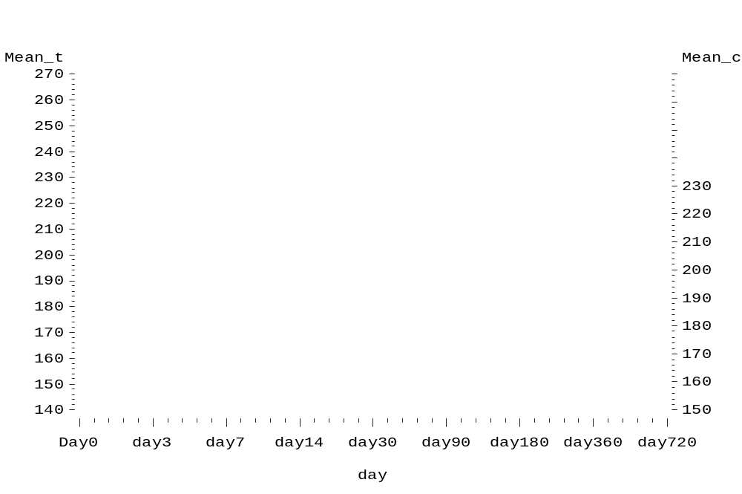
TABLE 21: T-TEST FOR PLT TEST

T-Tests
Variable | Method | Variances | DF | t Value | Pr > |t|
mean | Pooled | Equal | XX | XX | XX
mean | Satterthwaite | Unequal | XX | XX | XX

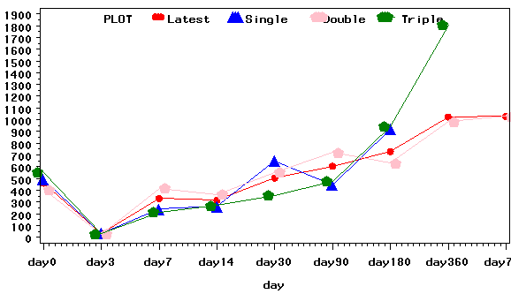

Cd3

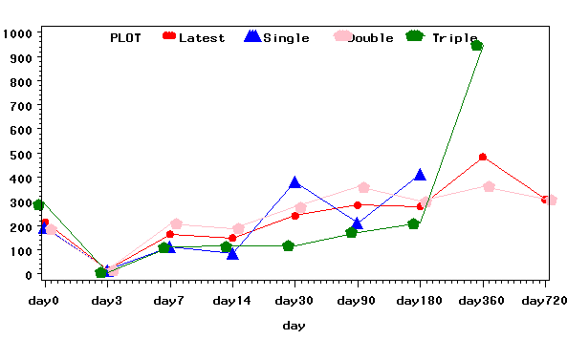

Cd4

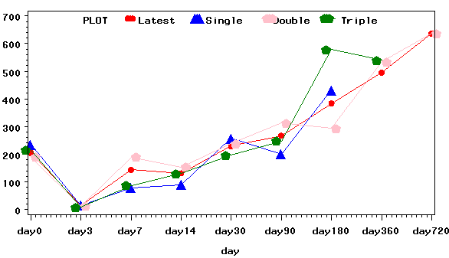

Cd8

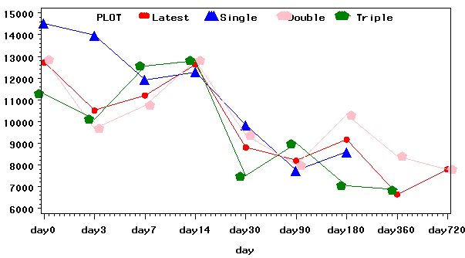

TLC

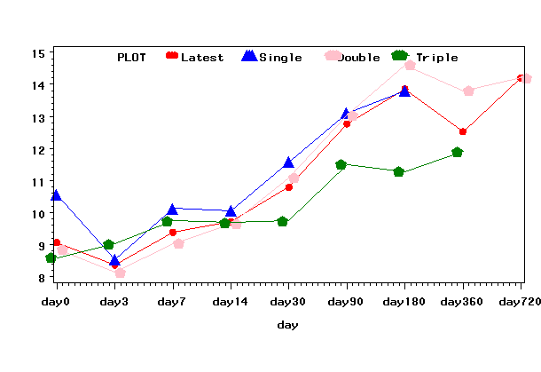

HB

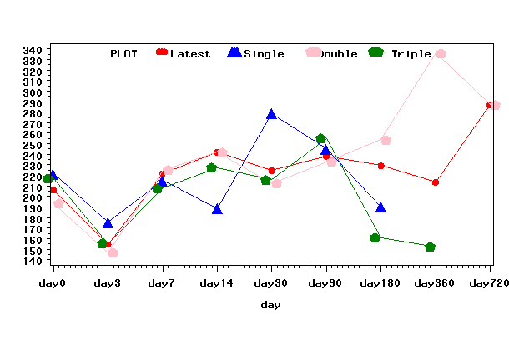

PLATE LETS

TTest or ANOVA

- Compare the Latest with Single dose using Ttest or ANOVA
Comparing Variables (cd3, cd4, cd8, Platelates and HB)
- Compare the Latest with Double dose using Ttest or ANOVA
Comparing Variables (cd3, cd4, cd8, Platelates and HB)
- Compare the Latest with Triple dose using Ttest or ANOVA
Comparing Variables (cd3, cd4, cd8, Platelates and HB)

Generate the all the reports for Latest, Single, double, triple, control Using Macros

