SIMATS ENGINEERING
ASSESSMENT TOOL 1

COURSE NAME: MLA03
COURSE CODE: Reinforcement learning
NAME: M.Madhulika
REGISTER NUMBER: 192472188

COURSE OUTCOME COVERED

CO1: Analyse reinforcement learning frameworks and Markov Decision Process concepts to model decision-making problems. (BL2, BL3)

Assessment Tool Weightage: 50%

Dr. G. A. Senthil

QUESTIONS: 10 Total Marks: 50

Annexure A

Descriptive Experiment Exam

Duration: 2hrs

Experiment 1: Installation of Reinforcement Learning Development Environment

Aim: To install and configure Anaconda Navigator, Python, TensorFlow, Keras, Gymnasium (OpenAI Gym), NumPy, Matplotlib, and other required libraries, and verify the environment by executing a simple Reinforcement Learning program.

Experiment 2: Familiarization with OpenAI Gym/Gymnasium Environments

Aim: To create, initialize, and interact with standard Reinforcement Learning environments such as FrozenLake, CartPole, and MountainCar using Gymnasium to understand the concepts of states, actions, rewards, and episodes.

Experiment 3: Implementation of the Reinforcement Learning Framework

Aim: To implement the basic Reinforcement Learning framework by designing an agent that interacts with an environment through states, actions, rewards, and policies using Python.

Experiment 4: Simulation of a Markov Decision Process (MDP)

Aim: To develop a simple Markov Decision Process model and simulate state transitions, reward functions, and policy execution for understanding sequential decision-making problems.

Experiment 5: Bellman Equation Demonstration

Aim: To implement Bellman Expectation and Bellman Optimality Equations for calculating state-value and action-value functions and analyse the convergence of value estimation.

Experiment 6: Exploration vs. Exploitation Strategies

Aim: To implement ε-Greedy, Greedy, and Random action-selection strategies and compare their performance in balancing exploration and exploitation during Reinforcement Learning.

Experiment 7: Multi-Armed Bandit Problem

Aim: To implement the Multi-Armed Bandit problem using ε-Greedy and Upper Confidence Bound (UCB) algorithms and evaluate cumulative rewards obtained by different action-selection methods.

Experiment 8: Reward Visualization in Reinforcement Learning

Aim: To simulate an RL agent in a simple environment and visualize cumulative rewards, episode rewards, and learning performance using Matplotlib graphs.

Experiment 9: TensorFlow and Keras-Based Neural Network for RL

Aim: To build a simple feed-forward neural network using TensorFlow and Keras for approximating value functions in Reinforcement Learning environments.

Experiment 10: Mini Reinforcement Learning Project Using CartPole

Aim: To develop a basic Reinforcement Learning agent using TensorFlow and Keras to solve the CartPole environment and evaluate its learning performance through episode rewards and success rate.

EXPERIMENT-1

Aim: To install and configure Anaconda Navigator, Python, TensorFlow, Keras, Gymnasium (OpenAI Gym), NumPy, Matplotlib, and other required libraries, and verify the environment by executing a simple Reinforcement Learning program.

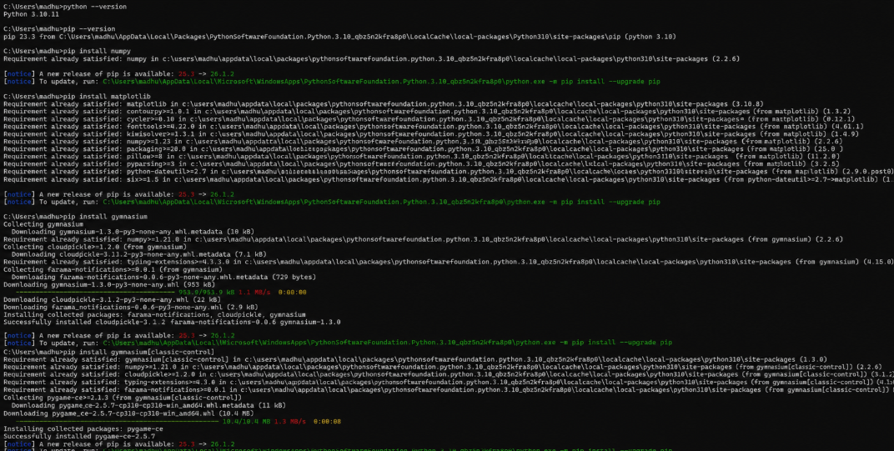

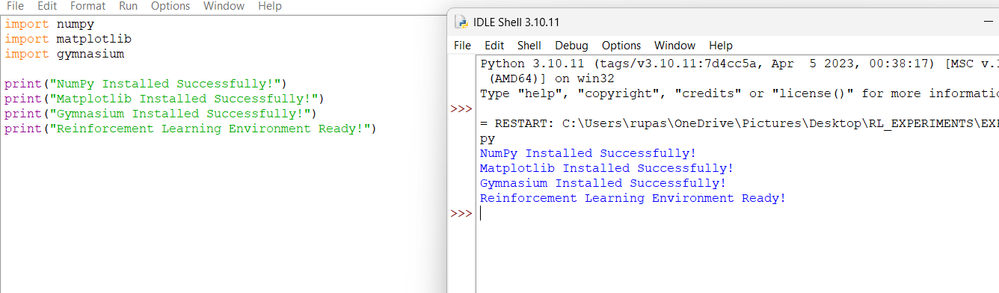

EXPERIMENT-2

Aim: To create, initialize, and interact with standard Reinforcement Learning environments such as FrozenLake, CartPole, and MountainCar using Gymnasium to understand the concepts of states, actions, rewards, and episodes.

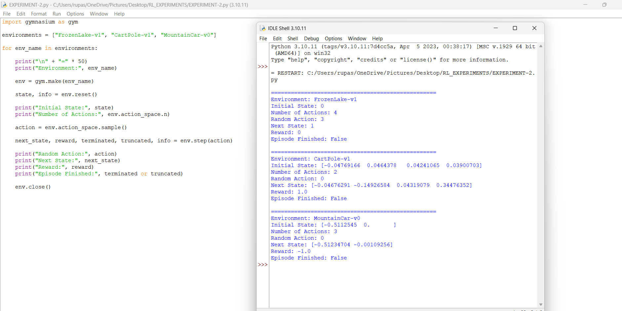

EXPERIMENT-3

Aim: To implement the basic Reinforcement Learning framework by designing an agent that interacts with an environment through states, actions, rewards, and policies using Python.

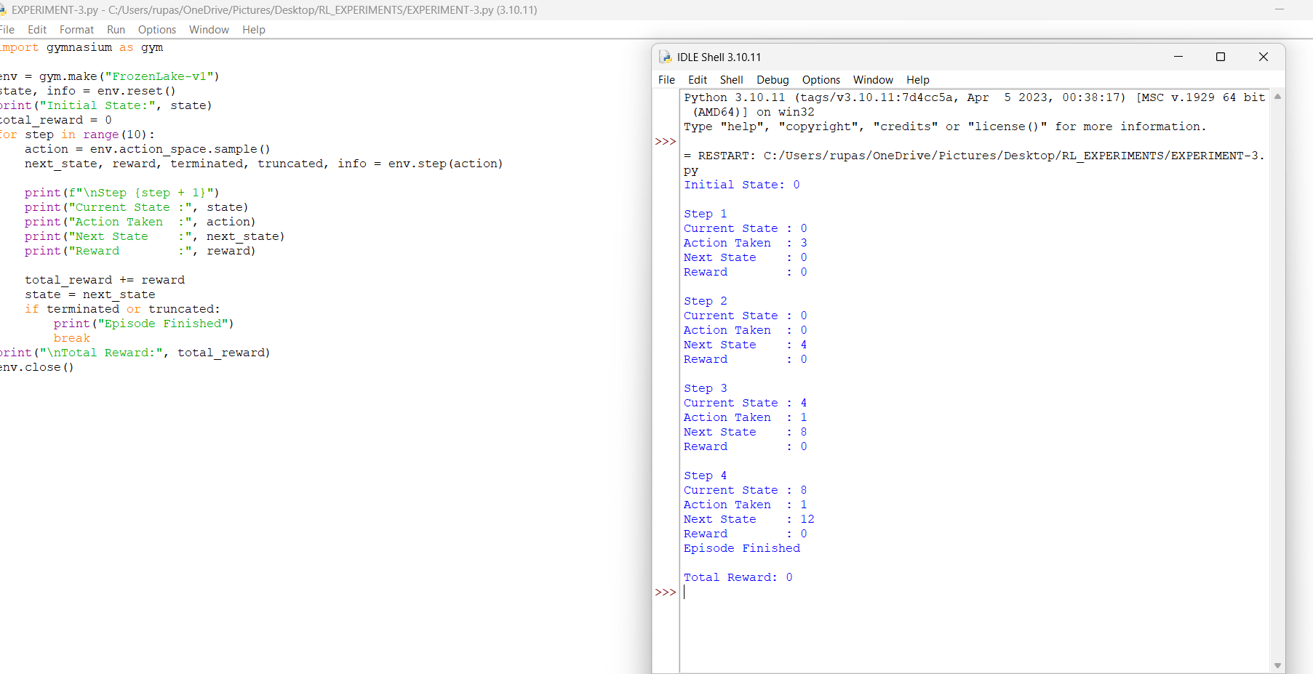

EXPERIMENT-4

Aim: To develop a simple Markov Decision Process model and simulate state transitions, reward functions, and policy execution for understanding sequential decision-making problems.

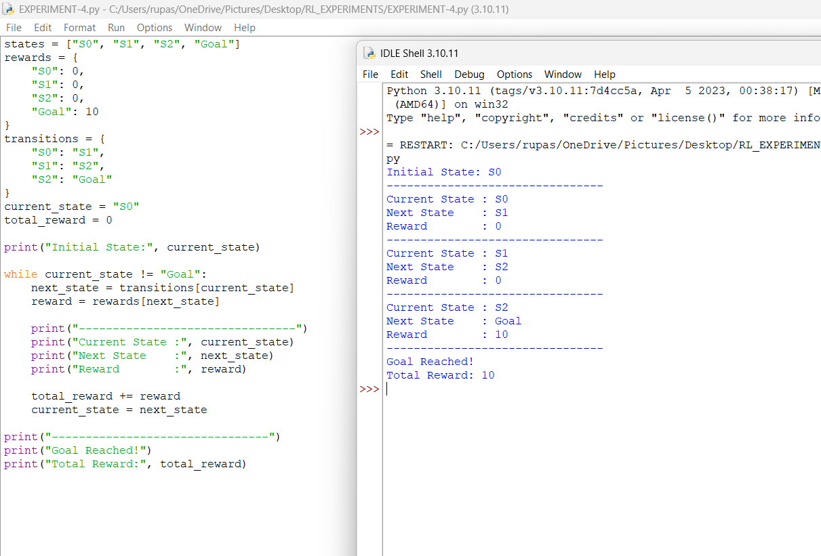

EXPERIMENT-5

Aim: To implement Bellman Expectation and Bellman Optimality Equations for calculating state-value and action-value functions and analyse the convergence of value estimation.

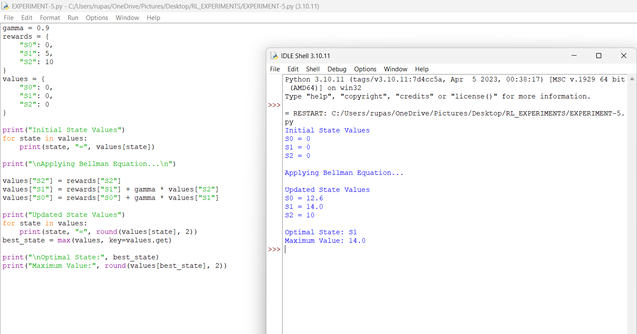

EXPERIMENT-6

Aim: To implement ε-Greedy, Greedy, and Random action-selection strategies and compare their performance in balancing exploration and exploitation during Reinforcement Learning.

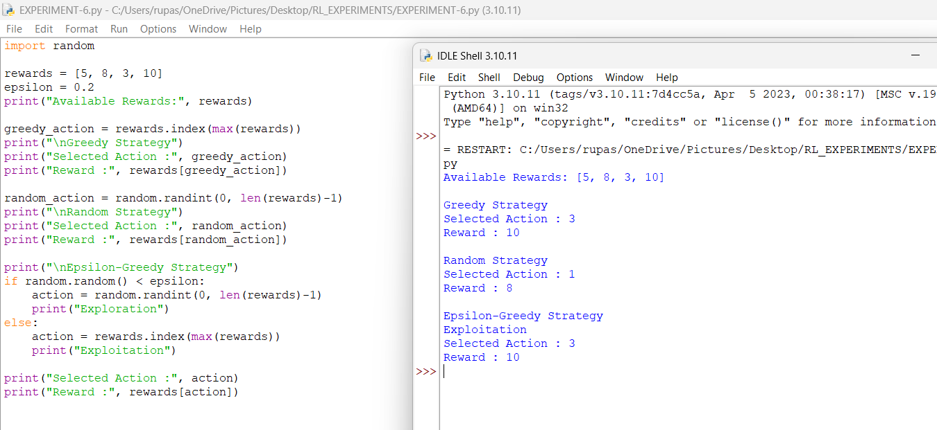

EXPERIMENT-7

Aim: To implement the Multi-Armed Bandit problem using ε-Greedy and Upper Confidence Bound (UCB) algorithms and evaluate cumulative rewards obtained by different action-selection methods.

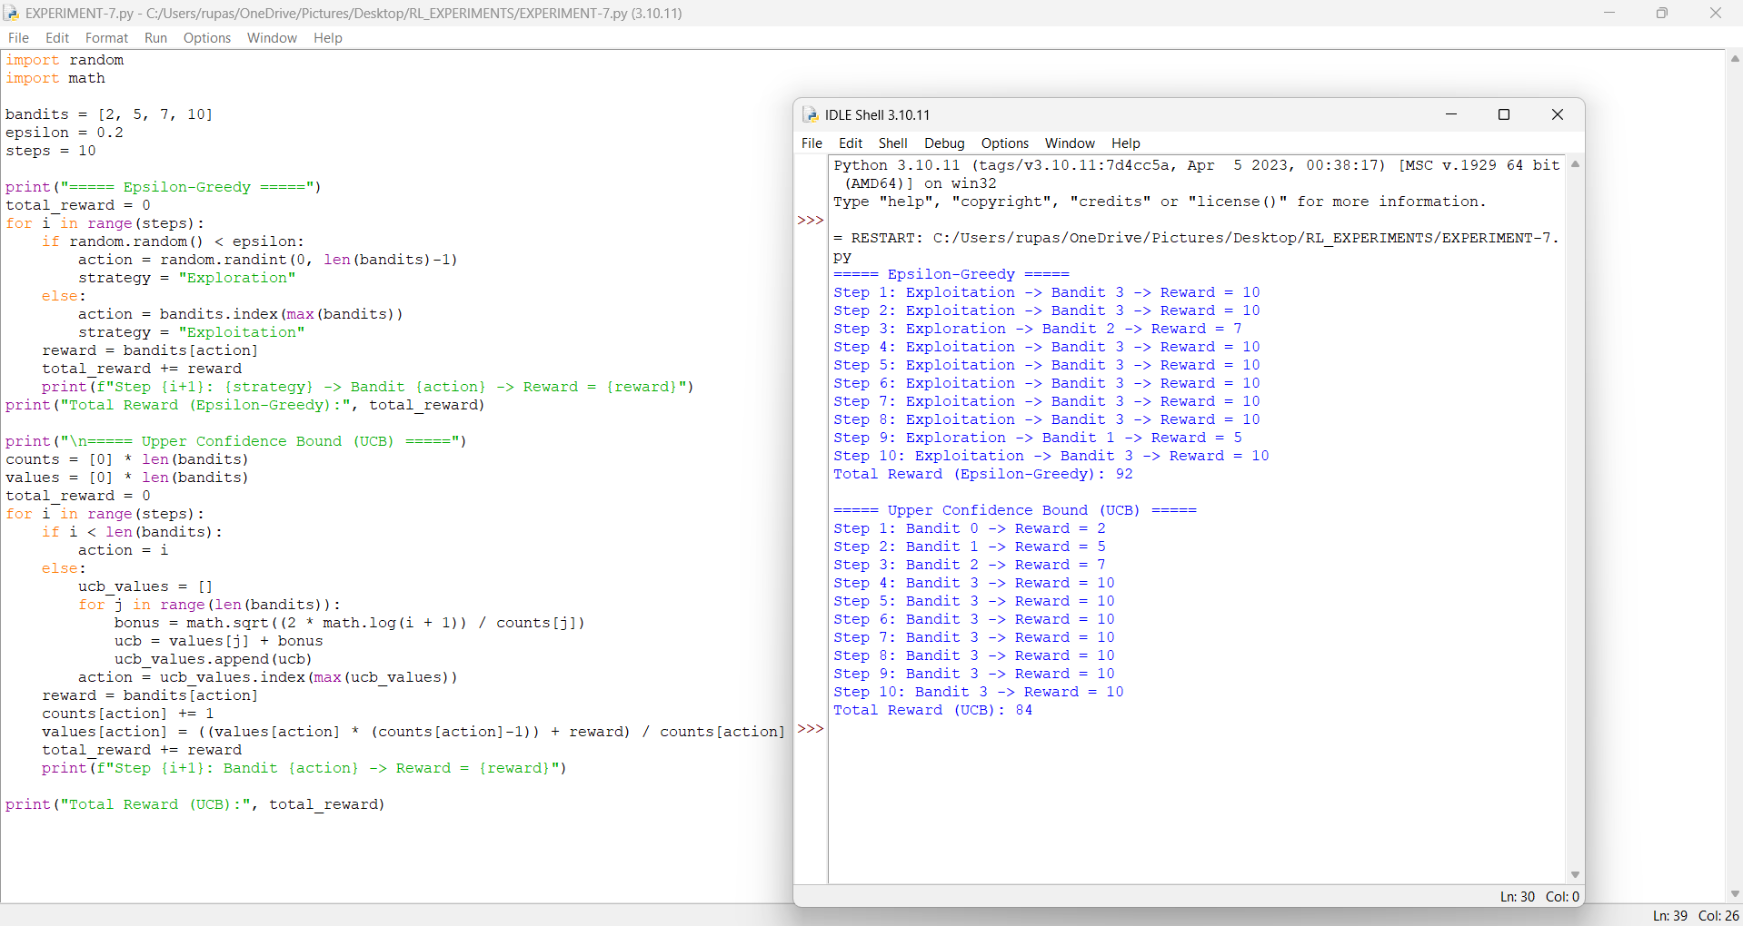

EXPERIMENT-8

Aim: To simulate an RL agent in a simple environment and visualize cumulative rewards, episode rewards, and learning performance using Matplotlib graphs.

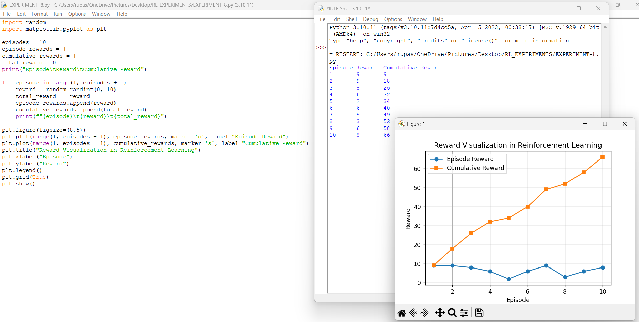

Code of Conduct:

I M.Madhulika (192472188) (Name / Reg No) certify that this submission is my original work and that I have adhered to the guidelines specified for this assessment.
I understand that any violation of academic integrity rules will result in disciplinary action.

Signature of the student:
M.Madhulika
RUBRICS FOR CALCULATION

Criteria | Weightage | Level 4 – Exemplary | Level 3 – Proficient | Level 2 – Developing | Level 1 – Beginning
Understanding of Concepts | 25% | Demonstrates thorough, accurate understanding of concepts | Good understanding with minor gaps | Basic understanding with some misconceptions | Poor understanding; major misconceptions
Explanation | 25% | Detailed, well-explained answers with relevant examples | Clear explanation with adequate details | Limited explanation; lacks depth | Poor or unclear explanation
Application | 20% | Effectively applies concepts with strong analytical ability | Applies concepts with minor errors | Limited application with weak analysis | No application or incorrect analysis
Organization | 15% | Well-structured answers with logical flow and coherence | Organized with minor issues in flow | Basic structure, lacks clarity | Poor organization, incoherent answers
Accuracy | 10% | Completely accurate and covers all required points | Mostly accurate with minor omissions | Partially correct with missing points | Incorrect answers with major gaps
Clarity | 5% | Clear, neat, professional presentation | Understandable with minor issues | Limited clarity, readability issues | Poorly written, difficult to understand

