ABSTRACT

The rapid growth of digital communication has increased the demand for real-time messaging applications that provide reliable, secure, and confidential communication between users. Traditional client–server chat applications may use TCP sockets for reliable message delivery, but communication without an additional security layer can expose transmitted information to unauthorized users through network interception and eavesdropping.

This project focuses on the design and development of a real-time client–server chat application using Transport Layer Security (TLS) to provide confidential, authenticated, and reliable communication. The proposed system follows a client–server architecture in which multiple clients establish connections with a centralized chat server and exchange messages through secure communication channels.

TCP is used as the underlying transport protocol because it provides connection-oriented and reliable delivery of data. TLS is implemented over the TCP connection to provide encryption, server authentication, and integrity protection. Before exchanging chat messages, the client and server establish a secure TLS session through the TLS handshake process.

The proposed application consists of a client module, a secure chat server module, and a security and network monitoring module. The server manages multiple client connections, receives messages, processes communication requests, and forwards messages to the intended clients. The clients establish secure connections with the server and exchange messages through the encrypted channel.

The project demonstrates important Computer Networks concepts including TCP, IP addressing, port numbers, socket programming, client–server architecture, reliable transport, TLS, digital certificates, encrypted communication, and network security. The system can also be analyzed using network monitoring and packet-analysis tools to observe TCP and TLS communication.
Overall, the proposed system provides a practical implementation of secure real-time communication and demonstrates how Transport Layer Security can improve confidentiality, integrity, authentication, and reliability in network-based applications.

S. No. | Contents | Page No.
1 | INTRODUCTION | 5
1.1 | Background Information | 5
1.2 | Project Objectives | 6
1.3 | Significance of the Project | 6
1.4 | Scope of the Project | 6
1.5 | Methodology Overview | 7
2 | PROBLEM IDENTIFICATION AND ANALYSIS | 8
2.1 | Description of the Problem | 8
2.2 | Review of Existing Systems | 8
2.3 | Comparative Analysis | 10
2.4 | Key Findings from Literature | 11
2.5 | Summary | 11
3 | SOLUTION DESIGN AND IMPLEMENTATION | 12
3.1 | Development and Design Process | 12
3.2 | Tools and Technologies Used | 13
3.3 | Solution Overview | 14
3.4 | Engineering Standards Applied | 15
3.5 | Solution Justification | 16
3.6 | Dataset / Test Scenario | 16
4 | RESULT AND RECOMMENDATION | 17
4.1 | Evaluation of Results | 17
4.2 | Challenges Encountered | 18
4.3 | Possible Improvements | 19
4.4 | Recommendations | 19
5 | REFLECTION ON LEARNING AND PERSONAL DEVELOPMENT | 20
5.1 | Key Learning Outcomes | 20
5.2 | Challenges Encountered and Overcome | 21
5.3 | Application of Engineering Standards | 21
5.4 | Insights into the Industry | 22
5.5 | Conclusion of Personal Development | 22
6 | CONCLUSION | 23
7 | REFERENCES | 24

CHAPTER 1
INTRODUCTION

  - Background Information

Real-time communication has become an essential component of modern computer networks. Chat applications are widely used in education, business, customer support, social communication, and collaborative environments. These applications require efficient communication mechanisms to exchange messages between users with minimum delay.

A common approach for developing a real-time chat application is the client–server architecture. In this architecture, clients connect to a central server using network sockets. The server manages the connected clients and acts as an intermediary for message exchange.

TCP is commonly used for such communication because it is a connection-oriented transport protocol that provides reliable and ordered delivery of data. However, TCP itself does not encrypt application data. If a chat application transmits messages through a plain TCP connection, the contents of the communication may potentially be exposed to network monitoring or interception.

Transport Layer Security provides a mechanism for protecting application data transmitted over a network. TLS establishes a secure channel between communicating endpoints and provides encryption, authentication, and integrity protection.

Therefore, this project focuses on designing and developing a real-time client–server chat application that combines TCP socket communication with TLS security. The system demonstrates how transport-layer concepts can be applied to create a reliable and secure communication application.

1.2 Project Objectives
The main objectives of this project are:
- To design a real-time client–server chat application using socket programming.
- To implement reliable communication using the TCP transport protocol.
- To establish secure communication between clients and the server using Transport Layer Security.
- To provide confidentiality and integrity protection for transmitted chat messages.
- To implement a server capable of managing multiple client connections.
- To implement TLS certificate-based server authentication.
- To test the communication system using network connectivity and packet-analysis techniques.
- To evaluate the reliability and security of the proposed communication system.

1.3 Significance of the Project
This project is significant for the following reasons:
- Confidential Communication: TLS protects chat messages from being transmitted as readable plaintext over the network.
- Data Integrity: TLS provides protection against unauthorized modification of transmitted data.
- Server Authentication: Digital certificates can be used to verify the identity of the communicating server.
- Reliable Communication: TCP provides reliable, ordered, and connection-oriented delivery of messages.
- Real-Time Messaging: The application allows connected clients to exchange messages through the server.
- Practical Networking Knowledge: The project provides practical exposure to TCP, sockets, ports, IP addressing, TLS, and packet communication.
- Security Awareness: The project demonstrates the importance of protecting application-layer communication over computer networks.

1.4 Scope of the Project
Included in this project:
- Client–server chat architecture
- TCP socket communication
- Multiple client connections
- Real-time text message exchange
- TLS-secured communication
- TLS certificate configuration
- Server authentication
- Secure message transmission
- Client connection management
- Network connectivity testing
- TCP and TLS packet analysis
Not included in this project:
- Voice and video communication
- Mobile application deployment
- Cloud-based large-scale deployment
- End-to-end encryption between individual clients
- Advanced enterprise identity management
- Intrusion detection and prevention systems
- Large-scale load balancing
- Production-level distributed server architecture

1.5 Methodology Overview
The methodology adopted for this project includes the following steps:
- Requirement Analysis: Identifying the communication, networking, and security requirements of the chat application.
- Architecture Design: Designing the client–server architecture and communication flow.
- Socket Implementation: Establishing TCP socket communication between clients and the server.
- Multi-Client Management: Implementing mechanisms for accepting and managing multiple connected clients.
- TLS Integration: Configuring TLS certificates and establishing secure communication channels.
- Message Processing: Implementing message transmission, reception, and forwarding between connected clients.
- Testing and Evaluation: Testing connectivity, message delivery, TLS handshaking, and secure communication.
- Network Analysis: Observing TCP and TLS communication using network-analysis tools.
- Documentation: Recording the architecture, implementation process, test scenarios, and results.
FIGURE 1 – Client–Server Chat Network Architecture

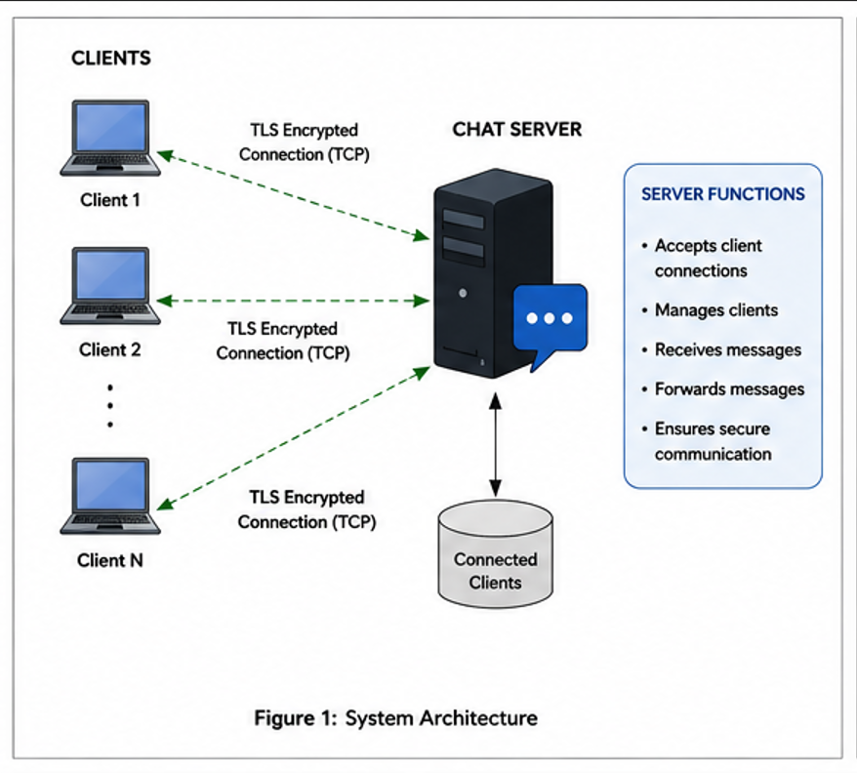

CHAPTER 2

PROBLEM IDENTIFICATION AND ANALYSIS

2.1 Description of the Problem
Real-time chat applications require continuous communication between users across a network. A basic socket-based chat application can establish communication using TCP, but TCP does not inherently provide encryption for application data.
When messages are transmitted through an unsecured connection, an attacker with access to the network may potentially observe or intercept the communication. This creates security concerns when sensitive or private information is exchanged.
The major problems associated with unsecured chat communication include:
- Lack of Confidentiality: Messages may be exposed to unauthorized parties.
- Network Eavesdropping: Attackers may monitor network traffic and attempt to inspect transmitted information.
- Lack of Authentication: A client may not be able to verify whether it is communicating with the intended server.
- Message Modification: Communication without integrity protection may be vulnerable to unauthorized modification.
- Security Limitations of Basic TCP: TCP provides reliable transport but does not itself provide application-data encryption.
Therefore, a secure communication mechanism is required to protect the chat application. The proposed solution integrates TLS with TCP socket communication.

2.2 Evidence of the Problem
Several communication approaches can be considered for real-time messaging.

Basic TCP Socket Chat
A basic TCP chat application establishes a direct socket connection between the client and server.

Advantages:
- Simple implementation
- Reliable communication
- Easy to understand
- Low implementation complexity

Limitations:
- No encryption by default
- No certificate-based server authentication
- Application data may be exposed to network interception

HTTP-Based Communication
HTTP can be used for communication between clients and servers.

Advantages:
- Widely supported
- Easy integration with web applications
- Standard application-layer protocol

Limitations:
- Plain HTTP does not provide encryption
- Additional mechanisms are required for real-time communication

HTTPS-Based Communication
HTTPS combines HTTP with TLS.

Advantages:
- Encrypted communication
- Server authentication
- Integrity protection

Limitations:
- Mainly designed around HTTP communication
- Not as direct for demonstrating raw TCP socket communication concepts
Proposed TLS-Based Chat
The proposed application directly combines TCP socket communication with TLS.

Advantages:
- Reliable TCP communication
- Encrypted communication
- Certificate-based authentication
- Practical demonstration of transport-layer security
- Suitable for real-time messaging

2.3 Comparative Analysis
Feature | Basic TCP Chat | HTTP Chat | HTTPS Chat | Proposed TLS Chat
TCP Communication | Yes | Yes | Yes | Yes
Reliable Delivery | Yes | Yes | Yes | Yes
Encryption | No | No | Yes | Yes
TLS | No | Optional | Yes | Yes
Server Authentication | No | No | Yes | Yes
Real-Time Messaging | Yes | Limited | Yes | Yes
Socket Programming | Yes | Usually abstracted | Usually abstracted | Yes
Network Security Demonstration | Low | Medium | High | High

The proposed system provides a balance between networking concepts and security by directly implementing TCP socket communication and TLS.

2.4 Key Findings from Literature

The analysis of computer networking and security concepts provides the following findings:

- TCP provides reliable, connection-oriented communication.
- Socket programming provides an interface for applications to communicate over networks.
- TLS can be used to protect application data transmitted over TCP.
- Digital certificates support authentication of communicating endpoints.
- Encryption prevents unauthorized parties from directly reading protected application data.
- Integrity protection helps detect unauthorized modification of transmitted data.
- Secure communication is important for applications that exchange private or sensitive information.

2.5 Summary

The analysis demonstrates that a basic TCP chat application can provide reliable communication but does not independently provide confidentiality or authentication. The integration of TLS addresses these security limitations while retaining TCP's reliable transport characteristics.
The proposed system therefore provides a practical approach for developing a secure real-time communication application.

CHAPTER 3

SOLUTION DESIGN AND IMPLEMENTATION
3.1 Development and Design Process
The solution was developed through the following key stages:
- Requirement Analysis: Identifying client, server, networking, and security requirements.
- Client–Server Architecture Design: Designing the centralized communication structure.
- TCP Socket Development: Implementing server and client sockets.
- Multi-Client Support: Designing the server to accept and manage multiple clients.
- TLS Certificate Configuration: Preparing the required certificates for secure communication.
- TLS Integration: Establishing TLS-secured communication over TCP connections.
- Message Processing: Implementing sending, receiving, and forwarding of chat messages.
- Testing: Verifying connection establishment, message delivery, and secure communication.
- Network Analysis: Observing the communication using network-analysis tools.

3.2 Tools and Technologies Used
Software
- Python
- OpenSSL
- Wireshark
- Visual Studio Code
- Operating System networking utilities
Networking Technologies
- TCP/IP
- Socket Programming
- Client–Server Architecture
- IP Addressing
- Port-Based Communication
- Transport Layer Security
Security Technologies
- TLS
- Digital Certificates
- Public-Key Cryptography
- Symmetric Encryption
- Certificate Authentication
- Integrity Protection

3.3 Solution Overview

The proposed system consists of three major modules.
Module 1 – Client Module
The client module is responsible for:
- Establishing a connection with the server
- Creating a TCP socket
- Initiating TLS communication
- Verifying the server certificate when configured
- Sending chat messages
- Receiving messages
- Displaying received messages
- Closing the connection securely

Module 2 – Secure Chat Server
The server module is responsible for:
- Creating the server socket
- Binding the socket to an IP address and port
- Listening for incoming connections
- Accepting multiple clients
- Establishing TLS sessions
- Receiving messages
- Processing messages
- Forwarding messages
- Managing connected clients
- Handling client disconnections

Module 3 – Security and Network Monitoring
This module focuses on:
- TLS certificate management
- Secure session establishment
- TLS handshake verification
- Network connectivity testing
- Packet analysis
FIGURE 2 – Proposed System Architecture
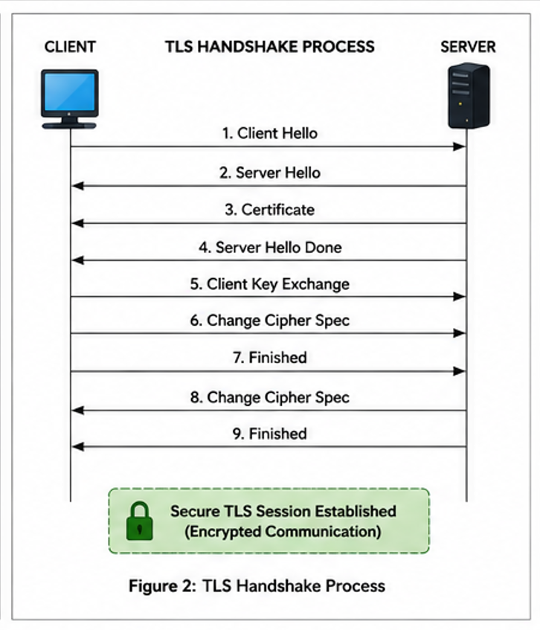

3.4 Engineering Standards Applied

The project applies established networking and security standards:
- TCP/IP: Used as the fundamental communication framework.
- TLS: Used for secure communication between the client and server.
- X.509: Used for digital certificate-based authentication.
- IPv4/IPv6: Used for network addressing.
- IETF Standards: Used as the foundation for TCP/IP and TLS communication.
- Socket Programming Standards: Used for application-level network communication.
Using established standards improves interoperability, reliability, security, and maintainability.

3.5 Solution Justification

The proposed TLS-based client–server architecture is suitable because it provides:
- Confidentiality for chat messages
- Integrity protection for transmitted data
- Server authentication
- Reliable TCP communication
- Real-time message exchange
- Multiple client support
- Practical implementation of transport-layer security
The architecture also provides a direct connection between theoretical Computer Networks concepts and their practical implementation.

3.6 Dataset / Test Scenario

Since this project is a networking application rather than a data-analysis system, controlled network test scenarios are used instead of a conventional dataset.

Client Connection Dataset
Client | IP Address | Server Port | Protocol | Expected Status
Client 1 | 192.168.1.101 | 5000 | TCP/TLS | Connected
Client 2 | 192.168.1.102 | 5000 | TCP/TLS | Connected
Client 3 | 192.168.1.103 | 5000 | TCP/TLS | Connected

Message Testing Dataset
Test No. | Sender | Receiver | Message Type | Expected Result
1 | Client 1 | Client 2 | Text Message | Successful
2 | Client 2 | Client 1 | Text Message | Successful
3 | Client 1 | Client 3 | Text Message | Successful
4 | Client 3 | Client 2 | Text Message | Successful
5 | Client 2 | Client 3 | Multiple Messages | Successful

Security Testing Dataset
Test No. | Test Condition | Expected Result
1 | Valid TLS configuration | Secure connection established
2 | Invalid certificate | Verification failure/rejection
3 | TLS connection | Application data protected
4 | Multiple clients | Simultaneous communication
5 | Client disconnection | Server handles termination
6 | Server unavailable | Client reports connection failure

CHAPTER 4

RESULT AND RECOMMENDATION
4.1 Evaluation of Results
The developed system is evaluated based on connectivity, reliability, security, and multi-client communication.

Successful Client–Server Communication
The application establishes communication between clients and the central server using TCP sockets.

Reliable Message Delivery
TCP provides connection-oriented communication and reliable delivery of transmitted data.

TLS-Secured Communication
TLS establishes a secure communication channel between the client and server before protected application data is exchanged.

Server Authentication
The TLS certificate mechanism provides a method for the client to authenticate the server when certificate verification is correctly configured.

Data Confidentiality
TLS protects application data from being directly exposed as plaintext during network transmission.

Data Integrity
TLS provides mechanisms to detect unauthorized modification of protected communication.

Multi-Client Communication
The server architecture supports multiple connected clients and manages their communication sessions.

Network Analysis
Packet-analysis tools can be used to observe TCP connection establishment and TLS communication. The protected application data should not appear as ordinary readable chat plaintext after the secure session has been established.

4.2 Challenges Encountered
Several technical challenges can occur during the development and testing process:
- Configuring TLS certificates correctly
- Understanding the TLS handshake process
- Establishing secure socket connections
- Managing multiple client connections
- Handling client disconnections
- Resolving port conflicts
- Handling invalid or expired certificates
- Debugging socket communication errors
- Understanding encrypted traffic in packet captures
These challenges can be resolved through systematic testing, configuration verification, and network troubleshooting.
.
4.3 Possible Improvements
Although the proposed system provides secure real-time communication, the following improvements can enhance the application:
- User registration and authentication
- Secure password management
- Database-based chat history
- Group chat functionality
- File transfer
- Message timestamps
- Graphical user interface
- End-to-end encryption
- Cloud deployment
- Server redundancy
- Load balancing
- Network monitoring and logging
4.4 Recommendations
Based on the proposed system, the following recommendations are provided:
- Use modern TLS versions supported by the implementation.
- Use properly managed certificates for production deployments.
- Implement strong user authentication.
- Protect private keys and certificate files from unauthorized access.
- Implement connection logging and monitoring.
- Add rate limiting to prevent excessive connection attempts.
- Perform regular security testing.
- Use secure configuration practices when deploying the application over public networks.

CHAPTER 5
REFLECTION ON LEARNING AND PERSONAL DEVELOPMENT
5.1 Key Learning Outcomes
This project provided practical knowledge of important Computer Networks concepts.
Academic Knowledge
The project strengthened my understanding of:
- TCP/IP
- Transport-layer communication
- Client–server architecture
- Socket programming
- IP addresses
- Port numbers
- Reliable data transmission
- TLS
- Network security
The implementation helped connect theoretical networking concepts with practical application development.
Technical Skills
Throughout the project, I developed technical proficiency in:
- Python socket programming
- TCP client–server communication
- TLS configuration
- Certificate handling
- Network troubleshooting
- Wireshark packet analysis
- Network connectivity testing
Problem-Solving and Critical Thinking
The development process required troubleshooting connection errors, certificate problems, socket failures, and communication issues. These challenges improved my ability to identify problems systematically, test possible solutions, and verify the resulting behavior.

5.2 Challenges Encountered and Overcome
The project involved several technical challenges, particularly in understanding how TLS operates over TCP.
Certificate configuration and secure connection establishment required careful testing. Understanding the difference between a normal TCP connection and a TLS-protected TCP connection also required practical experimentation.
These challenges improved my patience, troubleshooting ability, and understanding of network security.
5.3 Application of Engineering Standards
The project applies established networking and security standards instead of relying on a proprietary communication mechanism.
TCP/IP provides the communication foundation, while TLS provides secure transport communication. Digital certificates provide a standardized mechanism for authentication.
Following these standards improves interoperability, reliability, maintainability, and security.
5.4 Insights into the Industry
This project improved my understanding of how secure communication systems are designed in real-world environments.
Modern applications require both reliable data transmission and security. Network engineers and software developers must understand how protocols such as TCP and TLS work together to protect communication.
The project also provided exposure to areas such as:
- Network Engineering
- Cybersecurity
- Secure Software Development
- Network Administration
- Distributed Systems
5.5 Conclusion of Personal Development
Overall, the project contributed significantly to my academic and technical development.
It strengthened my understanding of Computer Networks and provided practical experience in socket programming, TCP communication, TLS security, and network troubleshooting.
The experience also improved my problem-solving skills and increased my awareness of the importance of secure communication in modern network applications.

CHAPTER 6
CONCLUSION
The primary objective of this project was to design and develop a real-time client–server chat application using Transport Layer Security for confidential and reliable communication.
The proposed system combines TCP socket communication with TLS security. TCP provides reliable and ordered transport of data, while TLS protects communication through encryption, authentication, and integrity mechanisms.
The client–server architecture allows multiple clients to communicate through a centralized server. The server manages client connections, processes messages, and facilitates communication between connected users.
The project demonstrates several fundamental Computer Networks concepts, including client–server architecture, TCP, IP addressing, port numbers, socket programming, reliable transport, TLS handshaking, digital certificates, and secure data transmission.
The implementation also provides a practical method for analyzing network communication through packet-analysis tools. This allows the behavior of TCP and TLS to be observed and understood beyond theoretical concepts.
Overall, the project demonstrates the importance of combining reliable transport and secure communication when developing modern real-time network applications. The proposed system provides a practical and educational implementation of TLS-based communication and establishes a strong foundation for future improvements such as authentication, database integration, group messaging, cloud deployment, and advanced security mechanisms.

CHAPTER 7

REFERENCES
- Kurose, J. F., & Ross, K. W. Computer Networking: A Top-Down Approach. Pearson.
- Forouzan, B. A. Data Communications and Networking. McGraw-Hill Education.
- Tanenbaum, A. S., & Wetherall, D. Computer Networks. Pearson.
- Stallings, W. Data and Computer Communications. Pearson.
- Stevens, W. R., Fenner, B., & Rudoff, A. M. UNIX Network Programming, Volume 1: The Sockets Networking API. Addison-Wesley.
- Stevens, W. R. TCP/IP Illustrated, Volume 1: The Protocols. Addison-Wesley.
- Comer, D. E. Internetworking with TCP/IP, Volume 1: Principles, Protocols, and Architecture. Pearson.
- Peterson, L. L., & Davie, B. S. Computer Networks: A Systems Approach. Morgan Kaufmann.
- Internet Engineering Task Force (IETF). The Transport Layer Security (TLS) Protocol Version 1.3. RFC 8446.
- Internet Engineering Task Force (IETF). The Transport Layer Security (TLS) Protocol Version 1.2. RFC 5246.
- Internet Engineering Task Force (IETF). Transmission Control Protocol. RFC 9293.
- Internet Engineering Task Force (IETF). Internet Protocol, Version 4 (IPv4). RFC 791.
- Internet Engineering Task Force (IETF). Internet Protocol, Version 6 (IPv6) Specification. RFC 8200.
- Internet Engineering Task Force (IETF). The Transport Layer Security (TLS) Protocol Version 1.3: Extensions. IETF Standards.
- Internet Engineering Task Force (IETF). Internet X.509 Public Key Infrastructure Certificate and Certificate Revocation List (CRL) Profile. RFC 5280.
- Internet Engineering Task Force (IETF). HTTP Over TLS. RFC 2818.
- Internet Engineering Task Force (IETF). Using TLS 1.3 with HTTP/2. IETF Standards.
- OpenSSL Project. OpenSSL Documentation. OpenSSL Project.
- Python Software Foundation. Python Socket Programming Documentation. Python Documentation.
- Python Software Foundation. Python ssl — TLS/SSL Wrapper for Socket Objects. Python Documentation.
- Wireshark Foundation. Wireshark User’s Guide. Wireshark Foundation.
- Wireshark Foundation. Wireshark Network Protocol Analyzer Documentation. Wireshark Foundation.
- Mozilla. Mozilla Root Store Policy. Mozilla Foundation.
- OWASP Foundation. Transport Layer Protection Cheat Sheet. OWASP.
- OWASP Foundation. Cryptographic Storage and Secure Communication Guidelines. OWASP.
- NIST. Guidelines for the Selection, Configuration, and Use of Transport Layer Security (TLS) Implementations. National Institute of Standards and Technology.
- NIST. Recommendation for Key Management: Part 1 – General. National Institute of Standards and Technology.
- Rescorla, E. The Transport Layer Security (TLS) Protocol Version 1.3. Internet Engineering Task Force.
- Dierks, T., & Rescorla, E. The Transport Layer Security (TLS) Protocol Version 1.2. Internet Engineering Task Force.
- Bishop, M. Computer Security: Art and Science. Addison-Wesley.

