1) Importing Data
Import the "LoanDetails" and "BorrowerDetails" sheets from the "bank loan.xlsx"
file into Power BI.

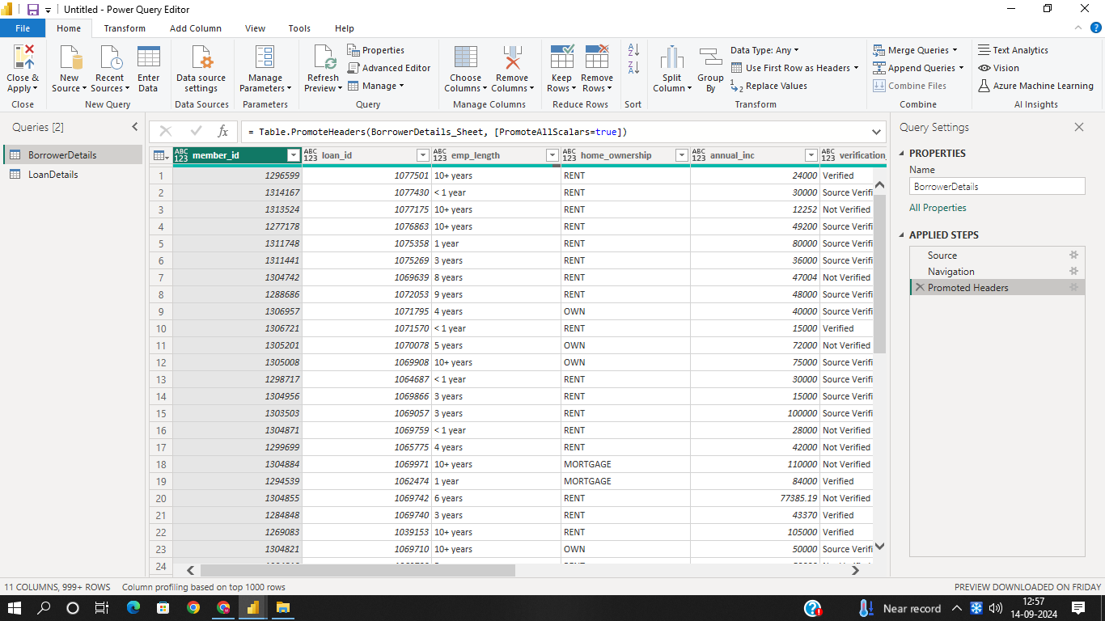

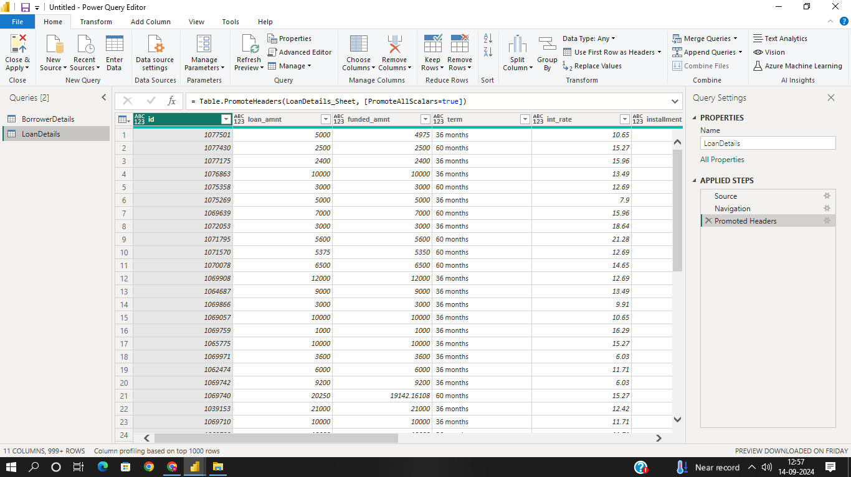

2) Transformation Using Power Query
Data Cleaning:
Handling Missing Values and Duplicates:
Replace missing values (null) in the 'emp_length' column of the "BorrowerDetails"
table with '0 year'.

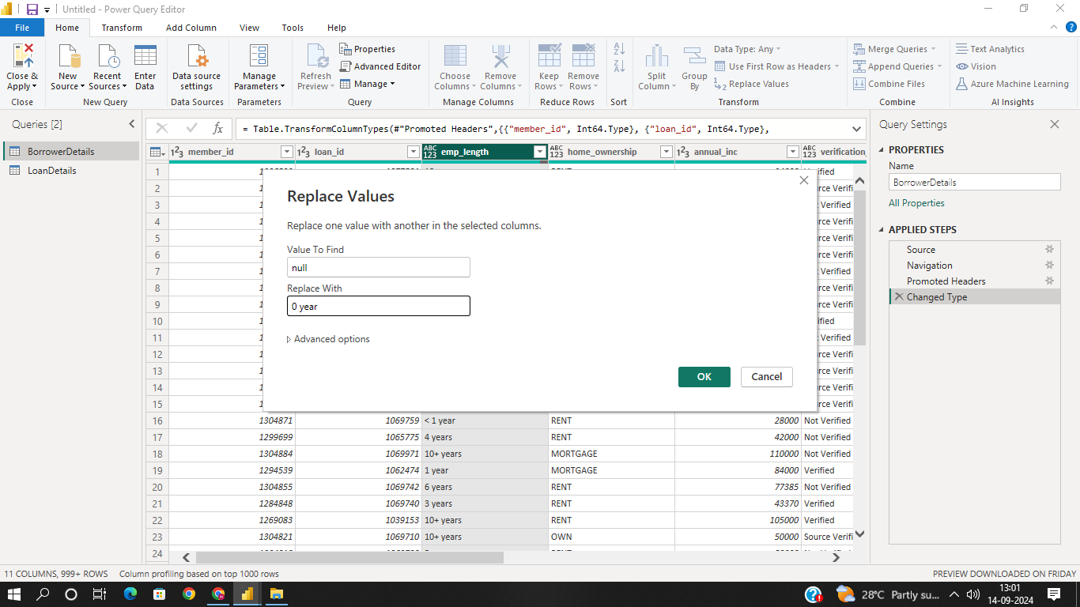

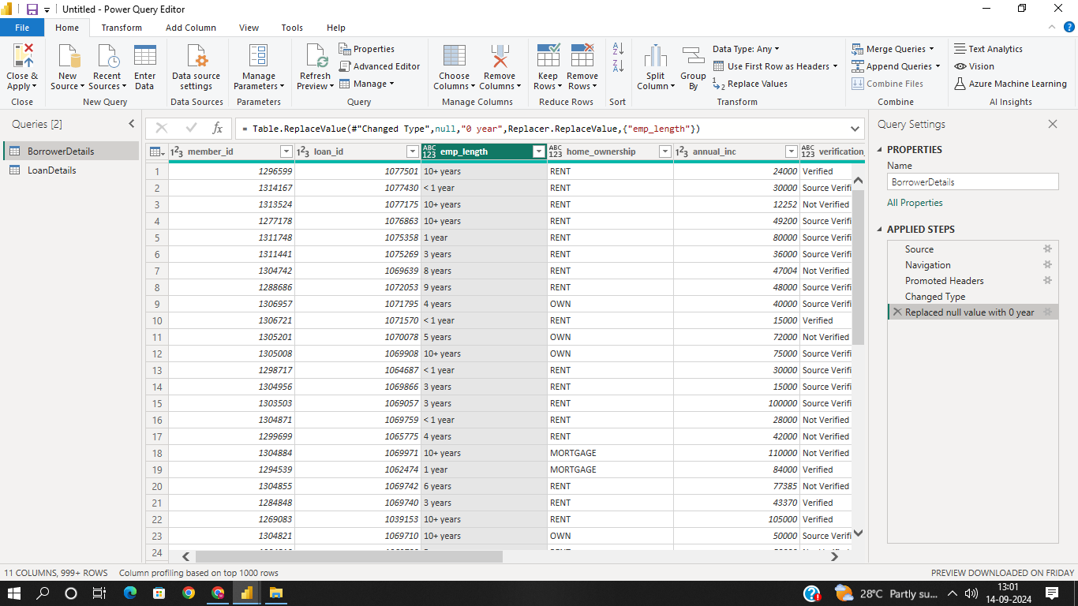

Remove rows with missing values in the 'last_pymnt_d' and 'delinq_2yrs' columns.

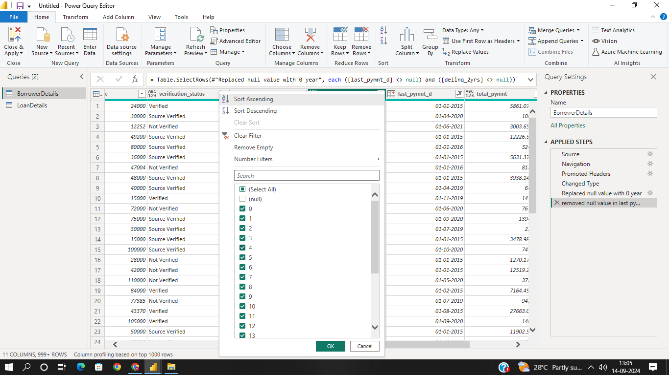

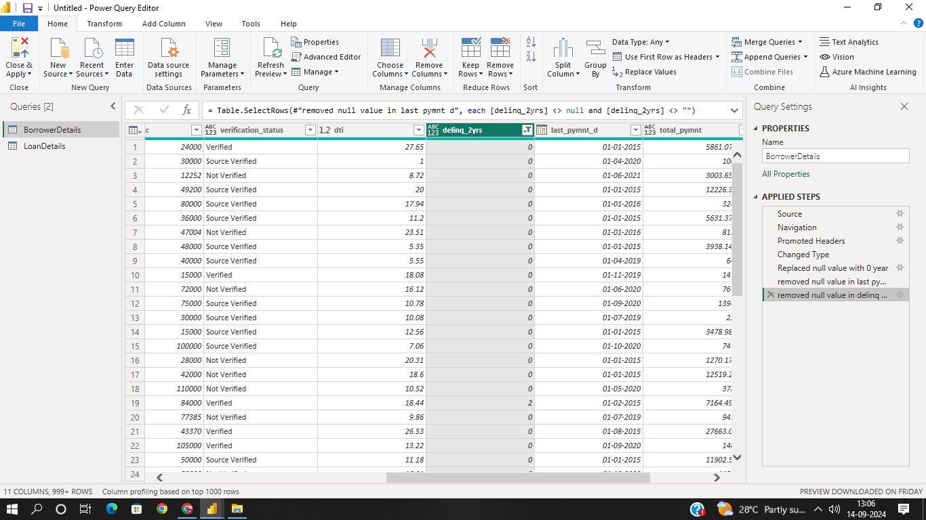

Remove duplicate rows in the 'id' column of the "LoanDetails" table
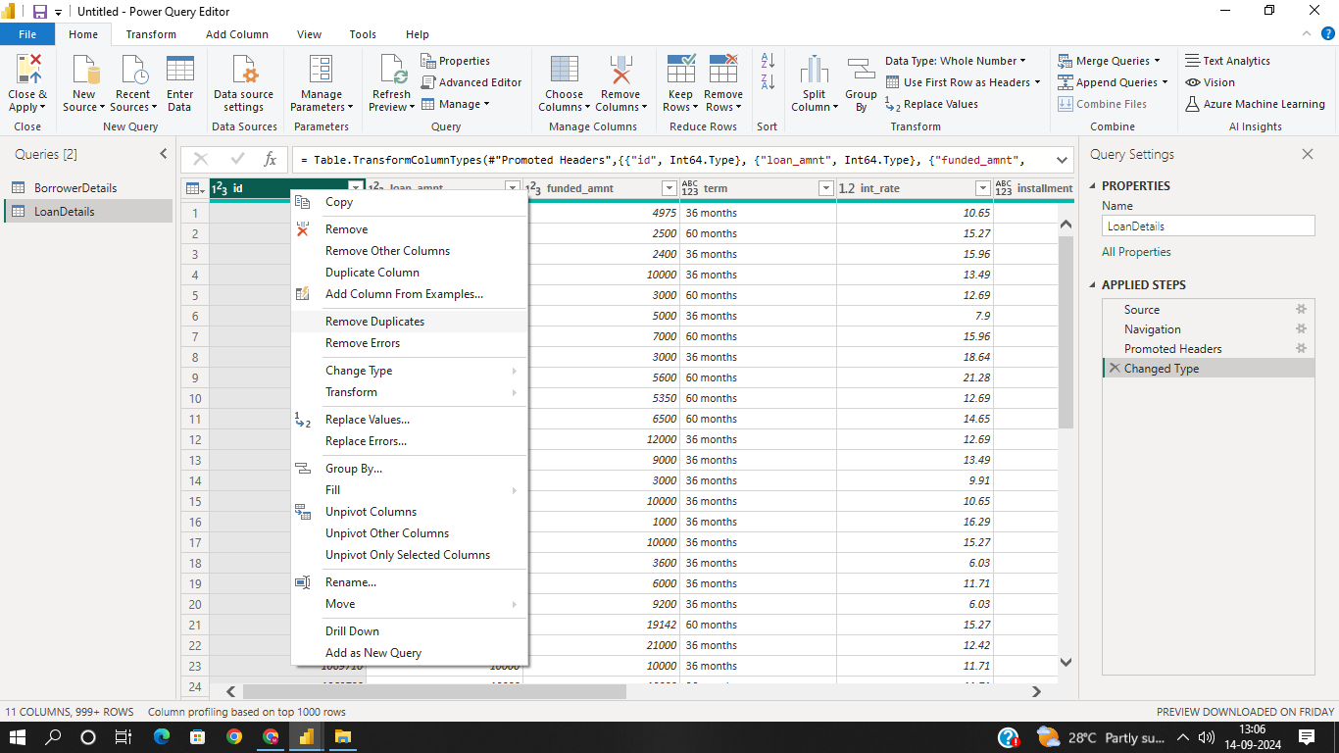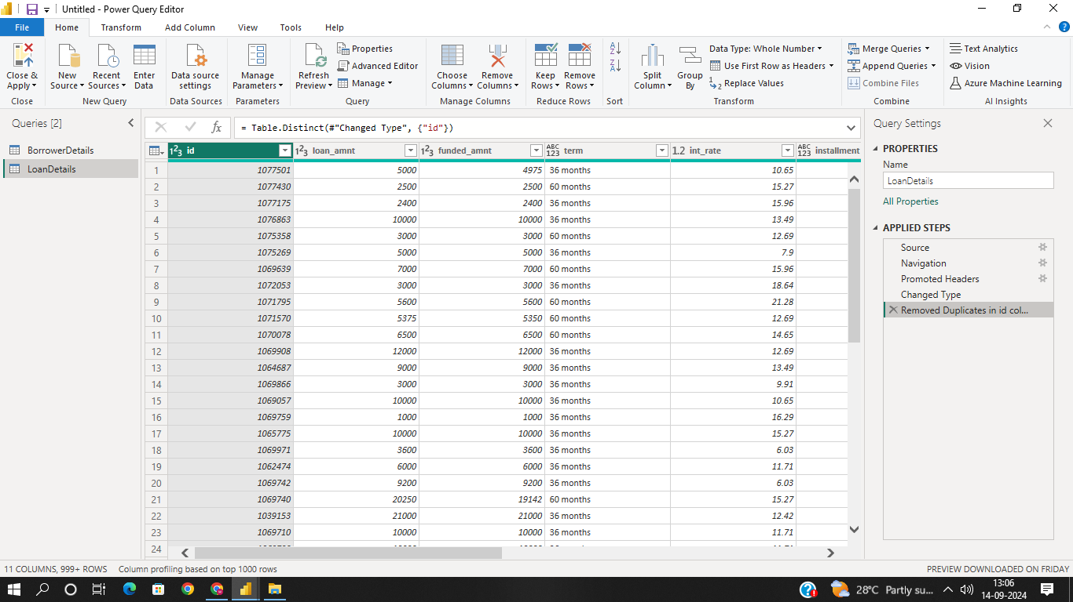

Dealing with Inconsistencies:
Ensure words in the 'purpose' column are separated by spaces instead of
underscores (e.g., "credit card" instead of "credit_card").
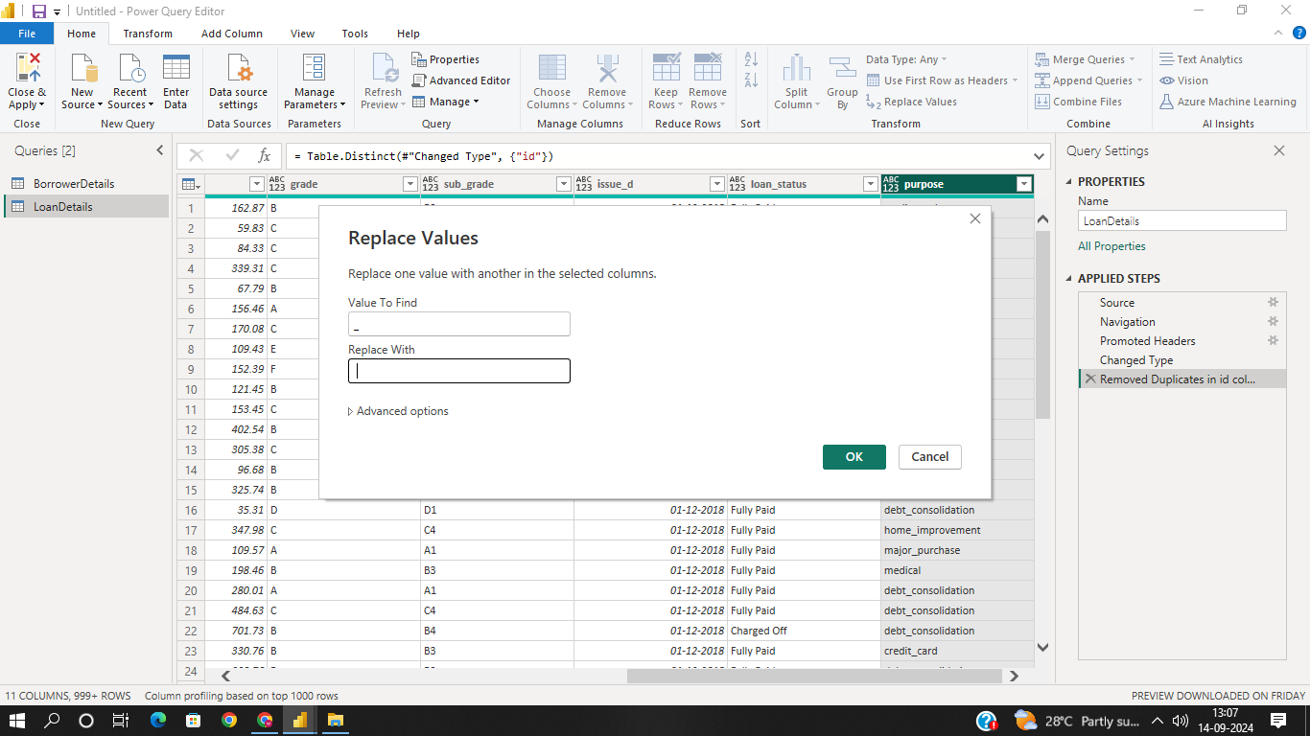

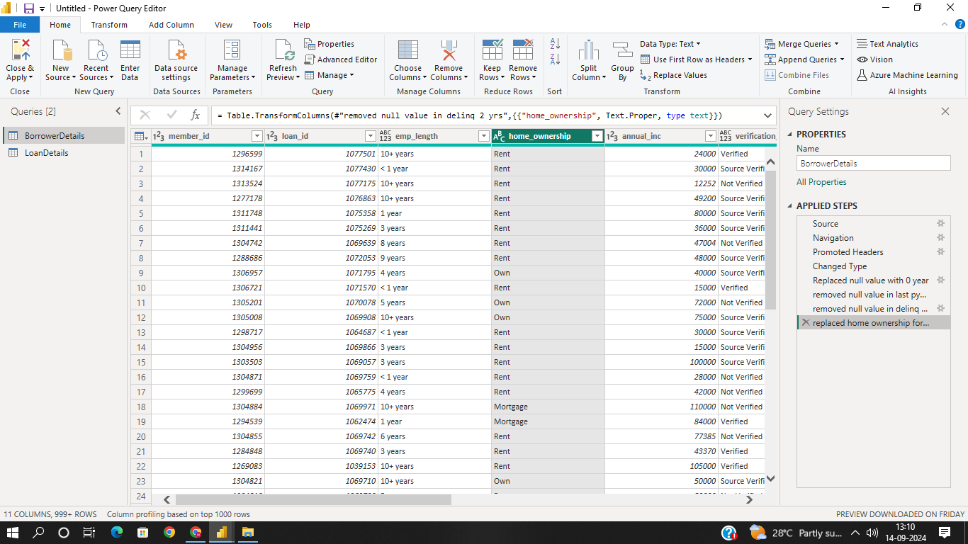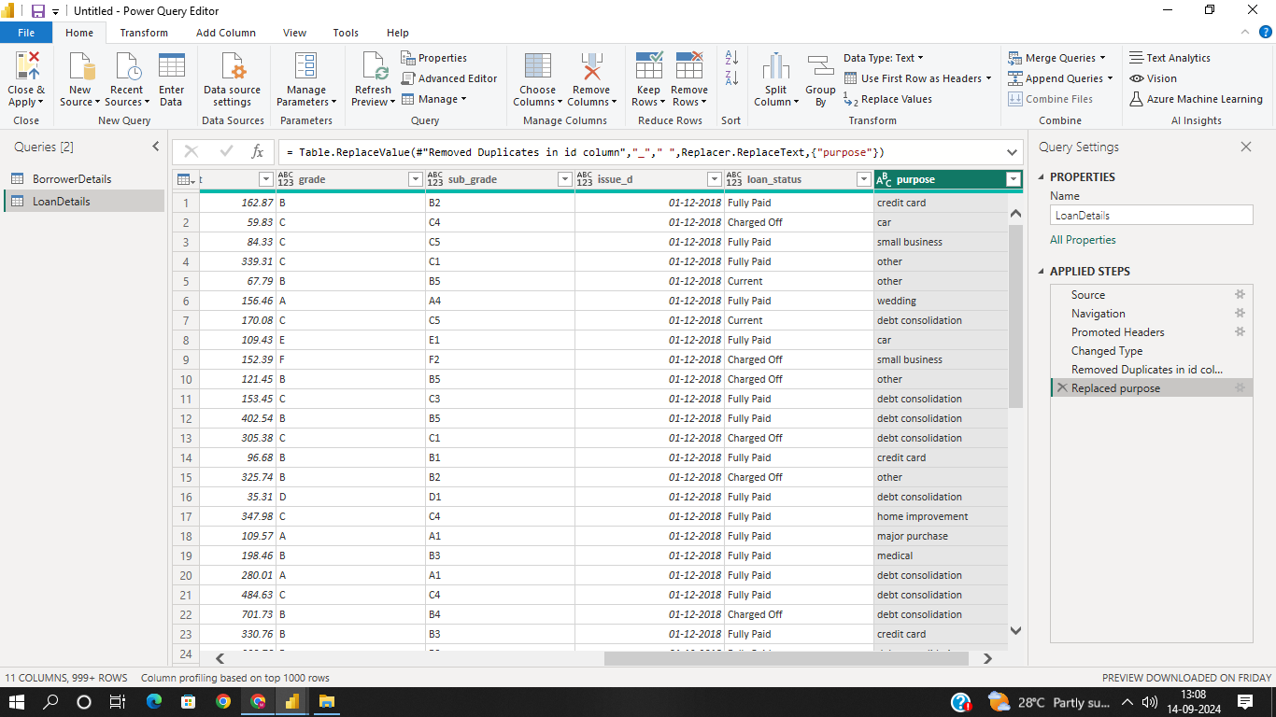
Format the 'purpose' and 'home_ownership' columns to proper case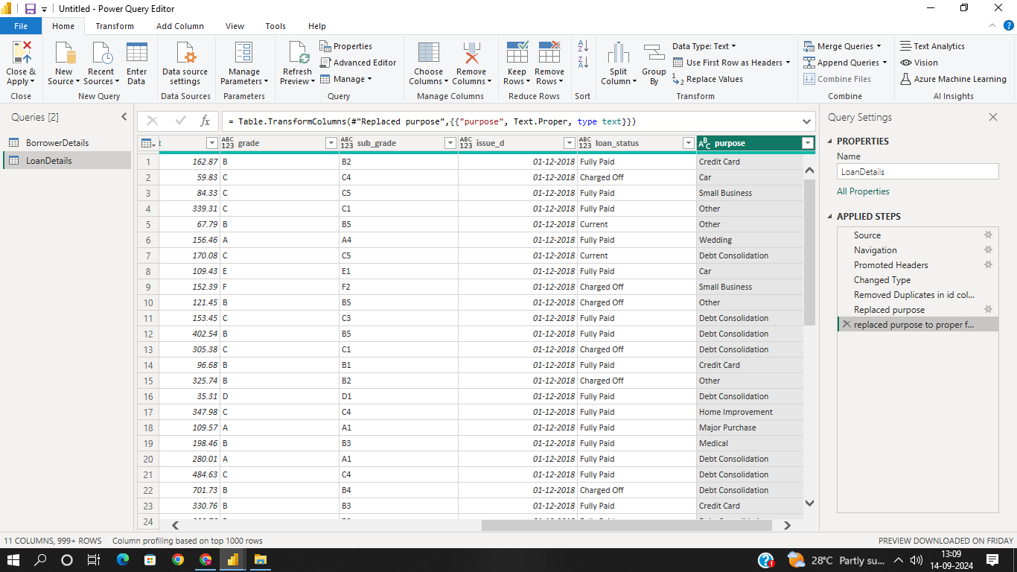
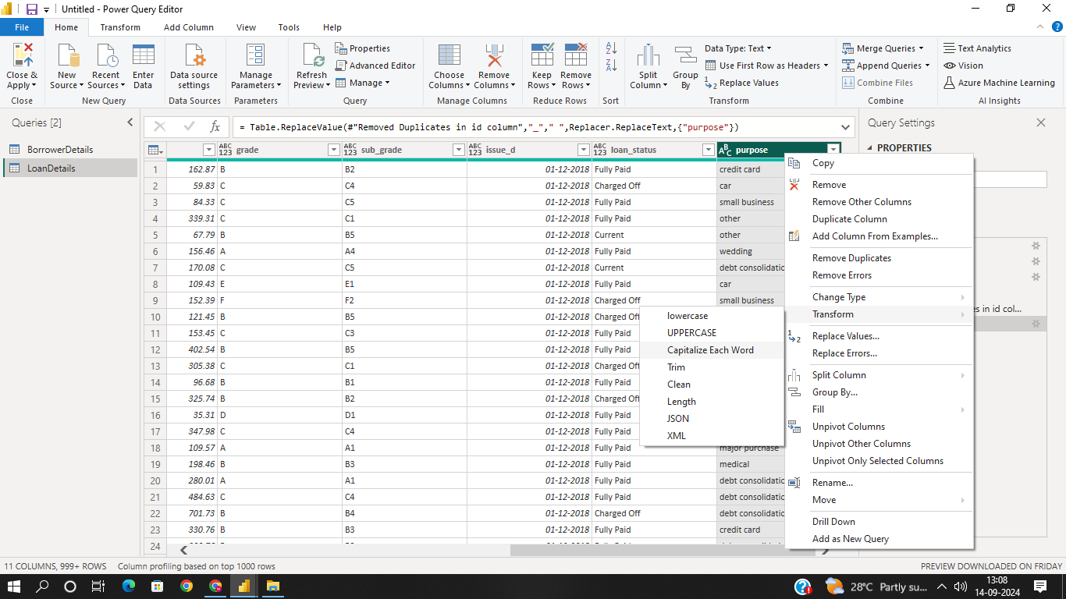

Data Transformation:
Column Transformation:
Change the data type of the 'total_pymnt' column to 'Fixed decimal number'.
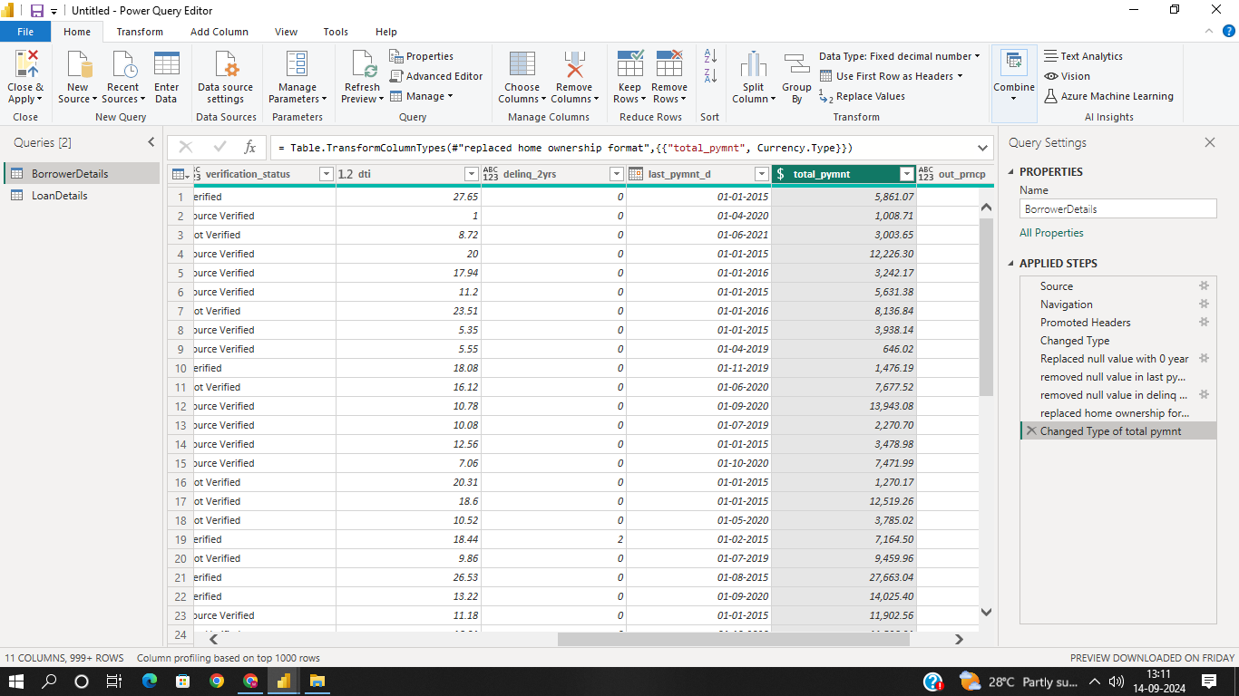

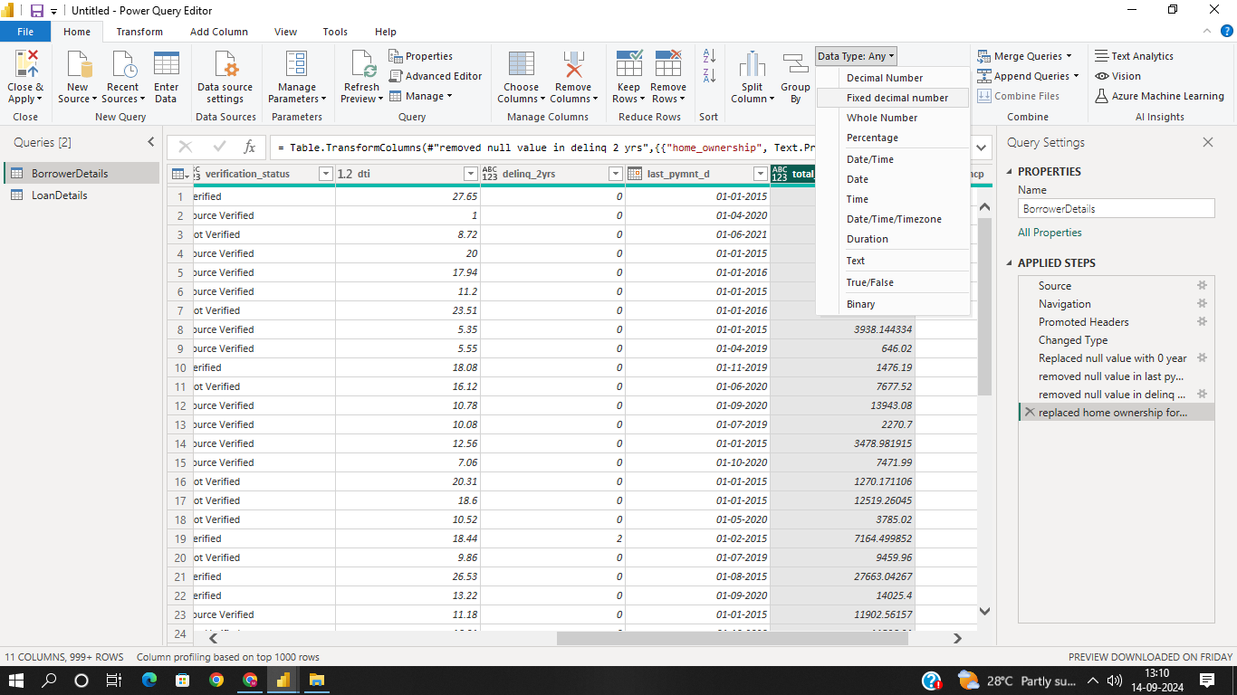

Round off the numbers in the 'funded_amnt' column to 2 decimal places.

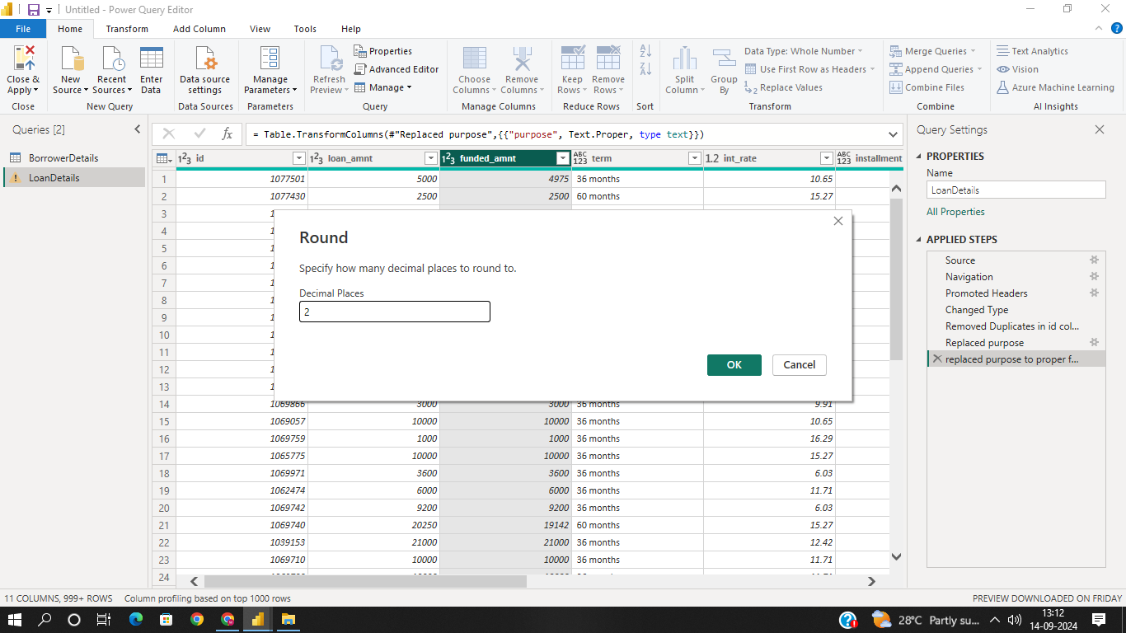
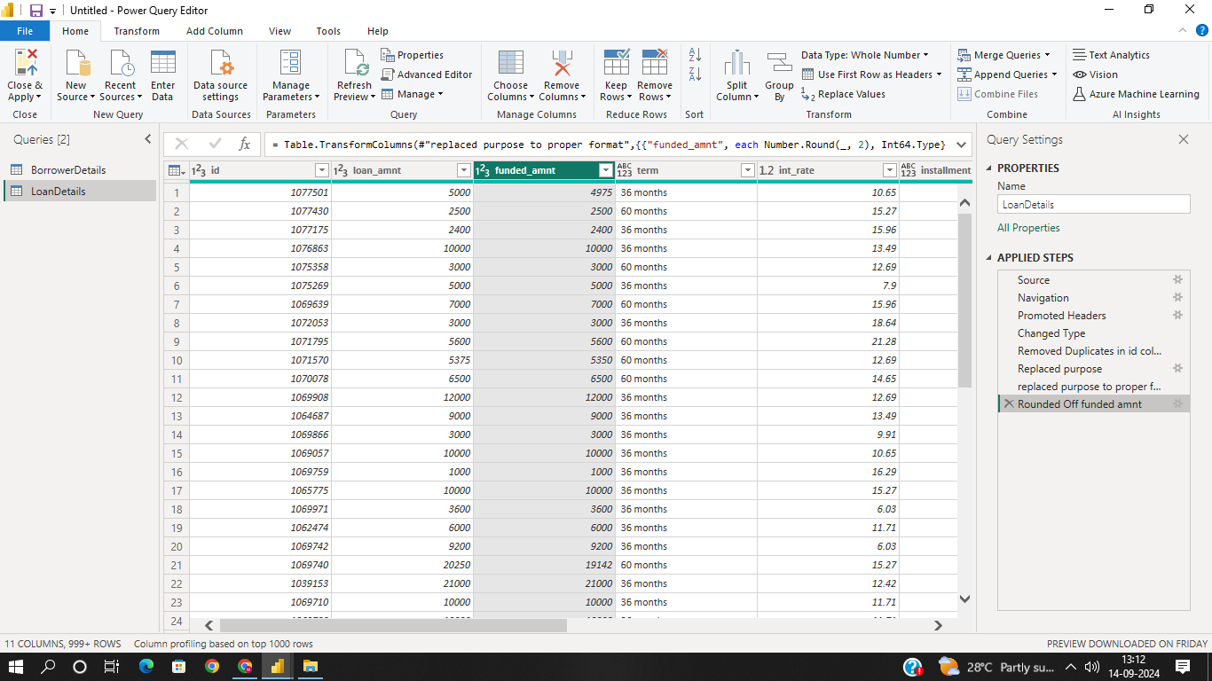
Column Renaming:
Rename the column 'issue_d' to 'issue_date'
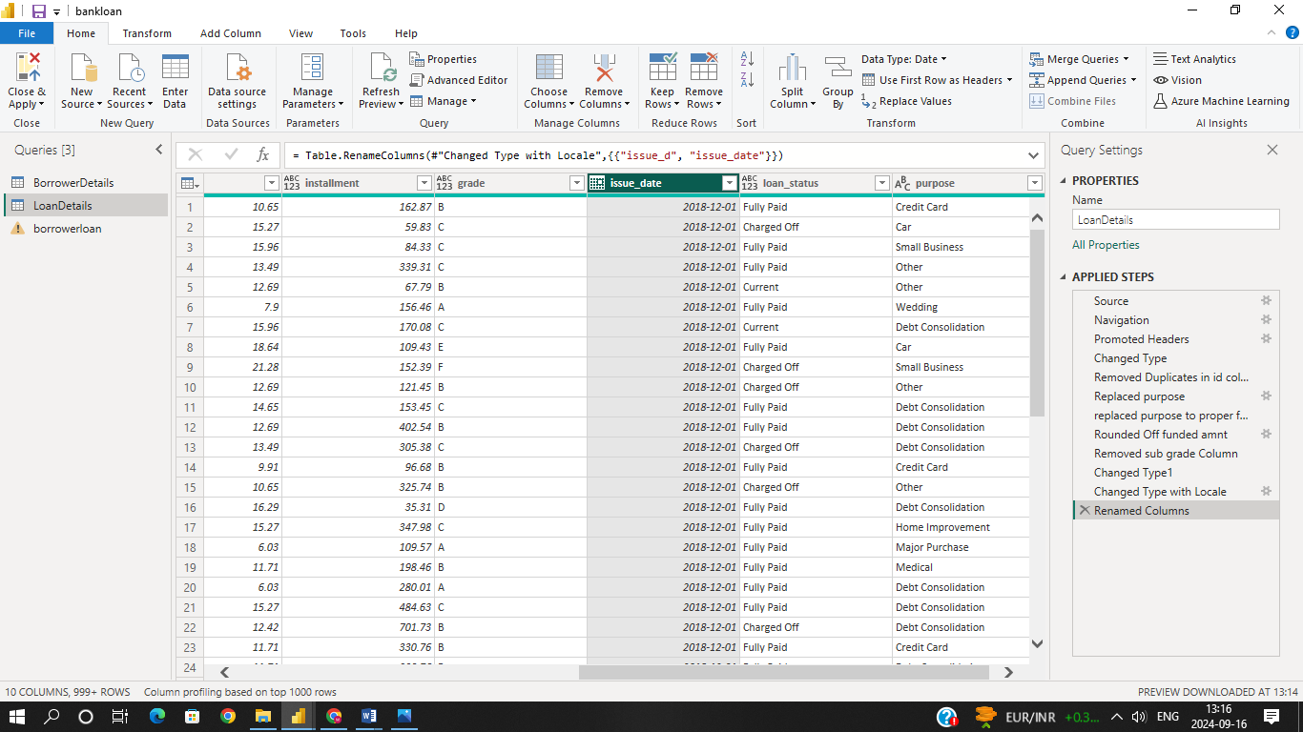
➢ Rename the column 'last_pymnt_d' to 'last_pymnt_date'.
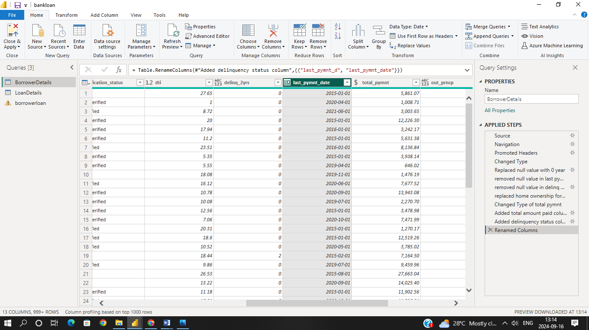

Creating New Columns:
Create a new custom column named 'total_amount_paid' to calculate the total
amount paid by each borrower by subtracting 'out_prncp' from 'total_pymnt'.
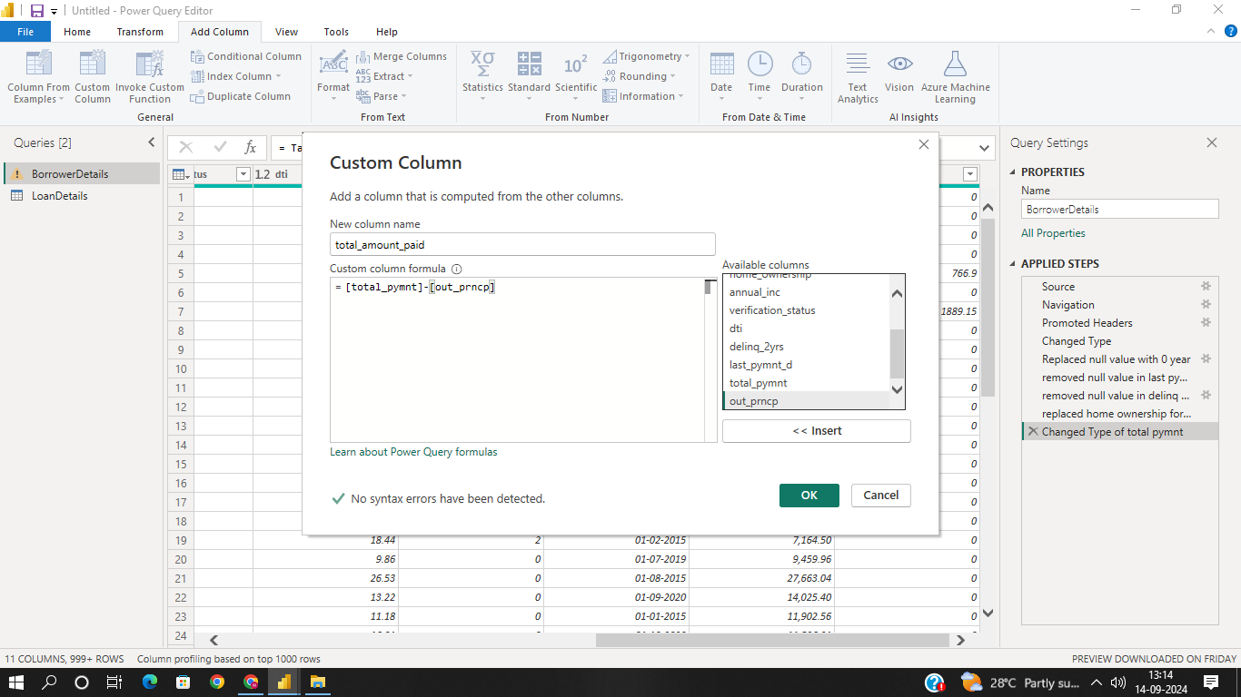
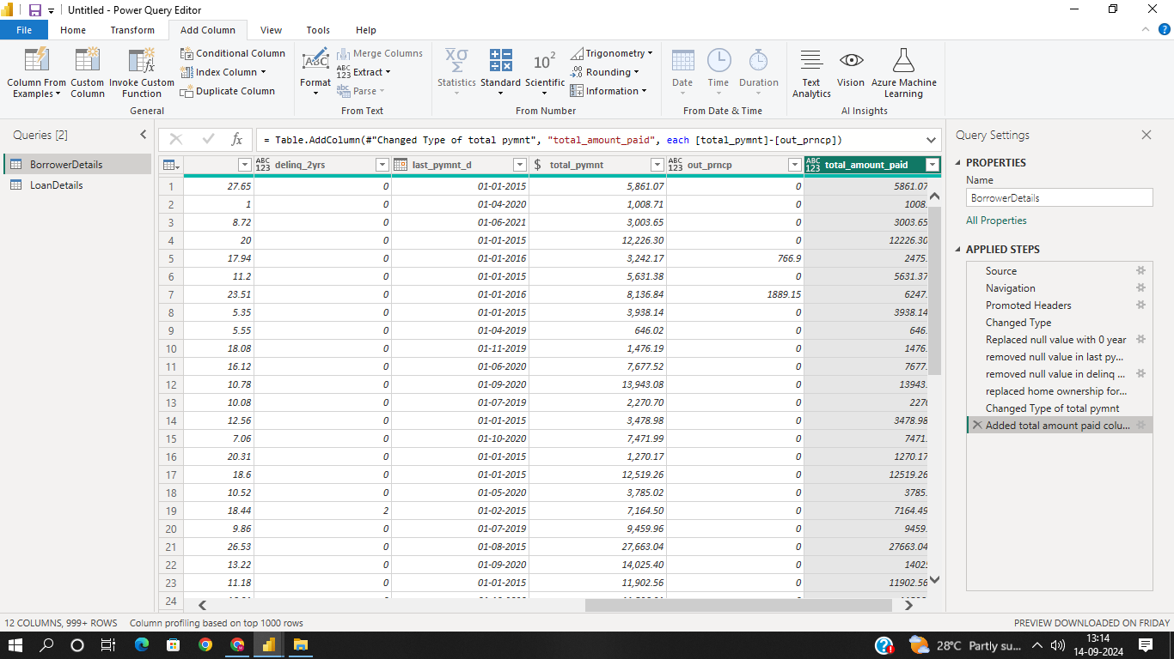

Add a new conditional column named 'delinquency_status' to identify if the
borrower has any delinquencies. If the number of delinquencies in 'delinq_2yrs' is
greater than 0, the status should be "Delinquent", otherwise "Not Delinquent".

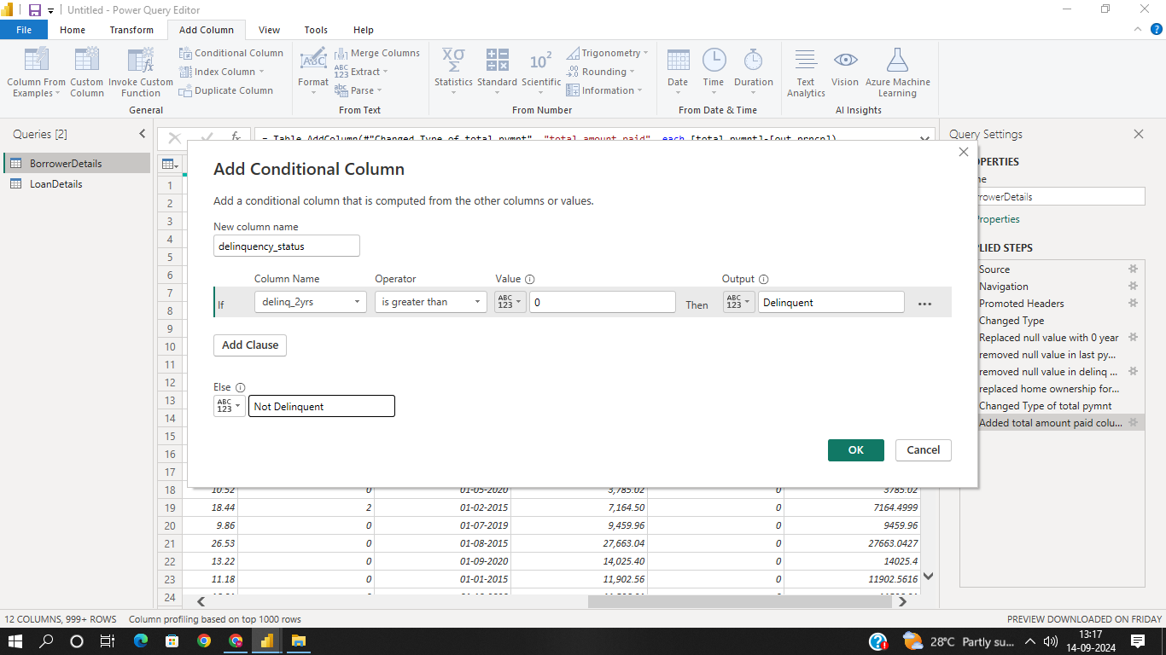
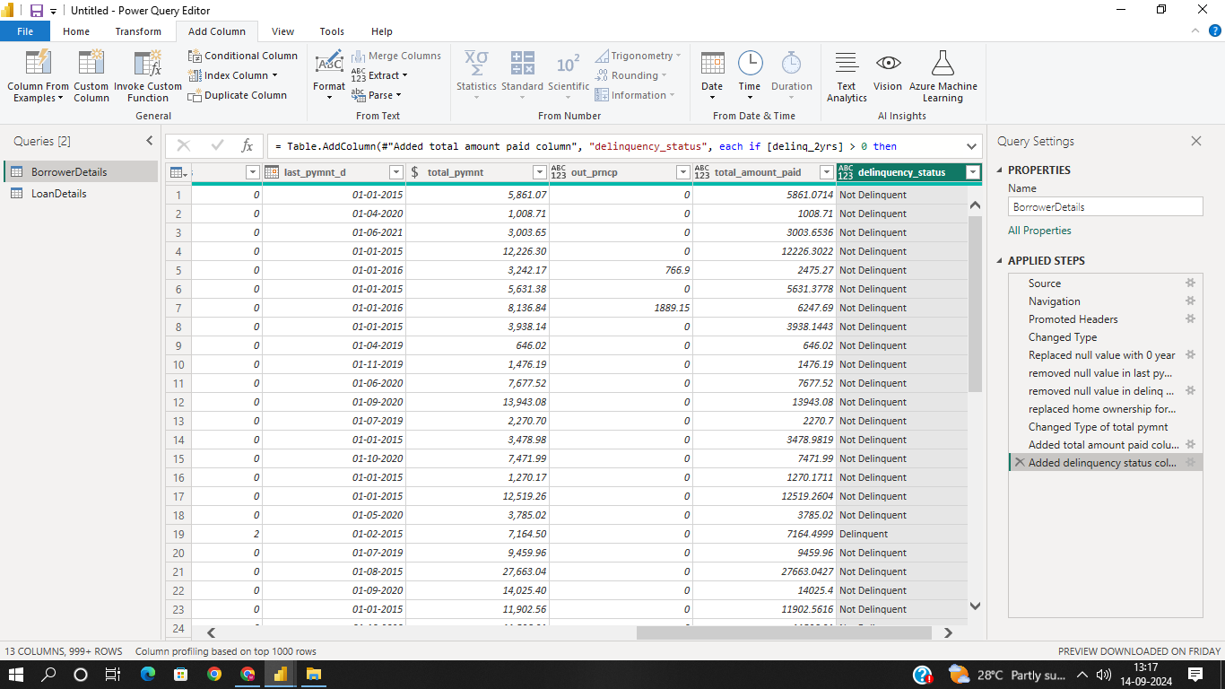

Column Dropping:
Remove the 'sub_grade' column as that does not significantly contribute to the
analysis.

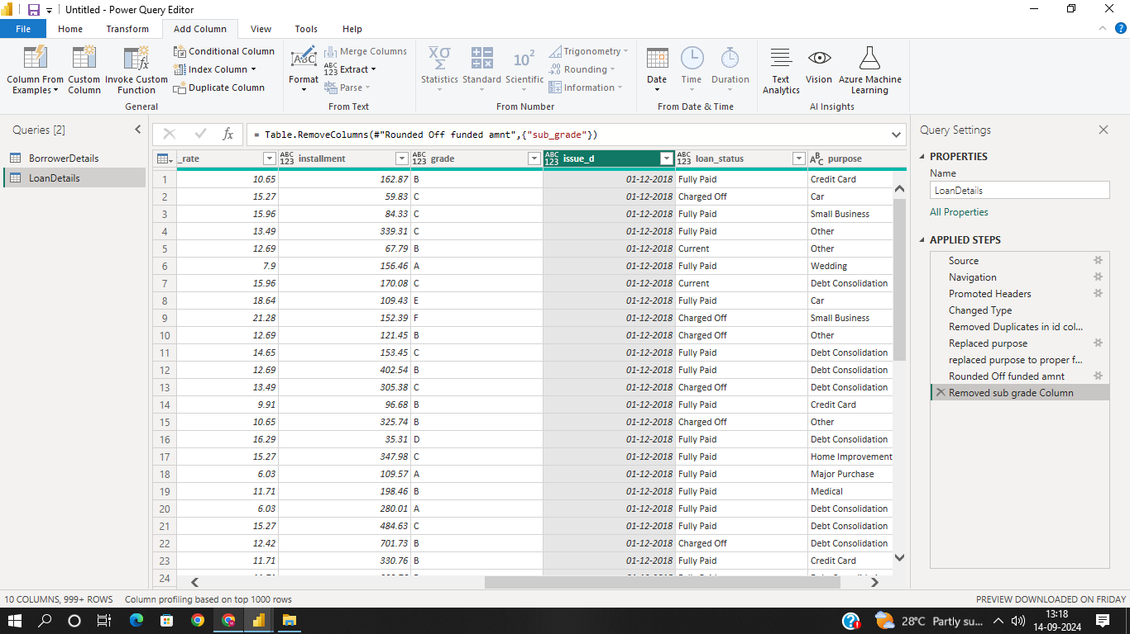

3) Data Modelling
Identify the common column between both the tables and establish relationships
between the two tables. Ensure the cross-filter direction is set to "Both". This step
is crucial for enabling cross-table analysis and ensuring data integrity within the
dataset.
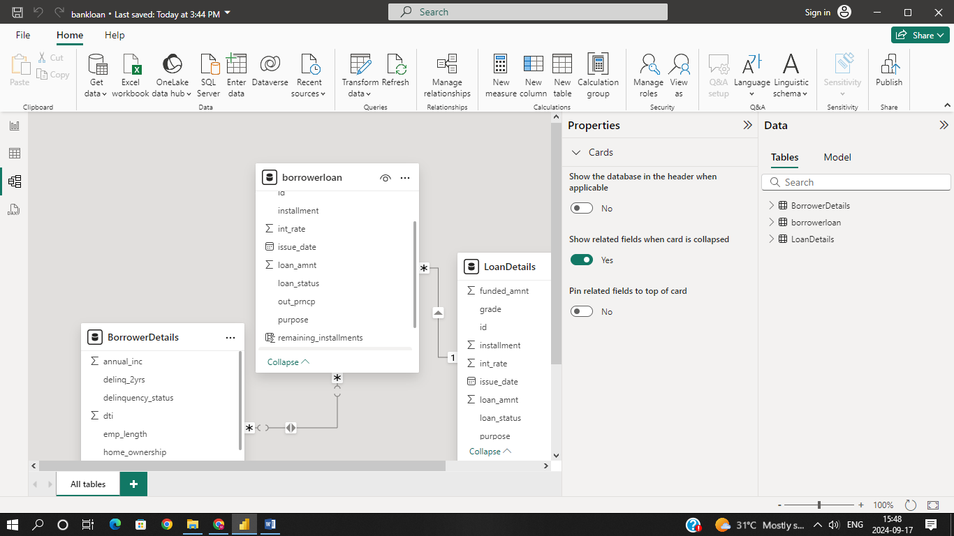

4) Creating Measures and Calculated Columns using DAX
➢ Create a new calculated column named 'remaining_installments' using DAX in the
"BorrowerDetails" table to calculate the number of remaining installments by
dividing the remaining principal amount ('out_prncp') by the monthly installment
amount ('installment') and round up
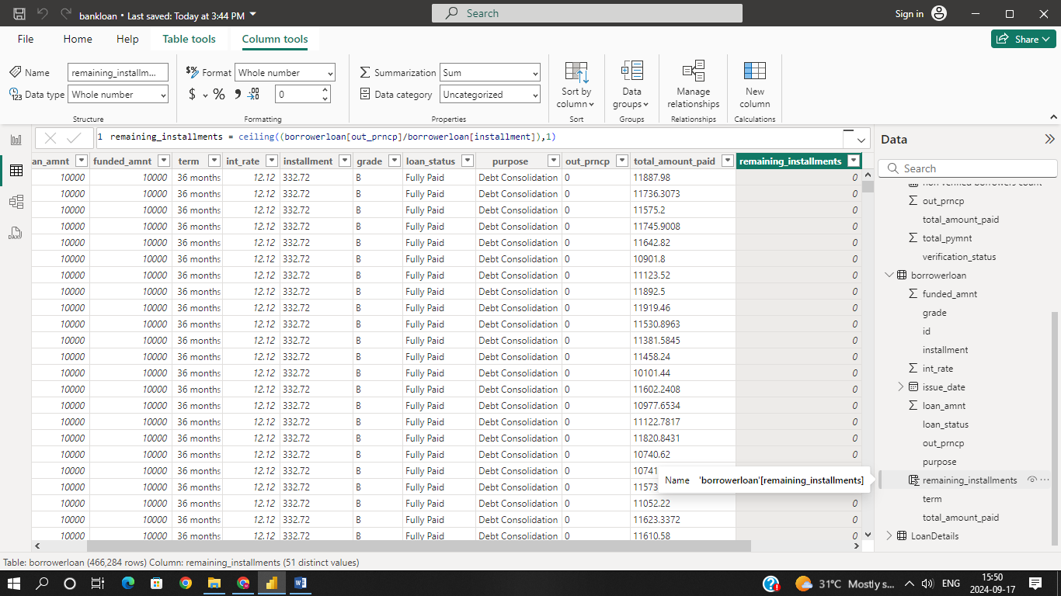

Create a measure named 'Non-Verified Borrowers Count' using DAX to count the
number of loans that have been 'Not Verified'.
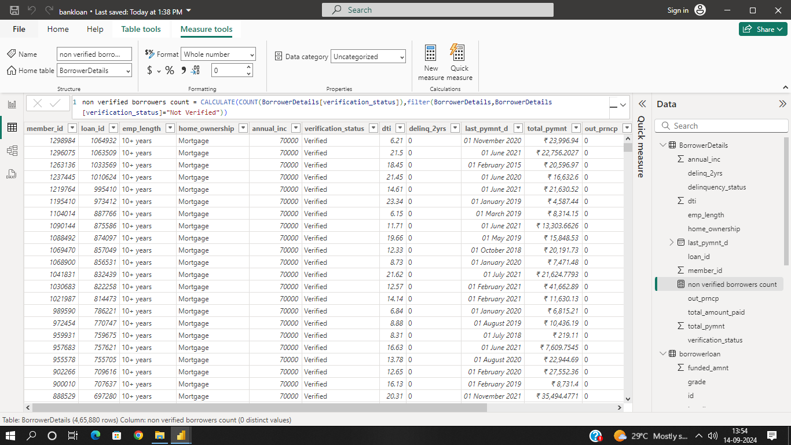

Create a measure named 'Fully Paid Loan Percentage' to calculate the percentage
of fully paid loans. Divide the number of loans with a "Fully Paid" loan status by
the total number of loans and then format this measure as Percentage.

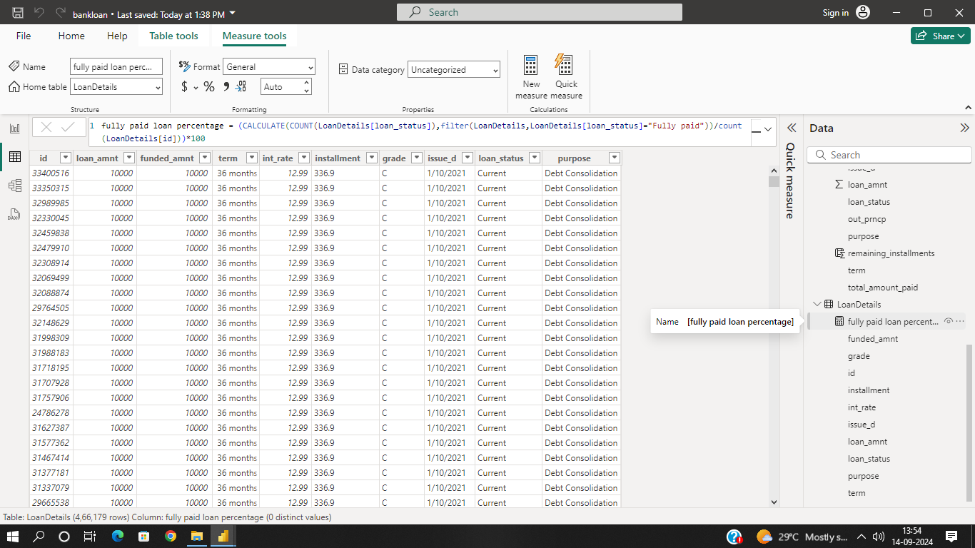

Creating Comprehensive Reports
Report 1: Loan Performance Analysis
The Loan Performance Analysis report aims to provide insights into the performance of
loans based on various factors such as loan amount, loan status, term, interest rate, and
purpose.
➢ Total Funded Amount: Create a card visual to display the total funded amount.
➢ Fully Paid Loan Percentage: Create a gauge chart to display the 'Fully Paid Loan
Percentage' measure.
➢ Average Interest Rate by Term: Create a multi-row card to show the average
interest rate for each term.
➢ Loan Status Distribution: Create a pie chart to visualize the sum of total
payments by loan status.
➢ Loan Amount by Purpose: Create a tree map to show the average loan amount by
purpose.
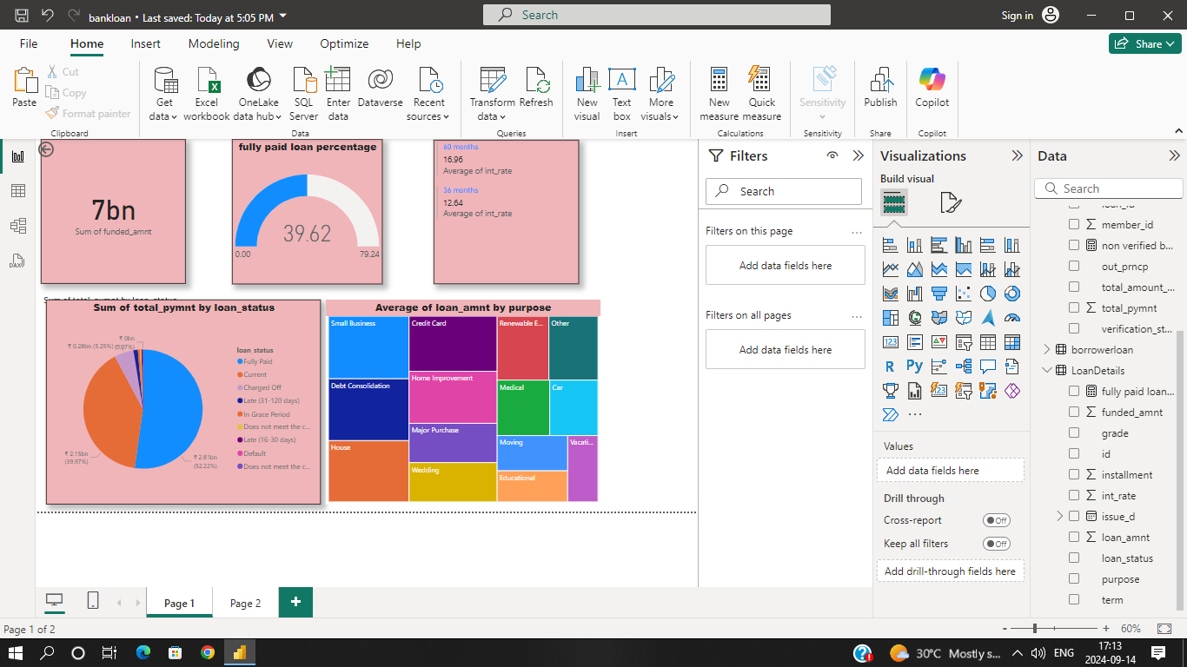
➢ Installment Over Time: Create a line chart to visualize the sum of installments by
Year and Quarter of the issue date.
➢ Maximum Total Amount Paid by Loan Status: Create a column chart to display
the maximum total amount paid by loan status.
➢ Minimum Annual Income by Grade: Create a funnel chart to show the minimum
annual income by grade.
➢ Issue Date Slicer: Add a slicer for the Month of the issue date to enable dynamic
data exploration.

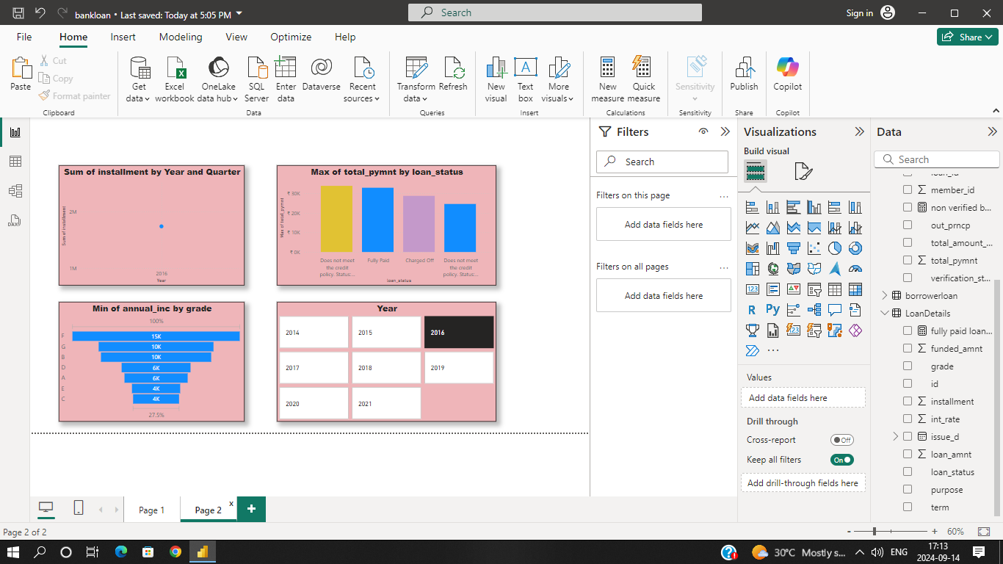
Loan Profile Analysis
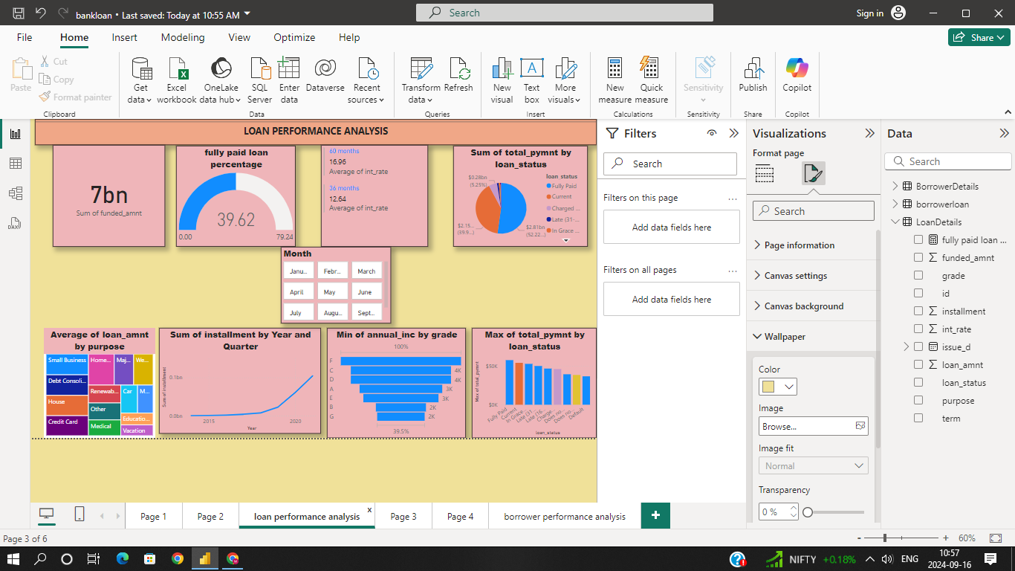
Report 2: Borrower Profile Analysis
The Borrower Profile Analysis report aims to provide insights into the characteristics of
borrowers such as home ownership, annual income, employment length, verification
status, debt-to-income ratio, and delinquency history.

➢ Average of Annual Income: Display the average of annual income using a card
visual.
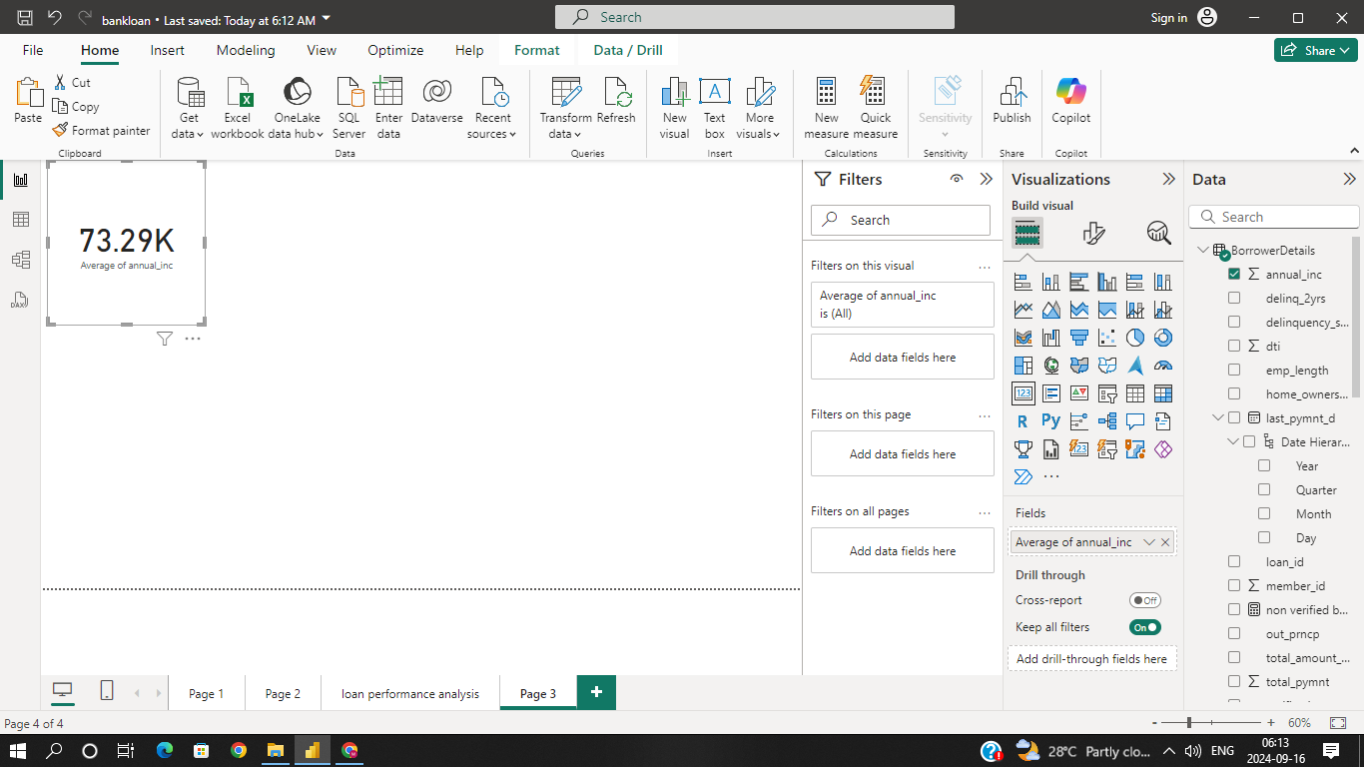

➢ Non-Verified Borrowers Count: Display the count of non-verified borrowers using
a card visual.

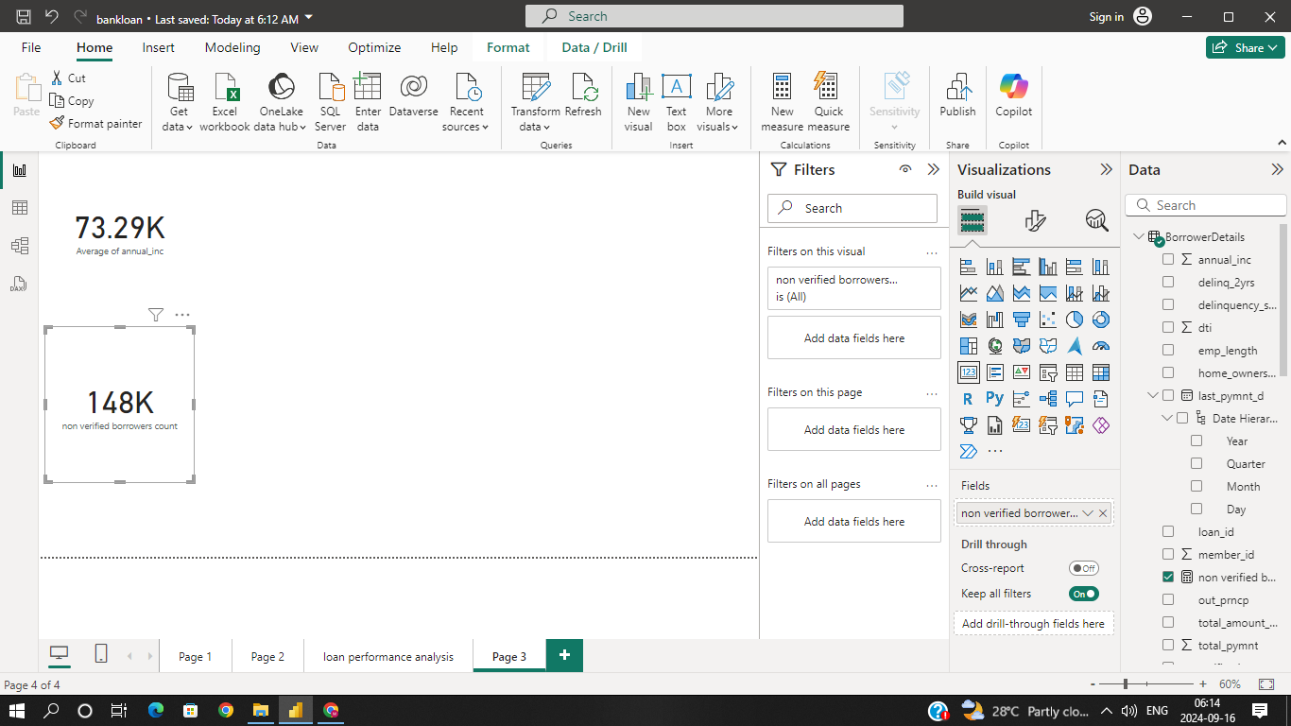

➢ Average Debt-to-Income by Delinquency Status: Create a multi-row card to show
the average debt-to-income ratio by delinquency status.
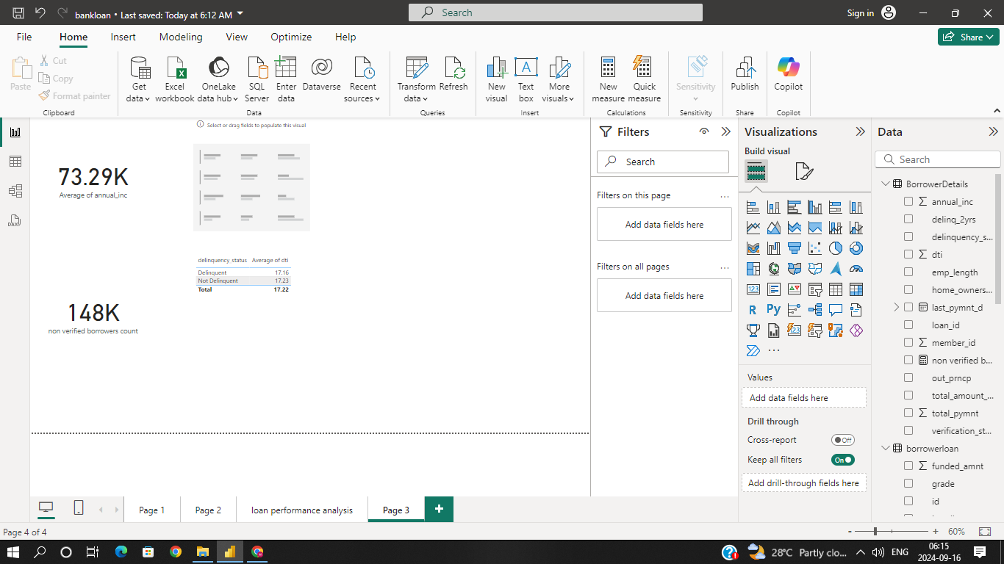

➢ Sum of Loan Amount by Home Ownership: Create a table to show the total loan
amount by home ownership.
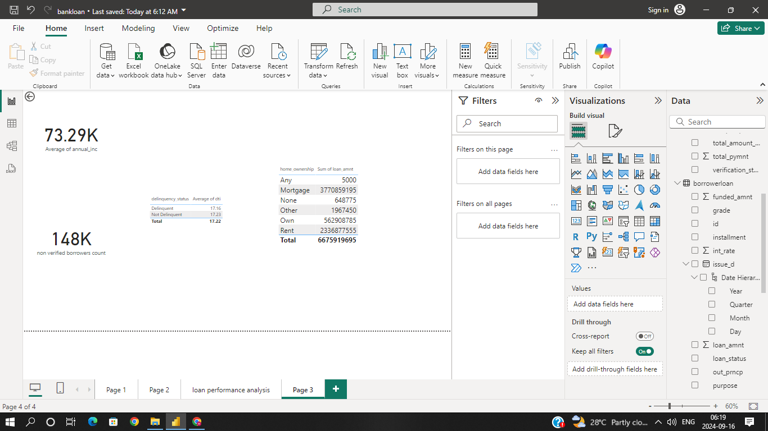

➢ Average Remaining Principal by Verification Status: Create a donut chart to
display the average remaining outstanding principal by verification status.
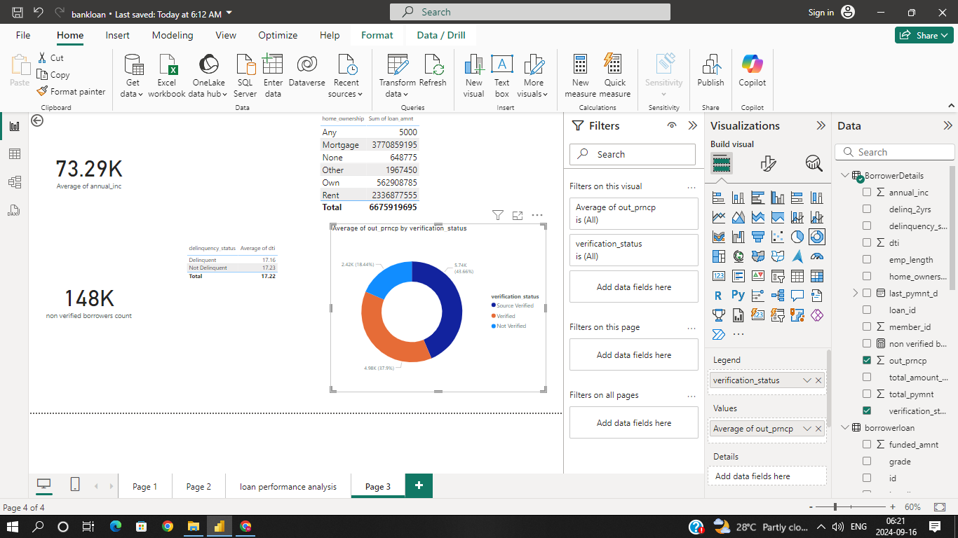

➢ Max Remaining Installments by Employment Length: Create a treemap to show
the maximum remaining installments by employment length.

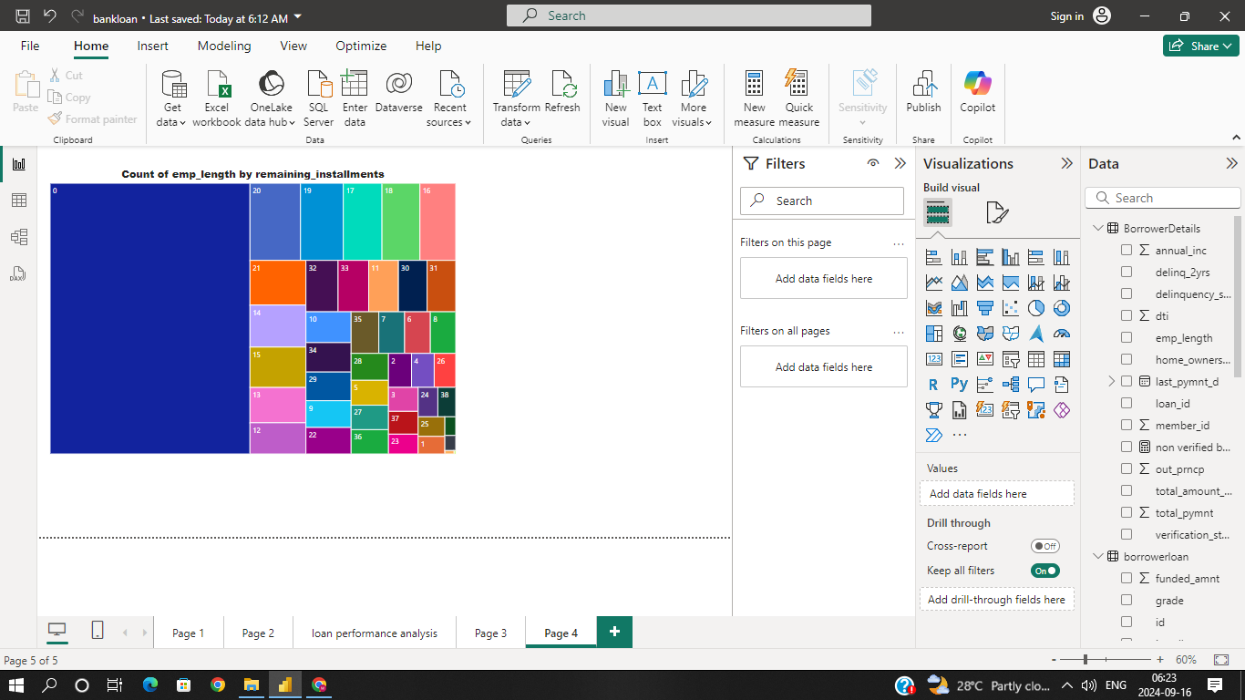

➢ Sum of Delinquencies by Home Ownership: Create a bar chart to show the total
number of delinquencies in the past 2 years by home ownership and filter the
visual to display only Mortgage, Rent, and Own.

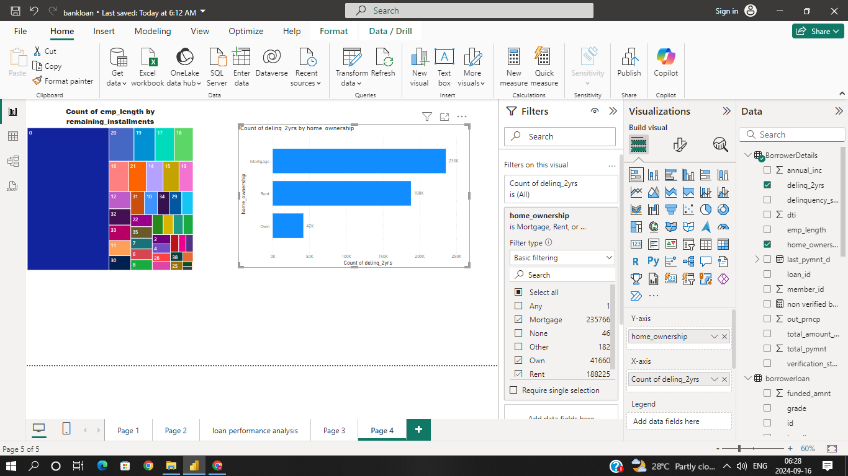

➢ Total Amount Paid and Funded Amount Over Time: Create a line chart to display
the sum of total amount paid and the sum of funded amount by the year of last
payment date.
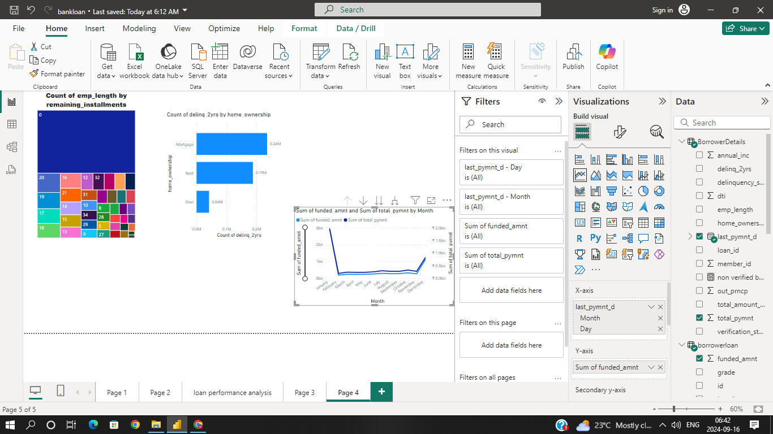
➢ KPI Visual: Create a KPI visual with the sum of total payment as the value, the
year of last payment date as the trend axis, and the sum of loan amount as the
target. Round off to 2 decimal points and format as $ currency.

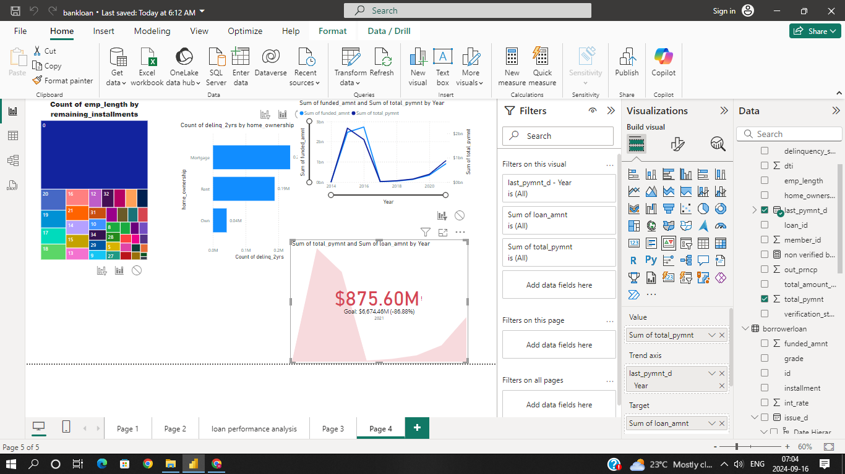

➢ Purpose Slicer: Add a slicer for loan purpose to enable dynamic data exploration.

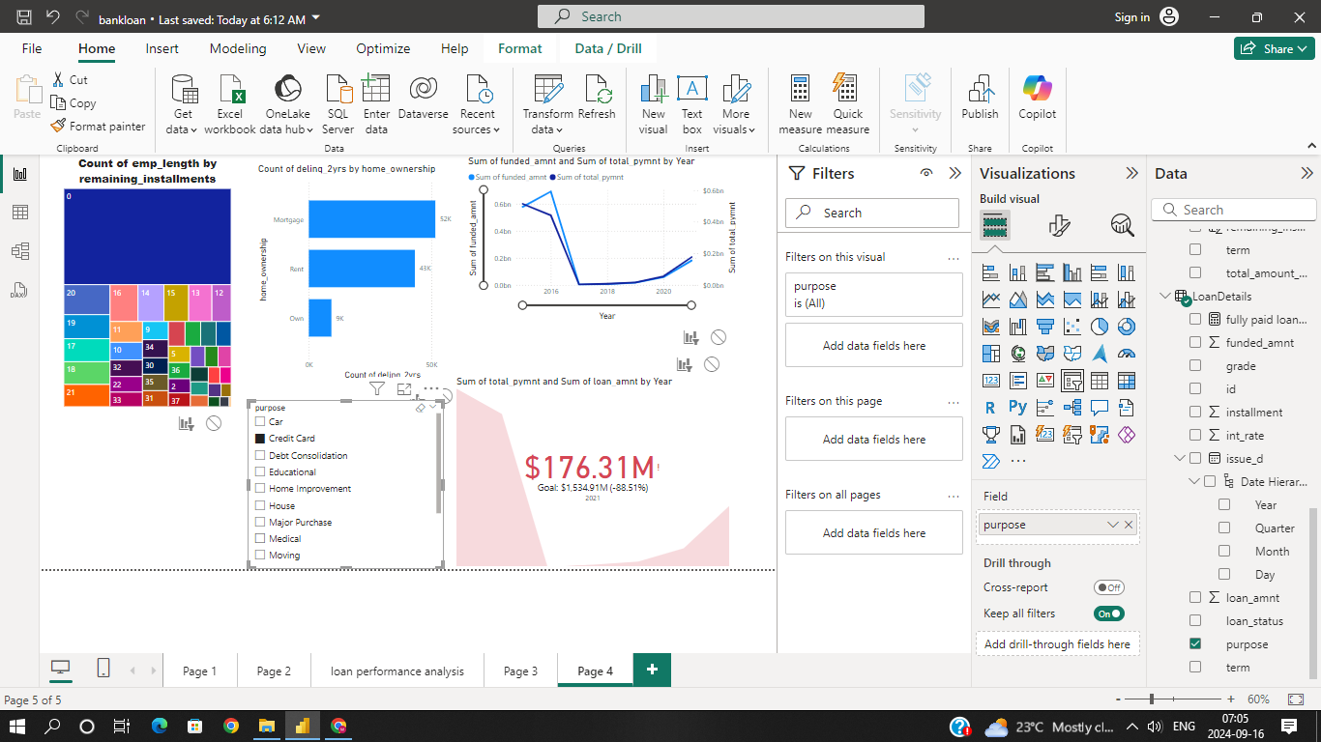
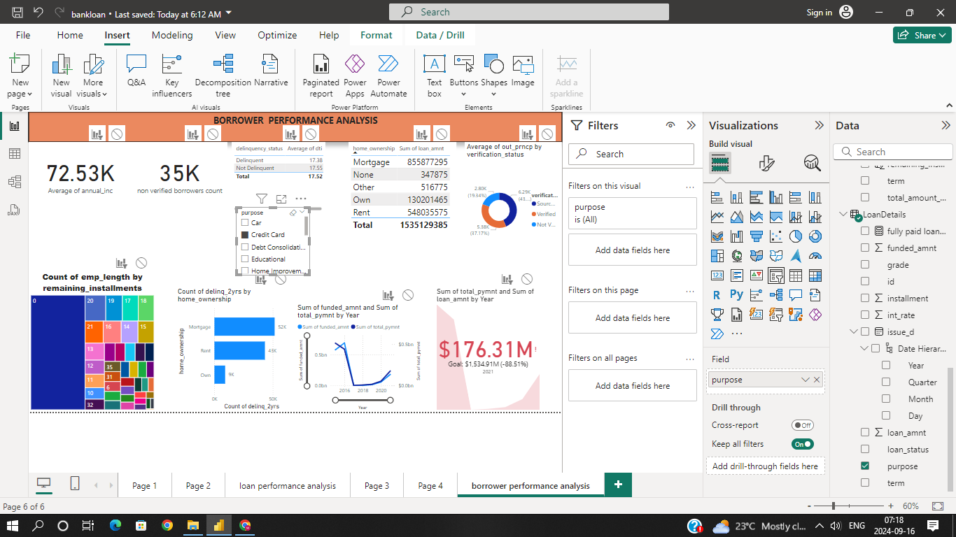

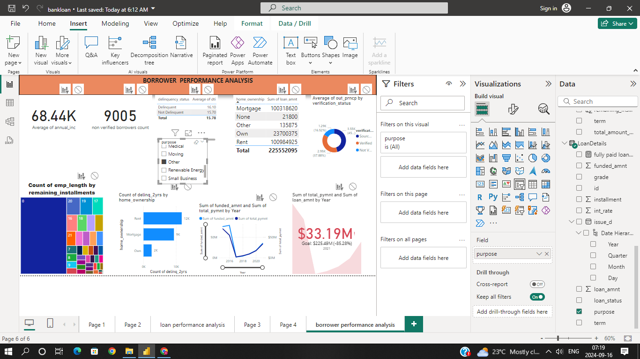

Borrower Performance Analysis

