INTERNSHIP REPORT
ON
TASK2GRAB – WEB DEVELOPMENT AND REWARDS PLATFORM IMPLEMENTATION
Submitted
To
School of Computer Science and Engineering
IILM University, Greater Noida, U.P.
In partial fulfilment of the requirement of degree of
B.Tech CSE AI/ML

BY
MADHUMITA SAH
Roll Number: 2410030682
Section: 3CSE4
Batch: 2026–27
Internship Supervisor: Harshit Sahani
Monetize Info LLP
10 June 2026 to 10 July 2026
2026–27

1. CANDIDATE’S DECLARATION
I, MADHUMITA SAH, hereby declare that the internship report titled “Task2Grab – Web Development and Rewards Platform Implementation” has been completed by me in partial fulfilment of the requirements for the award of the degree of Bachelor of Technology in Computer Science and Engineering (AI/ML). The report presents the work and learning acquired during my one-month internship at Monetize Info LLP from 10 June 2026 to 10 July 2026.
I further declare that the work described in this report represents my individual contribution within a collaborative development team. Wherever external sources or documentation have been used, they have been acknowledged in the bibliography. The report has not been submitted to any other institute for the fulfilment of any degree or diploma requirement.
I understand that I shall be responsible for any copyright or academic-integrity violation arising from material presented in this report.
Signature: Madhumita
Student Name: MADHUMITA SAH
Roll No.: 2410030682

2. ACKNOWLEDGEMENT
I would like to express my sincere gratitude to Monetize Info LLP for providing me with the opportunity to undertake a one-month internship as an Intern - Web Development. The internship provided valuable exposure to a real software-development environment and helped me understand how academic concepts are applied while contributing to an existing product.
I am thankful to my internship supervisor, Mr. Harshit Sahani, for his guidance and support throughout the internship. I also express my appreciation to the Team Lead for managing the main project tasks, dividing larger requirements into smaller assignments, and providing a structured environment in which interns could contribute to different parts of the project.
I am grateful to the other team members and interns for working collaboratively on different modules of Task2Grab. The experience of contributing alongside other developers helped me understand the importance of maintaining clear responsibility boundaries while working toward a common product.
I also thank the faculty members of the School of Computer Science and Engineering, IILM University, for providing academic guidance and the framework through which this internship experience could be documented. Finally, I am grateful to everyone who supported me during the internship and encouraged me throughout the learning process.
Signature: Madhumita
Student Name: MADHUMITA SAH
Roll No.: 2410030682

3. INTERNSHIP COMPLETION CERTIFICATE
The official internship completion certificate issued by Monetize Info LLP is reproduced below. It confirms that Miss. Madhumita Sah, a B.Tech CSE AI/ML student of IILM University, Greater Noida, completed a one-month internship at Monetize Info LLP from 10 June 2026 to 10 July 2026 as “Intern - Web Development”.
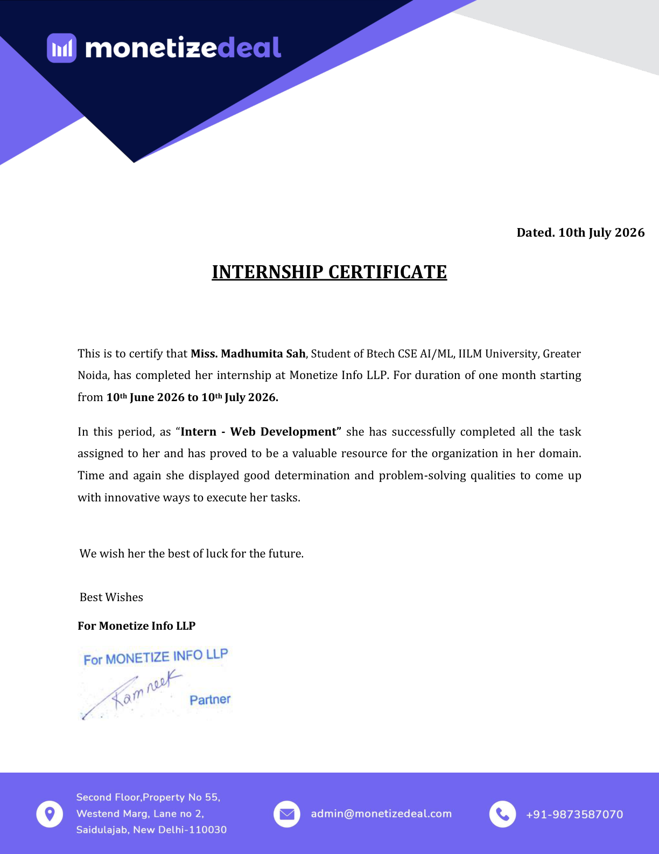
Figure 3.1: Internship Completion Certificate issued by Monetize Info LLP

LIST OF CONTENTS
1. Candidate’s Declaration .............................................. i
2. Acknowledgement ...................................................... ii
3. Internship Completion Certificate
4. Project Description .................................................. 1
4.1 Introduction ........................................................ 1
4.2 Organization Profile ................................................ 1
4.3 Problem Statement ................................................... 2
4.4 Project Objectives .................................................. 2
4.5 Scope of the Project ................................................ 3
4.6 Technologies and Tools Used ......................................... 4
4.7 System Architecture ................................................. 5
4.8 Methodology ......................................................... 6
4.9 Expected Outcomes ................................................... 7
4.10 Certificates of Completion and Other Communication Mail Proof ...... 8
5. Bibliography / References ............................................ 9

LIST OF TABLES
Table 4.1: Technologies and Tools Used .............................. 4
Table 4.2: Core React Native Packages ............................... 4
Table 4.3: Team Roles and Responsibilities .......................... 6
Table 4.4: Challenges and Practical Approaches ...................... 7

4. PROJECT DESCRIPTION
4.1 Introduction
The internship at Monetize Info LLP provided practical exposure to software development through work on Task2Grab, a task-based rewards platform. Task2Grab enables users to discover dynamically available campaigns or tasks, complete eligible activities, and receive rewards when successful completion is recognized. The project therefore combines user-facing interfaces with API-driven data and reward-related information.
During the internship, my primary responsibilities were related to the wallet system and task listing functionality. I worked on API integration required for task listing, rewards and wallet-related information, and contributed to displaying reward and wallet information in the interface. I also worked with application state management and translated provided Figma designs into React Native code for selected application areas.
The work was performed as part of a collaborative team under a Team Lead. The Team Lead managed the main project work and divided broader requirements into smaller tasks for interns. Other interns were responsible for different areas, including the website and login page, and navigation and AsyncStorage-related functionality. My contribution should therefore be understood as work on assigned modules rather than independent development of the complete Task2Grab application.
4.2 Organization Profile
Monetize Info LLP is the organization where the internship was completed. Its public-facing website operates under the MonetizeDeal name and presents the organization in the digital space, with services related to creator-focused monetization, product-link affiliation, campaign solutions and technology-enabled online services. The official website identifies Monetize Info LLP and provides its business contact information.
The internship project, Task2Grab, is associated with a task-and-reward platform through which users can discover tasks and receive rewards for successful completion. For this report, the organization profile is intentionally limited to information that can be supported by the internship certificate and the official company website. Specific claims about employee strength, revenue, founding year, internal departments or technical infrastructure are not made because they are outside the supplied evidence.
4.3 Problem Statement
A task-based rewards platform must present dynamically available tasks and reward-related information clearly enough for users to understand the opportunities available to them and the results of their completed activities. From a software-development perspective, this requires user interfaces that can consume remote data, represent changing information, and update the visible state of the application as data becomes available.
The development problem addressed within my internship scope was therefore focused on integrating API-driven task, reward and wallet information into the user interface while maintaining an understandable presentation of dynamic content. Wallet and reward information must be represented accurately because it directly communicates the outcome of users' completed tasks. The work also required translating provided Figma designs into functional React Native interfaces and coordinating these changes within a larger shared project.
Task completion and rewards in the overall Task2Grab platform are described as being tracked through postback-based verification. This report treats postback verification as a conceptual part of the platform and does not claim that I independently implemented its backend or verification mechanism.
4.4 Project Objectives
• To contribute to the development of the Task2Grab platform within an assigned team role.
• To implement and improve task listing functionality for dynamically available tasks or campaigns.
• To integrate APIs required for task, reward and wallet-related information.
• To display wallet and reward information obtained through application data sources.
• To translate provided Figma designs into functional React Native interfaces.
• To work with application state while handling dynamic API-driven information.
• To gain practical experience in real-world software development using React Native, Git and GitHub.
• To contribute effectively within a collaborative development environment under the supervision of a Team Lead.
4.5 Scope of the Project
The scope of the internship is considered at two levels: the broader Task2Grab project and my individual contribution. Task2Grab is a collaborative product, so the complete project scope is broader than the work assigned to me.
A. Overall Task2Grab Project Scope
• Presentation of dynamically available tasks or campaigns to users.
• User interaction with incentivized tasks and task-completion activities.
• Reward-related information associated with successful task completion.
• Wallet-related information presented to users.
• API-driven communication between the user-facing application and remote services.
• Conceptual postback-based verification associated with task completion and reward recognition.
• Web and mobile interfaces through which users interact with the platform.
B. Individual Scope of My Work
• Planning and understanding assigned application requirements.
• Task listing functionality and presentation of task/campaign information.
• Primary work on the wallet system.
• API integration for task listing, reward-related information and wallet-related information.
• Displaying reward and wallet information in the user interface.
• Working with application state for dynamic data.
• Translating provided Figma designs into React Native code.
• Contribution to selected parts of the mobile application and the broader Task2Grab project/website.
My scope did not include independent development of the complete application architecture or backend. I also did not independently develop all project components. Other interns handled areas such as the website and login page, and navigation and AsyncStorage-related functionality.
4.6 Technologies and Tools Used
The following technologies and tools were part of the project environment and are relevant to the internship work. Where a technology was part of the broader project stack, it is not presented as a claim that I independently implemented every associated feature.
Table 4.1: Technologies and Tools Used
Category | Technology / Tool | Version | Purpose / Relation to Work
Mobile Development | React Native | 0.79.5 | Framework used for selected mobile application development and UI implementation.
Development Environment | VS Code | — | Code editing and development environment used during implementation.
Version Control | Git | — | Used for tracking code changes during development.
Collaboration | GitHub | — | Used as part of repository-based collaboration and version-control workflow.
Android | Android build version | 35.0.0 | Build version associated with the Android project environment.
Design | Figma | — | Provided design reference translated into functional React Native interfaces.

Core packages used in the project environment included the following:
Table 4.2: Core React Native Packages
Package | Version | High-Level Purpose
@react-native-async-storage/async-storage | ^2.2.0 | Persistent key-value storage for React Native applications.
@react-native-clipboard/clipboard | ^1.16.3 | Clipboard-related functionality.
@react-native-community/blur | ^4.4.1 | Blur effects within the interface.
@react-native-community/checkbox | ^0.5.20 | Checkbox UI functionality.
@react-native-community/netinfo | ^11.4.1 | Network connectivity information.
@react-navigation/bottom-tabs | ^7.4.7 | Bottom-tab navigation support.
@react-navigation/core | ^7.13.7 | Core navigation functionality.
@react-navigation/drawer | ^7.5.8 | Drawer navigation support.

4.7 System Architecture
Because the supplied project information does not establish specific backend technologies, database systems, authentication mechanisms, API endpoint URLs or cloud infrastructure, the following architecture is a conceptual representation rather than a claim about hidden implementation details.
Figure 4.1: High-Level Conceptual System Architecture
Conceptual Layer | Role
User | Accesses the Task2Grab interface and interacts with available tasks.
Task2Grab Interface | Presents task listing, wallet and reward information.
API Integration Layer | Requests remote data and passes relevant responses to the application.
Backend Services | Conceptual remote services that provide task, reward and wallet-related data.
Task / Reward / Wallet Data | Data consumed by the application for user-facing presentation.

Conceptual task-to-reward verification flow:
1. User completes an available task.
2. Task completion information is generated or transmitted to the relevant service.
3. Postback-based verification conceptually confirms the qualifying completion event.
4. Reward validation/crediting is performed within the broader platform process.
5. Wallet and reward information becomes available for presentation to the user.
The above verification flow describes the project concept at a high level. It does not specify the actual server, database, endpoint, authentication or transaction implementation because those details were not provided.
4.8 Methodology
The internship followed a practical task-based collaborative development approach. The Team Lead managed the main project work and divided broader requirements into smaller assignments for the interns. I worked on the assigned modules, implemented interface and application changes, integrated required APIs, and coordinated my work with the wider project context.
1. Understanding requirements: Assigned requirements were understood in the context of the existing Task2Grab project and expected user experience.
2. Reviewing design requirements: Provided Figma designs were examined to understand the intended layout, components and visual structure.
3. Breaking work into smaller tasks: Larger requirements were addressed through smaller implementation tasks assigned by the Team Lead.
4. Implementing UI components: Relevant interface components were translated from design references into React Native code.
5. API integration: Required remote data was connected to the task listing, reward and wallet-related interface areas.
6. Application state management: Application state was handled so that dynamic API-driven information could be reflected in the interface.
7. Development-time checking and debugging: Implementations were checked during development and refined when UI or integration issues were identified.
8. Collaboration and version control: Git and GitHub were used as part of the development workflow while work remained separated by assigned responsibilities.
A simplified development flow is:
Figma Design → UI Structure Interpretation → React Native Components → Styling/Layout → API/State Integration → Development-Time Checking → Refinement
Table 4.3: Team Roles and Responsibilities
Team Role | Primary Responsibility
Team Lead | Managed the main tasks and divided larger work into smaller tasks for the interns.
Madhumita Sah | Wallet system; task listing; API integration; reward and wallet display; application state management; Figma-to-React Native implementation; selected mobile/application work.
Other Intern | Website and login page.
Other Intern | Navigation and AsyncStorage-related functionality.

The division of responsibilities ensured that the larger product could be developed collaboratively. I did not attribute the website/login, navigation or AsyncStorage responsibilities of other interns to my own contribution.
Challenges Faced and Practical Approaches
Table 4.4: Challenges and Practical Approaches
Challenge | Practical Approach
API-driven dynamic data | Integrated the required application data into the relevant interface areas and updated presentation based on received information.
Asynchronous operations | Handled API-driven information as asynchronous application data and considered loading/error states during interface development.
Wallet/reward synchronization | Worked with application state and received data so that wallet and reward information could be reflected in the user interface.
Figma-to-code translation | Interpreted the provided designs and converted their visual structure into React Native components and layouts.
Dynamic task listing | Structured the task-listing interface to present data obtained through API integration in a clear and usable form.
Working within a shared project | Followed the task boundaries set by the Team Lead and coordinated contributions with other interns working on different modules.

No formal dedicated testing phase was performed as part of my internship contribution. Therefore, this report does not claim formal test cases, automated testing, performance benchmarks or unit-testing results. Any checking or debugging mentioned above refers to ordinary development-time verification and refinement.
4.9 Expected Outcomes
The expected outcomes of the internship were directly connected to the assigned development responsibilities. The work provided practical experience in integrating dynamic data into application interfaces and in contributing to an existing software product rather than developing an isolated academic exercise.
• Functional presentation of dynamically available tasks through task-listing interfaces.
• API-driven display of task, reward and wallet-related information.
• Improved understanding of React Native-based application development.
• Practical experience with application state management for dynamic data.
• Experience translating Figma designs into functional interfaces.
• Practical exposure to Git and GitHub in a collaborative development workflow.
• Improved understanding of debugging and refinement during implementation.
• Experience working within a team where larger responsibilities were divided into smaller assigned tasks.
Learning Outcomes
From a technical perspective, the internship strengthened my understanding of React Native development, API integration, application state management, task listing, wallet and reward display, and Figma-to-code implementation. I also gained practical experience in working with the project environment through VS Code, Git and GitHub.
From a professional perspective, the internship helped me understand how individual development tasks fit into a larger software project. Working under a Team Lead and alongside other interns demonstrated the importance of clearly defined responsibilities, communication and coordination when multiple contributors work on different modules.
4.10 Certificates of Completion and Other Communication Mail Proof ...... 8
The official internship completion certificate issued by Monetize Info LLP is attached in Section 3 and reproduced as Figure 3.1. The certificate confirms that Miss. Madhumita Sah completed the internship from 10 June 2026 to 10 July 2026 as “Intern - Web Development”. It also records successful completion of the assigned tasks.
No additional communication email or project-evidence material was supplied for inclusion in this report. Accordingly, no unsupported email, screenshot, project metric or other evidence has been fabricated or added.
5. BIBLIOGRAPHY / REFERENCES
Monetize Info LLP / MonetizeDeal. Official Website. https://www.monetizedeal.com/. Accessed 10 September 2026.
Task2Grab. Task2Grab – Earn Money Online. Google Play listing, https://play.google.com/store/apps/details?id=com.task2grab. Accessed 10 September 2026.
Meta / React Native. React Native Documentation. https://reactnative.dev/. Accessed 10 September 2026.
React Navigation. React Navigation Documentation. https://reactnavigation.org/docs/getting-started/. Accessed 10 September 2026.
React Native Async Storage. Documentation. https://react-native-async-storage.github.io/. Accessed 10 September 2026.
Git. Git Documentation. https://git-scm.com/docs/git. Accessed 10 September 2026.
GitHub. GitHub Documentation. https://docs.github.com/en. Accessed 10 September 2026.

