To,
ICEICO Technologies Pvt Ltd

91 Ganesh Nagar Nandanvan Nagpur

Monthly Performance Report
Month April- 2026

Sr. No | Name | Place of Posting | Designation | Working Period (Monthly) |  | Leave Taken | Performance Satisfactory (Yes/ No)
 |  |  |  | From | To
 |  |  |  |  |  | 3 Full Day-
1 | Madhumita Sugandhi | Nagpur | Web Developer | 01-04-2026 | 30-04-2026 | [05/03/2026,  19/03/2026,  28/03/2026] | Yes

Late Login: 0
Full day leave:
Half day leave: 0
Early Logout: 0
Work Performance:
- Uplynk India - Frontend.
- Kickstartskill - Backend.
- Sincom - Updates.
- ca.ishwariglobaltech.com- Deployment.
- motionfoot.elixirrail.com- updates.

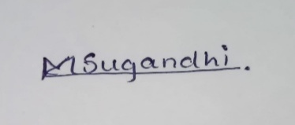

Employee Signature
Review by Reporting Person Signature OF Reporting Manager

