Resume
Ms.Madhumitha.S B.Tech (IT)
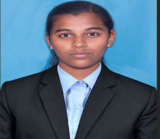
Residence :
5/225,
Periyakumarapalayam,
Dharapuram (t.k),
Tiruppur (d.t) -642201.
Mobile no :
7358451400
Mail id :
madhumithasenthilkumar52@gmail.com
Career Objective:
Seeking a challenging position in reputed organization where I can apply my engineering knowledge ,enhance my coding knowledge enhance my coding and communication skills and contribute to the development and growth of our organization.
Education details:
S.no | Degree | Name of the institution | CGPA / Percentage
1 | I-B.TECH (IT) | V.S.B Engineering college | 8.52
2 | 12 th standard | Veveaham Higher Secondary School | 91%
3 | 10 th standard | R.G.Matric Higher Secondary School | 89%

Technical Skills :
- Programming languages known : Python, C, Java
- Problems solving in geeks for geeks and in leetcode platforms.
Certification Courses:
- Basics of Python (Infosys Springboard )-2025
- Foundations of Python (Infosys Springboard)-2025

Achievements :
- Coding Challenges solved on Geeks for Geeks and leetcode.
Paper presentations:
- Presented a paper on “CYBER SECURITY “ at a communication training conducted by V.S.B Engineering College,Karur (2026).
Strengths:
- Quick learner with strong problem solving skills .
- Good teamwork and communication skills .
- Time management and organizational skills .
- Self motivated and hardworking.
Personal details :
Name : Madhumitha
Date of Birth : 12.05.2008
Gender : Female
Nationality : Indian
Languages Known : Tamil,English
Marital status : unmarried
Mobile number : 7358451400
Email-id : madhumithasenthilkumar52@gmail.com
Address : 5/225,
Periyakumarapalayam,
Dharapuram (t.k),
Tiruppur (d.t) -642201.
Declaration :
I hereby declare that all the above mentioned informations are true and correct to the best of my knowledge.

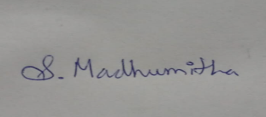
Place :- Tirupur
Date :- 06.06.2026
Signature :-

