1. Create the database and schema. Populate the Schema:
- Create a Database 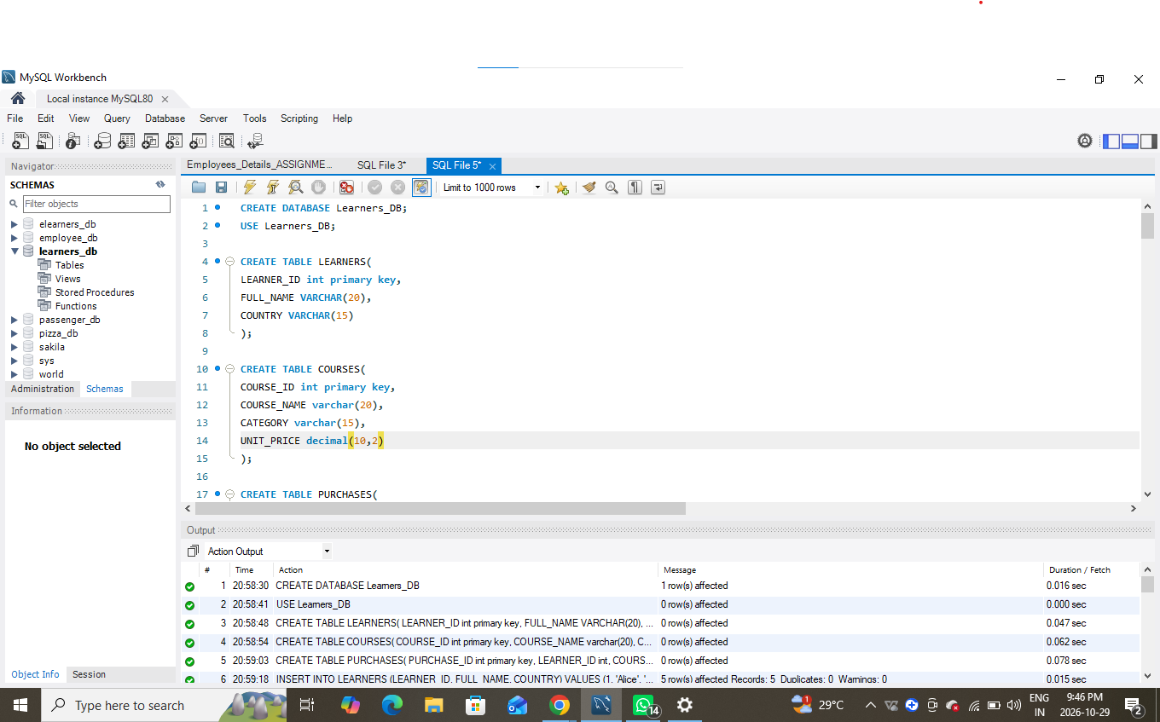

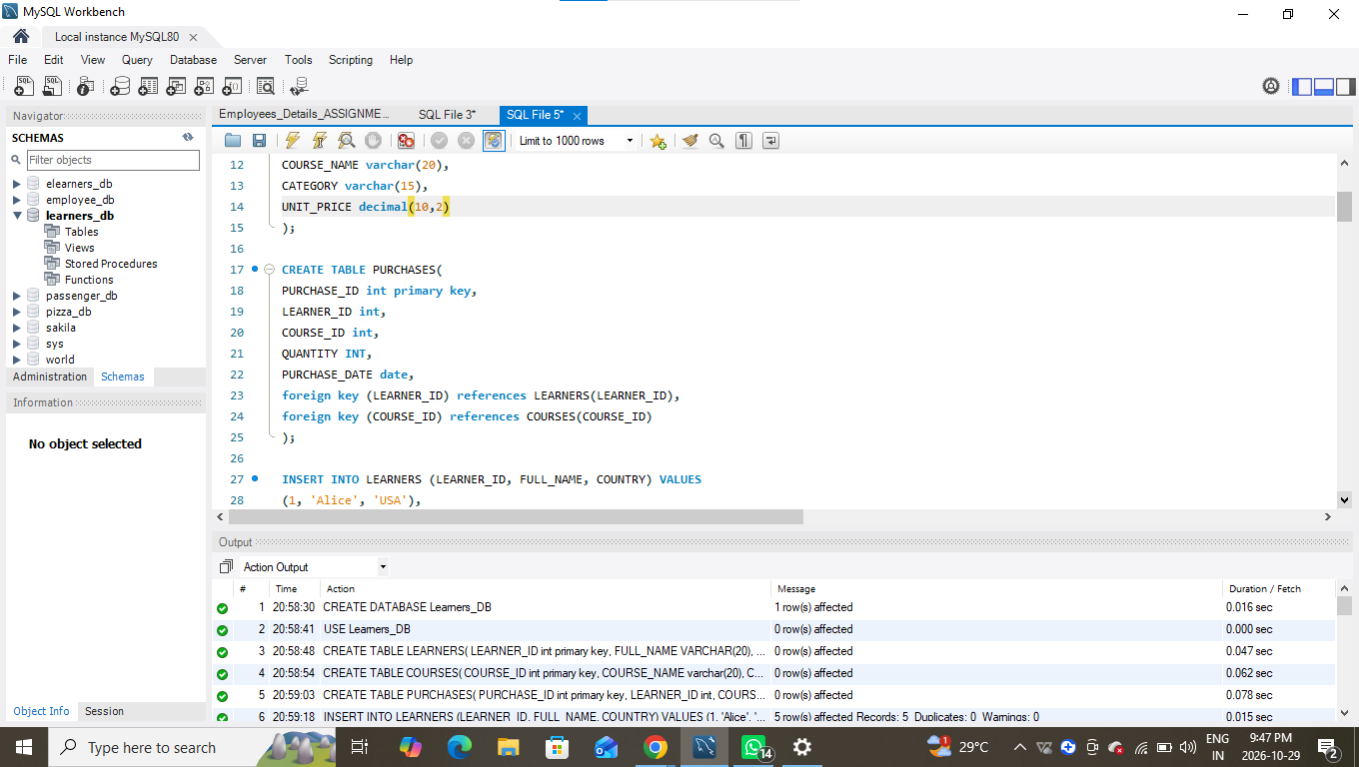
- Insert sample data covering at least:
  - 4–5 learners
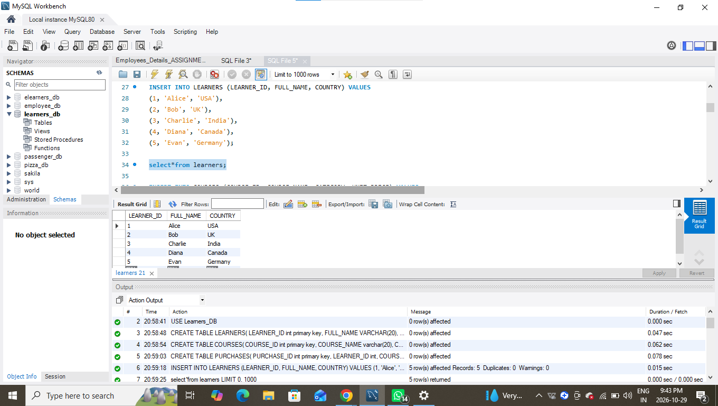
  - 4–5 courses (spread across multiple categories)
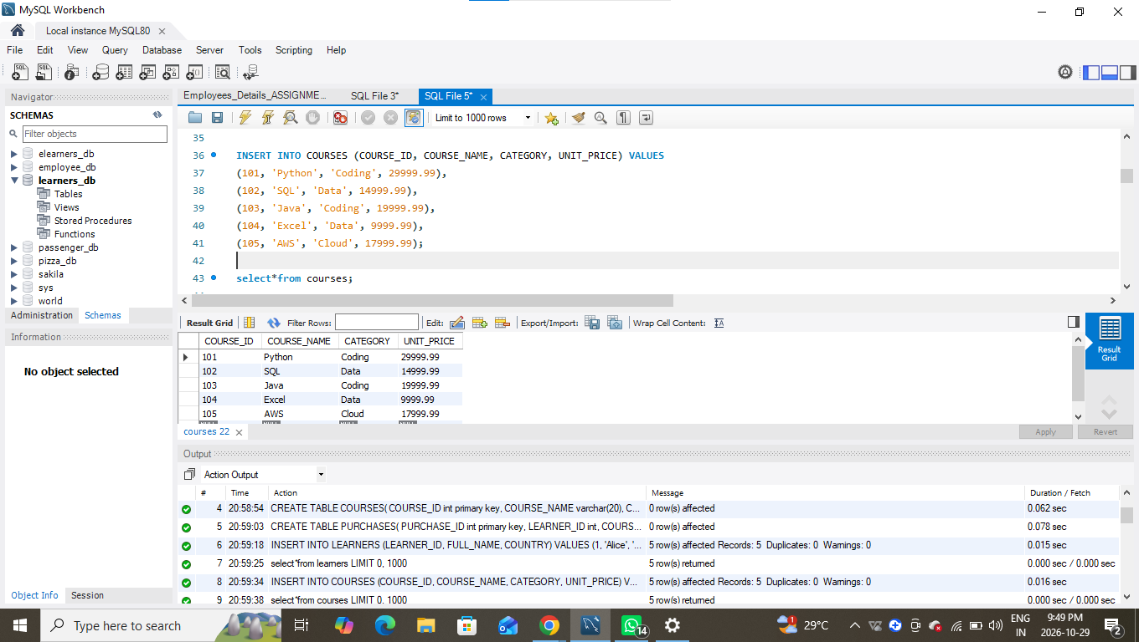

  - 6–8 purchase records
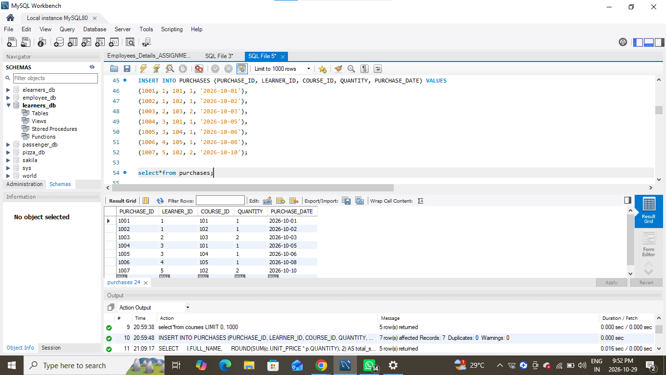

2. Data Exploration Using Joins
Data Presentation Guidelines for the following query
- Format currency values to 2 decimal places.
- Use aliases for column names (e.g., AS total_revenue).
- Sort results appropriately (e.g., highest total_spent first).
Use SQL INNER JOIN, LEFT JOIN, and RIGHT JOIN to:
- Combine learner, course, and purchase data.
- Display each learner’s purchase details (course name, category, quantity, total amount, and purchase date).
INNER JOIN
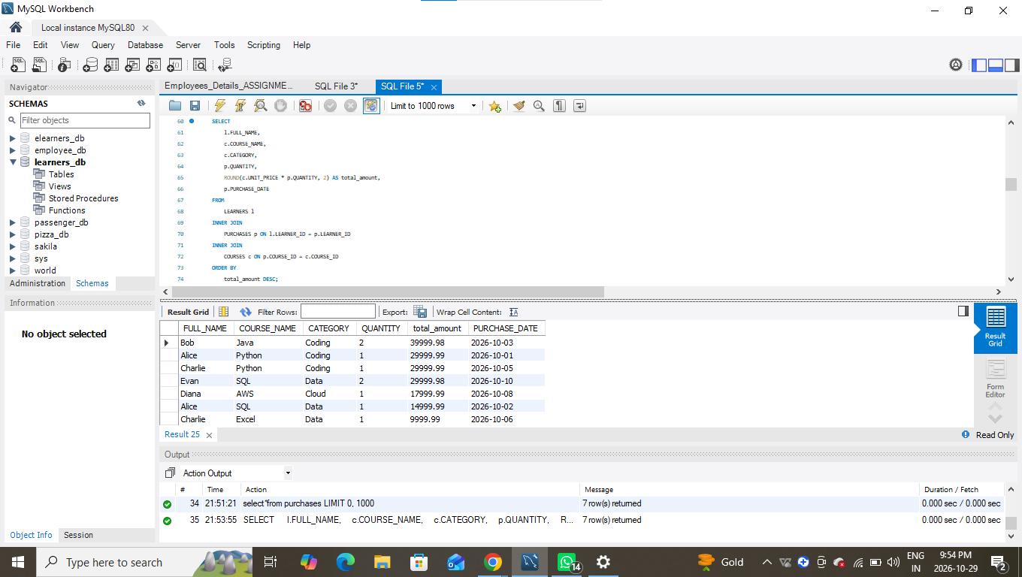

LEFT JOIN,
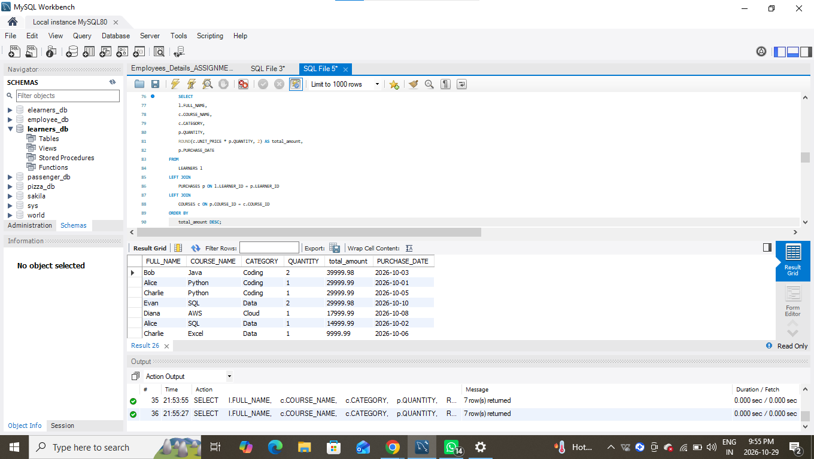

RIGHT JOIN
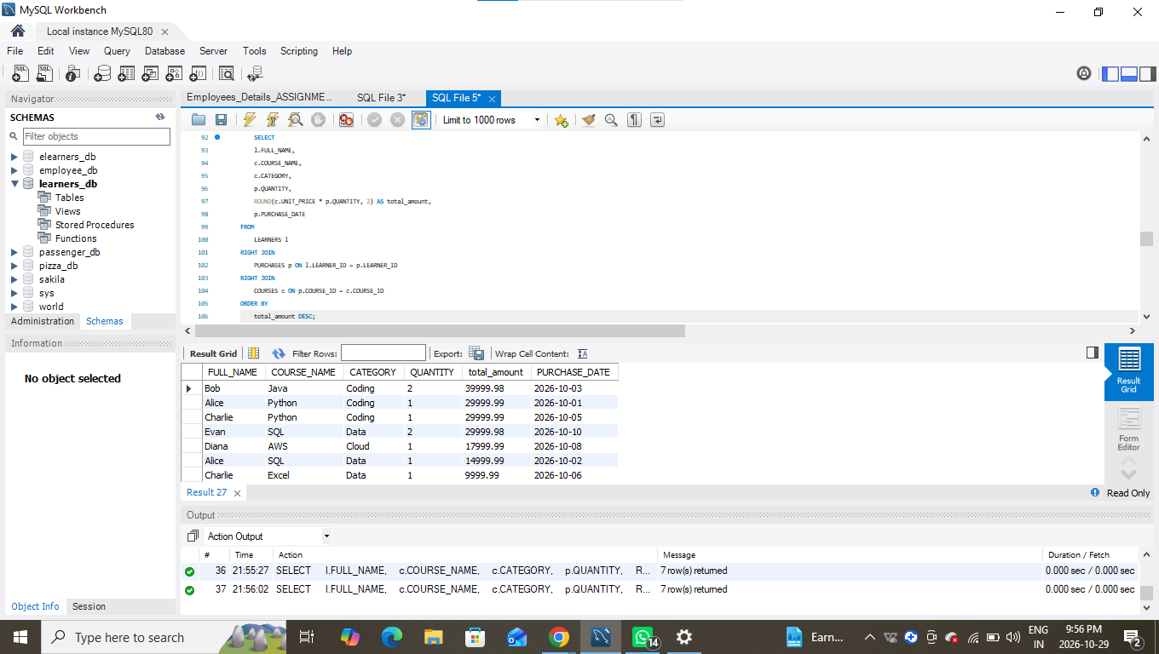
3. Analytical Queries :
Q1. Display each learner’s total spending (quantity × unit_price) along with their country.
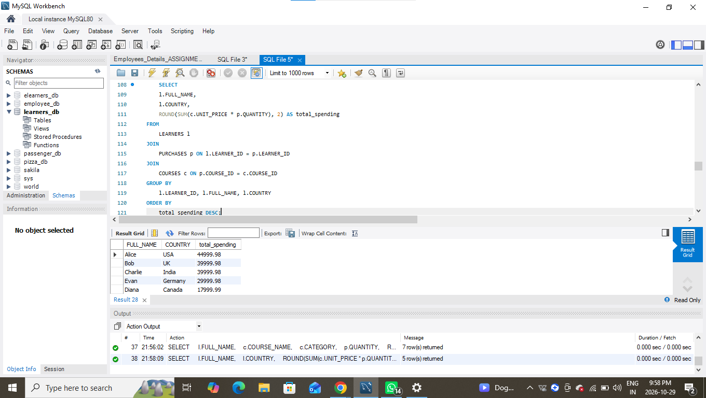
Q2. Find the top 3 most purchased courses based on total quantity sold.
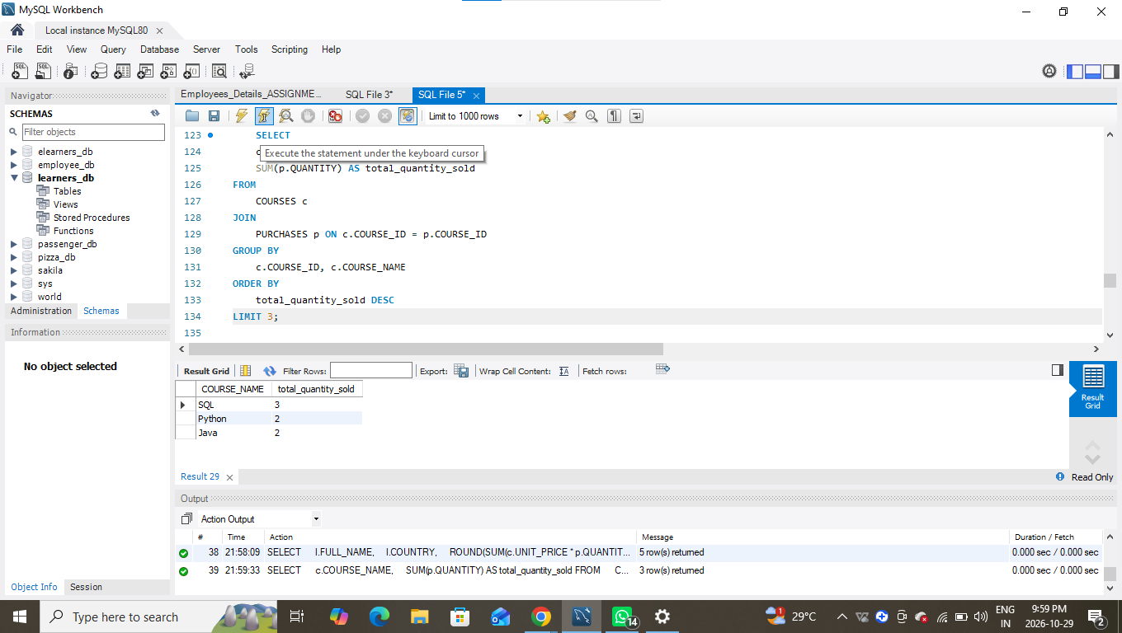

Q3. Show each course category’s total revenue and the number of unique learners who purchased from that category.
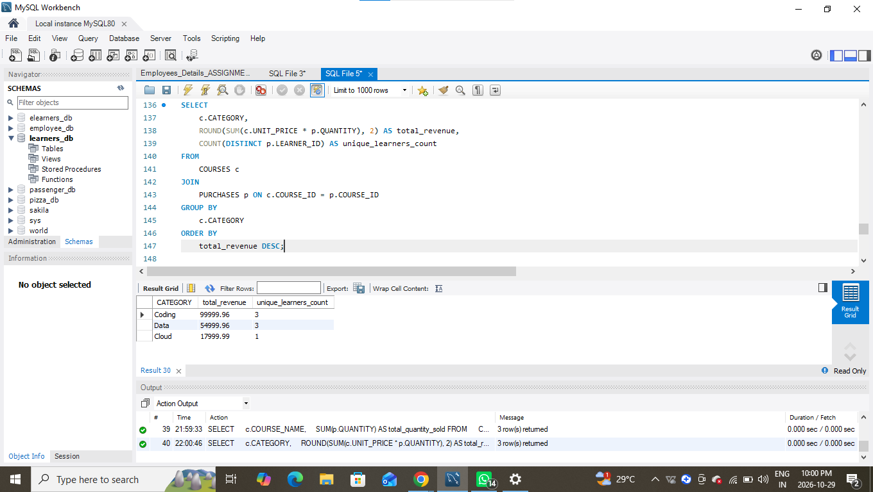
Q4. List all learners who have purchased courses from more than one category.
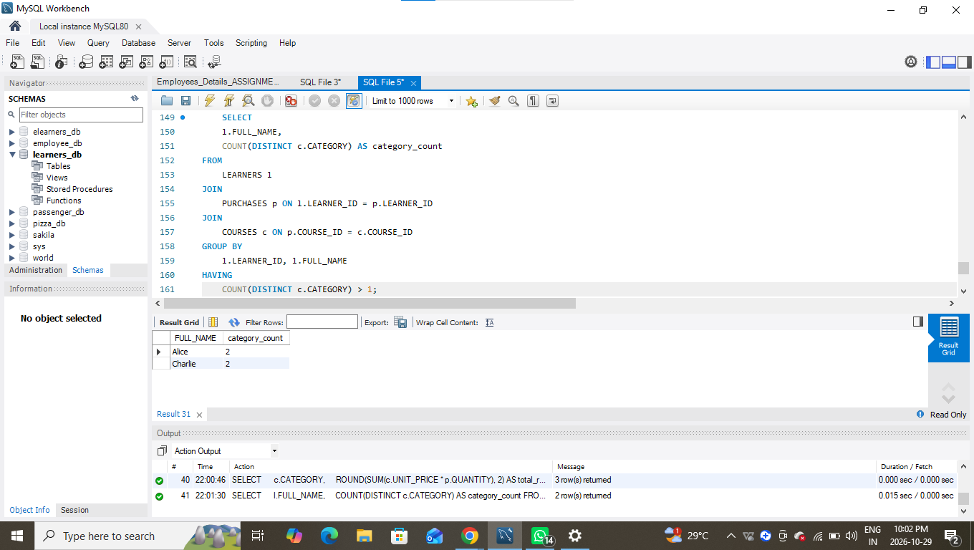
Q5. Identify courses that have not been purchased at all.
