SALESFORCE
Student Enrollment & Course Management System (SECMS)(NM)
Configuration & Implementation Documentation

Platform | Salesforce Developer Edition
Main Object | Student (student__c)
Automation | Record-Triggered Flow
Document Type | Project Documentation

Prepared based on the provided Salesforce configuration screenshots

1. Introduction
This documentation describes the configuration and implementation of a Student Enrollment & Course Management System (SECMS)(NM) using Salesforce. The screenshots show the creation and configuration of a custom Student object, its fields and relationships, validation rules, and record-triggered flow automation. The configuration is intended to organize student information and apply business rules automatically within Salesforce.

2. Objectives
- Create and configure a custom Student object in Salesforce.
- Define student-related fields such as address, date of birth and email.
- Configure picklist fields for controlled data entry.
- Create validation rules to maintain data quality.
- Create record-triggered flows for automation.
- Verify that the configured objects, rules and flows are deployed and active.

3. Student Object Configuration
The Salesforce Object Manager is used to create and manage objects. In the screenshots, the custom object named 'student' is available in Object Manager with the API name 'student__c'. The object is shown as a Custom Object and has a deployed status.
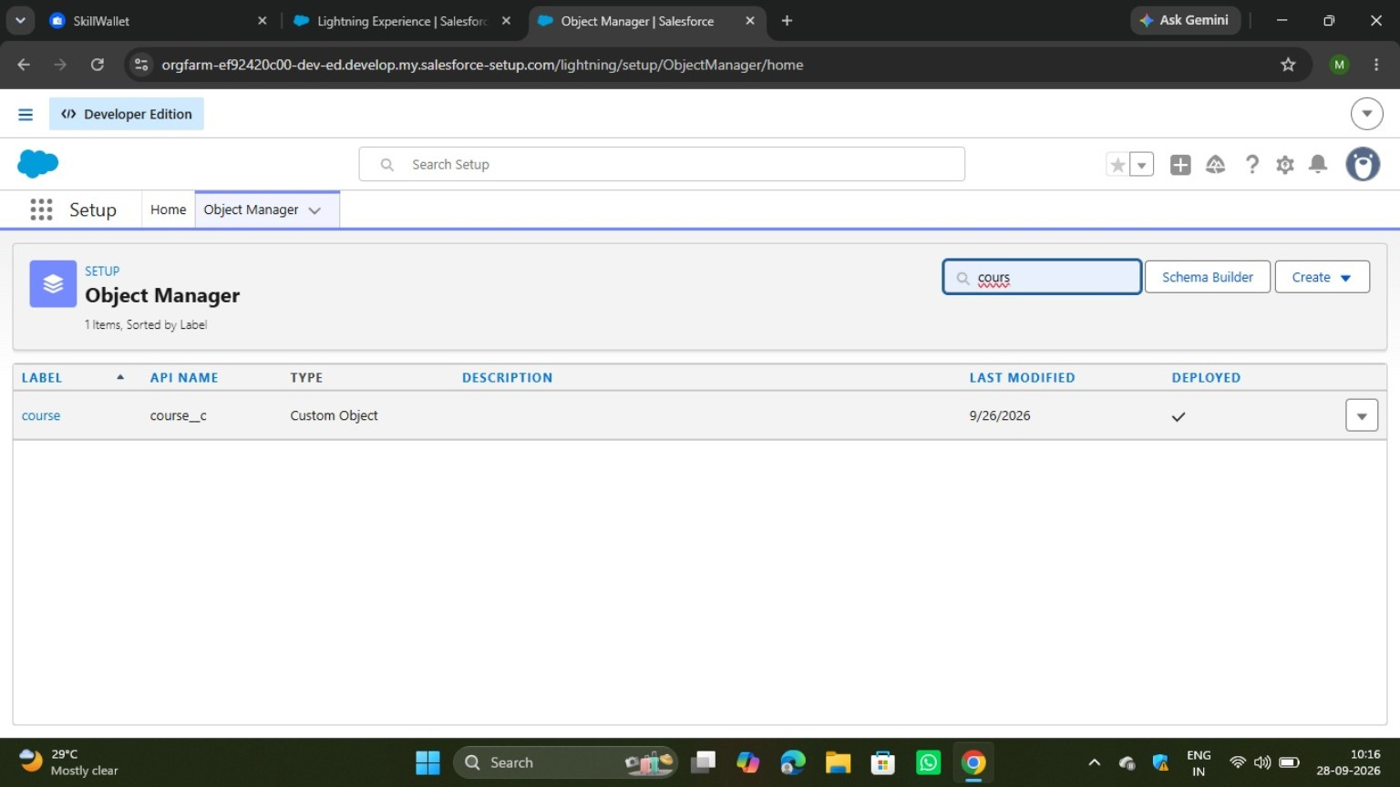
Figure 1: Object Manager showing the custom course object.
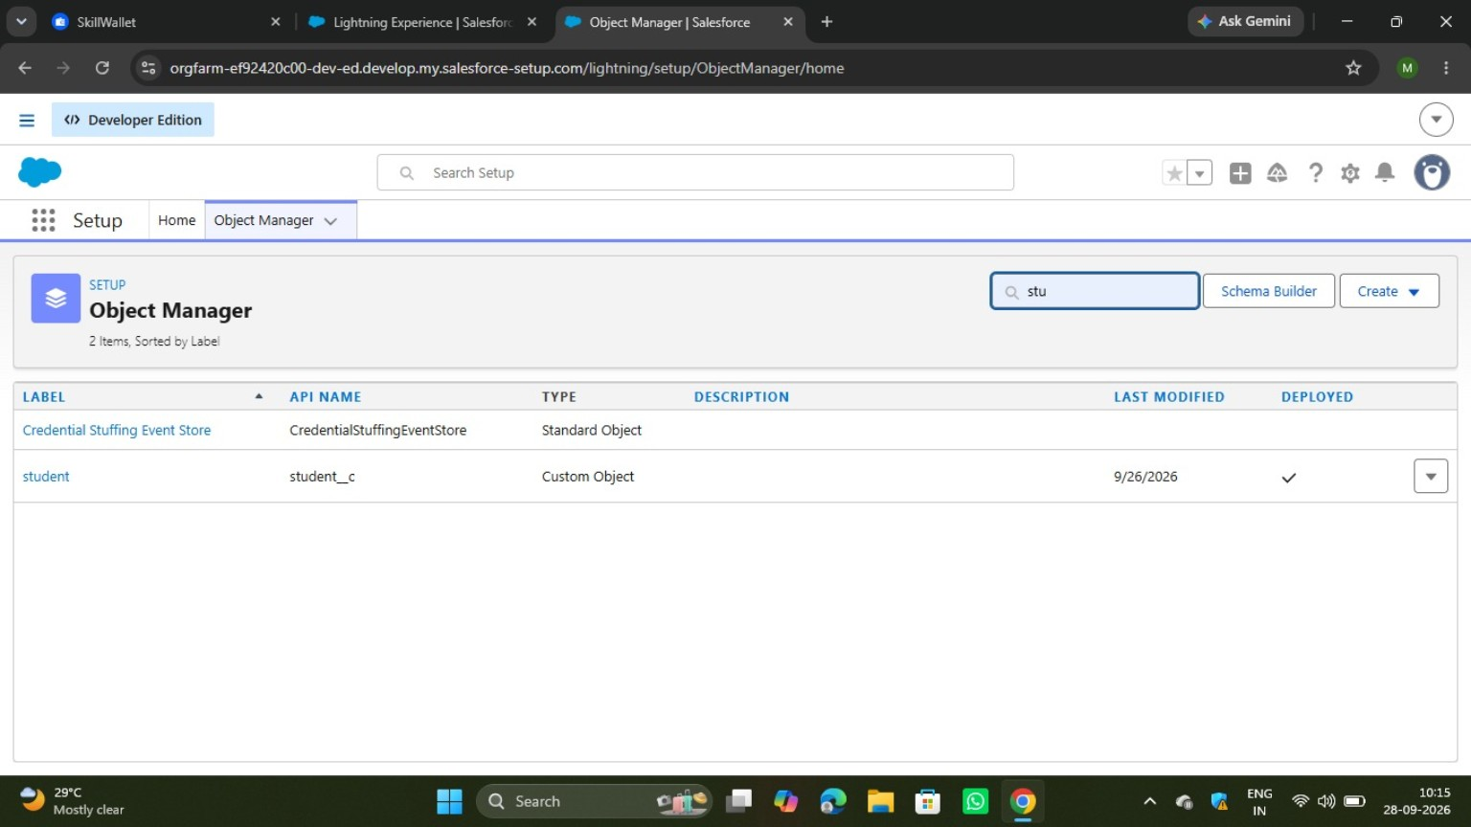
Figure 2: Object Manager showing the custom student object (student__c).
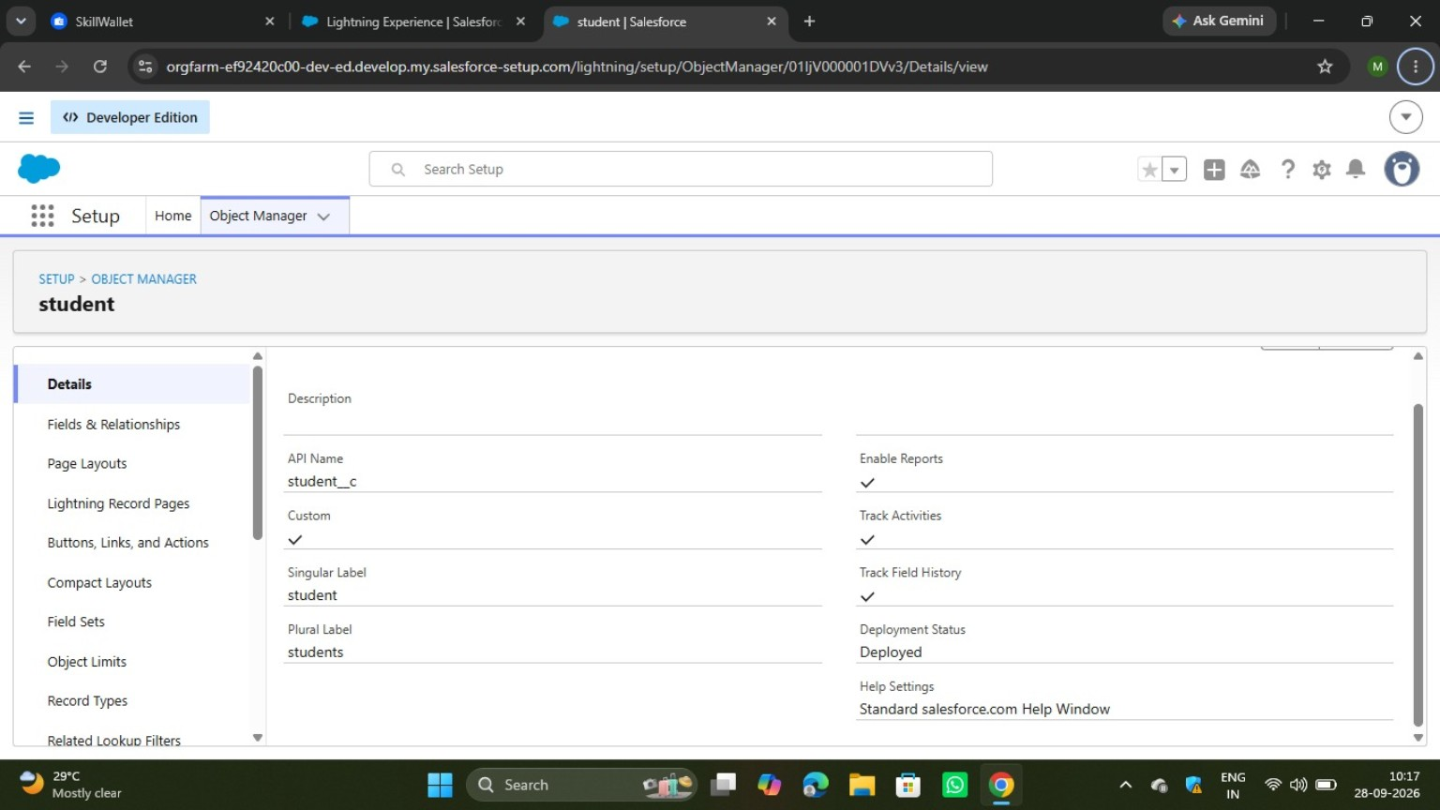
Figure 3: Student object details, including API name, labels and deployed status.

4. Fields and Relationships
The Fields & Relationships section contains the fields available for the Student object. The screenshots show fields such as Address, Date of Birth and Email, along with standard Salesforce fields such as Created By, Last Modified By and Owner.
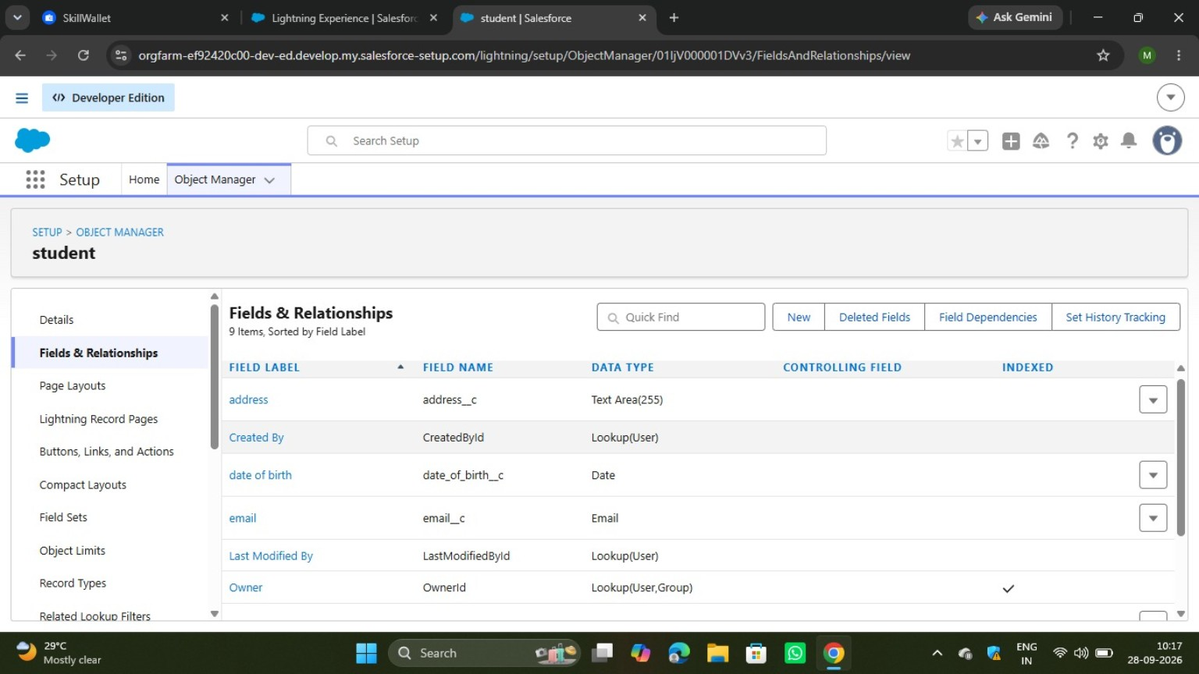
Figure 4: Student object – Fields & Relationships section.

4.1 Picklist Field Configuration
A new picklist field is being configured. The field setup screen provides options to enter the field label, choose a global picklist value set or enter individual values, define the field name, and add optional description/help text. Picklists help keep values consistent when users create or update student records.
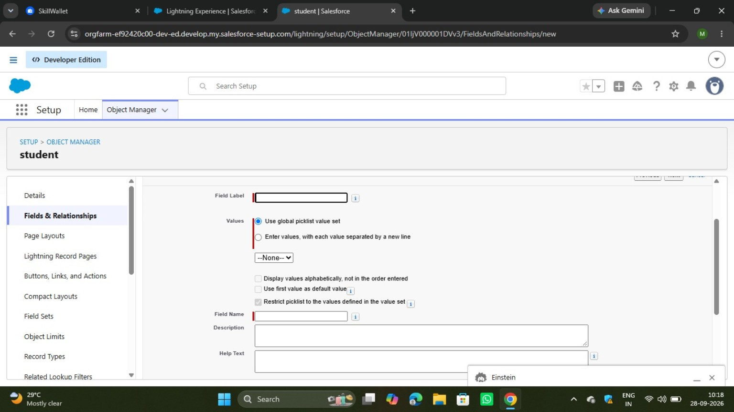
Figure 5: New Picklist field configuration screen.

5. Validation Rule
A validation rule named 'student_email_domain_validation' is configured for the Student object. The error location is the Email field, and the displayed message indicates that the email must be a valid student institutional email. The rule is shown as Active. This helps prevent invalid institutional email addresses from being saved.
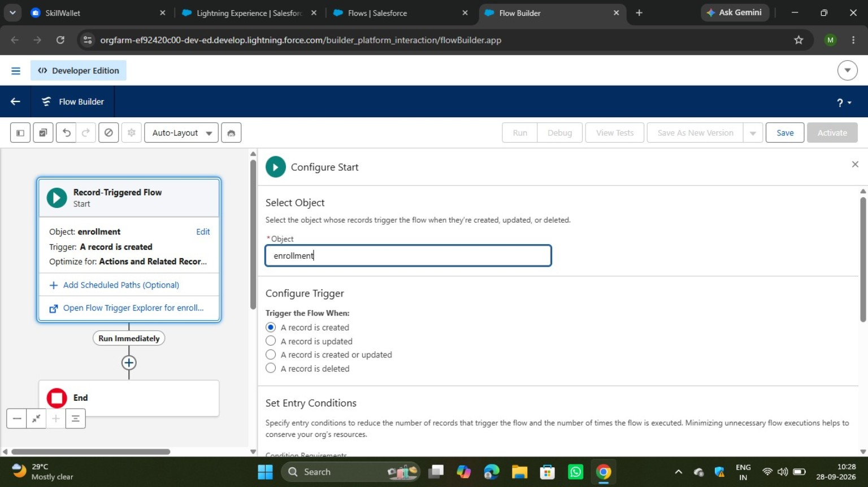
Figure 6: Active validation rule for student institutional email.

6. Record-Triggered Flow Automation
Salesforce Flow Builder is used to automate actions when records are created, updated or deleted. The screenshot shows a Record-Triggered Flow for the Enrollment object. The trigger is configured for a record to be created, and the flow is optimized for actions and related records.
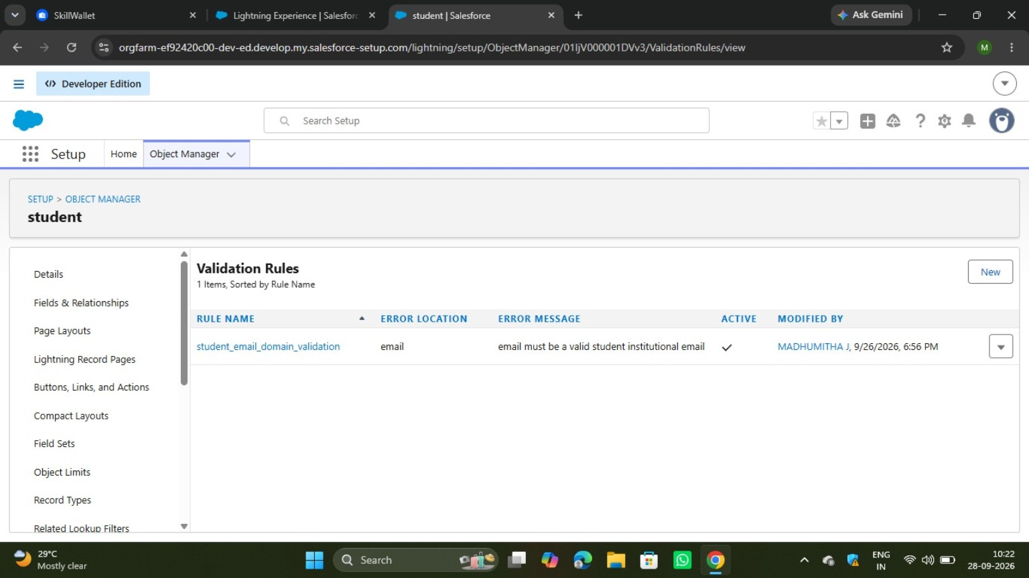
Figure 7: Flow Builder – Record-Triggered Flow configured for the Enrollment object.

6.1 Flow Management
The Salesforce Flows page lists available flows and their status. The screenshot shows multiple flows, including 'set enrollment date' and 'set student status active', with active status indicators. This confirms that automation has been created and maintained within the org.
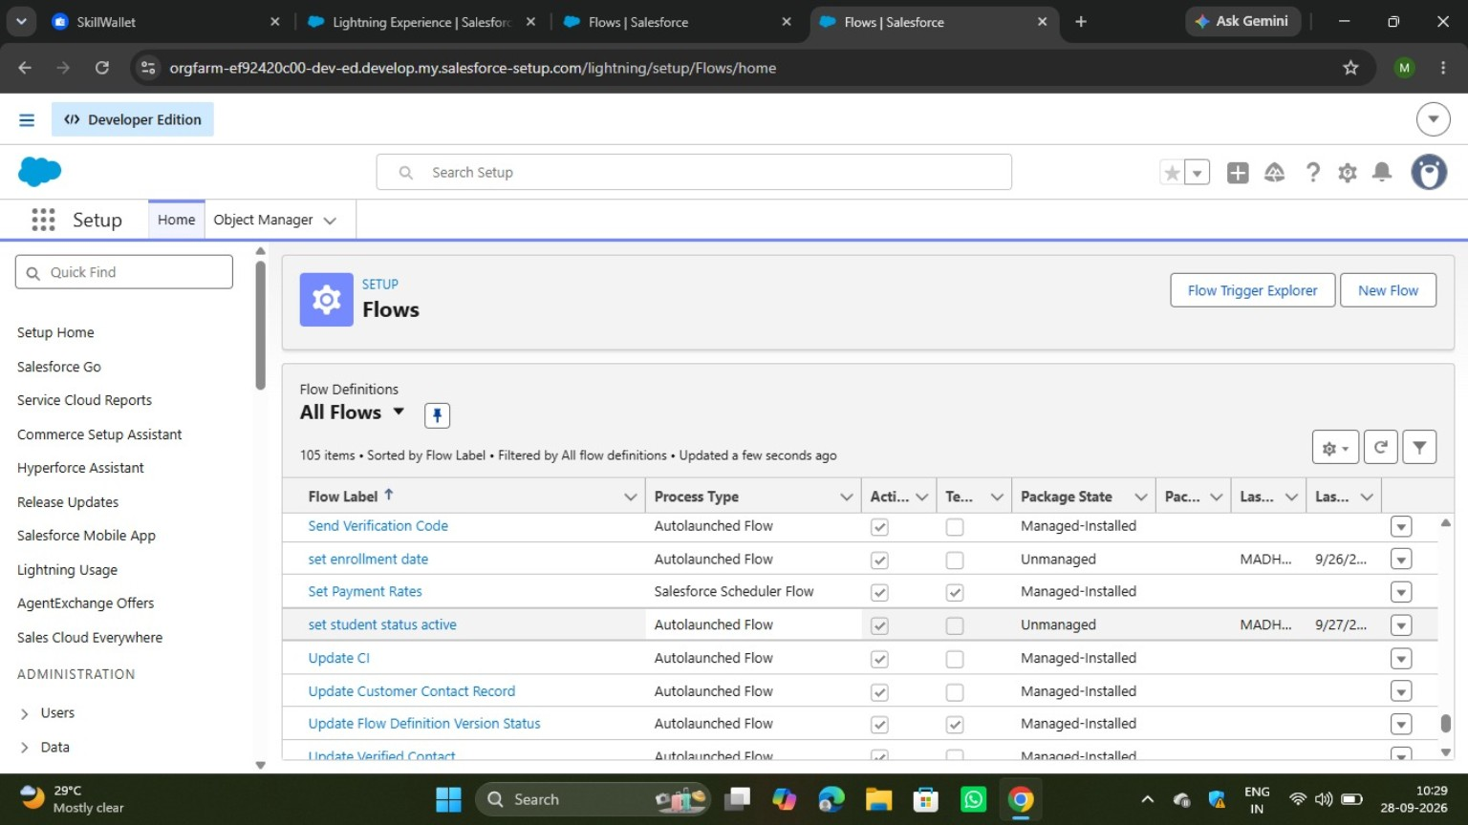
Figure 8: Salesforce Flows page showing configured and active flows.

7. Implementation Summary
Component | Configuration | Purpose
Student Object | student__c | Stores student-related records
Fields | Address, DOB, Email, etc. | Captures student information
Picklist | Controlled list of values | Maintains consistent data entry
Validation Rule | student_email_domain_validation | Validates institutional email
Record-Triggered Flow | Enrollment record creation | Automates actions related to enrollment
Flow Automation | Enrollment date / student status | Reduces manual updates

8. Conclusion
The Salesforce Student Management System has been configured using a custom Student object, custom fields, validation rules and Flow automation. The configuration improves structured student data management, helps maintain data quality through validation, and reduces manual work through automated processes. The screenshots provide evidence of the major configuration steps completed in the Salesforce Developer Edition environment.

9. Future Enhancements
- Add more student fields such as phone number, department, year and course.
- Create page layouts and Lightning record pages for a user-friendly interface.
- Add additional validation rules for phone numbers and required student details.
- Create reports and dashboards for student and enrollment analysis.
- Add more automated flows for status changes, notifications and record updates.

