**Table Creation**

create table movies(name varchar(20),actor varchar(20),actress varchar(20),year number(4),director varchar(20));

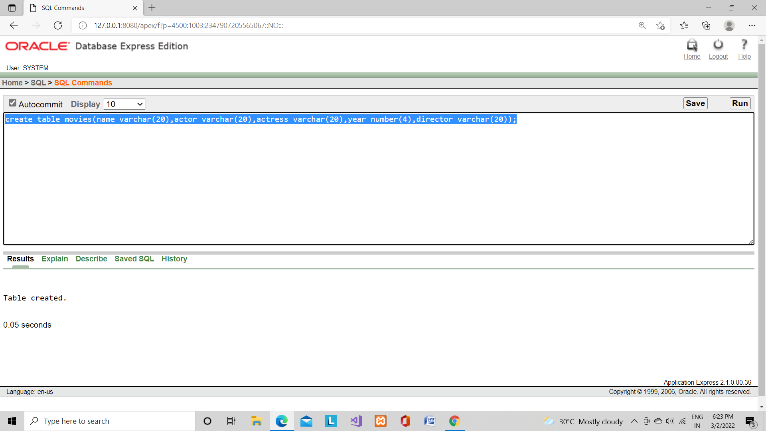

**Inserting and Retrieving Records**

insert into movies values('Avatar','Sam Worthington','Zoe Saldana',2009,'James Cameron');

insert into movies values('SpiderMan','Tom Holland','Zendaya',2021,'Jon Watts');

insert into movies values('Avengers','Robert Downey','Scarlett Johansson',2019,'Joe Russo');

insert into movies values('The Dark Knight','Christian Bale','Maggie Gyllenhaal',2008,'Christopher Nolan');

insert into movies values('Tenet','Juhan Ulfsak','Dimple Kapadia',2020,'Christopher Nolan');

select * from movies;

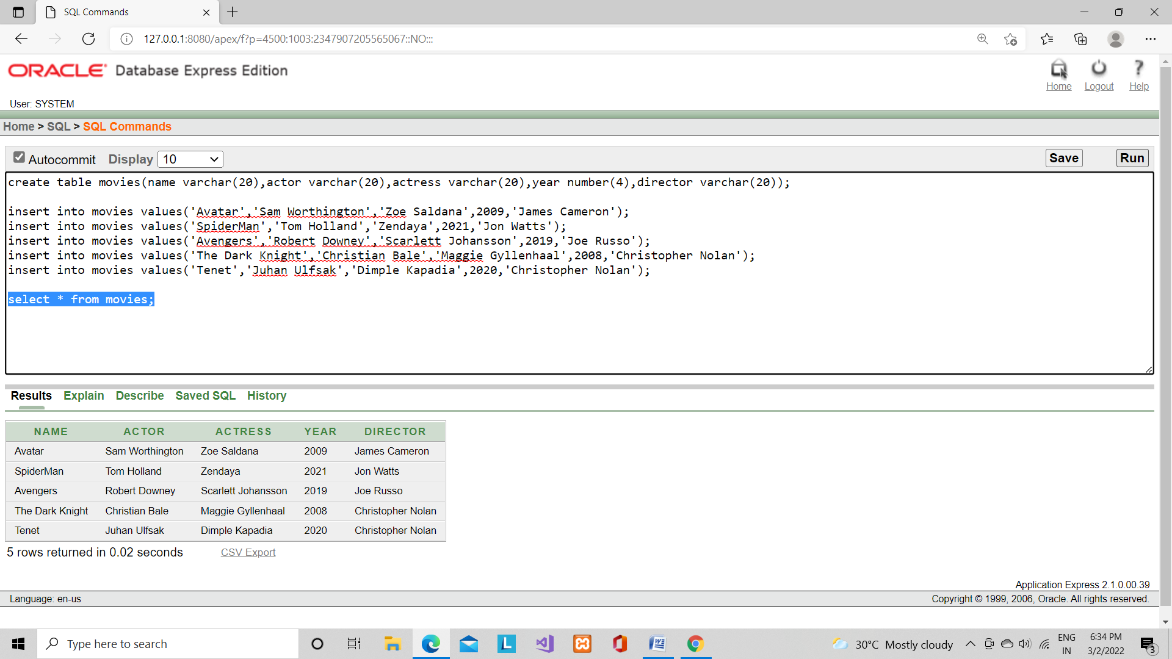

select * from movies where actor='Tom Holland';

