MESSAGE ORIENTED COMMUNICATION AND SOCKETS

Using sockets I have developed a skeleton of a simple cab booking application in golang. So what I have done is, I have considered 4 locations 1,2,3,4. Let us assume that there are 2 drivers and I have saved the driver details(name, his current location, age and contact no) in a structure in the server program. The pickup location and the drop location is collected from the client. Now the server checks which driver is near to the client’s location by finding the absolute difference of the driver’s location and the client’s pickup location. Now the cost for the ride is calculated and sent to client. If the client is okay with the cost, then it should send “ok” to the server. If the server receives “ok” from the client, then the server send the driver’s details to the client.

Here I have used 2 clients. Let us consider a scenario where 2 clients enter the same pickup and drop location to the server. And let us also assume that, there is only 1 driver near to that location. So this driver details will be sent to the one who gave the request first to the server. The other client will receive the details of the other driver but not about the nearest driver. Then the client ride history will be displayed to the respective clients. The ride history displays the previous pickup and drop locations of the client.

STARTING SERVER AND CONNECTING CLIENT:

1. After entering pickup and drop location from client side, the server calculates the cost and displays to client

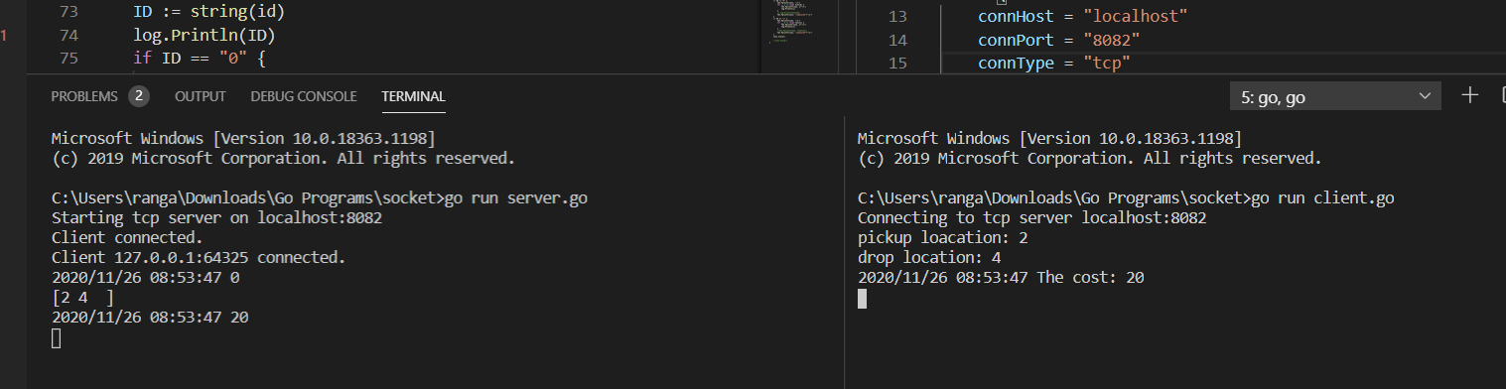

1. Now client types “ok” , so the server displays the driver details and also displays ride history of that client.

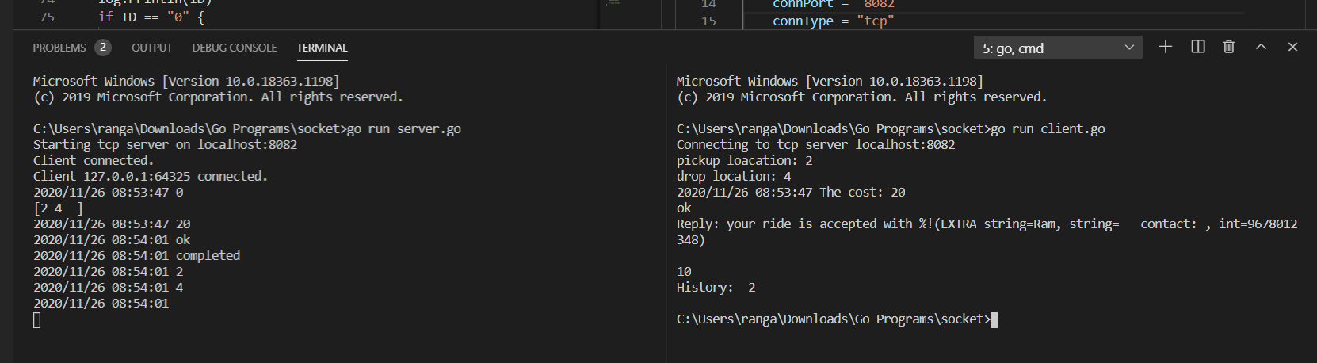

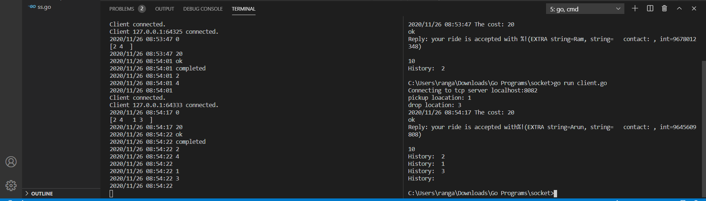

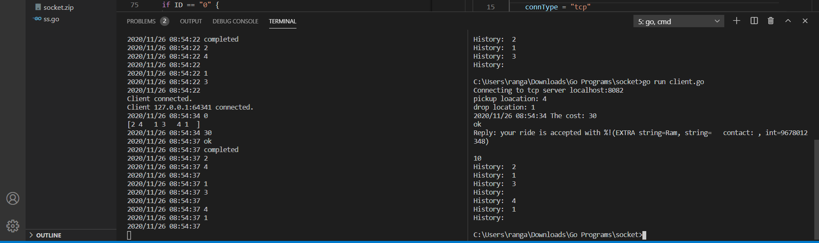

1. Lets say two clients enter the pickup location as 2 and one driver “ram” is at location 2. So driver “ram “ details will be visible to the client who has requested first.

