AIM

To develop an design a mobile on web application to change background colour and menu

PROCEDURE

* Create a wireframe according to the mobile application
* Select the basic theme for page to be created
* Use different shapes to create layout as menu icons
* Use assessts options to get different components to implement
* Get the needed images to make it look unique
* Now,after completion change the background to show comparison

SCREENSHOT

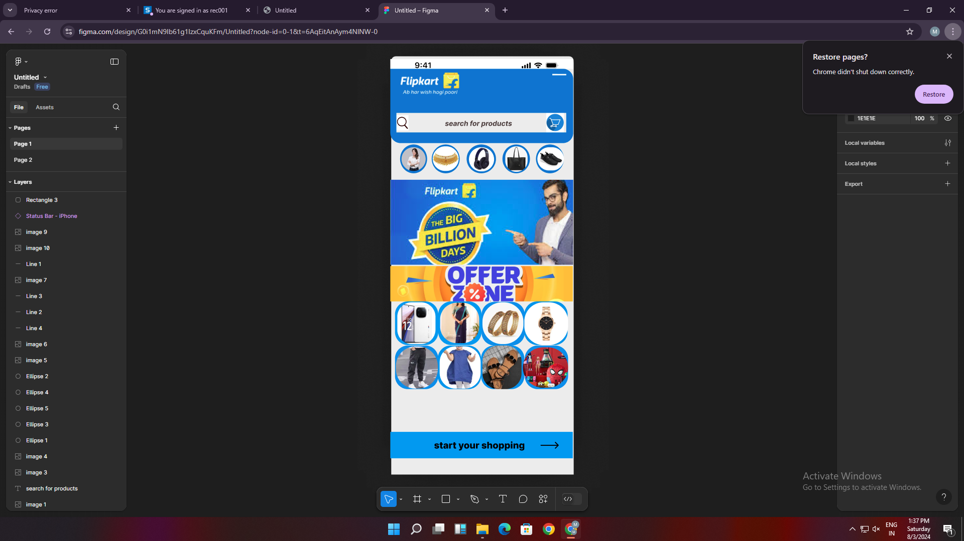

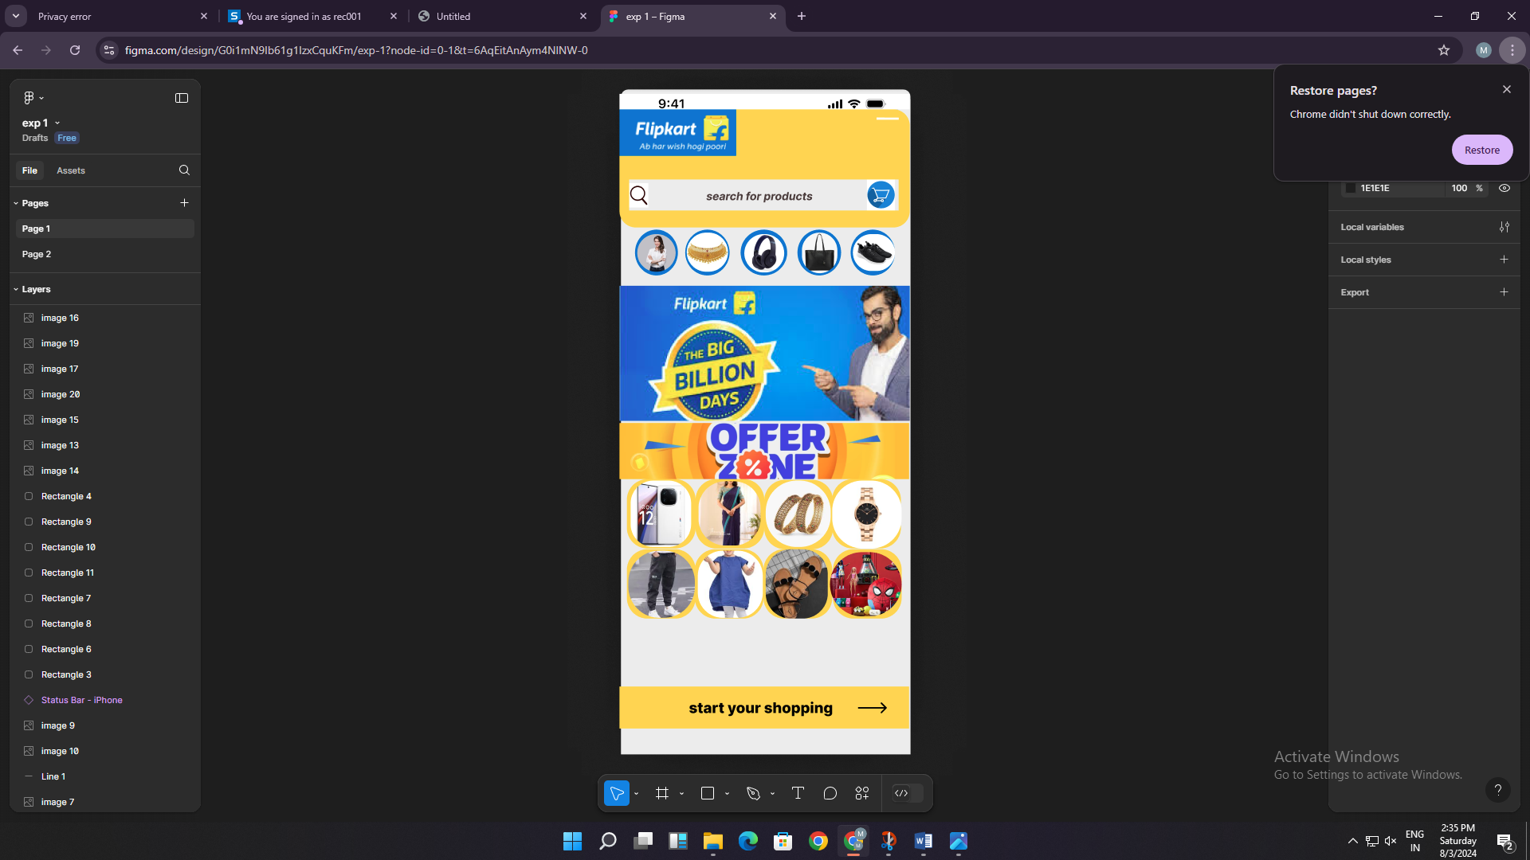

RESULT

A design of mobile on web application to change background colour and menu is developed