**Our directory after separation of python and html file**

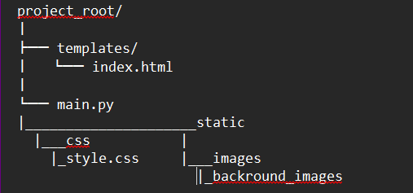

**Testing with postman**

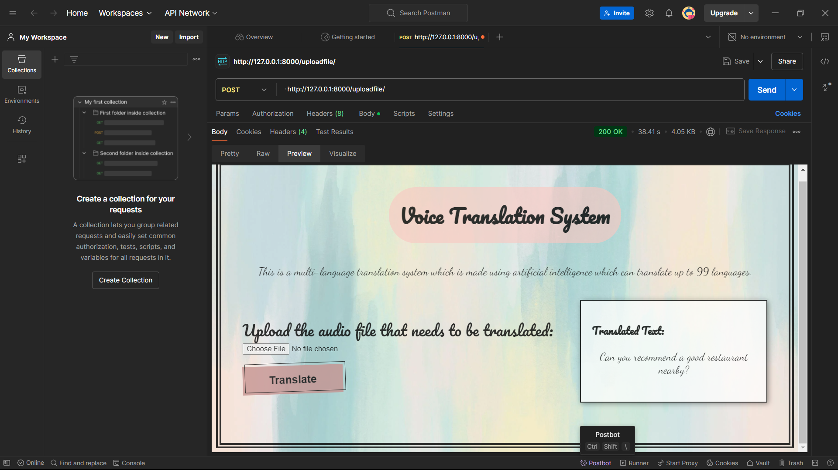

**Configuring NGINX for load balancing and reverse proxy**

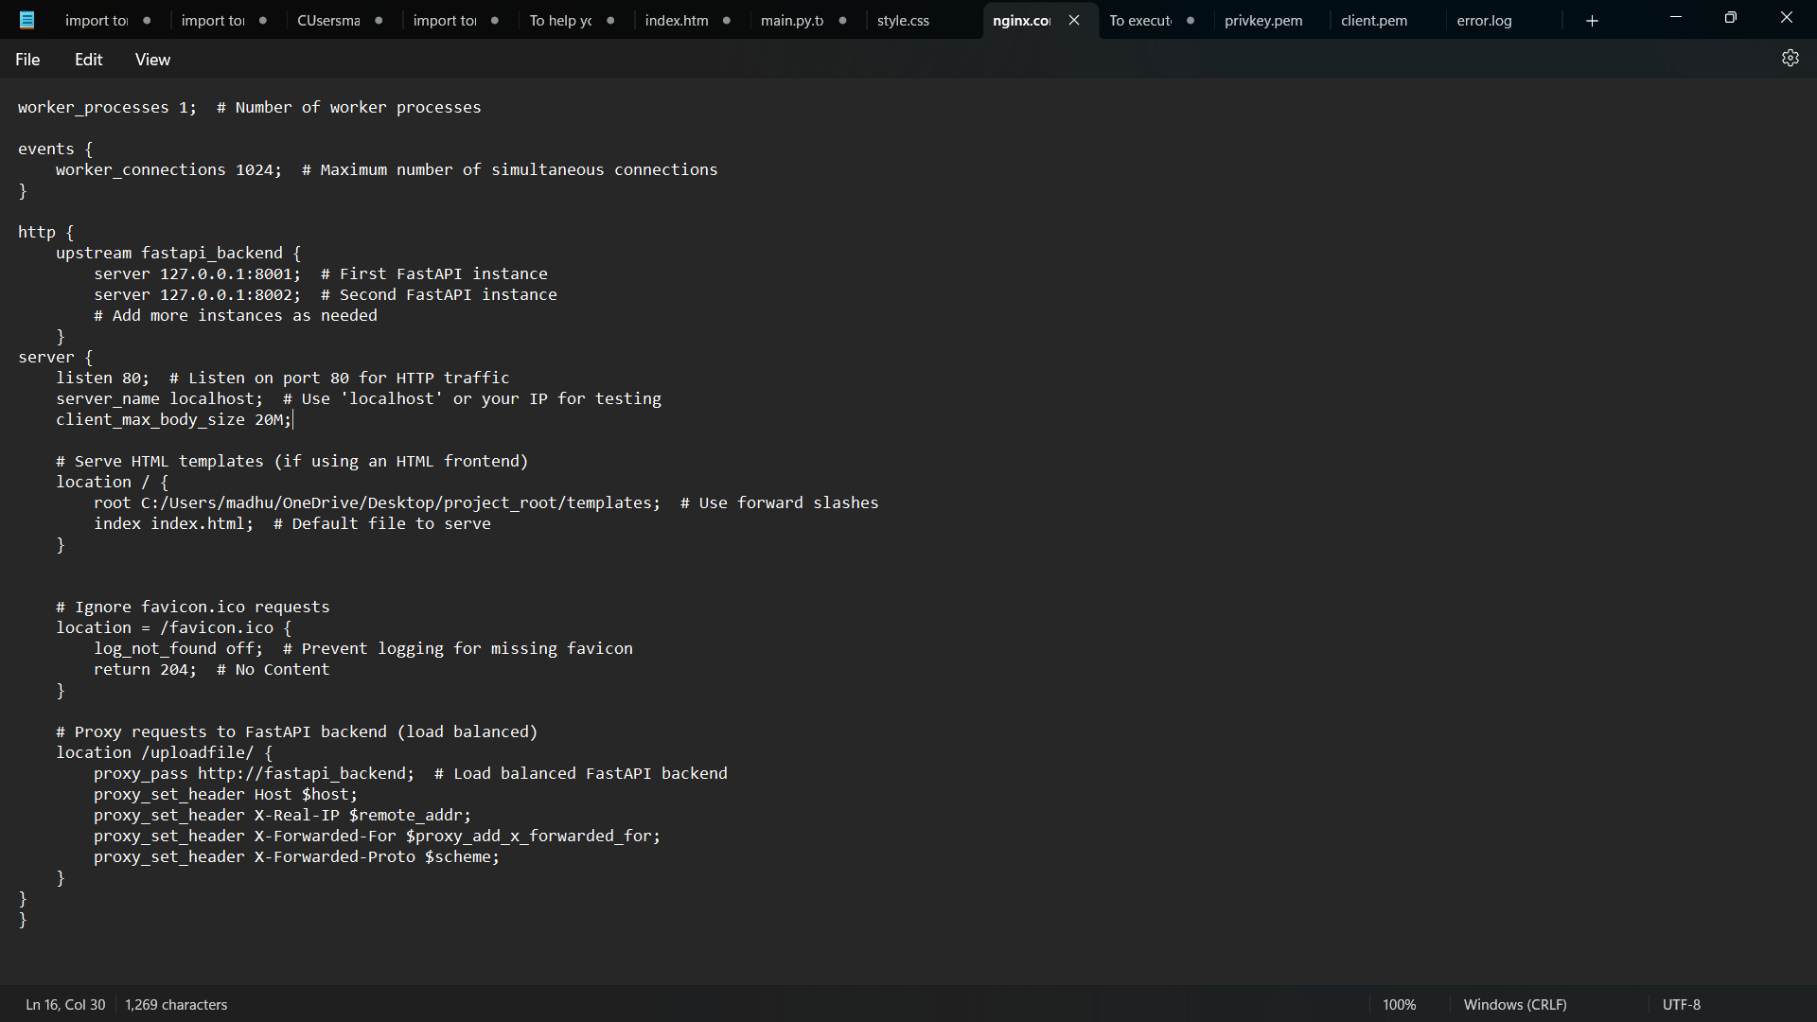

**Checking localhost after starting nginx**

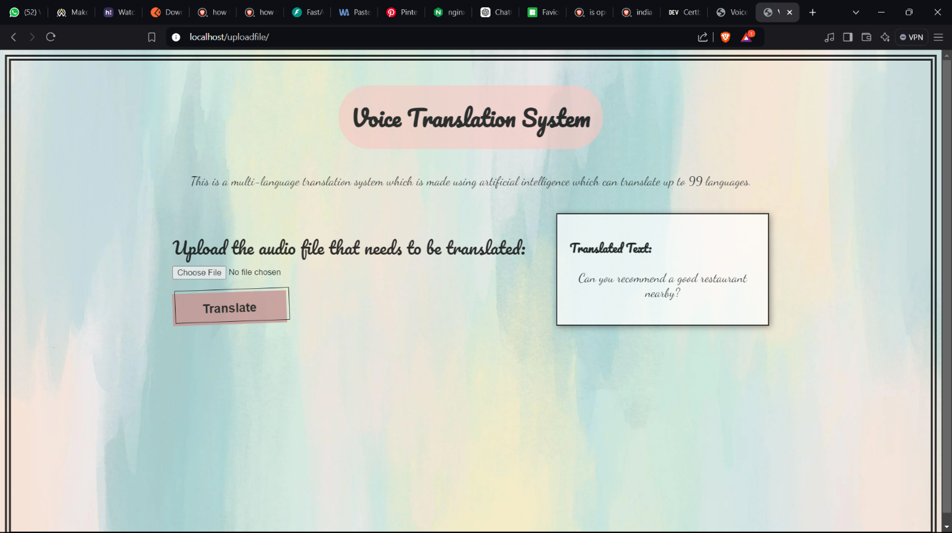

**Trying out in another device on the same network (using the ip address)**

