Assignment – 01

Advanced Embedded Software Development

Madhumitha Tolakanahalli Pradeep

24/01/2019

## **[Problem 1] Complete the Surveys and Agreements**

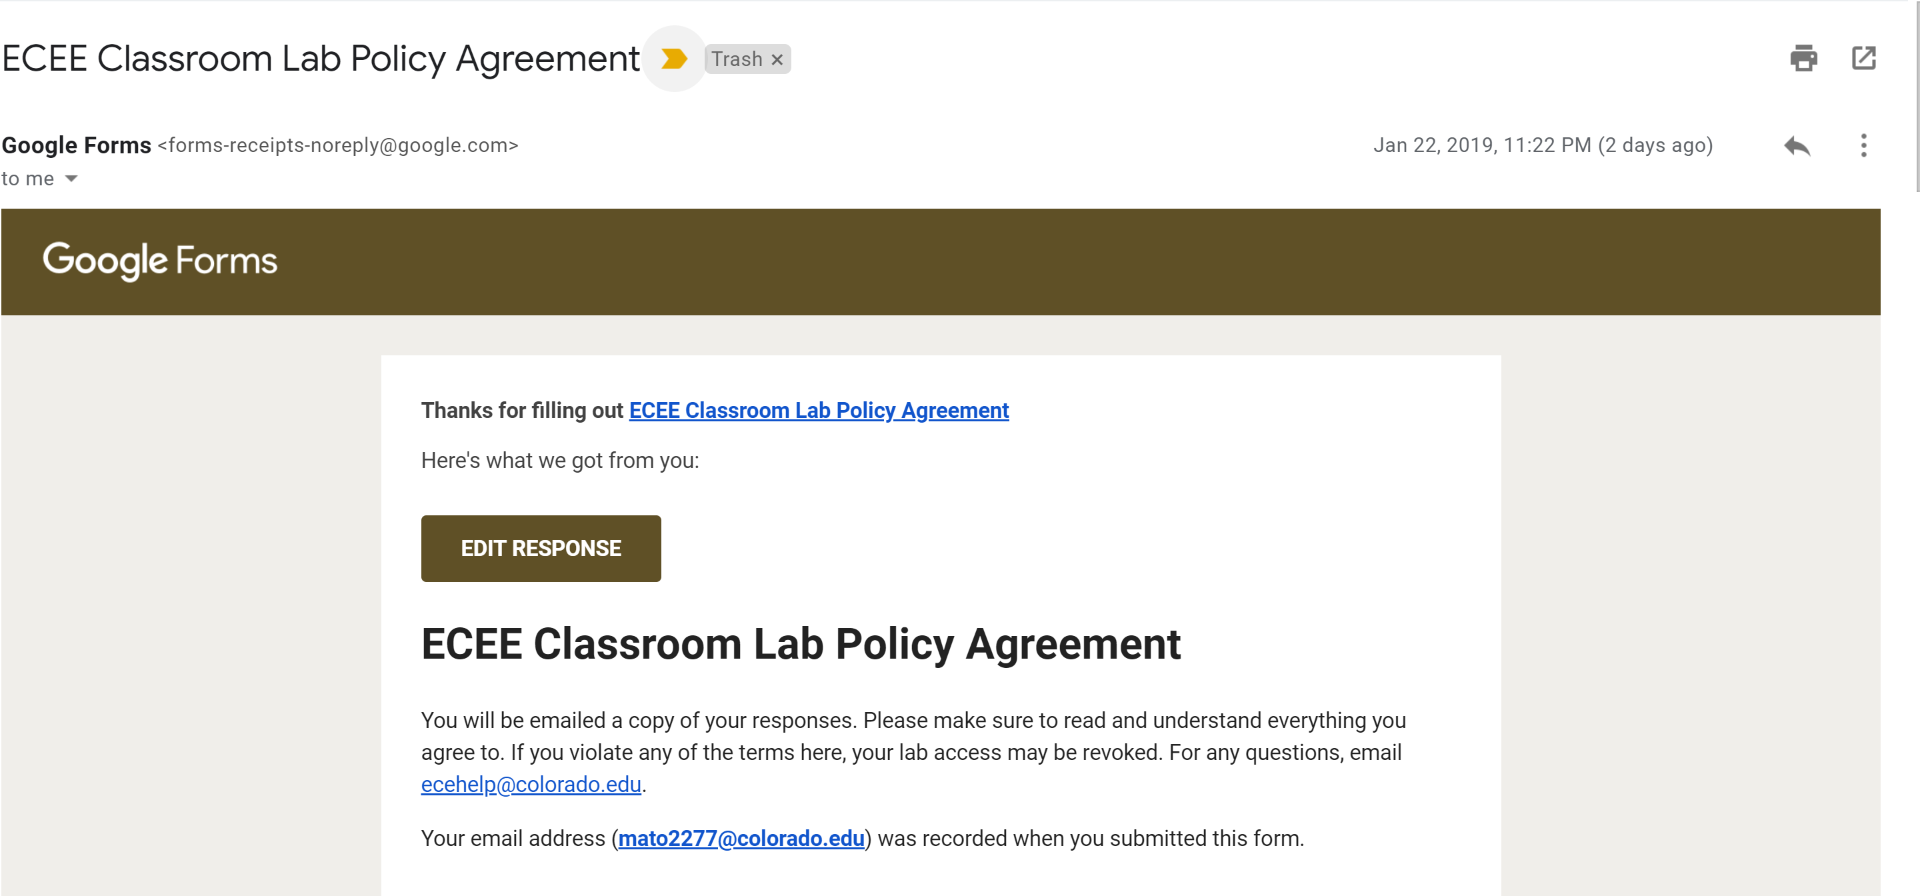

*COMPLETED*

## **[Problem 2] Go to Canvas and get familiar with the site**

*COMPLETED*

## **[Problem 3] Set up your slack account**

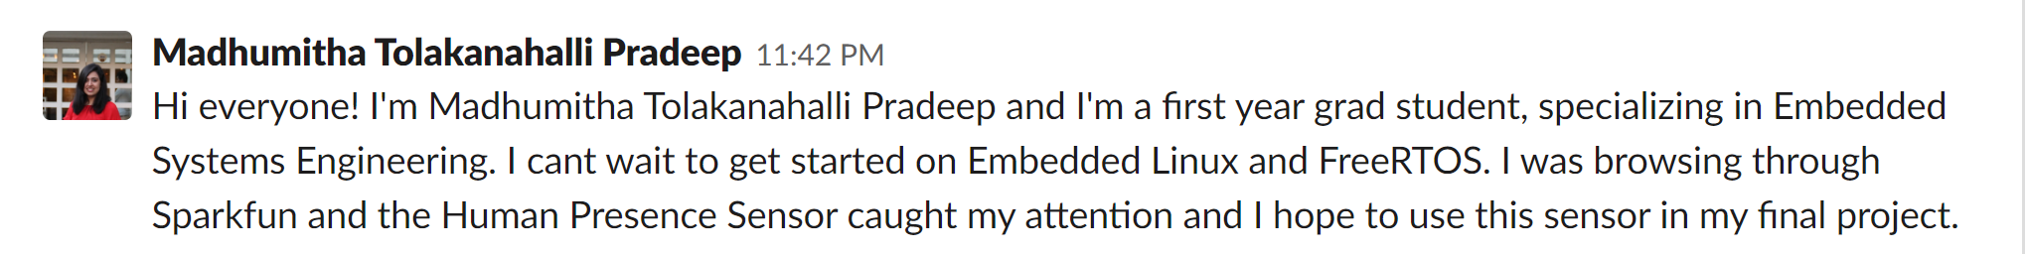*COMPLETED*

## **[Problem 4] Find a partner for the projects and acquire the development kits**

*COMPLETED*

## **[Problem 5] Set up your environment**

*COMPLETED*

## **[Problem 6] Script for OS Information**

- Script

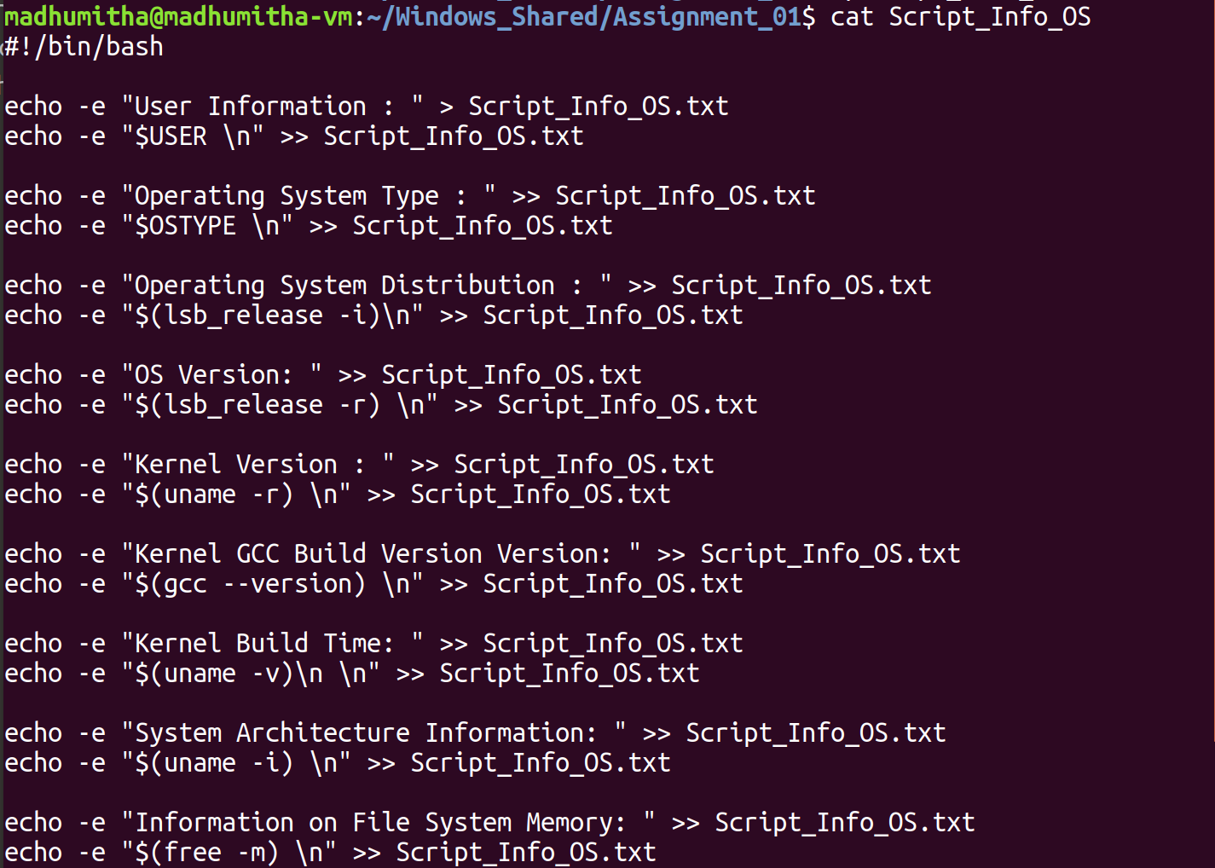

- Output

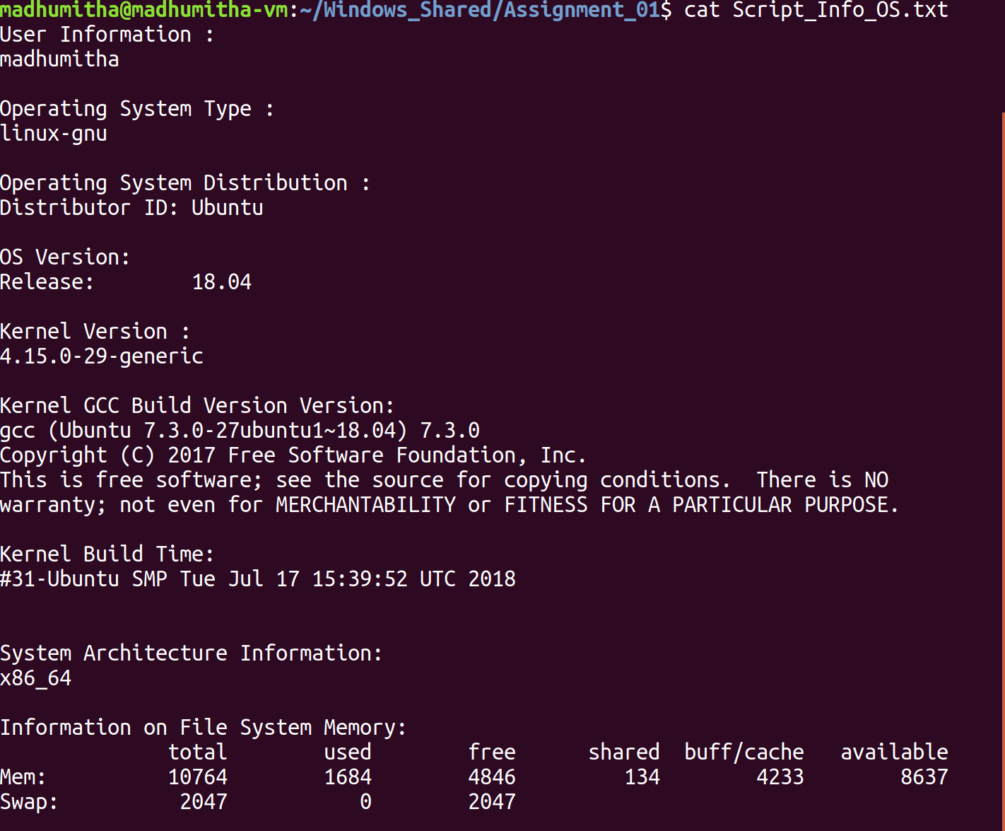

## **[Problem 7] Shared and Static Libraries**

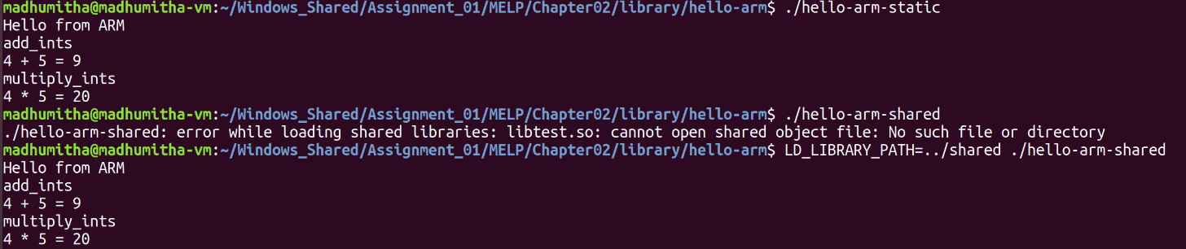- Executing hello-arm-static and hello-arm-shared

- Record of the difference in size of hello-arm-shared and hello-arm-static



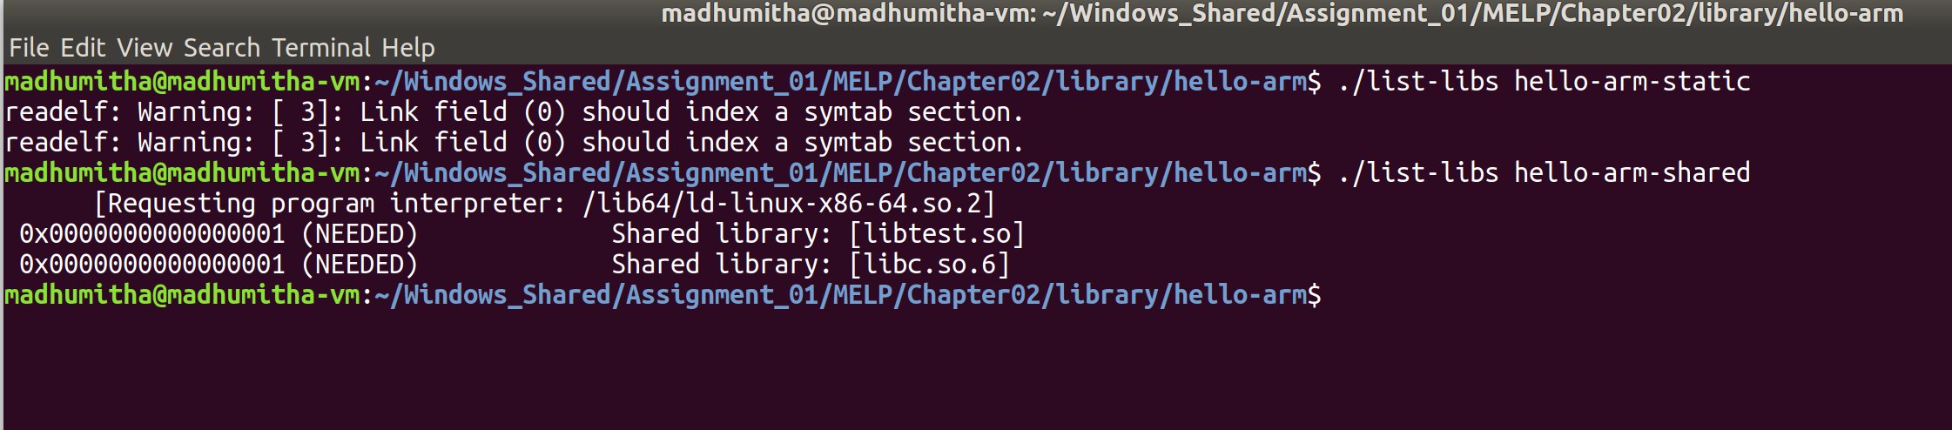 - Screenshot of output of ./list-libs

## **[Problem 8] Cross Compiling**

-Beagle Bone Black : arm_cortex_a8-linux-gnueabihf version

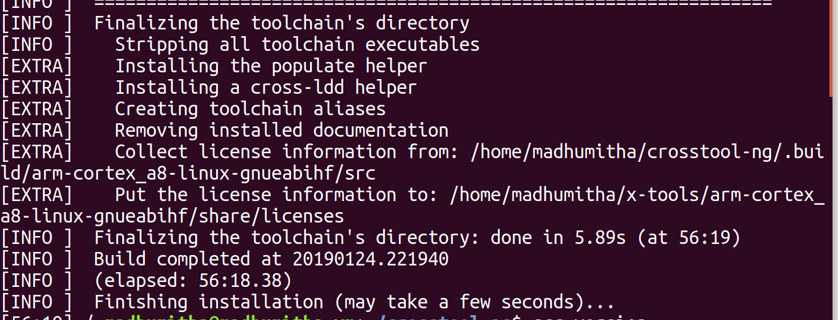

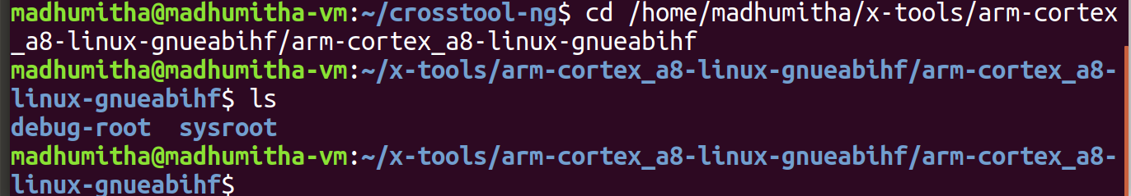- sysroot folder

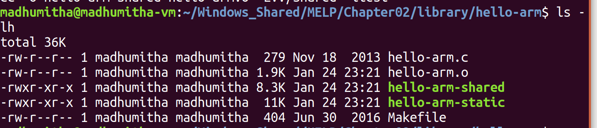- Executables

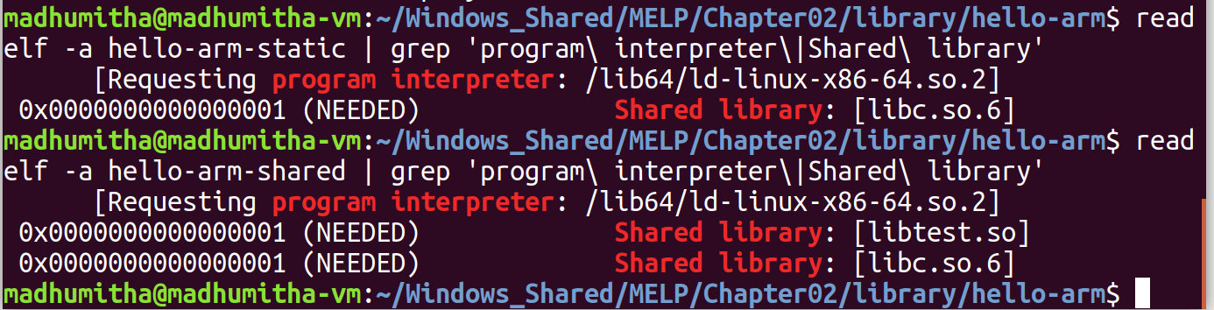-Output of grep