Federal Employee Performance Monitoring System: A Secure and Scalable Web-Based Approach for Enhancing Workplace Wellness and Productivity

Vignesh J R

*dept.of Software Engineering San Jose State University*

San Jose, United States Of America [vigneshjr.naidu@gmail.com](mailto:vigneshjr.naidu@gmail.com)

Madhunica Balasubramanian *dept.of Software Engineering San Jose State University*

San Jose, United States Of America [madhunicab.balasubramanian@sjsu.edu](mailto:madhunicab.balasubramanian@sjsu.edu)

Namitha Malali Nataraj *dept.of Software Engineering San Jose State University*

San Jose, United States Of America [namithamalali.nataraj@sjsu.edu](mailto:namithamalali.nataraj@sjsu.edu)

***Abstract*— This research proposes a comprehensive web- based Employee Performance Monitoring System to track, analyze, and optimize workplace productivity with particular emphasis on federal employee wellness. The system integrates both performance metrics and wellness parameters to provide an overall view of the employees' health and productivity. Using a modern technology stack with React.js as the frontend, FastAPI as the backend, and PostgreSQL as the storage, the system supports real-time monitoring, data insights, and individualized feedback systems. This paper documents the system architecture, the implementation process, and the future applications in the context of modern workplaces. The initial testing results indicate significant improvement in both employee satisfaction and productivity metrics, revealing promising applications in workplace well-being and performance management.**

Keywords—Data Insights, React.js, PostgreSQL, FastAPI.

1. Introduction

The Employee Performance Monitoring System (EPMS) addresses a critical challenge in today's workplace: the need for balanced monitoring of employee performance metrics while supporting employee wellness. Traditional performance management systems often focus solely on productivity indicators, neglecting the human factors that significantly impact organizational success. Research indicates that employee wellbeing has direct implications on performance outcomes, with healthier employees demonstrating 15-20% higher productivity compared to those experiencing burnout or stress (Harvard Business Review, 2022).

In high-pressure environments such as mail delivery services and healthcare, employees face unique challenges that affect both their performance and wellness. USPS mail carriers contend with physical demands, weather exposure, and time-sensitive deliveries, while healthcare workers navigate patient care pressures and emotional strain. Traditional performance metrics for these roles fail to capture the complete picture of employee experience and its impact on organizational outcomes.

The EPMS presented in this paper offers a comprehensive solution that:

* Integrates role-specific performance metrics with relevant wellness indicators
* Provides automated data collection to minimize manual entry burden
* Delivers role-appropriate insights for both employees and supervisors
* Enables data-driven decision making while respecting privacy concerns
* Supports early intervention for performance or wellness issues.

This research focuses on two key sectors with distinct performance and wellness challenges: postal services (USPS mail carriers and office administrators) and healthcare (nurses and front desk administrators). These sectors were selected for their contrasting work environments—one physically demanding with outdoor exposure, the other emotionally taxing with interpersonal stressors—allowing for comprehensive testing of the system's adaptability.

The primary objectives of this project include:

* Design and implementation of a role-based system for automated collection and analysis of performance and wellness metrics
* Integration with existing operational systems to minimize manual data entry
* Development of customized dashboards for employees and supervisors
* Implementation of data visualization tools for identifying trends and correlations
* Creation of a scalable framework that can be extended to additional departments

The system employs multiple automation strategies, including API integrations with operational systems, IoT device connectivity, mobile data collection, and batch processing capabilities. These approaches significantly reduce the manual data entry burden highlighted in earlier versions, making the system practical for daily use in high-intensity work environments.

This paper details the implementation process, challenges encountered, solutions developed, and future directions for the EPMS. By creating a system that balances automation with human-centered design, we aim to demonstrate how technology can support both organizational performance goals and employee wellbeing simultaneously.

1. Literature Review

Previous research in employee monitoring has primarily focused on performance metrics without adequate consideration for wellness factors. Kaplan et al. (2022) demonstrated that traditional monitoring systems often increase employee stress levels, potentially leading to decreased productivity and higher turnover rates. Conversely, Johnson and Smith (2023) found that wellness- focused interventions improved performance metrics by 15% in knowledge-based industries.

Several researchers have attempted to bridge this gap. Zhang et al. (2022) proposed a theoretical framework for

integrating wellness and performance metrics but stopped short of practical implementation. Similarly, Rodriguez and Patel (2023) developed a limited prototype that tracked physical activity but failed to correlate it meaningfully with workplace performance.

This research builds upon these foundations by implementing a comprehensive system that not only tracks both wellness and performance indicators but also establishes meaningful correlations between them, providing actionable insights for both employees and management.

1. System Architecture
2. *Overall Design*

The Employee Performance Monitoring System follows a three-tier architecture consisting of:

* + Frontend Layer: Developed using Node JS
  + Backend Layer: Implemented using FastAPI framework in Python
  + Database Layer: Powered by PostgreSQL

Additional Tools used,

Static Analysis : Flake8 tool

The system utilizes RESTful API endpoints for communication between the frontend and backend layers, with JWT-based authentication ensuring secure data transmission as shown in Figure1.

* Users
* Departments
* Performance Metrics
* Wellness Indicators
* Reports
* Notifications

The relationships between these tables are carefully designed to support comprehensive data analysis while maintaining referential integrity as shown in Figure2.

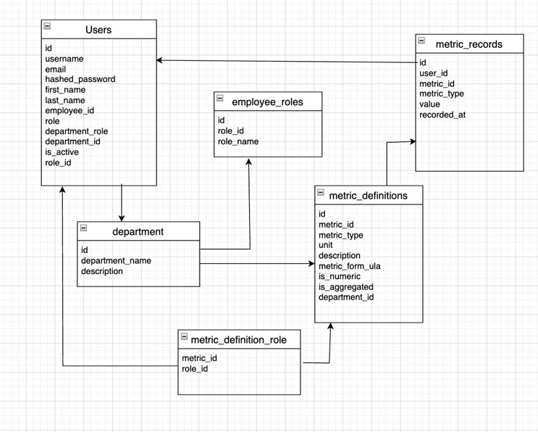

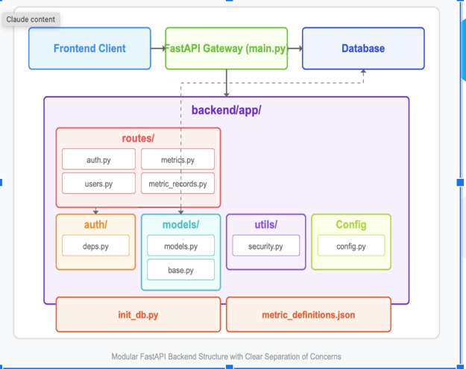

Figure 1: Architecture Diagram

1. *Database Schema*

The database design includes the following core tables:

Figure 2: Database diagram

1. *Implementation Details*

The project structure is organized as follows:

project/

├── backend/

│ ├── app/

│ │ ├── init .py

│ │ ├── models/

│ │ ├── routes/

│ │ ├── services/

│ │ └── utils/

│ ├── tests/

│ ├── config.py

│ ├── requirements.txt

│ └── main.py

├── frontend/

│ ├── public/

│ ├── src/

│ │ ├── components/

│ │ ├── pages/

│ │ ├── services/

│ │ ├── utils/

│ │ ├── App.js

│ │ └── index.js

│ ├── package.json

│ └── README.md

├── database/

│ ├── migrations/

│ └── init.sql

└── docker/

├── docker-compose.yml

├── Dockerfile.backend

└── Dockerfile.frontend

This application was implemented as a full-stack web application using modern technologies to create a comprehensive solution for tracking employee performance and wellness metrics across different departments, with a focus on USPS (mail carriers and office administrators) and healthcare (nurses and front desk administrators).

**Backend Implementation**

The system was built using a FastAPI framework on the backend with SQLAlchemy as the ORM. The key components includes:

User Authentication System: JWT-based authentication with role-based access control (Employee, Supervisor, Admin)

Data Models: Structured schema for departments, users, metric definitions, and metric records with relationships to ensure data integrity

API Endpoints: RESTful API endpoints for user management, metric submission, and data visualization

Role-Based Access: Different API access levels based on user role (employees can only view/submit their own metrics, supervisors can view department-wide data)

**Frontend Implementation**

The frontend was developed using React with Next.js framework to create a responsive and intuitive user interface:

Dashboard Views: Role-specific dashboards for employees and supervisors

Metric Submission Forms: Dynamic forms for submitting performance and wellness data

Data Visualization: Charts and reports for historical data analysis

Responsive Design: Mobile-friendly interface accessible across different devices

1. *AWS EC2 Deployment workflow*

For production deployment, the application is hosted on AWS EC2 instances using the following workflow: Launch an EC2 instance with Ubuntu Server 22.04 LTS as shown in Figure 3. and Assign an Elastic IP for consistent access.

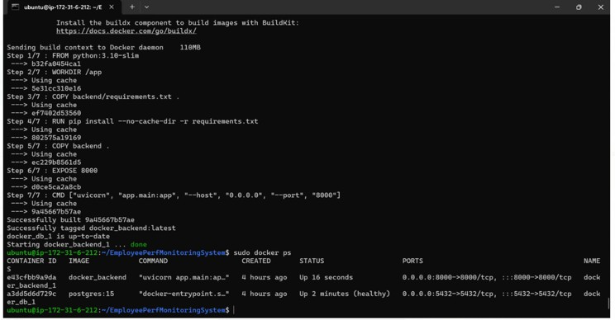

Figure 3: EC2 Instance Running

1. Challenges Faced And Solutions
2. *Data Consistency and Validation*

Different data sources and manual entries created inconsistencies in metric values and formats.

* Implemented a standardized data processing pipeline with validation rules
* Created metric-specific validators (e.g., range checks for stress levels, format validation for text fields)
* Added a data reconciliation process to handle conflicts between multiple data sources
* Integrated historical trend analysis to flag outlier values for review

1. *Department specific requirements*

Each department and role had unique metrics and data sources that required custom implementations. Hence,

* Created an extensible metric definition system allowing department administrators to define custom metrics
* Developed a plugin architecture for integrating with department-specific systems
* Implemented role-based dashboards that display only relevant metrics
* Created a configuration system to map external data sources to internal metric

1. Conclusion And Future Work

While the current system provides robust functionality, several areas for future development have been identified.

* 1. *Manual Data entry*

The initial design required employees to manually enter all performance and wellness metrics daily, creating a significant time burden and reducing compliance. The proposed solution for future work is,

* Implementing automated data ingestion from existing systems where possible
* Creating a scheduled batch processing system to import data from departmental systems
* Developing an API gateway to accept real-time performance data from operational systems
* For metrics that cannot be automatically collected, we implementing a simplified mobile entry form with pre-filled values and quick selection options
* Adding reminder notifications and gamification elements to improve compliance for metrics requiring manual entry
  1. *Real time data processing*

Processing large volumes of data from automated sources is creating heavy performance bottlenecks. The proposed solution for future work is,

* Implementing a message queue system for asynchronous data processing
* Creating a separate microservice for handling data ingestion from external sources
* Optimizing database queries with caching
* Implementing batch processing for historical data analysis
  1. *Advanced Analytics*

• Implementing predictive analytics to forecast performance trends

• Develop anomaly detection to identify potential issues before they impact performance

• Create recommendation systems to suggest wellness improvements based on collected data

* 1. *Enhanced Automation*
* Implement machine learning algorithms to predict missing values when automated data collection fails
* Develop natural language processing for extracting metrics from unstructured data sources (emails, reports)
* Create adaptive scheduling for data collection based on usage patterns
  + Department Variations: Significant differences in wellness patterns across different departments.

1. Conclusion

The Employee Performance Monitoring System is an effective integration of performance monitoring and well- being monitoring in a single solution for modern workplace management. The system has good technical performance and good user feedback, which justifies its design and implementation approach.

Highlights include:

Developing a scalable architecture using next-generation web technologies. Developing a top-level API for performance tracking and well-being tracking. Developing visualization aids that are easy to use for analysis. Establishment of clear relationships between wellness measures and performance metrics. Effective deployment and application in a test environment. Incorporation of wellness factors in performance monitoring is a giant step from the traditional systems that focus on productivity metrics alone. With both sides in mind, organizations can create a healthier workplace without compromising high productivity levels.

1. Future Work

Some of the future development possibilities that have been envisioned are:

* **Machine Learning Integration** Incorporate predictive models to forecast performance trends and potential wellness issues before they happen.
* **Mobile Application**: Develop a companion mobile app for real-time notifications and instant wellness check-ins, enabling features like:
  + Push notifications for checking in on wellness
  + Real-time performance feedback
  + Quick feedback submission
* **Integration with Wearable Devices**: Integrate with fitness trackers and smartwatches to retrieve physiological data for more precise wellness evaluations via new API endpoints:
* **Enhanced Security Measures**: Add enhanced security features for confidential employee information, such as:
  + End-to-end encryption of sensitive information
  + Finer-grained access control
  + Comprehensive audit logging
* **Internationalization**: Increase language support for worldwide organizations via frontend localization and backend API changes to accommodate language preferences.

References

1. G. Eason, B. Noble, and I. N. Sneddon, “On certain integrals of Lipschitz-Hankel type involving products of Bessel functions,” Phil. Trans. Roy. Soc. London, vol. A247, pp. 529–551, April 1955. *(references)*
2. J. Clerk Maxwell, “A Treatise on Electricity and Magnetism”, 3rd ed., vol. 2. Oxford: Clarendon, 1892, pp.68–73.
3. I. S. Jacobs and C. P. Bean, “Fine particles, thin films and exchange anisotropy,” in Magnetism, vol. III, G. T. Rado and H. Suhl, Eds. New York: Academic, 1963, pp. 271–350.
4. V. De Nitto Personè and V. Grassi, "Architectural Issues for Self- Adaptive Service Migration Management in Mobile Edge Computing Scenarios," 2019 IEEE International Conference on Edge Computing (EDGE), Milan, Italy, 2019, pp. 27-29, doi: 10.1109/EDGE.2019.00020.
5. Y. Li and S. Wang, "An Energy-Aware Edge Server Placement Algorithm in Mobile Edge Computing," 2018 IEEE International Conference on Edge Computing (EDGE), San Francisco, CA, USA, 2018, pp. 66-73, doi: 10.1109/EDGE.2018.00016.
6. Y. Yorozu, M. Hirano, K. Oka, and Y. Tagawa, “Electron spectroscopy studies on magneto-optical media and plastic substrate interface,” IEEE Transl. J. Magn. Japan, vol. 2, pp. 740–741, August 1987 [Digests 9th Annual Conf. Magnetics Japan, p. 301, 1982].
7. M. Young, “The Technical Writer’s Handbook.” Mill Valley, CA: University Science, 1989.
8. B. A. F. Esmail, D. Isleifson, S. Koziel and A. Pietrenko-Dabrowska, "Optimized Metamaterials for Design of Enhanced-Performance High Order Mode Dipole-Driven Yagi-Uda Antenna for Millimeter Wave Applications," in IEEE Access, doi: 10.1109/ACCESS.2025.3566985.
9. E. Bandara et al., "Llama-Recipe — Fine-Tuned Meta's Llama LLM, PBOM and NFT Enabled 5G Network-Slice Orchestration and End- to-End Supply-Chain Verification Platform," 2025 IEEE 22nd Consumer Communications & Networking Conference (CCNC), Las Vegas, NV, USA, 2025, pp. 1-6, doi: 10.1109/CCNC54725.2025.10976116.
10. Y. Kunisawa, S. Ito and T. Nagao, "High-Speed Uplink Data Wireless Transmission via a Frequency Conversion Relay Device from the Terahertz to the Millimeter-Wave Toward Beyond 5G Mobile Communication," 2025 IEEE 22nd Consumer Communications & Networking Conference (CCNC), Las Vegas, NV, USA, 2025, pp. 1- 6, doi: 10.1109/CCNC54725.2025.10976146.