Cloud Deployment steps using simple springboot , react and H2 Database by packaging the jar and copying to the ec2 instance. Clone my code from my repo to learn for yourself and a gets hands on experience.
========================================================================
Deploying your backend and database (using H2) in EC2,

- Package your app
Modify application.properties and pom.xml
./mvnw clean package -DskipTests ( I am skipping this, as I am having some issues with maven-fire-pplugin)
You will find this inside target/ demo-0.0.1-SNAPSHOT.jar
- Setting up EC2 instance
Got o amazon aws ec2 instance setup
Choose ubuntu -> x86 -> tier 2
Create key-pair , download and keep it safe (.pem file)
Allow ssh, http, https and you are good to launch now!
You will see something like this,
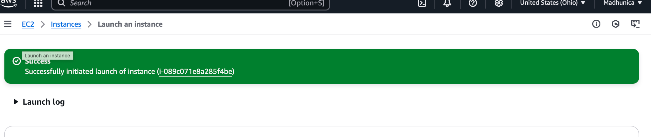

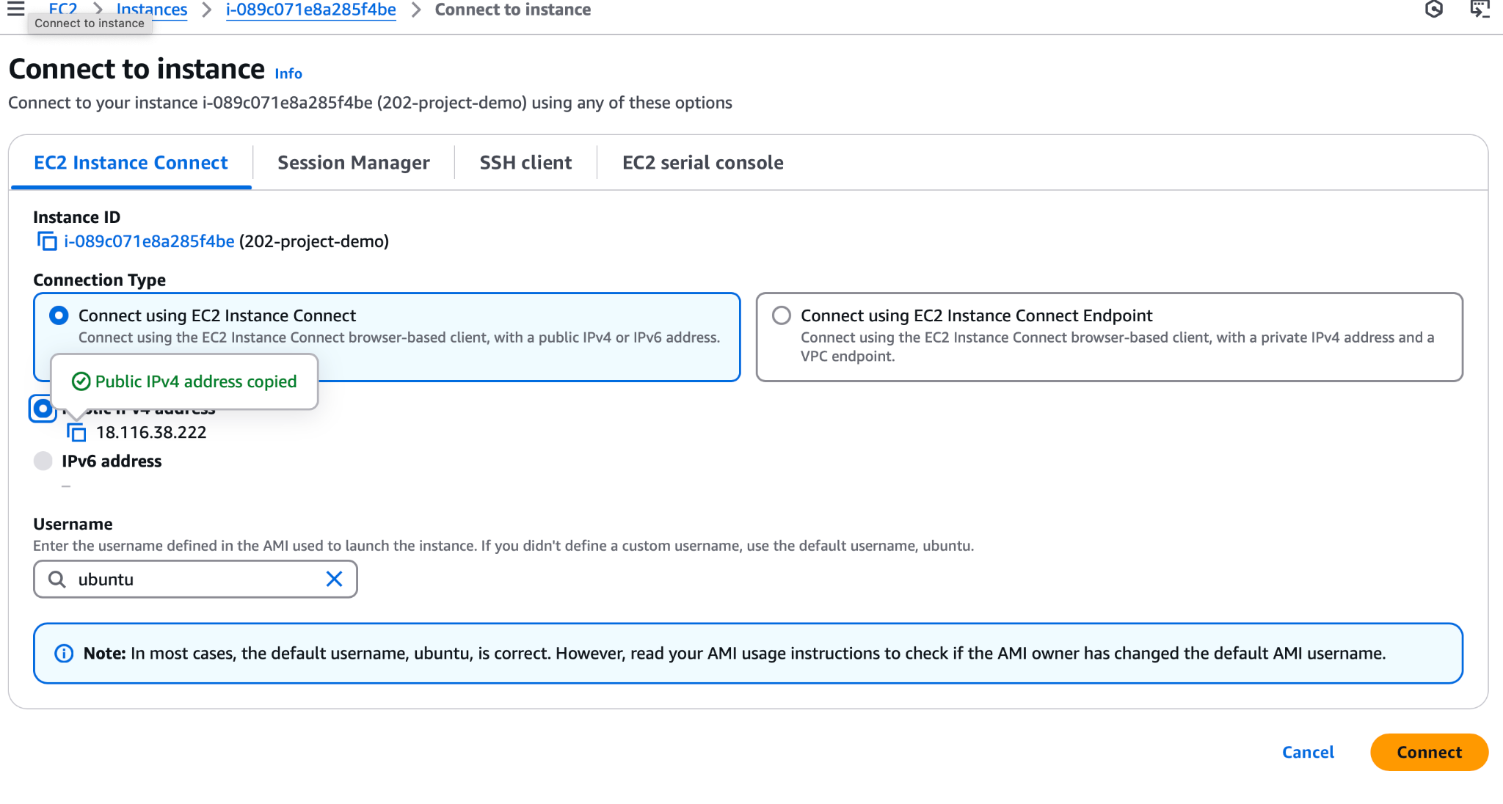
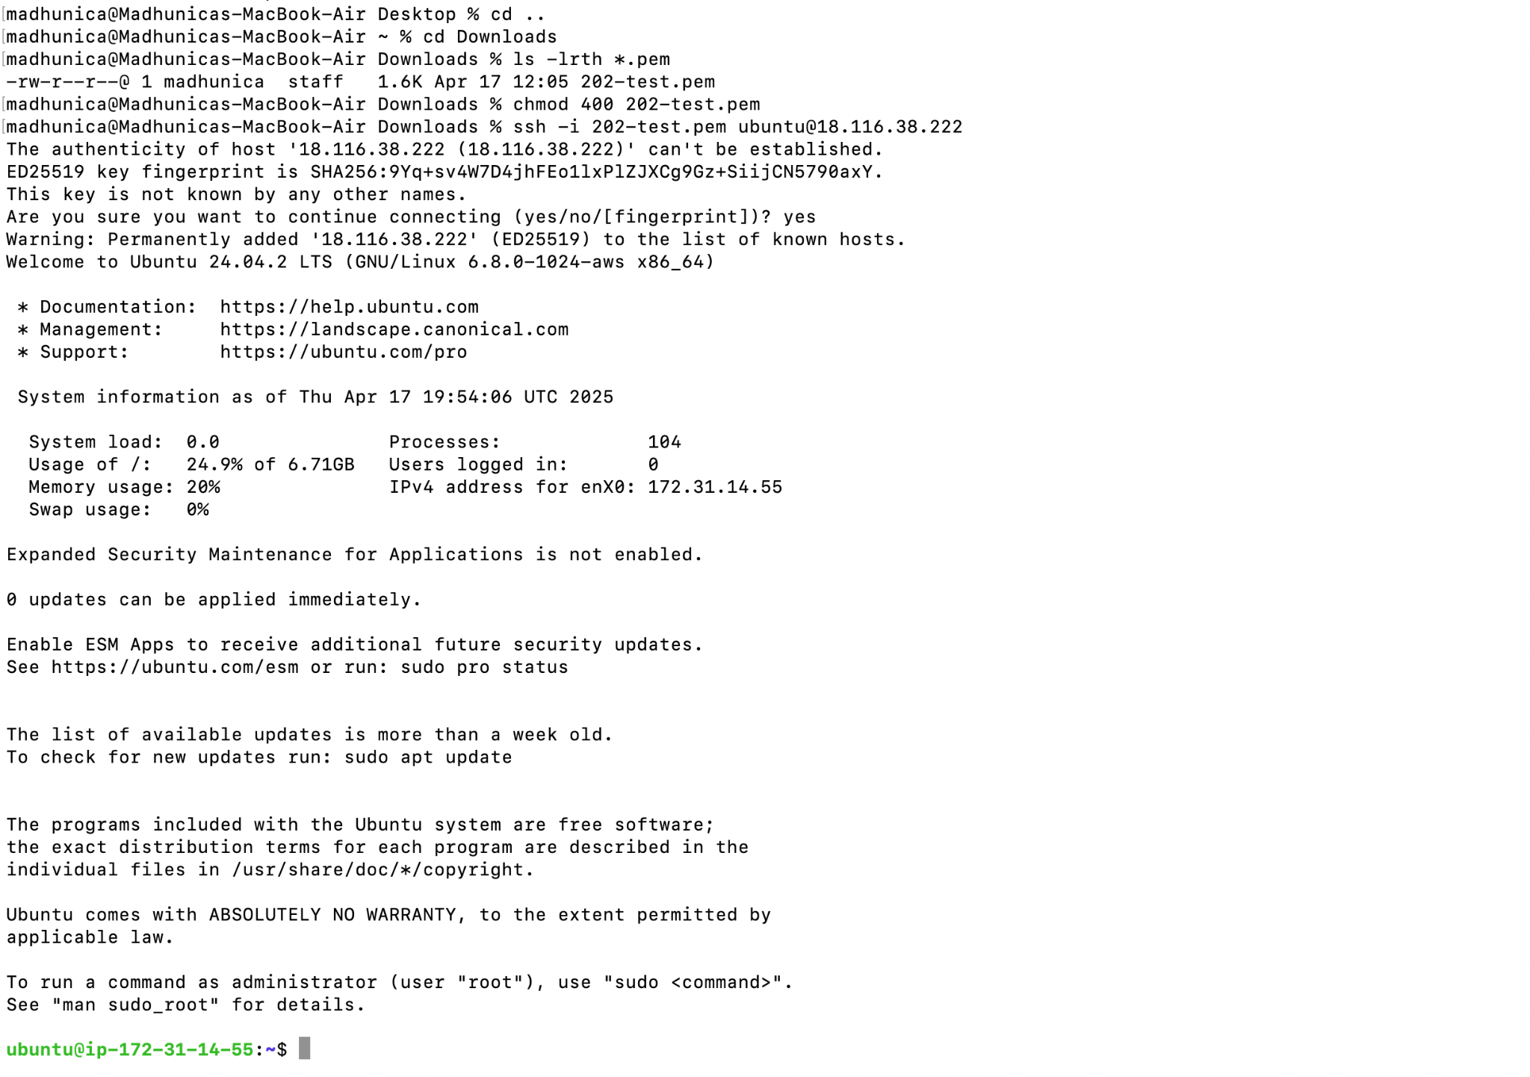
ls -lrth *.pem
-rw-r--r--@ 1 madhunica staff 1.6K Apr 17 12:05 202-test.pem
chmod 400 202-test.pem
ssh -i 202-test.pem ubuntu@18.116.38.222

- Now, you need to install java (version 17) and postgres (f you want to keep your db local) or you can use H2.
sudo apt update
sudo apt install openjdk-17-jdk -y
java -version # confirm it's installed

If you want local, sudo apt install postgresql postgresql-contrib -y

Keep your key in your proj folder location and do this,
scp -i 202-test.pem target/demo-0.0.1-SNAPSHOT.jar ubuntu@18.116.38.222:/home/ubuntu

- NOTE::
This is very slow, in your next attempt try,
Pro Tip (for later): If you deploy frequently, we can:
- Compress the file with gzip before transfer
- Set up Git on the EC2 and pull directly from GitHub
- Or use a file host like S3
5. java -jar demo-0.0.1-SNAPSHOT.jar
ubuntu@ip-172-31-14-55:~$ ls -lrth
total 56M
-rw-r--r-- 1 ubuntu ubuntu 56M Apr 17 20:07 demo-0.0.1-SNAPSHOT.jar
ubuntu@ip-172-31-14-55:~$

6. You should see the jar running via ls cmd
ubuntu@ip-172-31-14-55:~$ ps -ef | grep "java"
ubuntu 3923 1192 1 20:35 pts/0 00:00:15 java -jar demo-0.0.1-SNAPSHOT.jar
ubuntu 4054 4024 0 20:52 pts/1 00:00:00 grep --color=auto java
ubuntu@ip-172-31-14-55:~$

7. Possible Failures and Stalls::
I. Tests doesn’t compile so, give -DSkipTests (this can be debugged later if reqd)
Ii. Setup application.properties properly to use H2 DB instead of locally setting up postgres DB or think if we can stick to postgres DB only.
Iii. If you couldn’t access the H2 console, check the security config and add port 8080 under custom tcp in bound rule and save it.

Alternatively, you can check vai curl command like this madhunica@Madhunicas-MacBook-Air Downloads % curl http://18.116.38.222:8080
madhunica@Madhunicas-MacBook-Air Downloads %

Iv. Sometimes, you need to update this as well on properties if you still can’t reach the ip address.
server.address=0.0.0.0
V. If you still can’t login to H2 console,you have to check the following in your application locally,
Check application.properties for the username you have given.
Check if by any chance, aws e2 is asking you to use auto generated password instead
Tes your jdbc connection to h2 locally using this in browser, localhost:8080/h2-console
And then run clean install and package the jar file.
Scp the same to your ec2 instance and try to access the console using this,
http://18.116.38.222:8080/h2-console/

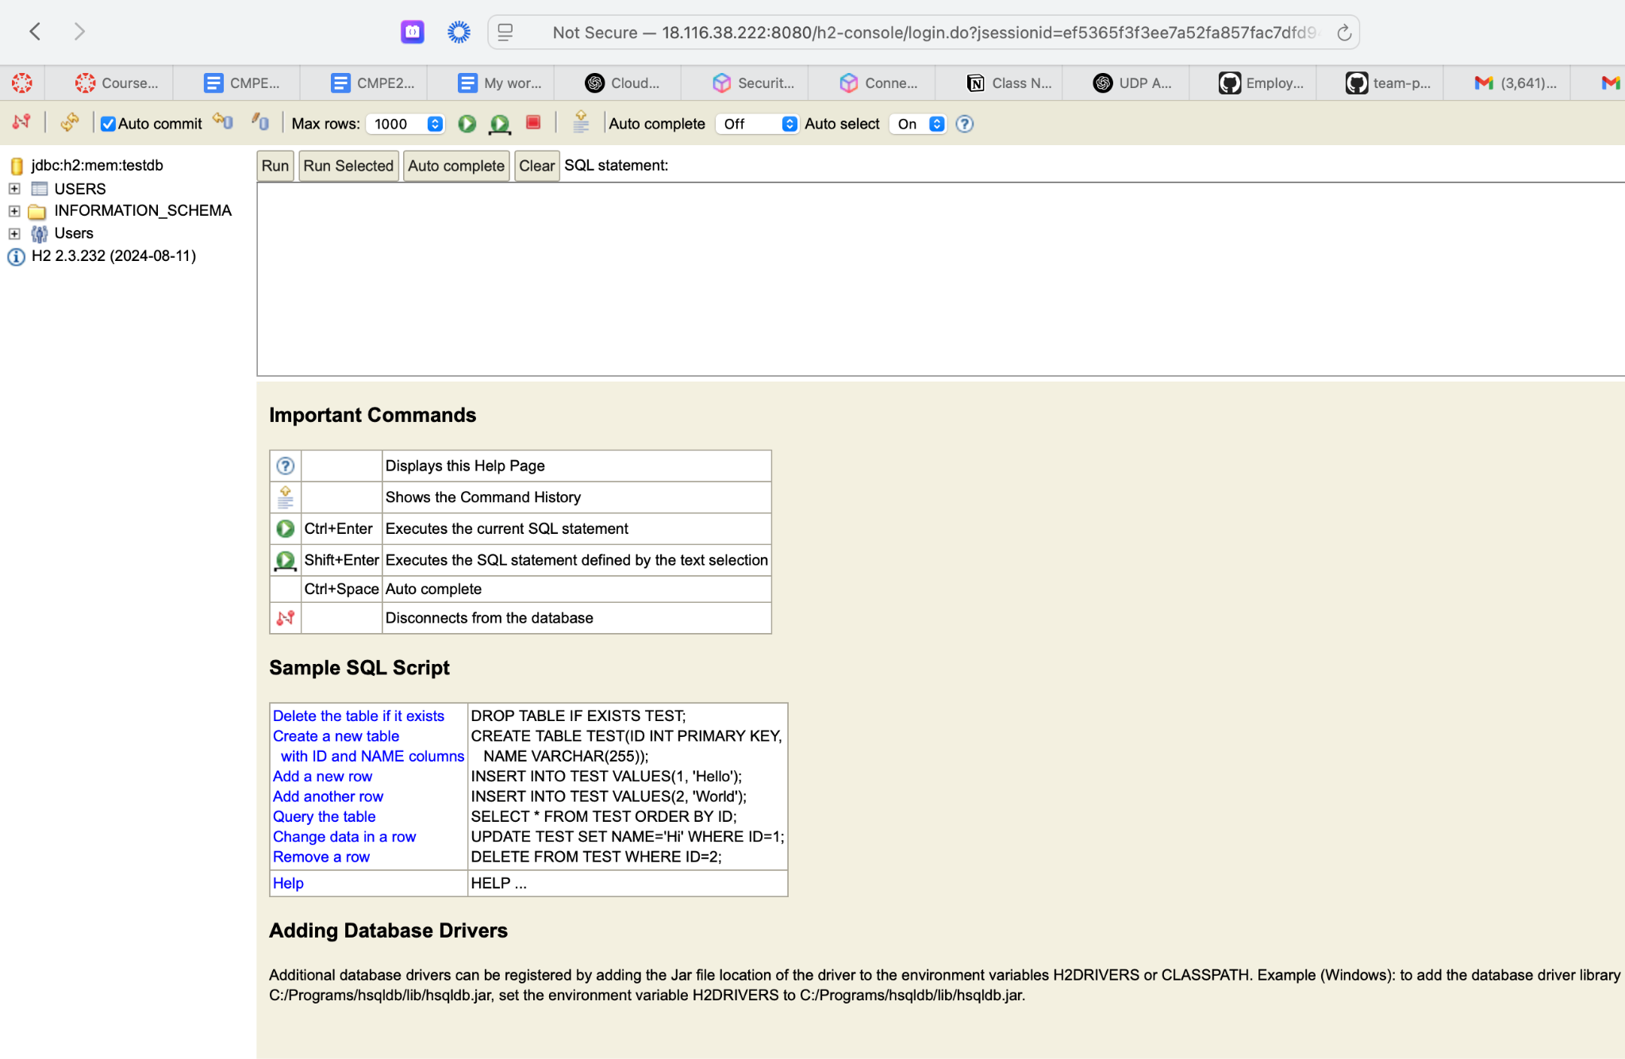
Viewing entries from the created table.
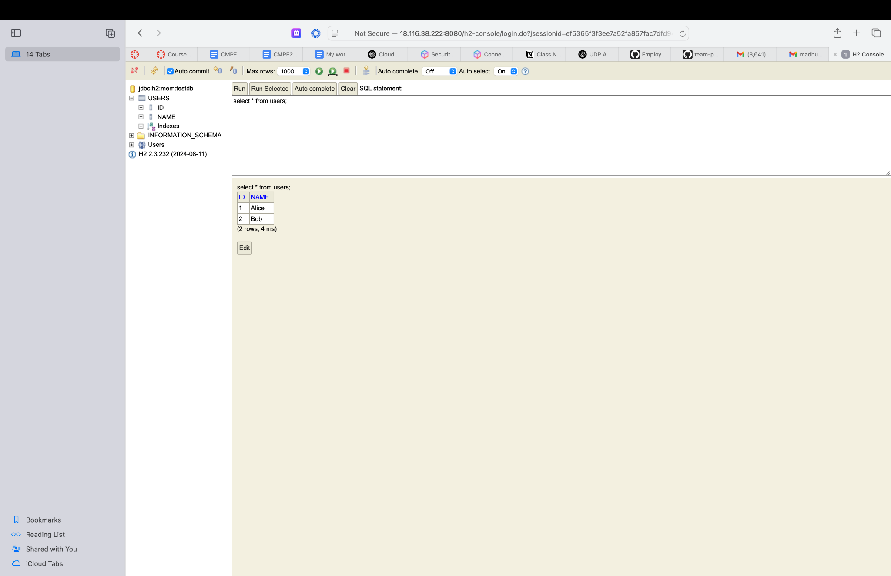
Deploying frontend in the EC2 instance,

- Package the frontend from your local app folder.
Navigate to frontend -> give npm run build
You should be able to see this message,
The build folder is ready to be deployed.
You may serve it with a static server:
npm install -g serve
serve -s build
- Copy the build folder to your ec2 instance,
scp -i 202-test.pem -r build ubuntu@18.116.38.222:/home/ubuntu/react-app
- Install Nginx on EC2
Login to your ec2 console
sudo apt update
sudo apt install nginx -y
- Allow HTTP traffic,
sudo ufw allow 'Nginx HTTP'
- In your code, ensure you have api end point define.
useEffect(() => {
fetch('http://18.116.38.222:8080/api/users')
.then(res => res.json())
.then(data => setUsers(data));
}, []);

- Ensure the api end point is proper in the controller,
// UserController.java
@RestController
@RequestMapping("/api/users")

- Update the sudo vim /etc/nginx/sites-available/default file properly.

- If required, re compile front en d and copy the build dir again.
sudo nginx -t # check for syntax errors
sudo systemctl reload nginx or
sudo systemctl restart nginx
- Chek using curl command first,
curl http://localhost:8080/api/users

- Use browser to access front end -> http://18.116.38.222:8080/api/users
- If you want a welcome page kind of with some URL like
http://18.116.38.222:8080/
You need to have something called a homecontroller that displays some dummy message for you.
