OV Exception - AI Root Cause & Prevention POC
  - Complete Application Guide (Functional + Technical)

OV Exception — AI Root Cause & Prevention POC

Complete Application Guide (Functional + Technical)
Purpose of this document: explain how the application works end-to-end, in plain language, so that anyone can understand it deeply and confidently explain it to a team. No advanced AI knowledge assumed.
Contents
- The Business Problem
- The Big Picture
- Functional Flow (user's perspective)
- Technical Architecture
- The Database
- The Cache
- How the AI Works
- How the APIs Work
- The Recommendations Engine
- A Complete Real-World Example
- Parameter Cheat Sheet
- Honest Caveats for the Demo
- One-Paragraph Version
- Appendix: Running the App

PART 1 — The Business Problem (Why this exists)
In LTL freight, an OV = "Overage" exception means: extra freight showed up that nobody ordered.
A skid arrives at a terminal, and there are 14 cartons when the paperwork says 12. Or a loose box is sitting in a bay with no label. Someone has to figure out whose freight it is and why it ended up there.
Today an OS&D clerk investigates each one by hand, writes free-text notes, and closes it with a 2-letter "clearing code". Nobody ever aggregates the notes. So the company fixes the same 500 problems one at a time, forever, and never learns "Terminal MPS has a labeling problem."
This app reads those notes with an AI, assigns a root cause category, and then tells you what to fix.

PART 2 — The Big Picture (One diagram)
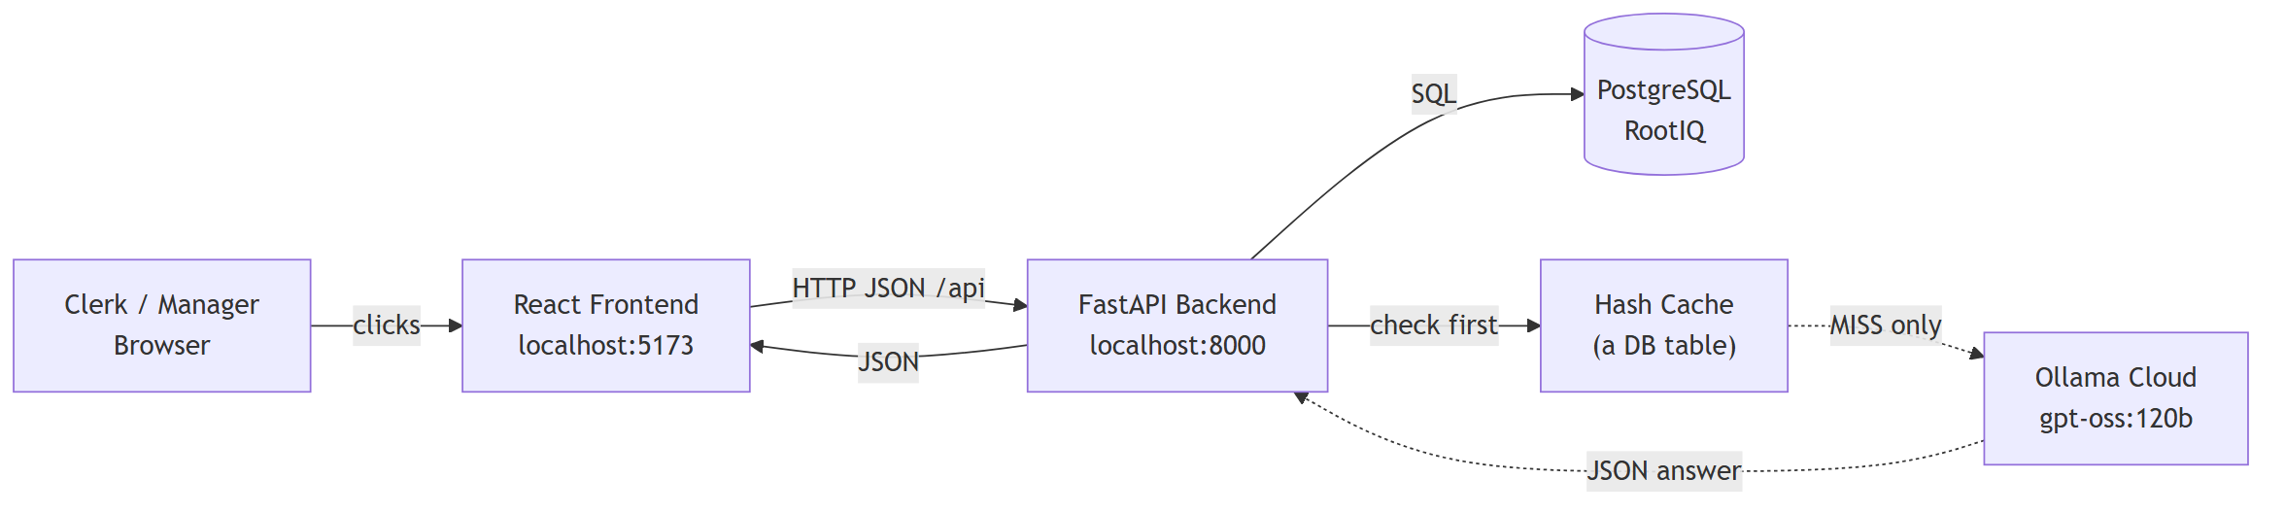
Five parts, that's it:
Part | What it is | Its one job
Frontend | React + Vite | Show screens, collect clicks
Backend | FastAPI (Python) | Rules, orchestration, the "brain stem"
Database | PostgreSQL | Remember everything, forever
Cache | A Postgres table | Stop us paying the AI twice for the same question
AI | Ollama Cloud LLM | Read English notes → return a category
Key insight to tell your team: The AI is not the application. The AI is one function call inside the application, that takes text in and gives a category out. Everything else is ordinary web software.

PART 3 — Functional Flow (What a human actually does)

The 4 screens and the journey
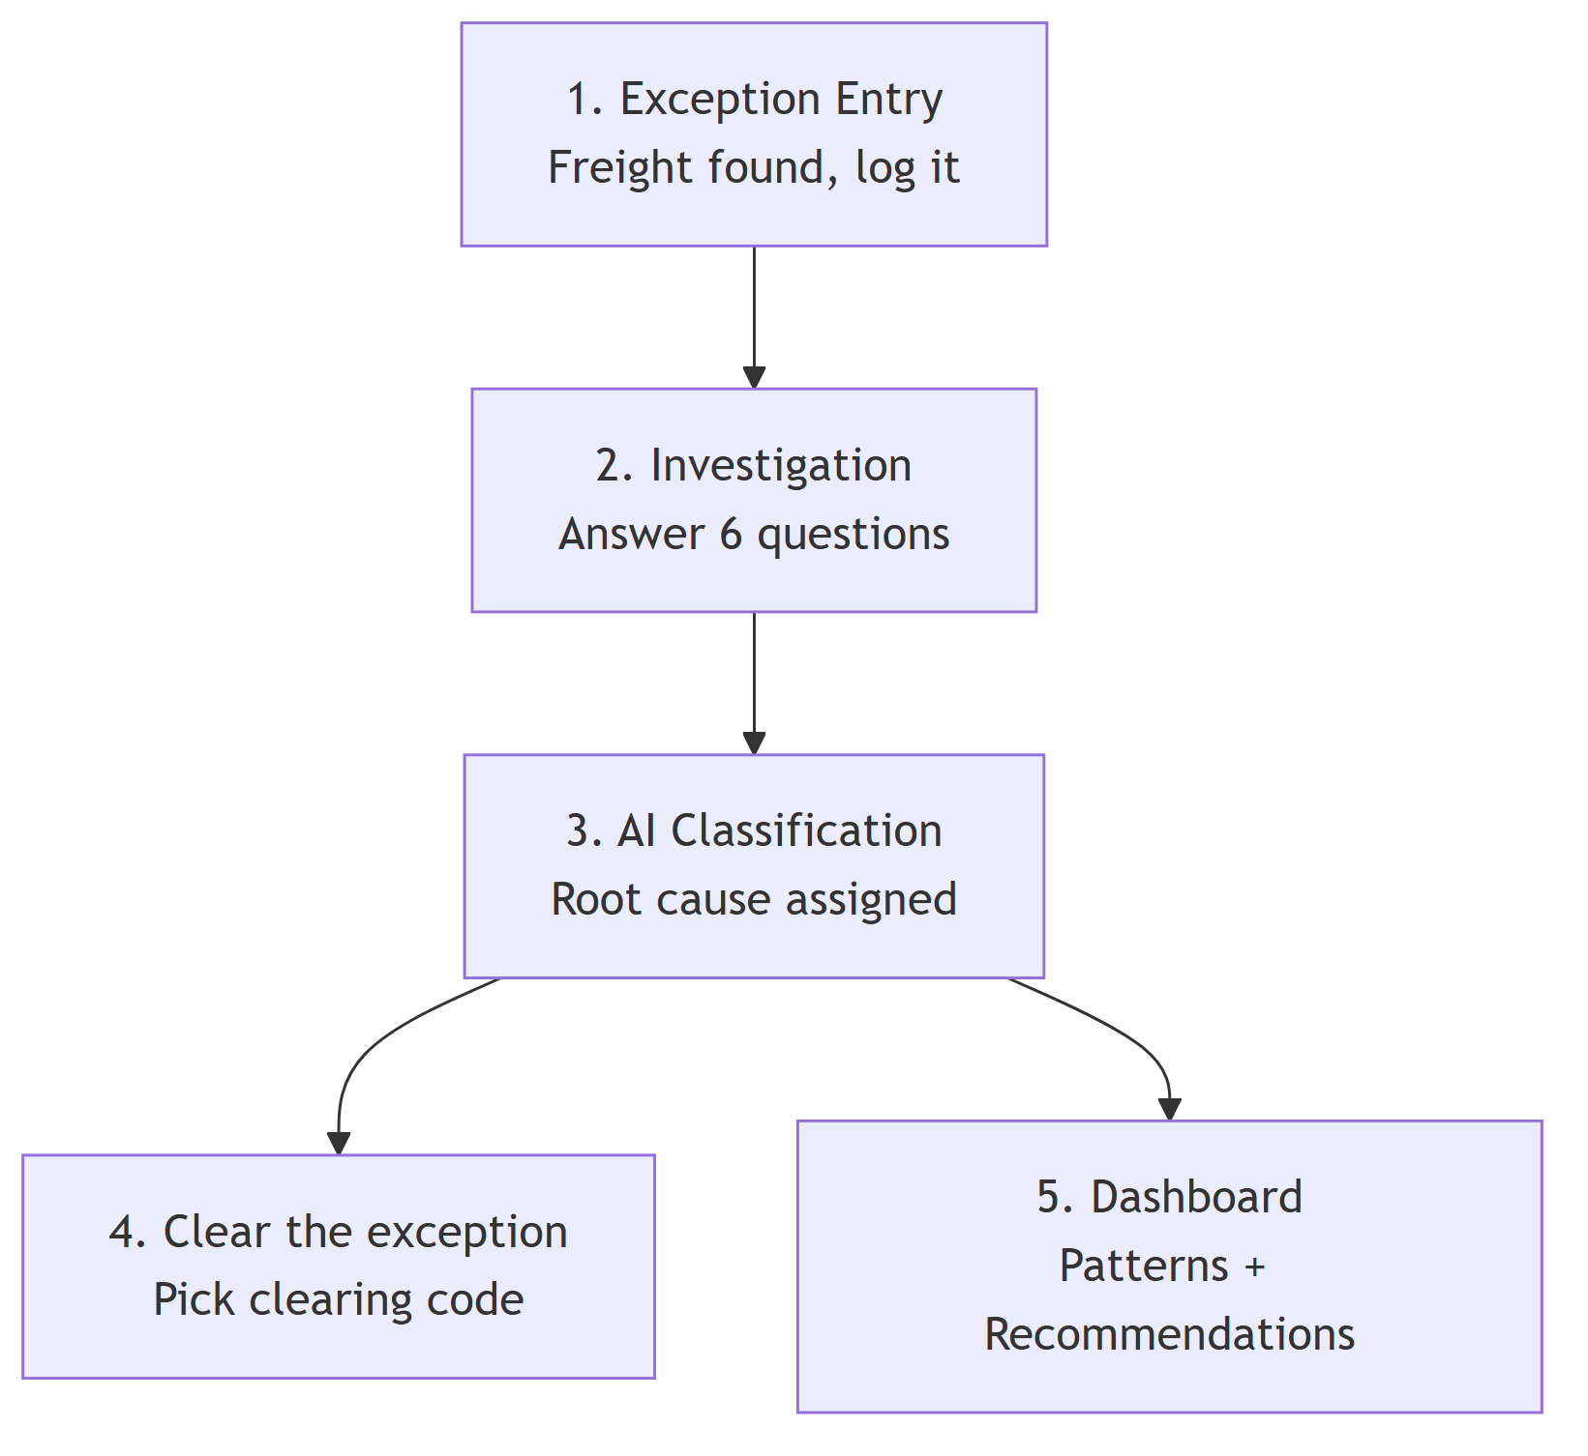

Step 1 — An exception is created
A clerk finds unexpected freight. They record: PRO number, origin/destination terminal, shipper, consignee, where it was found (trailer or bay), pieces, weight, commodity, hazmat flag, value range, and free-text details.
→ Screen: frontend/src/pages/ExceptionsPage.jsx

Step 2 — Investigation (this is where the AI's fuel comes from)
The clerk works through 6 yes/no questions, and — critically — types a sentence explaining each answer. These six come straight from the real AS400 system:
Question key | Shown to the user as
od400Check | Was the OD400 checked?
billOfLadingCheck | Was the bill of lading checked for errors?
drCheck | Was the delivery receipt checked?
psCheck | Was a packing slip found and checked?
consigneeCheck | Was the consignee contacted?
shipmentCheck | Were related shipments checked?
→ Defined in backend/app/questions.py
The backend glues these 6 answers into one paragraph called combined_notes_text. That paragraph is the only thing the AI reads.

Step 3 — Classify
The user clicks "Classify". Two seconds later a card appears:
Missed Scan · confidence 0.90 · AI FRESH "Why?" → Freight moved through checkpoints with no scan recorded at any of them.
If the AI is wrong, the user picks the correct category from a dropdown → this is saved as a human override. Nothing is deleted; it's added as a new row in the history.
→ Screen: frontend/src/pages/ExceptionDetailPage.jsx

Step 4 — Clear it
Pick a clearing code (SV, CG, DA…), exception closes.

Step 5 — The Dashboard (the actual business value)
- A bar chart: which root causes are most common
- 4 tiles: total classified, cache hit rate, AI calls saved, accuracy
- 3–5 AI-written prevention recommendations, each clickable to see the exact exceptions that justify it
→ Screen: frontend/src/pages/DashboardPage.jsx

PART 4 — Technical Architecture (Layer by layer)
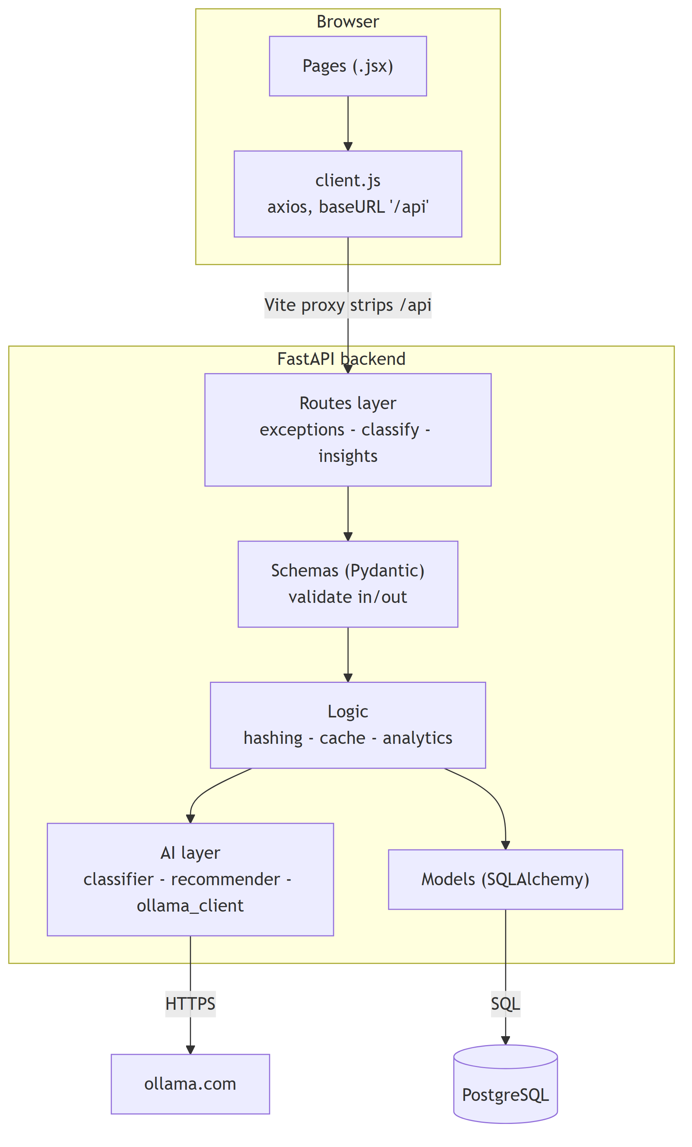

Why the folders are split this way
Folder/file | Responsibility
backend/app/routes/ | HTTP only — URLs, status codes. No business logic.
backend/app/schemas.py | The contract. Validates incoming JSON, shapes outgoing JSON.
backend/app/models.py | The tables. What Postgres physically stores.
backend/app/dedup/ | Hashing + cache. Saves money.
backend/app/ai/ | Everything LLM.
backend/app/analytics.py | pandas aggregation for the dashboard.
The single most important design rule here: all AI network traffic goes through one file — backend/app/ai/ollama_client.py. If you want to swap Ollama for OpenAI or Bedrock tomorrow, you edit that one file and nothing else breaks.

PART 5 — The Database (6 tables)
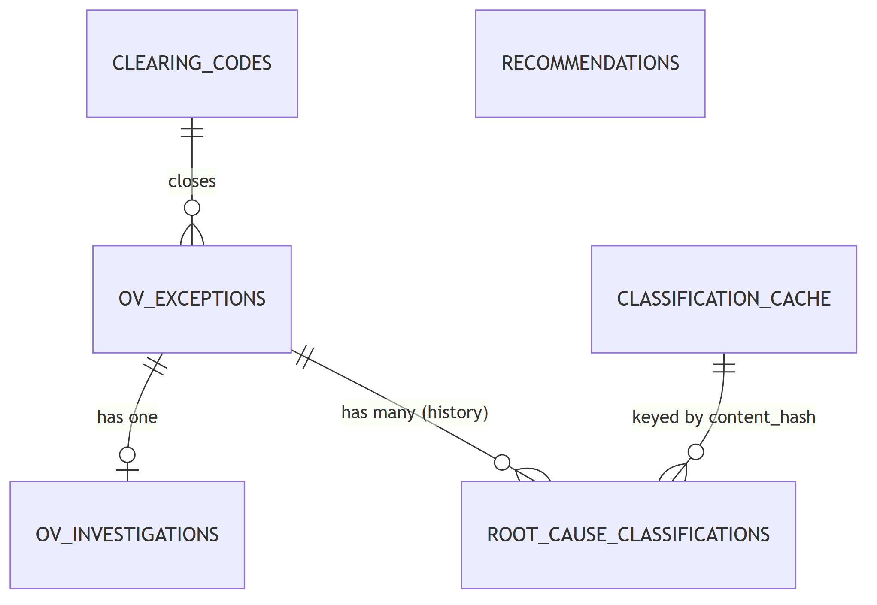
Table | Holds | Note
ov_exceptions | The freight facts + content_hash | 6,580 rows today
ov_investigations | The 6 Q&A steps + combined_notes_text | The AI's input lives here
root_cause_classifications | Append-only audit log | 1 row per classification event
classification_cache | 1 row per unique text + hit_count | This IS the cache
clearing_codes | 15 two-letter codes | Reference data
recommendations | AI prevention advice + evidence IDs

Why TWO classification tables? (Common question)
- classification_cache = "what is the answer to this question?" — one row per unique question, updated in place.
- root_cause_classifications = "who asked, when, and what did they get?" — never updated, only appended.
This is what makes overrides safe and makes cache-hit-rate measurable.

PART 6 — The Cache (the money-saver)
Every AI call costs time (~2–4 seconds) and money. Many exceptions are literally identical — same PRO, same notes (re-entered, re-opened, duplicated by the AS400 feed).

How the fingerprint is made
payload = f"{normalize(pro_number)}|{normalize(combined_notes_text)}"
content_hash = sha256(payload).hexdigest()
→ backend/app/dedup/hashing.py
normalize() = lowercase + trim + collapse repeated spaces. So "No Error" and "no error" produce the same fingerprint.
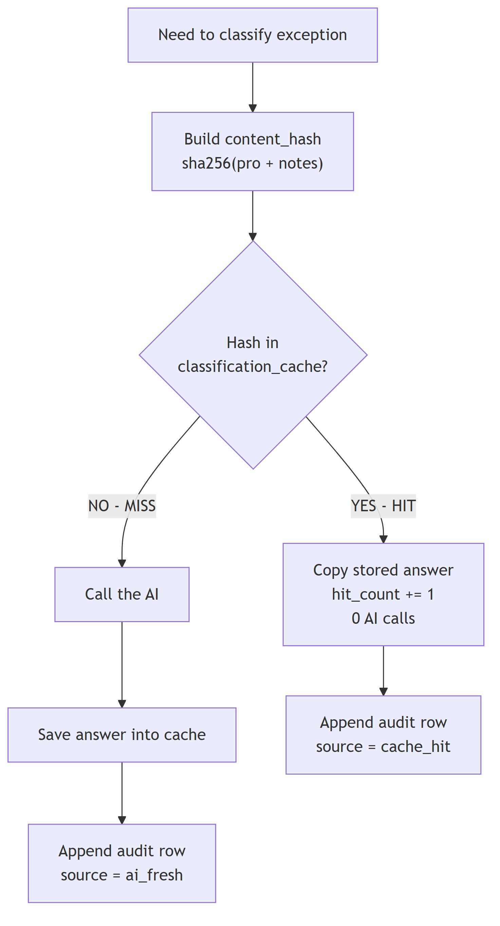
→ Logic in classify_one() at backend/app/routes/classify.py
Two honest limitations to state out loud:
- It's exact-match only. "box was crushed" and "carton was crushed" are different fingerprints. Catching those needs embeddings — that's Phase 2.
- additional_details is sent to the AI but deliberately excluded from the fingerprint, so trivial cosmetic edits don't destroy your cache hit rate.

PART 7 — How the AI Actually Works

7.1 The model and its settings
Parameter | Value | Where defined | Why
OLLAMA_BASE_URL | https://ollama.com | backend/.env | Hosted, no GPU needed locally
OLLAMA_MODEL | gpt-oss:120b | backend/.env | 120-billion-parameter open model
OLLAMA_API_KEY | (secret) | backend/.env | Sent as Authorization: Bearer …
OLLAMA_TIMEOUT_SECONDS | 180 | backend/.env | Big model, be patient
temperature | 0.0 | backend/app/ai/classifier.py | Most important one — see below
format | "json" | backend/app/ai/ollama_client.py | Forces JSON-only output
stream | false | backend/app/ai/ollama_client.py | We want one complete answer
All read into a typed Settings object in backend/app/config.py.
Explaining temperature to a non-AI audience: temperature is the model's "creativity dial", 0 to 1. At 0.9 it's a brainstorming partner — ask twice, get two different answers. At 0.0 it's a calculator — same input always gives the same output. For classification you want a calculator, so we pin it at 0. (The recommender deliberately omits it, so it can be a bit more creative when writing advice.)

7.2 The 12 categories the AI must choose from
The model cannot invent a category. It must return one of exactly these:
Improper Packaging · Missed Scan · Data Entry / Scan Mismatch · Misrouting
Load Swap / Co-mingled Shipment · Handling Damage · Documentation Errors
Shipper Load & Count Discrepancy · Consignee Issue · Carrier Error
Labeling Error · Other
→ backend/app/ai/taxonomy.py
Each one has a written definition, and there are 9 hand-written worked examples ("few-shot examples") that get pasted into every prompt. Showing the model 9 solved examples is dramatically more reliable than just describing the task.

7.3 The exact prompt we send
System prompt (sets the persona):
"You are an LTL freight OS&D analyst. You classify the root cause of OVERAGE (OV) exceptions from investigation notes. You answer only with a single JSON object."
User prompt (assembled fresh each time):
Classify the root cause of this overage (OV) freight exception.
ALLOWED CATEGORIES (use the exact string, nothing else):
- Improper Packaging: Packaging failed or came apart in transit...
- Missed Scan: Freight was never scanned at a checkpoint where it should have been.
... [all 12 with definitions] ...
EXAMPLES:
... [9 worked examples: notes -> JSON answer] ...
Rules:
- "category" MUST be exactly one of the allowed category strings above.
- "confidence" is a float between 0 and 1.
- "reasoning" is one or two sentences citing the evidence in the notes.
- If the notes are too thin to determine a cause, use "Other" with a low confidence.
INVESTIGATION NOTES:
<<< the clerk's 6 answers go here >>>
JSON:
→ build_prompt() in backend/app/ai/classifier.py

7.4 What comes back
{
"category": "Missed Scan",
"confidence": 0.9,
"reasoning": "Freight moved through checkpoints with no scan recorded at any of them."
}

7.5 The safety ladder (what happens when AI misbehaves)
LLMs sometimes wrap JSON in markdown fences, add chatty preamble, or invent a category. We never let that crash the app:
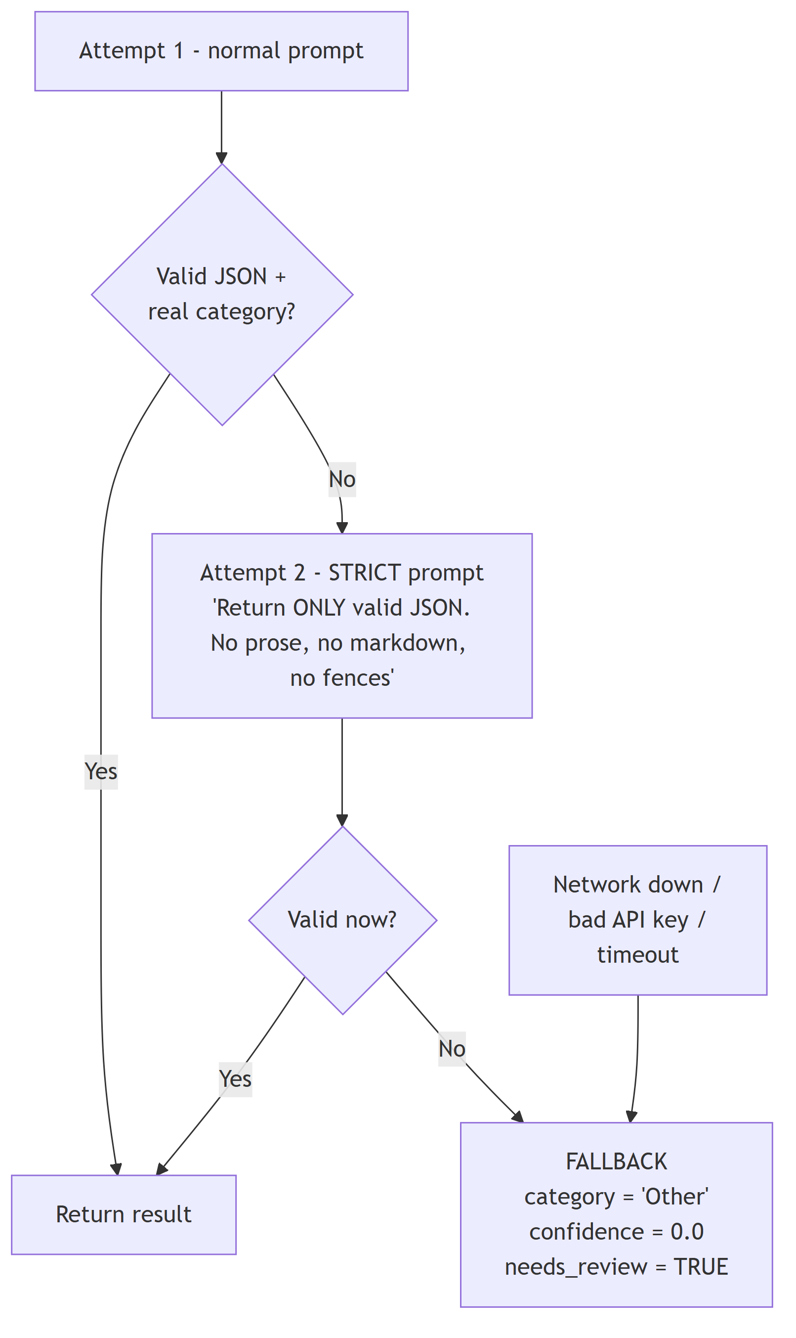
Notice it also digs JSON out of surrounding text with a regex before giving up. And if the whole AI service is offline, every record simply comes back as Other + needs_review — the app never crashes, it just degrades.

PART 8 — How the APIs Work

8.1 The connection chain
The frontend never hardcodes localhost:8000. It calls /api/..., and Vite's dev proxy rewrites it:
Browser -> GET /api/ov-exceptions
Vite -> strips "/api" -> GET http://localhost:8000/ov-exceptions
FastAPI -> matches route -> returns JSON
CORS is controlled by CORS_ORIGINS=http://localhost:5173 in .env → applied in backend/app/main.py.

8.2 Full endpoint list
Method | Endpoint | Purpose
GET | /health | Is DB + Ollama alive?
GET | /investigation-questions | The 6 questions for the form
GET | /clearing-codes | The 15 closing codes
POST | /ov-exceptions | Create an exception
GET | /ov-exceptions | List, filtered + paged
GET | /ov-exceptions/{id} | Full detail
POST | /ov-exceptions/{id}/investigation | Save the 6 answers
POST | /ov-exceptions/{id}/clear | Close it
GET | /classify/taxonomy | The 12 categories
POST | /classify/{id} | Classify one
POST | /classify/batch | Classify many (?limit=, ?force=)
GET | /classify/{id}/history | Full audit trail
POST | /classify/{id}/override | Human correction
GET | /insights/distribution | Chart data
GET | /insights/cache-stats | Hit rate, calls saved
GET | /insights/accuracy | vs. hand-labeled set
GET | /insights/filters | Dropdown options
POST | /insights/recommendations/generate | Ask AI for advice
GET | /insights/recommendations | Read saved advice
GET | /insights/recommendations/{id}/evidence | Proof behind advice
FastAPI auto-generates live docs at http://localhost:8000/docs — great for demos.

8.3 A request traced end to end
POST /classify/3f2a…
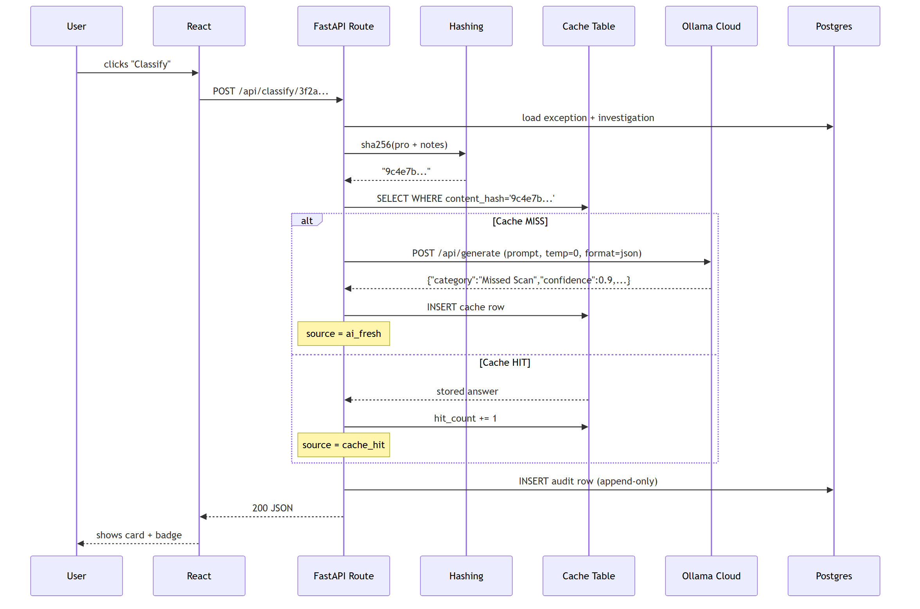
Response the frontend receives:
{
"id": "b81f...",
"ov_exception_id": "3f2a...",
"category": "Missed Scan",
"confidence": 0.9,
"reasoning": "Freight moved through checkpoints with no scan recorded at any of them.",
"model_used": "ollama:gpt-oss:120b",
"source": "ai_fresh",
"needs_review": false,
"classified_at": "2026-09-16T10:22:41Z"
}
The source field is what draws the green AI FRESH vs blue CACHE HIT badge in the UI.

PART 9 — The Second AI Feature: Recommendations
This one is different, and the difference matters.
Classification reads ONE exception's text. Recommendations read NO text at all — only numbers.
We send the model a statistics report, like:
Scope: terminal=all, commodity=all, window=last 90 days
Total classified OV exceptions: 80
Root cause distribution:
- Missed Scan: 18 (22.5%)
- Improper Packaging: 12 (15.0%)
Category by origin terminal:
- origin_terminal=MPS, category=Labeling Error -> 9
And ask for actions "a terminal manager could act on this week."
Each saved recommendation stores supporting_exception_ids — the actual exception IDs behind it. That's what makes the dashboard's "show me the proof" click-through work, and it's what stops this being an AI that just makes things up.
→ backend/app/ai/recommender.py + backend/app/analytics.py

PART 10 — A Complete Real-World Example
Real record from the imported data — OSD #907082312:
① Freight arrives: PRO 12035975310, MPS → ACA, cosmetics/toilet preparations, found in a bay.
② Clerk investigates — answers the 6 questions:
Question | Y/N | What they typed
OD400 checked? | N | "created by OSD"
BOL checked? | Y | "no error"
Delivery receipt checked? | Y | "it was signed cleared but the pc do not match"
Packing slip found? | N | "no packing list was found"
Consignee contacted? | Y | "yes reached out by email … no response"
Related shipments checked? | Y | "all shipments were delivered clear"
③ Backend builds combined_notes_text:
Was the OD400 checked? [N] created by OSD
Was the bill of lading checked for errors? [Y] no error
Was the delivery receipt checked? [Y] it was signed cleared but the pc do not match
Was a packing slip found and checked? [N] no packing list was found
Was the consignee contacted? [Y] yes reached out by email ... no response
Were related shipments checked? [Y] all shipments were delivered clear
④ Fingerprint: sha256("12035975310|was the od400 checked? [n] created by osd…") → a7f3…
⑤ Cache lookup: not found → MISS.
⑥ AI call: prompt (12 categories + 9 examples + those notes) → gpt-oss:120b at temperature 0.
⑦ AI returns:
{"category": "Shipper Load & Count Discrepancy", "confidence": 0.85,
"reasoning": "The delivery receipt was signed clear but the piece count does not match, and no packing slip was present to reconcile."}
⑧ Saved twice: cache row a7f3… (so the next identical record is free) + audit row (source = ai_fresh).
⑨ User sees the card. Agrees. Clears it with code CG.
⑩ On the dashboard, this joins 40 other count-mismatch cases and the AI writes:
"Require a piece-count verification scan at MPS outbound before sealing for ACA — 41 overages in 90 days trace to count discrepancies signed clear at delivery."
⑪ Later, a duplicate arrives with the same PRO and same notes → fingerprint a7f3… → CACHE HIT → answer returned in ~5 milliseconds, zero AI cost.

PART 11 — Parameter Cheat Sheet

Environment (backend/.env — never committed)
Variable | Purpose
DATABASE_URL | Which Postgres to use
OLLAMA_BASE_URL | Where the AI lives
OLLAMA_MODEL | Which brain to use
OLLAMA_API_KEY | Authentication
OLLAMA_TIMEOUT_SECONDS | How long before giving up
CORS_ORIGINS | Which website may call the API

In code
Parameter | Value | File
temperature | 0.0 | backend/app/ai/classifier.py
format | "json" | backend/app/ai/ollama_client.py
ROOT_CAUSE_TAXONOMY | 12 categories | backend/app/ai/taxonomy.py
FEW_SHOT_EXAMPLES | 9 examples | backend/app/ai/taxonomy.py
INVESTIGATION_QUESTIONS | 6 AS400 checks | backend/app/questions.py
limit (batch) | default 200, max 1000 | backend/app/routes/classify.py
days (insights) | default 90 | backend/app/analytics.py

Key response fields
Field | Meaning
source | ai_fresh / cache_hit / human_override
needs_review | true = AI failed, a human must look
confidence | 0–1, the model's own certainty
model_used | e.g. ollama:gpt-oss:120b or human:jdoe
content_hash | The dedup fingerprint

PART 12 — Things to Say Honestly When You Present
These will come up, and having the answer ready is what makes the demo credible:
- "The 100% accuracy number is on synthetic data." It came from 25 hand-written templates, which are far cleaner than real analyst prose. Don't quote it externally. The real accuracy number has to come from hand-labeling real records.
- Dedup is exact-match only. Reworded duplicates won't hit. Semantic dedup via embeddings is Phase 2.
- Only 3,380 of the 6,500 real records have investigation text. The other ~3,120 have nothing for the AI to read and will correctly return Other. Classify the subset.
- The AI never decides anything final. Humans can override, and every override is preserved as history.
- The real export contains genuine PII — real consignee names and personal email addresses inside the notes — and classification transmits that text to ollama.com. Clear this with data governance before any bulk classification run. This is the one item on the list that is a blocker, not a caveat.

One-Paragraph Version (for a hallway explanation)
"Clerks investigate overage freight and type notes. Our app hashes those notes into a fingerprint and checks a cache table. If we've seen identical notes before, we reuse the answer for free. If not, we send the notes to a 120-billion-parameter language model with a fixed list of 12 root causes and 9 worked examples, at temperature zero so it behaves like a calculator, and it returns JSON with a category, a confidence and a one-line reason. We store that as an append-only audit record so humans can override it without losing history. Then we aggregate all the classifications with pandas, send the statistics back to the AI, and it writes 3–5 specific prevention actions — each one linked to the exact exceptions that prove it. Net effect: instead of fixing 6,500 problems one at a time, you fix the 5 causes behind them."

Appendix — Running the App

Backend
cd backend
.venv/Scripts/python.exe -m uvicorn app.main:app --reload --port 8000

Frontend
cd frontend
npm run dev # http://localhost:5173

Import the real data
cd backend
python -m app.seed.import_mock --dry-run # map + count, writes nothing
python -m app.seed.import_mock # full 6,500-record load
python -m app.seed.import_mock --with-notes-only # only rows with investigation text
python -m app.seed.import_mock --limit 300 # small demo slice

Generate synthetic demo data instead
python -m app.seed.seed_data --count 80 --duplicates 8 --labeled 26 --reset

Tests
cd backend && .venv/Scripts/python.exe -m pytest -q # 24 tests

Health check
curl http://localhost:8000/health
Expected:
{"status":"ok","database":"127.0.0.1:5432/RootIQ","ollama":{"available":true,"model":"gpt-oss:120b","model_pulled":true}}

