T P MADHU PRAKASH
1NT19IS176
ISE - C2

Execrcise-1: Mongo DB
Use The mongo dB database to Exercise NOSQL Queries to Demonstrate the following with an
USECASE

1) Create database:

MongoDB use DATABASE_NAME is used to create database.

> use madhu
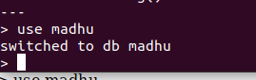

2) Basic CRUD operations
Creating a collection in the database:
db.createCollection('details')
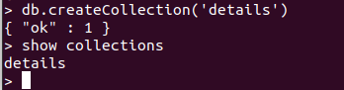

Crud: Create
---->Insert one
> db.details.insertOne(
{
"name": "madhu",
"dept": "ISE"
})

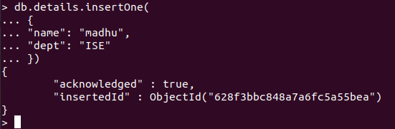

------>Insert Many

db.details.insertMany(
[
{"name": "Akash" , "dept":"ISE" },
{"name" : "Ullaas" , "dept" : "CSE"},
]
)

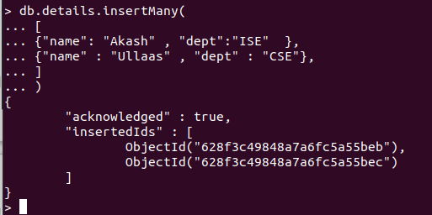

cRud : Read

db.details.find()

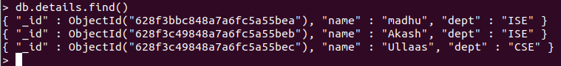
db.details.find().pretty()

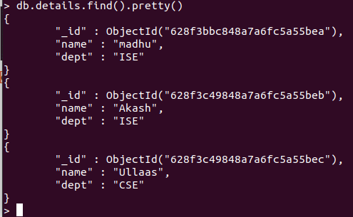

crUd : Update

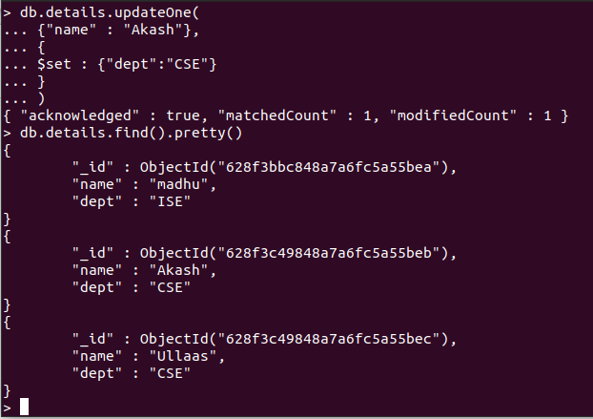

------> Update One

db.details.updateOne(
{"name" : "Akash"},
{
$set : {"dept":"CSE"}
}
)

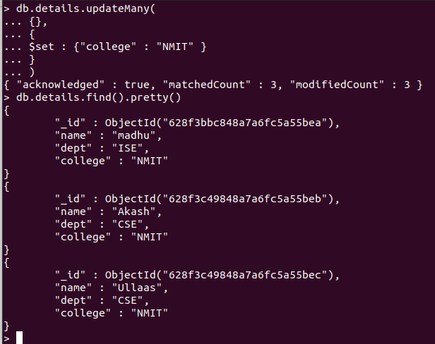

----->Update Many

db.details.updateMany(
{},
{
$set : {"college" : "NMIT" }
}
)

-----> Using unset
db.details.updateOne(
{"name" : "madhu"},
{ $unset : { "dept" : ""}})

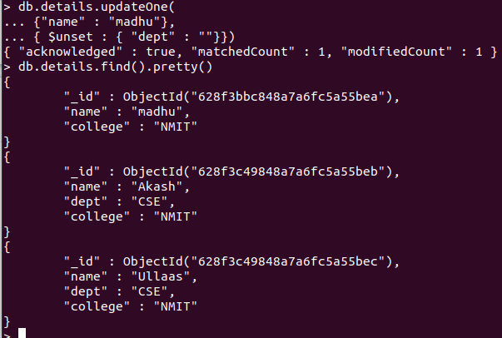

cruD : Delete

db.details.deleteOne( { "name": "Ullaas"} )
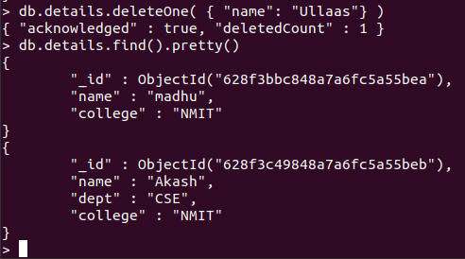

3 & 4) Aggregation and Pipeline

----- adding more data to perform aggreate functions-----
db.details.insertOne(
{
"name": "vinayak",
"dept": "CSE",
"college" : "NMIT",
"age" : 20,
})

db.details.insertOne(
{
"name": "ullaas",
"dept": "ISE",
"college" : "NMIT",
"age" : 20
})

db.details.updateOne(
{"name" : "Akash"},
{
$set : {"age":19}
}
)

db.details.updateOne(
{"name" : "madhu"},
{
$set : {"age":21},
$set : {"dept":"ISE"}
}
)

------------------------------------------------------------------------------------
AND
Using AND operator to display details of students with age greater 18 than and Department : ISE

db.details.find({$and:[{age:{$gte:20}},{dept:"ISE"}]}).pretty();
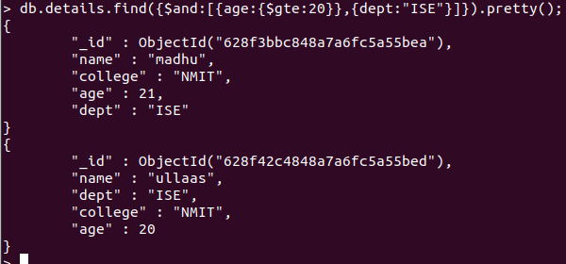

OR
Using OR operator to display details of students with age greater 20 than or Department :CSE

db.details.find({$or:[{age:{$gt:20}},{dept:"CSE"}]}).pretty();

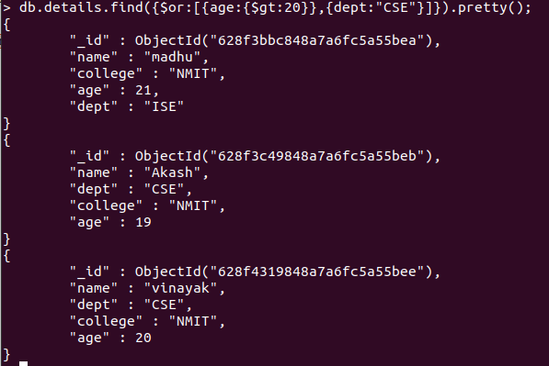

Displaying the total number of students in both the Departments and maximum age from both Departments

db.details.aggregate([{$group: {_id:"$dept", total_st: {$sum:1}, max_age:{$max:"$age"} } }])

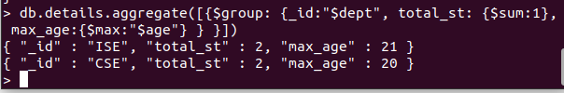

Displaying details of a student having the largest age in the Department – ISE

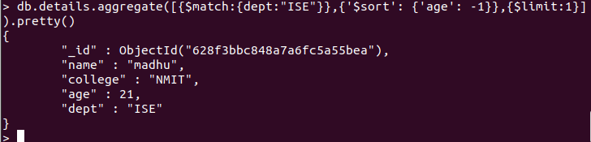
db.details.aggregate([{$match:{dept:"ISE"}},{'$sort': {'age': -1}},{$limit:1}]).pretty()
5) MapReduce

AVERAGE:
var map=function(){emit(this.dept,this.age)};
var reduce=function(dept,age){return Array.avg(age);};
db.details.mapReduce(map,reduce,{out:"newcollection"});
db.newcollection.find()
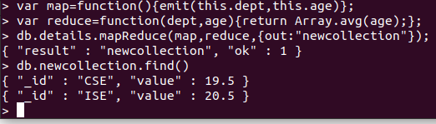

SUM:
var map=function(){emit(this.dept,this.age)};
var reduce=function(dept,age){return Array.sum(age);};
db.details.mapReduce(map,reduce,{out:"newcollection"});
db.newcollection.find()

