Guidelines for preparation of the full paper (Title)

First A. Author¹*, Second B. Author², Third C. Author^{2,3}

¹Affiliation (institution only, see example)
² Department of Chemistry, Indian Institute of Technology Madras, Chennai 600036, India
³Department of Mechanical and Aerospace Engineering, Indian Institute of Technology Hyderabad, Hyderabad 502285, India
*Corresponding author: e-mail: xxx@xxx.xxx

Keywords: (Example) Gas turbine propulsion, Rocket propulsion, High-speed propulsion ramjet/scramjet, other propulsion concepts, Flame velocity, Rich and lean burning, Rocket Propellant parameters

Abstract: Authors are invited to submit a 4- 6 page full-length paper electronically on or before 30th September 2026. The full paper should contain the main concepts of the work, results and conclusions in detail.

1. INTRODUCTION
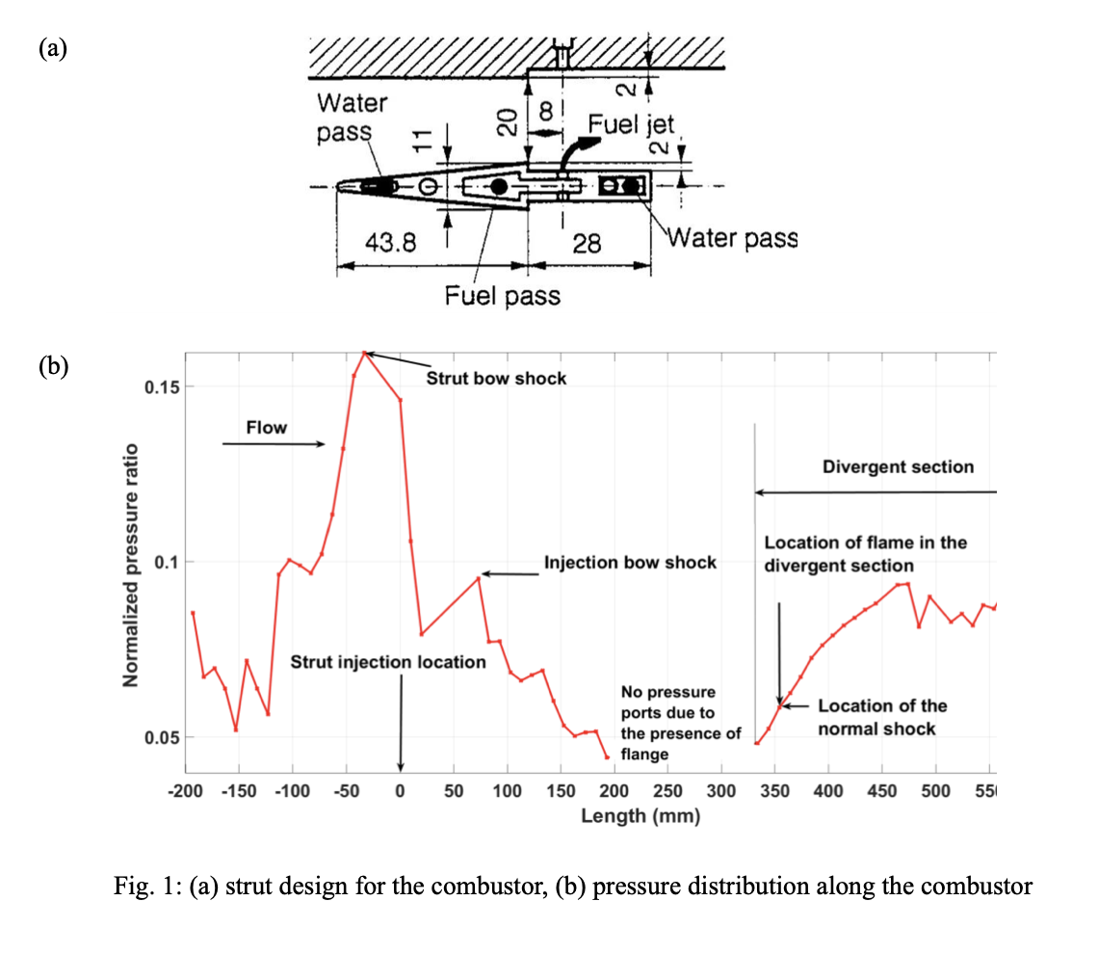
The paper must be written in English following the format provided below in the two-column format. Times New Roman font 11 pt. must be used, except for the title (12 pt.), affiliations and references (9 pt.). The text width is 150 mm and should be within only 4-6 pages including all text. The file must be submitted only in doc/pdf formats, and other formats are not accepted. Figure/picture [Fig. 1] or table [Table 1], if any, should be centered and located inside paper margins. Text should not wrap around figures or tables. Table captions (10-point font) should be centered above tables, and figure captions (10-point font) should be centered below figures. The text in the figures must be clear and of sufficient font size for clear visibility and easy reading.
Fig 1. (a) Strut design for the combustor, (b) Pressure distribution along the combustor
Brieﬂy discuss in this section the rationale for the work carried out with proper literature review and references, the motivation, and objectives.

2. METHODOLOGY USED - EXPERIMENTAL / NUMERICAL / ANALYTICAL
Discuss in this section the methodology adopted for carrying out the work done.
(Picture Example)

3. RESULTS AND DISCUSSION
Discuss the outcomes of the work with relevant plots, ﬁgures and discussions. Ensure the fonts in the plots are clear enough to read. Ensure that the axes in the plots are correctly labelled. Ensure all the figures are appropriately captioned. Ensure that the markings in figures, if any, are clearly visible to the reader. The ﬁgures and plots caption is in Times New Roman 11pt, justiﬁed, and single-spaced.

4. CONCLUSIONS

Concluding remarks of the work presented in the paper.

ACKNOWLEDGEMENTS
Details of the funding agency/grant, if any, must be in Times New Roman font 11pt size.

REFERENCES
- A. B. Author, C. D. Author, Journal Title 1, 37–42 (2013).
- A. B. Author, C. D. Author, E. F. Author, Book Title (Publisher, City, 2012), 135–142.
- A. B. Author, Proc. of the ... Conference... (Publisher, City, 2014), 45–52.
- A. B. Author, Thesis Title (Ph.D. thesis, A University, 1998).

