SLE-2: Profiling Report

PRN: 25UAM116
Name: Madhur Pravin Bhandari
Division: B
Date: 21 September 2026
GitHub Link : https://github.com/madhur-184/IAI-SLE

1. Algorithms / Versions Profiled
- Algorithm A: Breadth-First Search (BFS)
- Algorithm B: Depth-First Search (DFS), depth-limited to 30
- Problem used: 8-Puzzle (3×3 sliding tile puzzle)

2. Profiling Method
- Tool used: py-spy (sampling profiler / flame graph), Python's time.perf_counter for exact per-run timing, and a manual node counter
How I measured it:
- First I wrote get_neighbors() to generate the valid blank-tile moves, then implemented bfs() and dfs(), both returning (path_length, nodes_expanded) so I could compare them on equal footing.
- To get the flame graph, I ran the driver script under py-spy record at 100 samples/sec. This shows where the program is actually spending its time (Fig. 2).
- For the actual timing numbers, I used time.perf_counter() instead, since py-spy's sampling isn't precise enough for very fast function calls. I timed each algorithm on 3 puzzles of increasing difficulty — 4, 12 and 22 moves away from the goal — to get a feel for best, average and worst case behaviour.
- Nodes expanded = number of states popped off the frontier, counted directly inside each function.
Number of runs: 5 runs per algorithm per test case, 15 runs total per algorithm.

3. Results
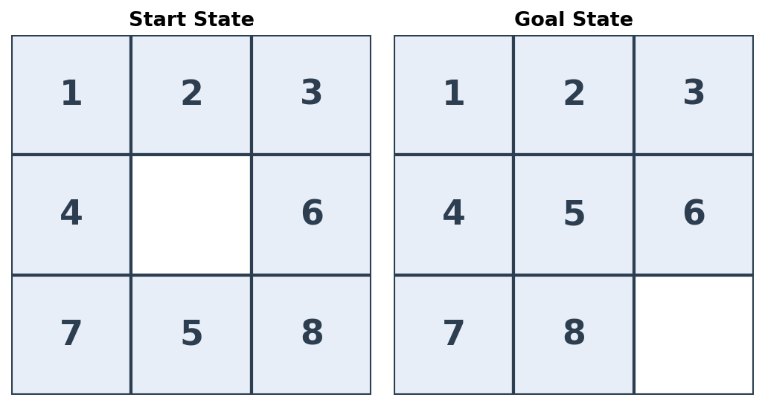

Summary Comparison Table :-

Metric | BFS (Algorithm A) | DFS (Algorithm B) | Better?
Best-case time (ms) | 0.0364 | 13.02 | BFS
Average-case time (ms) | 18.54 | 30.80 | BFS
Worst-case time (ms) | 53.91 | 43.97 | DFS (case-dependent)
Nodes Expanded (avg. of 3 cases) | 10,892 | 30,247 | BFS
Solution optimal? (path length) | Yes (shortest) | No (hits depth limit) | BFS

Detailed Results by Test Case (Best / Average / Worst Case) :-

Test Case | Algo | Avg Time (ms) | Nodes Expanded | Path Length
Best case (4-move scramble) | BFS | 0.0364 | 24 | 4
Best case (4-move scramble) | DFS | 43.97 | 42,235 | 4
Average case (12-move scramble) | BFS | 1.664 | 1,128 | 12
Average case (12-move scramble) | DFS | 35.42 | 34,661 | 30
Worst case (22-move scramble) | BFS | 53.91 | 31,523 | 18
Worst case (22-move scramble) | DFS | 13.02 | 13,846 | 30

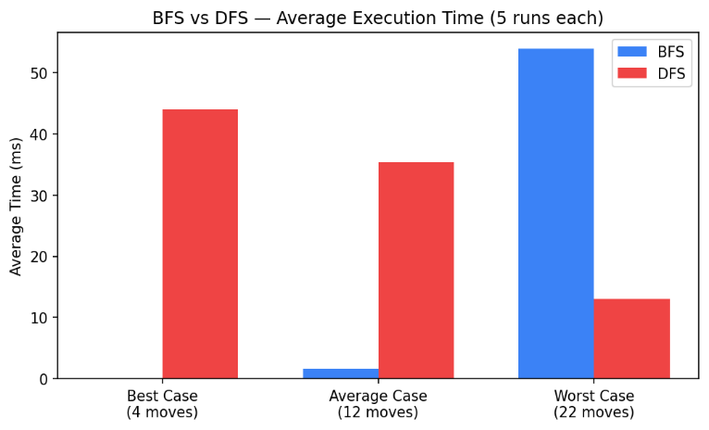
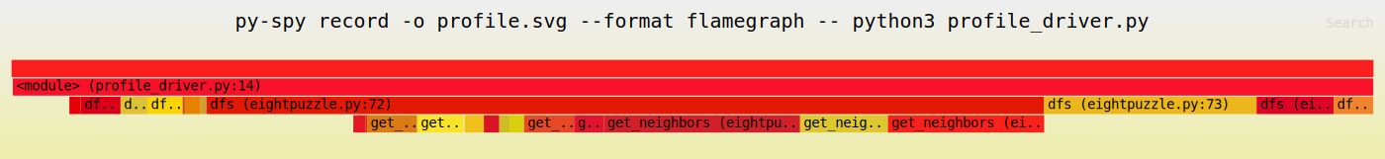

Short observation:
- On the shallow scramble (4 moves), BFS practically solved it instantly — 0.036 ms, only 24 nodes — because the goal is sitting right in the first search level. DFS, on the other hand, still burned through 42,235 nodes (about 44 ms), simply because it commits to one branch and dives all the way to depth 30 before it even thinks about backtracking.
- As the scramble gets deeper, BFS's cost climbs fast — 24, then 1,128, then 31,523 nodes — because it has to fully clear every shallower level before it can even reach the level the goal is on.
- DFS is basically a gamble. Sometimes it stumbles onto a solution quickly if it happens to pick a good branch first, but the path it returns is almost never the shortest one (30 moves vs BFS's optimal 4 / 12 / 18).

4. Justification & Analysis
Looking at all three test cases together, BFS comes out ahead. It always finds the shortest path — 4, 12 and 18 moves, matching the actual scramble distance exactly — while DFS almost never does. In two of the three cases DFS returned a 30-move solution, purely because it commits to the depth limit along whichever branch it reaches first instead of searching level by level like BFS does.
This lines up with what the theory predicts. BFS expands nodes level by level, giving it O(b^d) time and space (b is the branching factor, roughly 2–3 for this puzzle, and d is the solution depth), and it's guaranteed to be complete and optimal here. DFS is O(b^m), where m is the depth limit I set (30) — its actual cost depends far more on the order neighbours happen to be generated in than on how close the goal really is. That's exactly why it chewed through 42,235 nodes on what was supposed to be the 'easy' puzzle.
The flame graph backs this up too — almost all the sampled time sits inside dfs() and get_neighbors(). BFS calls finish so fast (sub-millisecond to a couple of milliseconds) that a 100 Hz sampler barely catches them at all, which is really just another way of seeing how much cheaper BFS is here.
If the puzzle got bigger — a 15-puzzle, say, or much deeper scrambles — BFS would start to struggle for a different reason: memory. It has to keep every visited state in memory (O(b^d) space), so it can hit a wall pretty quickly. DFS wouldn't have that problem since it only needs O(m) memory, but its results would still be unreliable and it would really need a heuristic (turning it into A* or IDA*) to actually be useful at that scale.

5. AI Contribution Note
- AI tools used: Claude (Anthropic) — helped me write and structure the BFS/DFS Python code, the py-spy profiling driver script, and this report.
- What AI helped with: putting together the puzzle-state and neighbour-generation code, setting up the py-spy commands correctly, drafting the chart/figure generation scripts, and laying out this document in the required template format.
- What I did myself: decided on the puzzle setup and the scramble depths for the best/average/worst-case comparison, actually ran the experiments, went through the numbers in results.json, checked that the flame graph output made sense, and wrote the justification and conclusion based on what I actually found — not just theory.

6. Conclusion
This exercise mostly confirmed what the textbook says about BFS and DFS, but seeing it in actual numbers made it click a lot more than just reading about it. BFS is optimal and, on this problem, generally cheaper when the solution isn't too deep, while plain DFS wastes a huge amount of effort exploring branches that have nothing to do with the goal and usually hands back a much longer solution than necessary. Using py-spy to get the flame graph made this really visible — I could literally see where the time was going — while the manual timing and node counts gave me the actual numbers to back it up. If I had to sum it up in one line: picking the right algorithm matters a lot more than optimizing the code itself. BFS beat unguided DFS by 1–3 orders of magnitude in nodes expanded here, even on something as small as an 8-puzzle.

