Decision Tree:
- A decision tree is a non-parametric supervised learning algorithm for classification and regression tasks.
- It has a hierarchical tree structure consisting of a root node, branches, internal nodes, and leaf nodes.
- t is a graphical representation for getting all the possible solutions to a problem/decision based on given conditions.
- It is called a decision tree because, similar to a tree, it starts with the root node, which expands on further branches and constructs a tree-like structure.
- It is a tree-structured classifier, where internal nodes represent the features of a dataset, branches represent the decision rules and each leaf node represents the outcome.
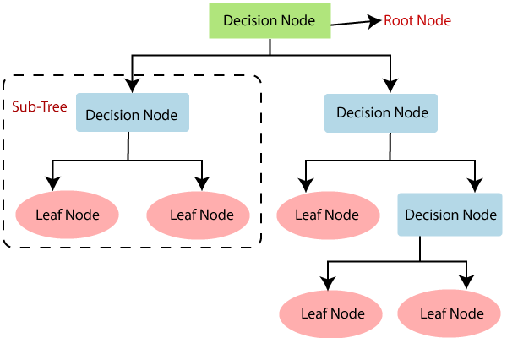
Attribute Selection Measures
While implementing a Decision tree, the main issue arises that how to select the best attribute for the root node and for sub-nodes. So, to solve such problems there is a technique which is called as Attribute selection measure or ASM. By this measurement, we can easily select the best attribute for the nodes of the tree. There are two popular techniques for ASM, which are:
Entropy
Information Gain
Gini Index

Entropy: Entropy is a metric to measure the impurity in a given attribute. It specifies randomness in data. Entropy can be calculated as:
Attribute having minimum entropy will split first.
Entropy(s)= -P(yes)log2 P(yes)- P(no) log2 P(no)
Where,
S= Total number of samples
P(yes)= probability of yes
P(no)= probability of no

Information Gain: (1-Entropy)
Information gain is the measurement of changes in entropy after the segmentation of a dataset based on an attribute.
It calculates how much information a feature provides us about a class.
According to the value of information gain, we split the node and build the decision tree.
A decision tree algorithm always tries to maximize the value of information gain, and a node/attribute having the highest information gain is split first. It can be calculated using the below formula:
Information Gain= Entropy(S)- [(Weighted Avg) *Entropy(each feature) ]

Gini Index:
Gini index is a measure of impurity or purity used while creating a decision tree in the CART(Classification and Regression Tree) algorithm.
An attribute with the low Gini index should be preferred for splitting.
It only creates binary splits, and the CART algorithm uses the Gini index to create binary splits.
Gini index can be calculated using the below formula:
Gini Index= 1- ∑(Px)²

