Practical #6
Practical Title:
To deploy and manage a simple web application using version control and hosting techniques
Theory:
1. What is Web Hosting?
Web hosting is a service that allows individuals or organizations to store their website files on a server so that they can be accessed over the internet. It makes a website available to users worldwide through a domain or URL.
2. What is GitHub Hosting (GitHub Pages)?
GitHub Pages is a free hosting service provided by GitHub that allows users to deploy static websites directly from a GitHub repository. It is mainly used for hosting HTML, CSS, and JavaScript projects.
3. Role of Version Control in Deployment:
Version control helps track changes in code, manage different versions, and collaborate efficiently. It ensures that:
- Changes can be reverted if needed
- Multiple developers can work together
- Deployment becomes systematic and error-free

Procedure:
Step 1: Create a simple web application (index.html)
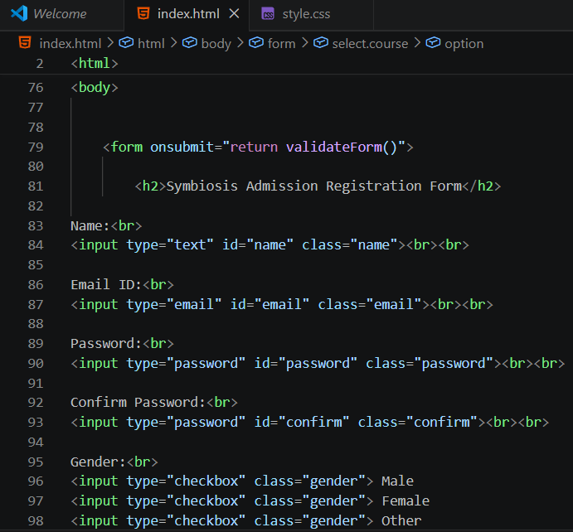
Step 2: Initialize Git repository -
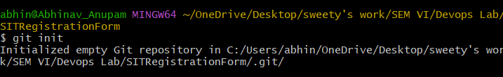
Step 3: Add and Commit files –
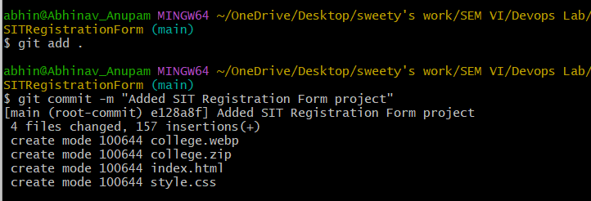

Step 4: Create GitHub repository

Step 5: Push code to GitHub -
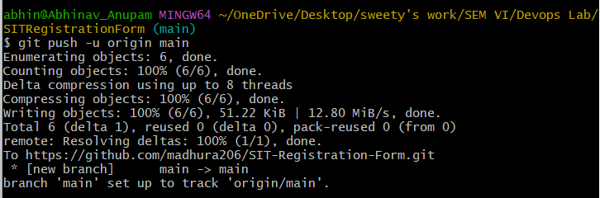
Step 6: Enable GitHub Pages
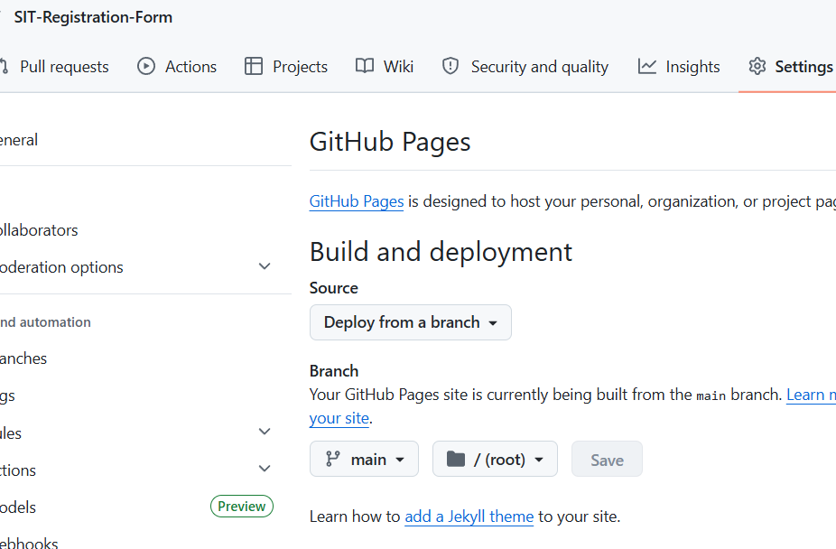
Step 7: Access deployed website using provided link
- https://madhura206.github.io/SIT-Registration-Form/
Activity / Task:
Task 1:
Deploy your own web application using GitHub Pages.
Repository Link:
https://github.com/madhura206/SIT-Registration-Form
Live Website Link:
http://127.0.0.1:5500/Developer2/Test-website/index.html
Task 2:
Make changes in your code and update the live website.
Commands Used:
git add .
git commit -m "Added SIT Registration Form project"
git push
Task 3:
Explain the benefits of using GitHub for deployment.
GitHub simplifies deployment by providing version control, easy hosting, and collaboration tools. It allows developers to manage and update their projects efficiently while making them accessible online.
Advantages:
- Free hosting for static websites
- Easy deployment process
- Version control integration
- Supports collaboration
- Automatic updates on push
Challenges:
- Only supports static websites
- Requires basic Git knowledge
- Limited customization compared to paid hosting

Conclusions:
This practical helped in understanding the process of deploying a web application using GitHub and version control. We learned how to host a website, manage code changes, and update the live application efficiently. It improved our practical knowledge of real-world deployment techniques.

