Practical #7
Practical Title:
To understand automated testing concepts and Selenium architecture for web applications
Theory:
1. What is Automated Testing?
Automated testing is the process of using software tools to execute test cases automatically without manual intervention. It helps in improving accuracy, speed, and efficiency of testing.
2. What is Selenium?
Selenium is an open-source automation testing tool used to test web applications. It supports multiple programming languages like Java, Python, and C#.
3. Selenium Components:
Selenium IDE:
A browser extension used for recording and playback of test cases without coding.
Selenium WebDriver:
A tool used to automate browser actions by writing scripts in programming languages.
Selenium Grid:
Used to run tests on multiple machines and browsers simultaneously.
4. Selenium Architecture:
Selenium follows a client-server architecture:
- Test scripts are written in a programming language (Java, Python, etc.)
- WebDriver acts as a bridge between script and browser
- Browser drivers (ChromeDriver, GeckoDriver) execute commands in the browser
Procedure:
Step 1: Install Selenium and required dependencies
Step 2: Setup WebDriver
Step 3: Write a simple test script
Step 4: Perform actions (click, input, etc.)
Step 5: Execute the test script
Output Screenshots:
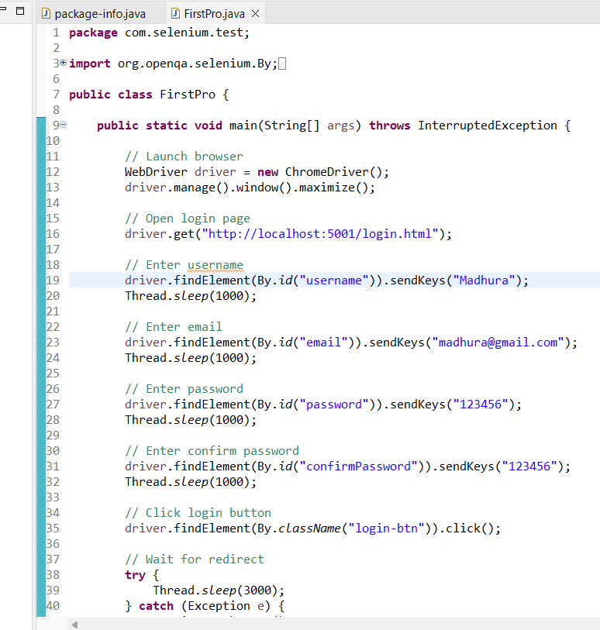
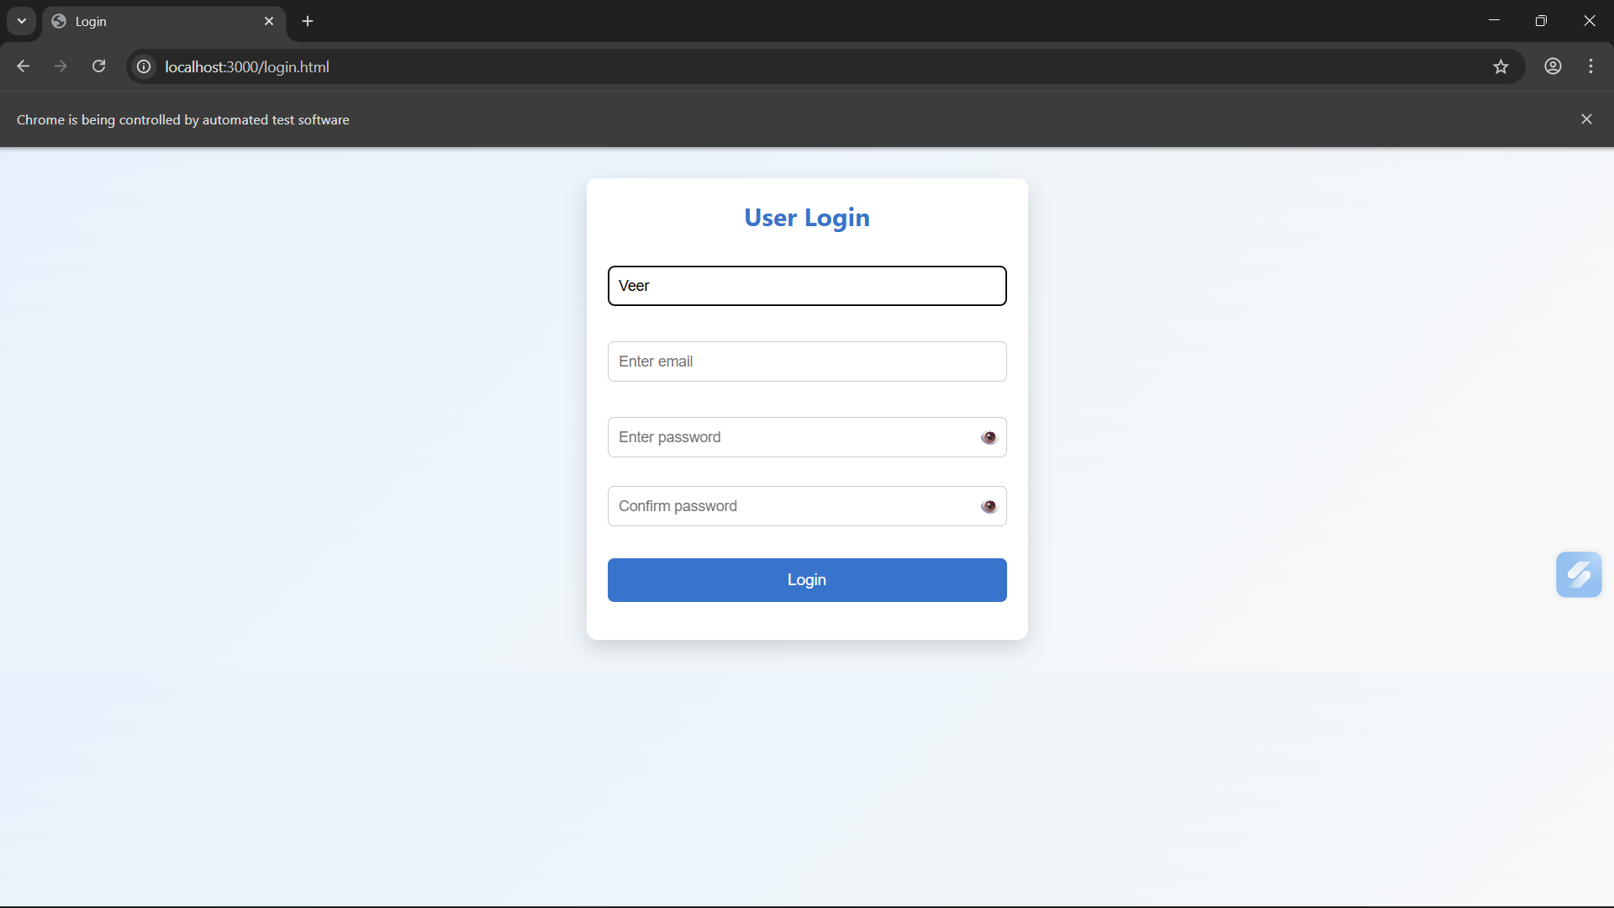
Activity / Task:
Task 1:
Write a Selenium script to open a website and perform basic actions.
Code:
package com.selenium.test;

import org.openqa.selenium.By;
import org.openqa.selenium.WebDriver;
import org.openqa.selenium.chrome.ChromeDriver;

public class FirstPro {
public static void main(String[] args) throws InterruptedException {
// Launch browser
WebDriver driver = new ChromeDriver();
driver.manage().window().maximize();

// Open login page
driver.get("http://localhost:5001/login.html");

// Enter username
driver.findElement(By.id("username")).sendKeys("Madhura");
Thread.sleep(1000);

// Enter email
driver.findElement(By.id("email")).sendKeys("madhura@gmail.com");
Thread.sleep(1000);

// Enter password
driver.findElement(By.id("password")).sendKeys("123456");
Thread.sleep(1000);

// Enter confirm password
driver.findElement(By.id("confirmPassword")).sendKeys("123456");
Thread.sleep(1000);

// Click login button
driver.findElement(By.className("login-btn")).click();

// Wait for redirect
try {
Thread.sleep(3000);
} catch (Exception e) {
e.printStackTrace();
}
// Check if redirected to index.html
String currentURL = driver.getCurrentUrl();

if(currentURL.contains("index.html")) {
System.out.println("TEST PASSED");
} else {
System.out.println("TEST FAILED");
}
Thread.sleep(10000);
// Close browser
driver.quit();
}
}
Task 3:
List advantages of automated testing over manual testing.
Advantages
- Faster execution of test cases
- High accuracy (no human error)
- Reusability of test scripts
- Supports regression testing
- Saves time and cost in long run
Challenges
- Initial setup cost is high
- Requires programming knowledge
- Not suitable for UI changes frequently

Conclusion
This practical provided a clear understanding of automated testing using Selenium.
We learned how to write scripts to automate browser actions and execute test cases efficiently. It highlighted the importance of automation in improving testing speed, accuracy, and reliability.

