Practical #10
Practical Title:
To implement a basic CI pipeline by integrating GitHub, automated testing, and Jenkins jobs
Theory:
1. What is Continuous Integration (CI)?
Continuous Integration (CI) is a DevOps practice where developers frequently integrate their code into a shared repository. Each integration is automatically built and tested to detect errors early and maintain code quality.
It ensures faster development, early bug detection, and a stable codebase throughout the software lifecycle.
2. Why is GitHub used in a CI pipeline?
GitHub is used in a CI pipeline as a central repository to store and manage source code. It enables version control, collaboration among developers, and triggers CI processes whenever changes are pushed to the repository.
It also integrates easily with CI tools to automate builds and testing.
3. What is the role of automated testing in CI?
Automated testing plays a crucial role in CI by automatically verifying the functionality and correctness of the code after every integration. It helps detect bugs early, ensures code reliability, and reduces manual testing effort.
This improves software quality and speeds up the development process.
4. What is the role of Jenkins in CI?
Jenkins acts as the automation server in a CI pipeline. It fetches code from GitHub, triggers builds, runs automated tests, and provides results through console output or reports.
Jenkins ensures continuous and automated execution of the pipeline, making development faster and more efficient.
Procedure:
Step 1: Create or use an existing GitHub repository
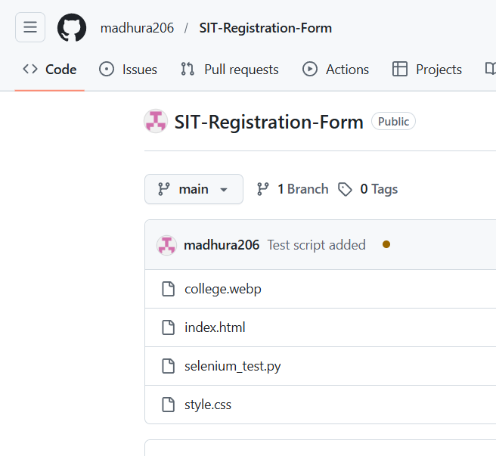
Step 2: Add project files and test scripts to the repository
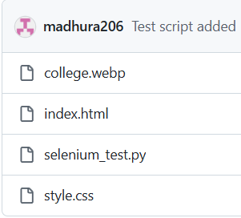
Step 3: Commit and push the code to GitHub
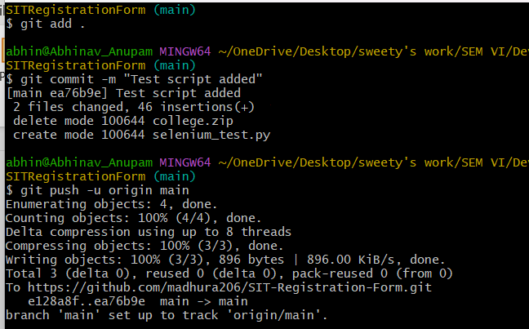
Step 4: Install and open Jenkins dashboard
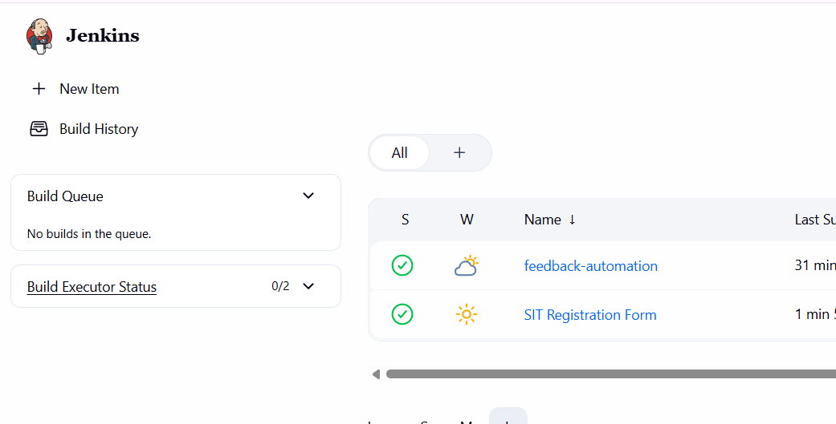
Step 5: Create a new Jenkins job or pipeline

Step 6: Connect Jenkins with GitHub repository
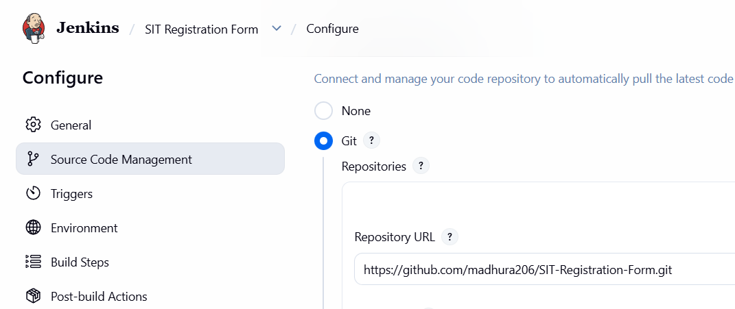

Step 7: Configure build steps and test execution
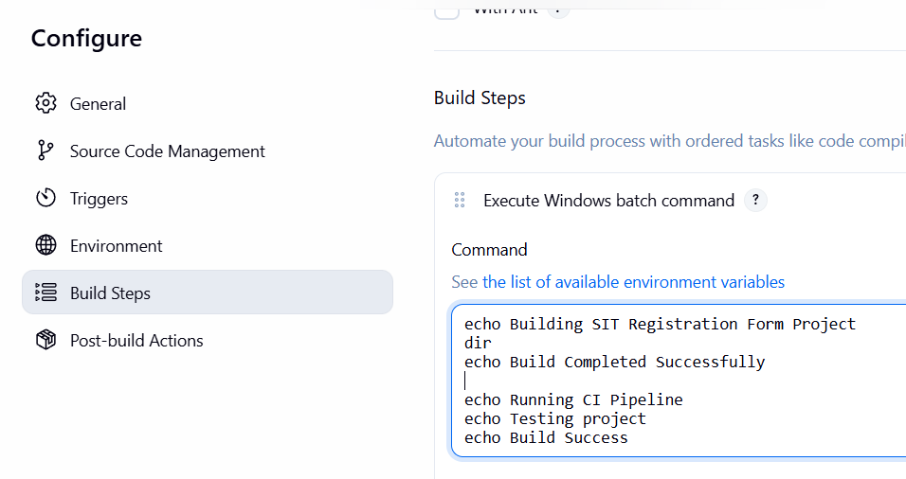
Step 8: Run the Jenkins job
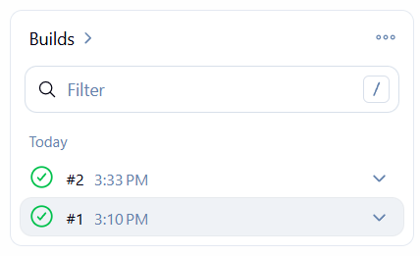
Step 9: Verify build status and console output
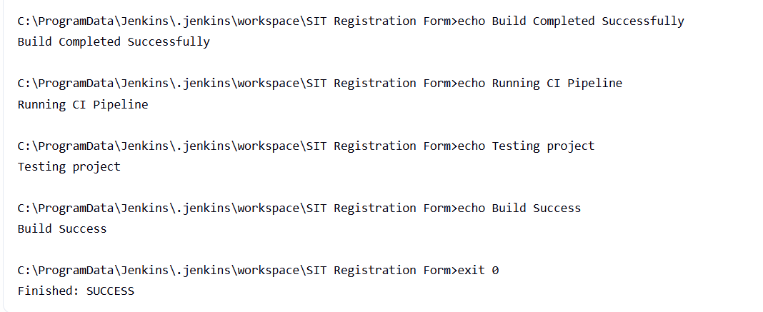
Step 10: Make changes in GitHub and trigger the pipeline again

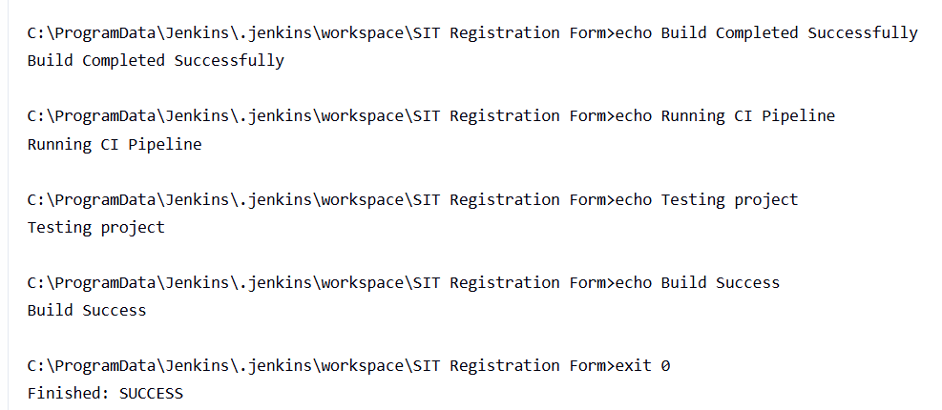
Activity / Task:
Task 1:
Create a Jenkins job that fetches code from GitHub and executes the test script.


Repository Link:
https://github.com/madhura206/SIT-Registration-Form
Task 2:
Write the build result after successful and failed execution.
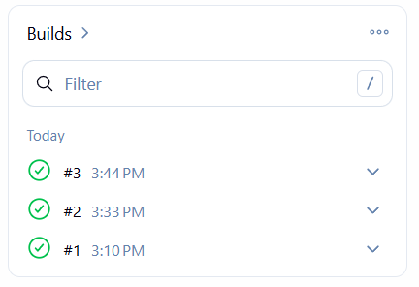
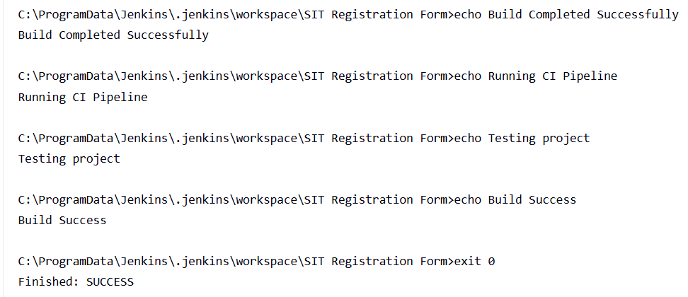
__________________________________________
Task 3:
Explain the complete flow of CI pipeline from code push to build/test execution.
Ans. The Continuous Integration (CI) pipeline automates the process of integrating code, building the project, and testing it to ensure quality and reliability.
- Code Push to Repository
- Developer writes code and pushes it to GitHub
- Developer writes code and pushes it to GitHub

- Trigger CI Pipeline
- Jenkins detects changes using:
- Poll SCM
- OR Webhook
- Jenkins automatically starts the job

- Fetch Source Code
- Jenkins connects to GitHub
- Downloads the latest code from repository

- Build Process
- Jenkins executes build steps
- Example:
- Compile code
- Run scripts
- Run scripts

- Automated Testing
- Automated Testing
- Verifies:
- Functionality
- Input/output behavior

- Generate Results
- Jenkins shows:
- Console output
- Build status (SUCCESS / FAILURE)

- Feedback to Developer
- Developer checks results
- Fixes errors if build fails
- Pushes updated code again
Advantages
1. Faster Development and Delivery – Integrating GitHub with Jenkins enables automatic builds and testing, reducing development time and speeding up software delivery.
2. Early Bug Detection – Automated testing helps identify errors immediately after code is pushed, reducing the cost and effort of fixing bugs later.
3. Automation of Workflow – The CI pipeline automates code integration, build, and testing processes, minimizing manual effort and increasing efficiency.
4. Improved Code Quality – Continuous testing ensures that only stable and error-free code is maintained in the repository.
5. Better Collaboration – Developers can work together efficiently using GitHub, and frequent integration reduces conflicts and improves teamwork.
Challenges
1. Initial Setup Complexity – Setting up Jenkins, integrating it with GitHub, and configuring automated tests requires proper understanding and time.
2. Maintenance of Pipeline – CI pipelines need regular updates when project structure, dependencies, or test scripts change.
3. Dependency on Tools – The pipeline depends on tools like Jenkins and testing frameworks; any failure or misconfiguration can affect the entire process.

Conclusion
The basic CI pipeline was successfully implemented by integrating GitHub, automated testing,
and Jenkins jobs. The process demonstrated how code changes can automatically trigger build
and testing, improving efficiency and reliability. This practical highlighted the importance of
automation in ensuring faster development and better software quality.

