Practical #3
Practical Title:
To apply GitHub-based collaboration techniques including branching and merging
Theory:
1. What is GitHub Collaboration?
GitHub collaboration is the process where multiple developers work together on the same project using GitHub. It allows team members to share code, track changes, manage versions, and contribute simultaneously without conflicts.
GitHub provides features like repositories, branches, pull requests, and issues that make collaboration efficient and organized.
2. What is Branching in Git?
Branching in Git is a feature that allows developers to create separate versions of a project.
The main branch (main/master) always contains stable code, while other branches are used for development.
3. What is Merging?
Merging is the process of combining changes from one branch into another.
After completing work in a branch, it is merged into the main branch so that:
- New features are added
- Updates become part of the main project
4. What is Pull Request (PR)?
A Pull Request is a request to merge changes from one branch into another.
It allows:
- Code review by teammates
- Discussion before merging
- Approval or rejection of changes

Procedure:
Step 1: Create a GitHub Repository
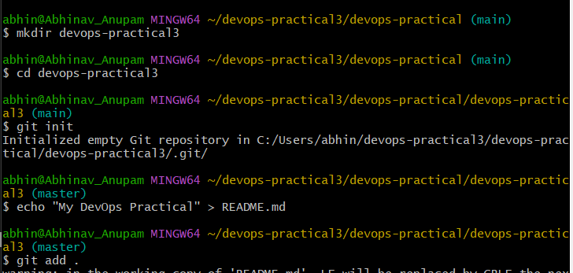
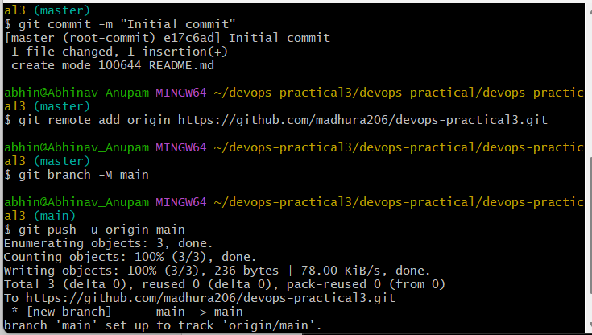
Step 2: Clone Repository
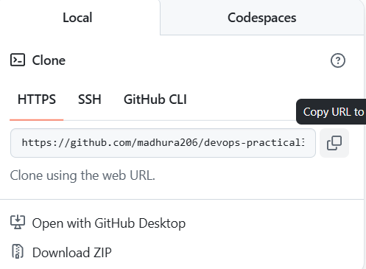
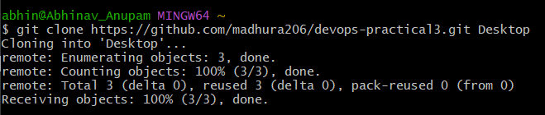
Step 3: Create a New Branch
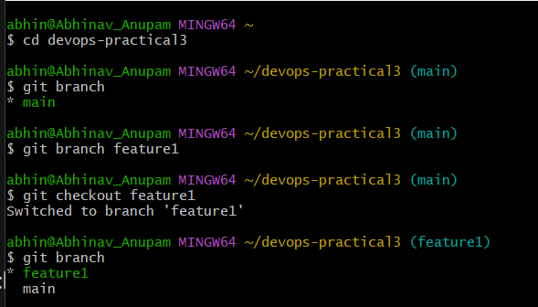
Step 4: Make Changes and Commit
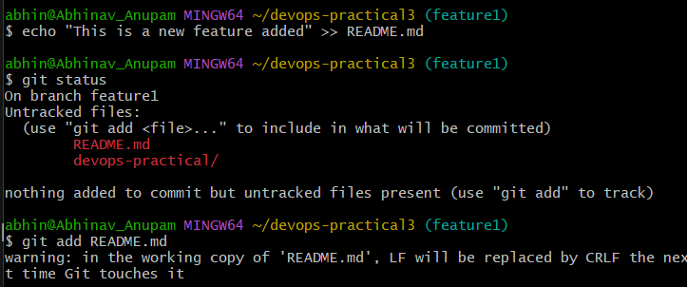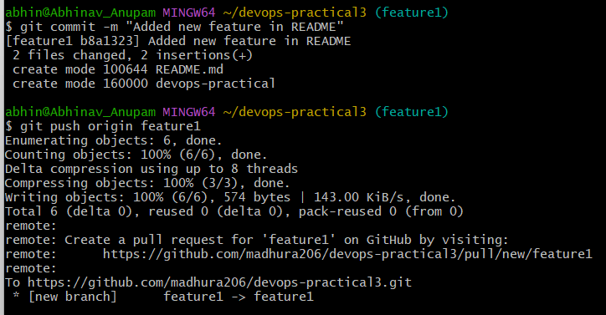
Step 5: Push Branch to GitHub
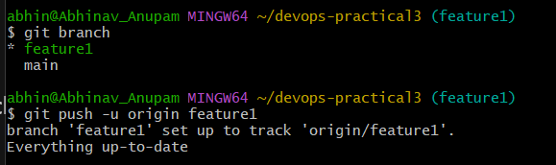
Step 6: Create Pull Request on GitHub
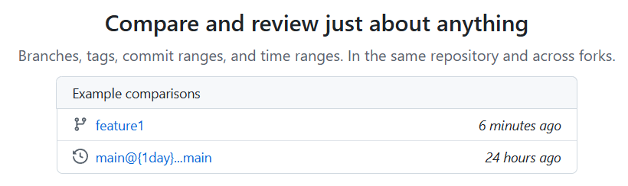
Step 7: Merge Pull Request
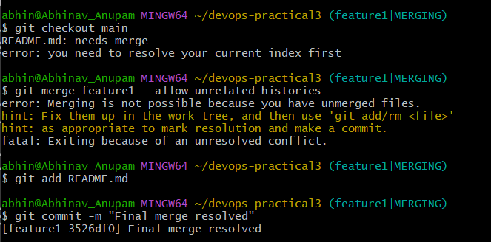
Step 8: Pull Updated Code
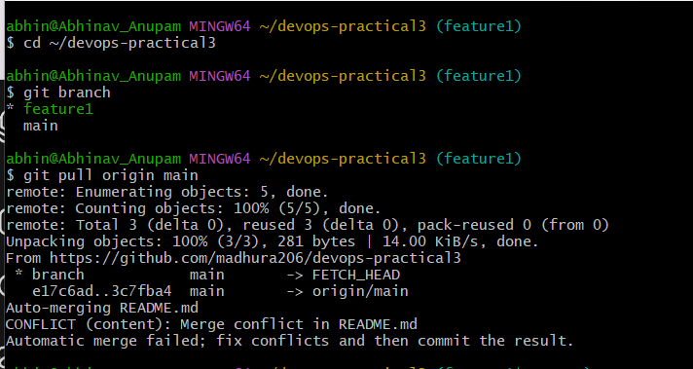
Activity / Task:
Task 1:
Create a repository and collaborate with at least one teammate.
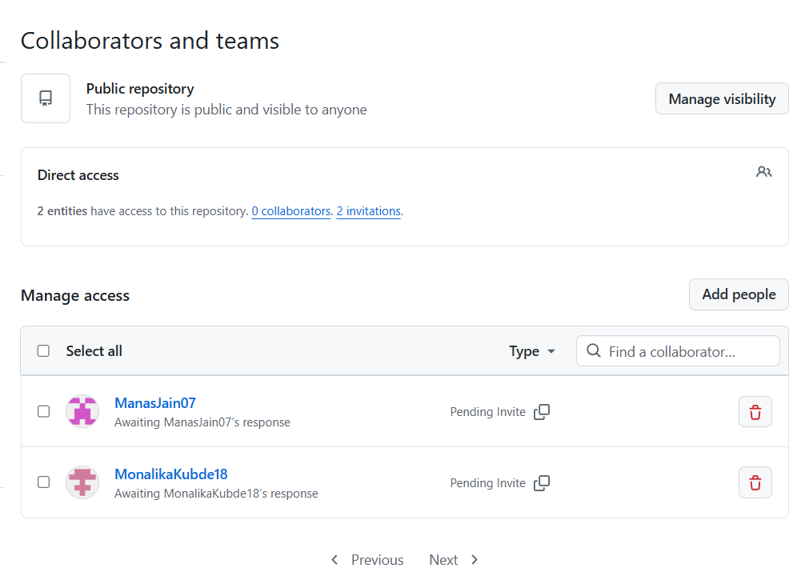
Repository Link:
https://github.com/madhura206/Student-Notes-Sharing-App
Task 2:
Write the steps to resolve merge conflicts.
Step 1: git clone https://github.com/madhura206/devops-practical3.git
cd devops-practical3
Step 2: git checkout -b feature1
Step 3: echo "Feature branch change" >> file.txt
git add .
git commit -m "Feature change"
git push origin feature1

Step 4: git checkout main

Step 5: echo "Main branch change" >> file.txt
git add .
git commit -m "Main change"
git push origin main

Step 6: git merge feature1

Step7 : git status

Step 8: Open File & Resolve Conflict

Step 9: git add file.txt

Step 10: git commit -m "Resolved merge conflict"

Step 11: git push origin main
Advantages of GitHub Collaboration
1. Real-time teamwork: Multiple developers can work on the same project simultaneously.
2. Version control: Tracks all changes, so you can revert to previous versions anytime.
3. Code review via Pull Requests: Helps maintain code quality and reduces errors.
4. Branching & merging: Developers can work independently without affecting the main code.
5. Easy sharing & access: Code can be accessed from anywhere by authorized collaborators.

Challenges
1. Merge conflicts: Occur when multiple people edit the same part of code.
2. Learning curve: Beginners may find Git commands confusing initially.
3. Access & permission issues: Incorrect permissions can restrict collaboration or cause issues.
Conclusion
This practical helped in understanding GitHub collaboration using branching, merging, and pull requests. It improved teamwork skills and version control practices. Overall, it ensured efficient and organized project development.

