Practical #4
Practical Title:
To apply GitHub-based collaboration techniques including merging and remote repository management
Theory:
1. What is Merging in Git?
Merging in Git is the process of combining changes from one branch into another branch. It helps integrate work done in different branches into a single codebase.
2. Types of Merge:
Fast-forward Merge:
This happens when there are no new commits in the target branch. Git simply moves the pointer forward to include new changes.
Three-way Merge
This happens when both branches have new commits. Git creates a new merge commit by combining changes from both branches.
3. What is Remote Repository?
A remote repository is a version of your project stored on the internet (like GitHub). It allows multiple users to collaborate and share code.
4. Common Remote Commands:
git remote add origin <url> → Connect local repo to remote
git remote -v → View remote repositories
git push origin main → Upload code to remote repo
git pull origin main → Fetch and update local repo
git fetch origin → Download changes without merging
Procedure:
Step 1: Create Local Repository
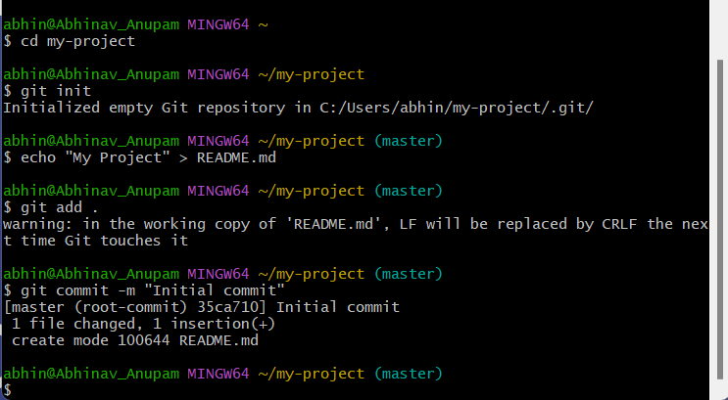
Step 2: Add Remote Repository
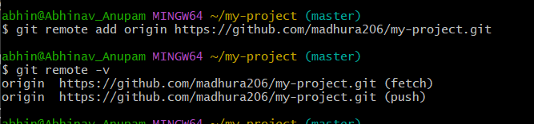
Step 3: Create Branch and Commit Changes
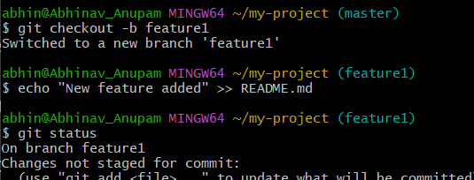
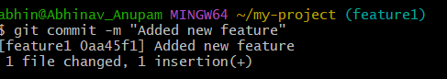
Step 4: Push Branch to Remote
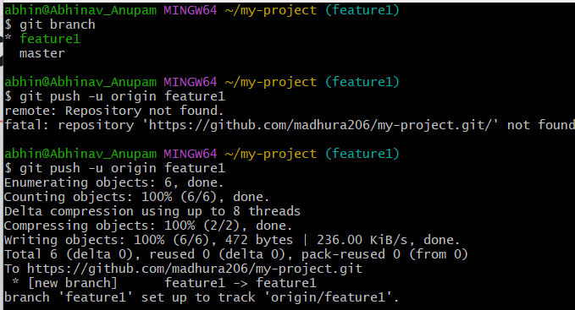
Step 5: Merge Branch into Main
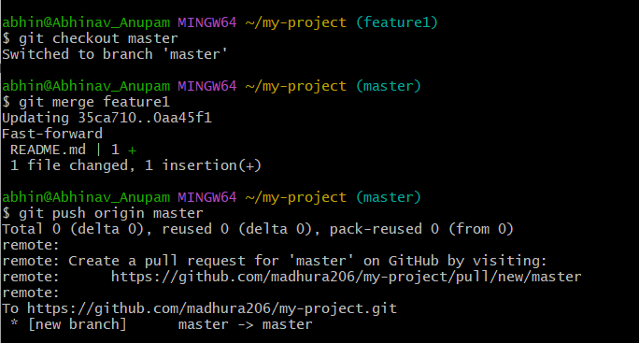
Step 6: Push Merged Code
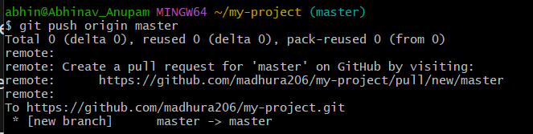

Step 7: Fetch and Pull Updates
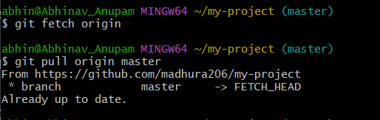
Activity / Task:
Task 1:
Create a remote repository and link it with local repository.
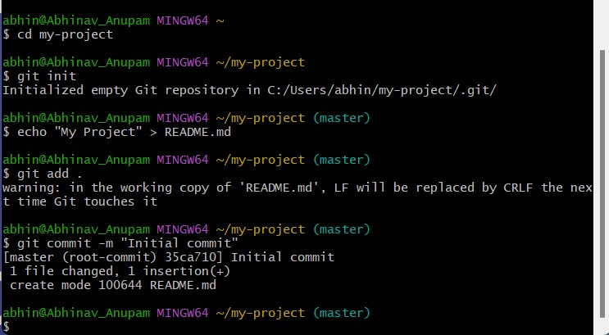
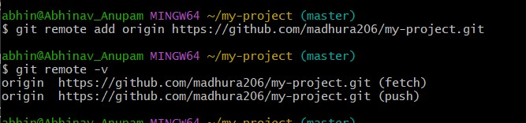
Repository Link:
https://github.com/madhura206/my-project
Task 2:
Perform branch merging and push changes to GitHub.
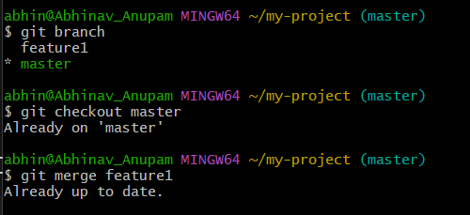
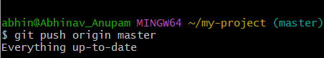
Commands Used:
1. git branch
2. git checkout master
3. git checkout master
4. git push origin master
Task 3:
Explain difference between git fetch and git pull.
Feature | git fetch | git pull
Action | Downloads changes | Downloads + merges
Local files | No change | Updates local files
Safety | Safe (no risk) | May cause conflicts
Use case | Review changes first | Directly update code
Advantages
1. Efficient collaboration
Multiple developers can work on the same project simultaneously.
2. Version control
Tracks changes and allows reverting to previous versions.
3. Branching and merging
Enables safe development without affecting the main code.
4. Remote access
Code can be accessed and managed from anywhere.
5. Code review support
Pull requests help improve code quality and reduce errors.
Challenges
1. Merge conflicts
Occur when multiple users edit the same part of code.
2. Learning complexity
Beginners may find Git commands and workflows difficult.

Conclusion
This practical provided knowledge about merging techniques and managing remote repositories. It strengthened understanding of Git commands like fetch, pull, and push. It also highlighted the importance of collaboration and code synchronization.

