Practical #5
Practical Title:
To understand the structure of a basic web application and its role in a DevOps pipeline
Theory:
1. What is a Web Application?
A web application is a software program that runs on a web server and is accessed through a web browser over the internet.
Example: Gmail, Facebook, Amazon.
2. Components of a Web Application:
Frontend:
The user interface of the application that users interact with. It is built using HTML, CSS, and JavaScript.
Backend:
The server-side logic that processes user requests, handles business logic, and communicates with the database. It is built using languages like Java, Python, Node.js, etc.
Database:
Stores and manages the application’s data such as user information, records, and transactions.
Examples: MySQL, MongoDB.
3. What is DevOps Pipeline?
A DevOps pipeline is a set of automated processes that allow developers to build, test, and deploy applications quickly and efficiently.
It includes stages like coding, building, testing, and deployment.
Procedure:
Step 1: Create a Basic Web Page (HTML)
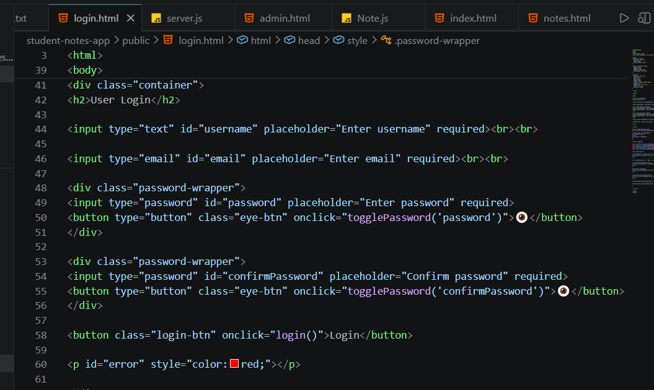
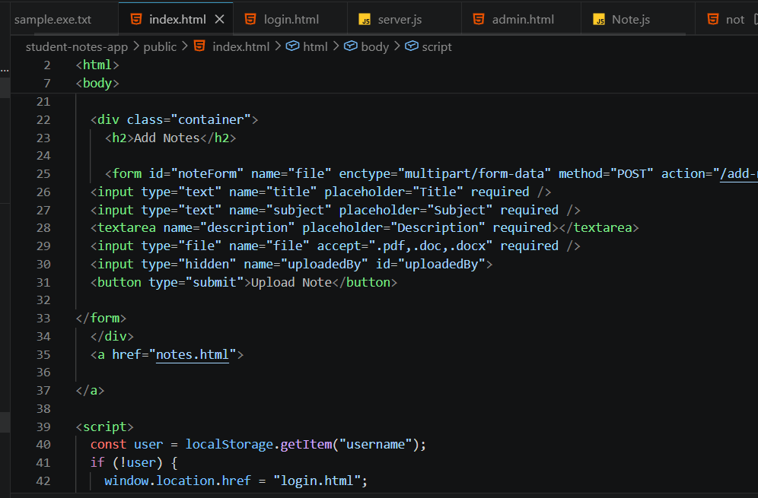
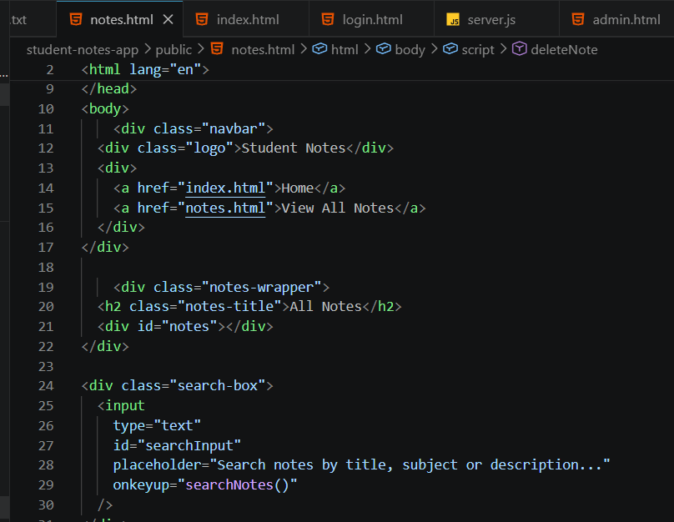
Step 2: Add Styling using CSS
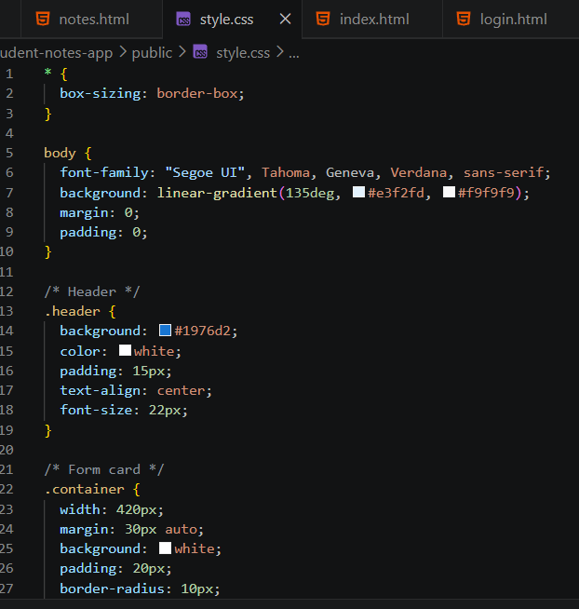

Step 3: Add Simple JavaScript Functionality
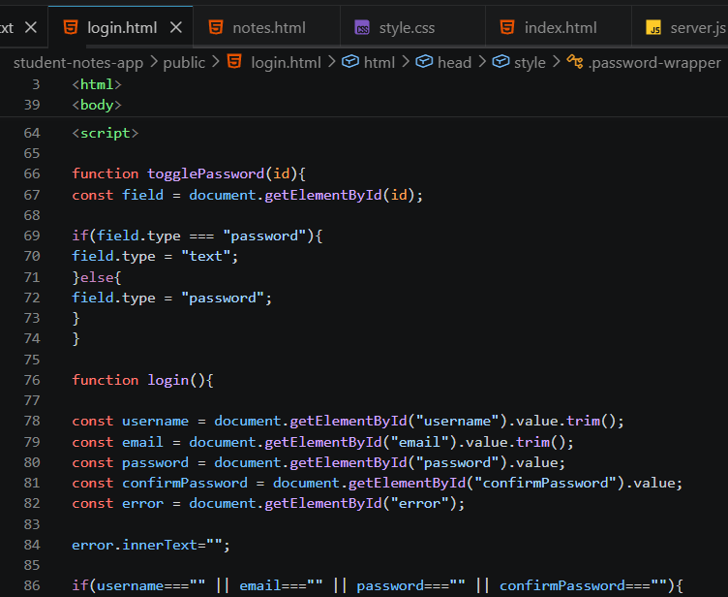
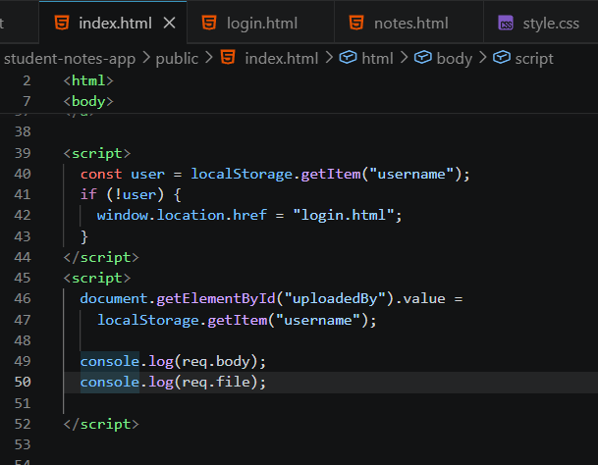
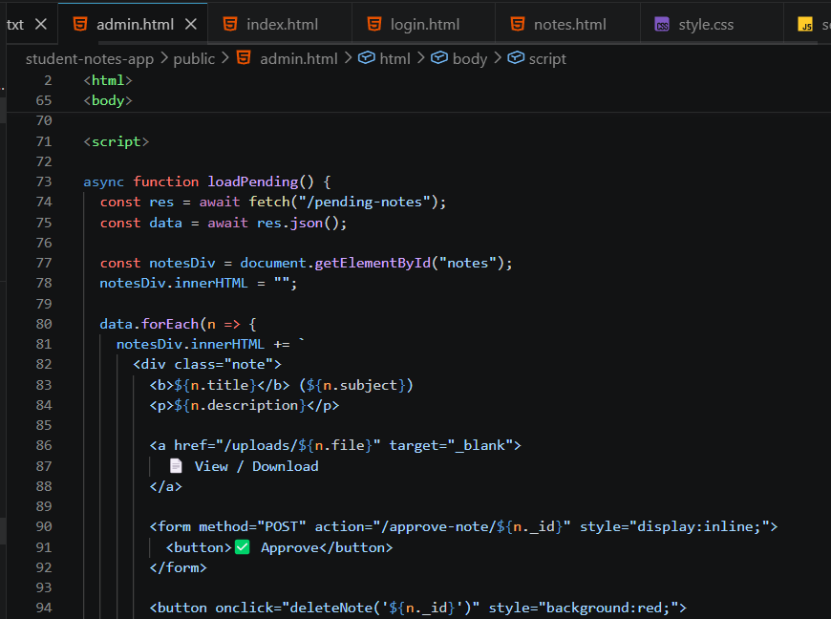
Step 4: Run the Web Page in Browser
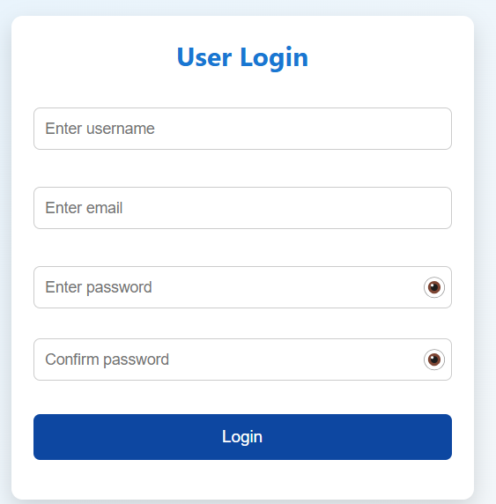
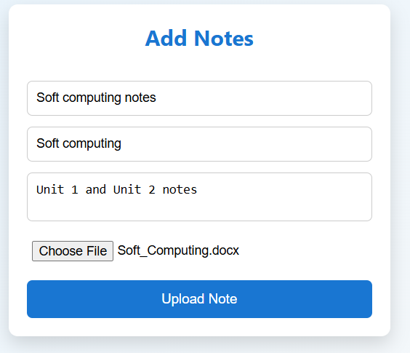
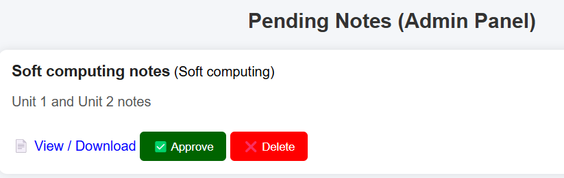
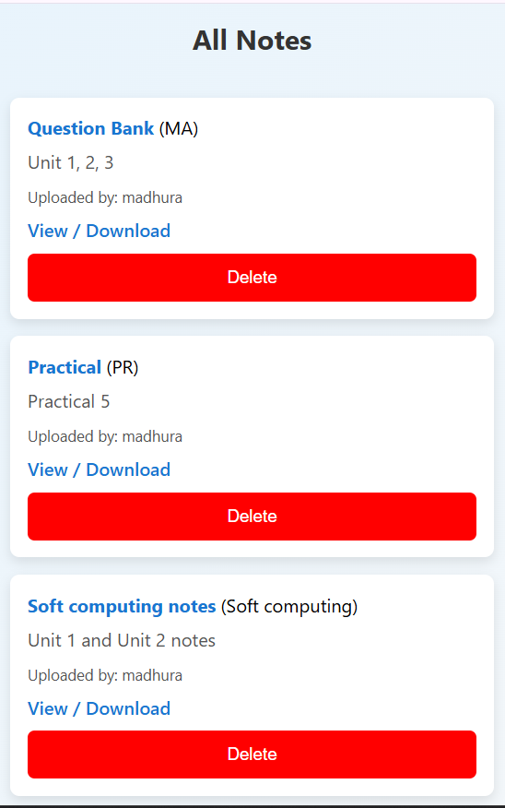
Step 5: (Optional) Upload the Web App to GitHub
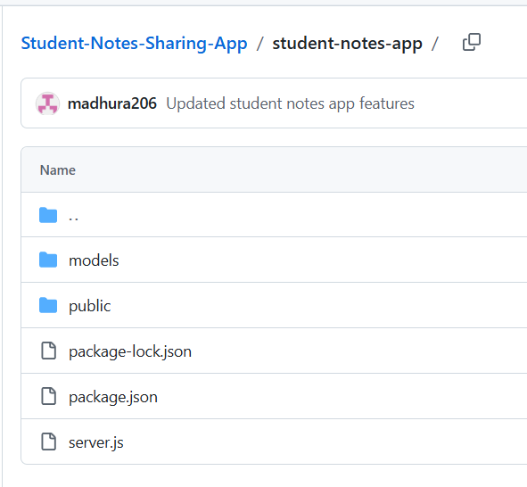
Activity / Task:
Task 1:
Create a simple web application (e.g., Student Form or Feedback Form)
Description:
The SIT (Symbiosis Institute of Technology) Registration Form is a web-based application designed to collect user details for admission purposes. It is developed using HTML, CSS, and JavaScript.
The form includes input fields such as Name, Email ID, Password, Confirm Password, Gender selection, and Course selection. Each input field is styled using CSS to improve the user interface and make the form visually appealing.
Client-side validation is implemented using JavaScript to ensure proper data entry. The form checks that:
- Name and Email fields are not empty
- Password is at least 6 characters long
- Password and Confirm Password match
If any validation fails, an alert message is displayed. On successful validation, a confirmation message "Registration Successful" is shown.
The form is centered on the page with a styled background image, providing a clean and user-friendly interface.
Task 2:
Explain how this application can be used in a DevOps pipeline.
This application can be integrated into a DevOps pipeline to automate its development and deployment.
- The code is stored in GitHub for version control.
- CI tools automatically build and test the form when changes are made.
- After successful testing, the application is deployed to a server.
- Continuous monitoring helps improve performance.
Task 3:
List steps to deploy this application on a server.
Ans. Steps to Deploy this Application on a Server
- Prepare the Application
Ensure all files (HTML, CSS, image) are complete and working.
- Choose a Server
Select a web server or hosting platform (e.g., Apache, Nginx, or cloud hosting).
- Upload Files
Transfer the project files to the server using FTP, Git, or command line.
- Configure Server
Place files in the server’s root directory (e.g., /var/www/html).
- Start/Restart Server
Run the web server so the application becomes active.
- Access in Browser
Open the server URL or IP address to view the application.
My web app deployed on Netlify.
Link: SITRegistrationForm

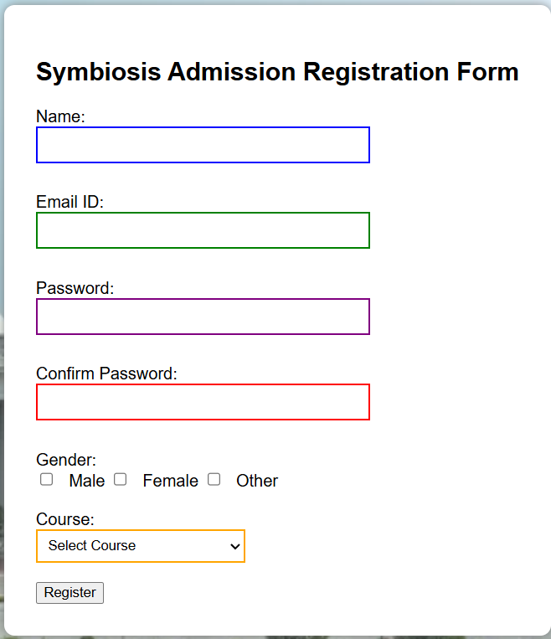

Advantages
1. Helps understand the basic structure of web applications (frontend, backend, database).
2. Improves knowledge of real-world application development.
3. Enables automation through DevOps practices like CI/CD.
4. Increases collaboration using tools like Git and GitHub.
5. Faster development, testing, and deployment process.
Challenges
1. Beginners may find DevOps tools and workflows difficult.
2. Setting up servers and deployment can be complex.
3. Debugging errors during integration and deployment can be time-consuming.
Conclusion
This practical helped in understanding the structure of a web application and its integration with a DevOps pipeline. It demonstrated how development, testing, and deployment can be automated. Overall, it connected theoretical concepts with real-world application development.

