Practical #9
Practical Title:
To understand continuous integration concepts and Jenkins architecture for build automation
Theory:
1. What is Continuous Integration (CI)?
Continuous Integration (CI) is a DevOps practice where developers frequently integrate their code into a shared repository. Each integration is automatically built and tested to detect errors early and ensure code quality.
It helps in identifying bugs quickly, improving collaboration among team members, and maintaining a stable and reliable codebase throughout the development process.
2. What is Jenkins?
Jenkins is an open-source automation tool used for Continuous Integration and Continuous Delivery (CI/CD). It helps automate building, testing, and deploying applications, making the development process faster and more reliable.
Jenkins also supports integration with various tools and plugins, enabling a complete automation pipeline for efficient software development.
3. Features of Jenkins:
Open Source – Free and widely used
Extensible – Supports thousands of plugins
Automation – Automates build, test, and deployment
Easy Integration – Works with Git, Maven, Docker, etc.
Continuous Monitoring – Tracks builds and errors
Distributed Builds – Can run jobs on multiple machines for faster execution
4. Jenkins Architecture:
Jenkins follows a Master-Agent (Controller-Agent) architecture:
- Master (Controller):
Manages jobs, schedules builds, and monitors execution. It acts as the central control unit of Jenkins.
- Agent (Node/Slave):
Executes tasks assigned by the master on different machines, helping distribute workload.
- Communication:
Master and agents communicate through secure channels to perform distributed builds efficiently.
This architecture improves scalability, reduces workload on a single system, and speeds up the overall build process.
Procedure:
Step 1: Install Jenkins and start server
Step 2: Access Jenkins Dashboard (http://localhost:8080)
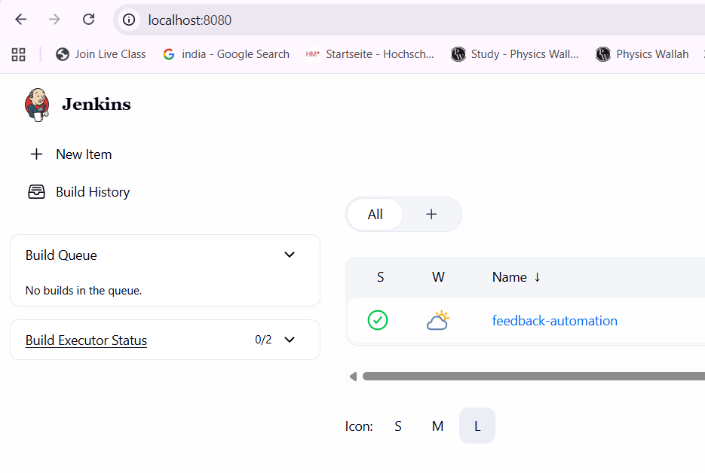
Step 3: Create a new job (Freestyle Project)
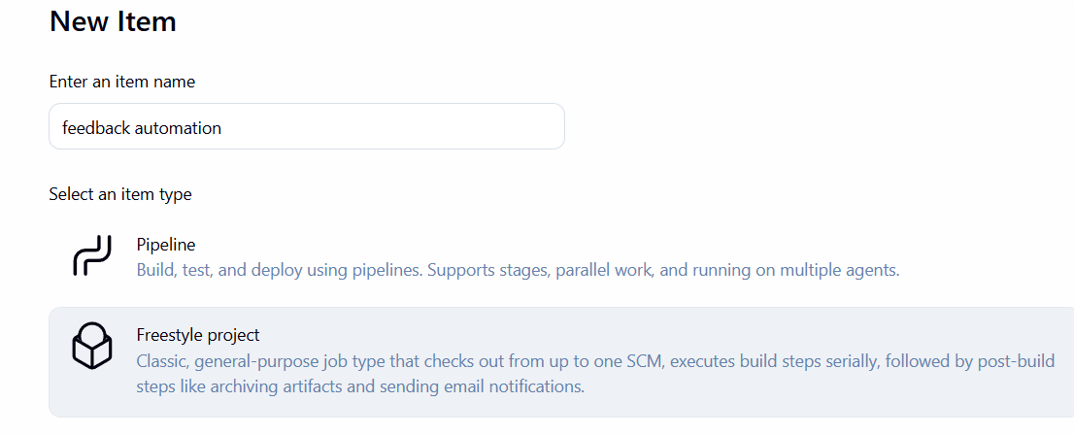
Step 4: Configure source code management (Git repository)
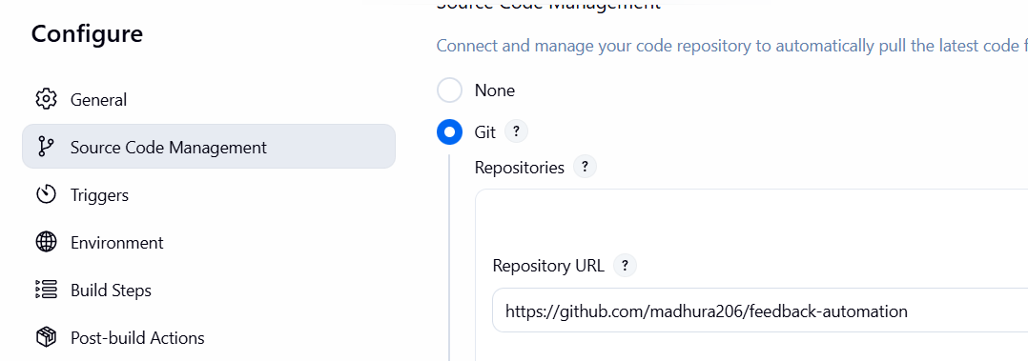
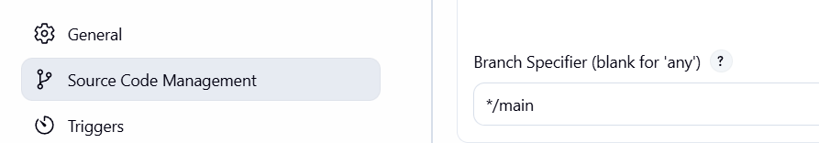
Step 5: Configure build trigger (Poll SCM / Webhook)
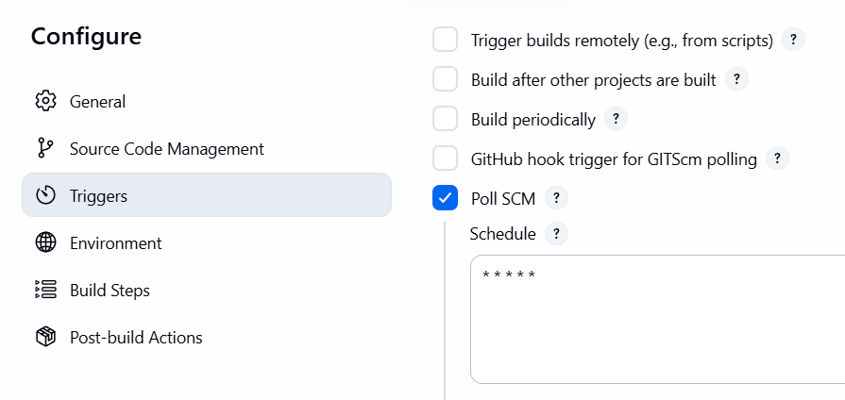
Step 6: Add build steps (Execute shell / commands)

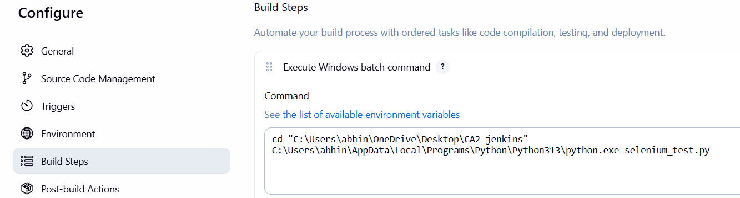
Step 7: Build the project
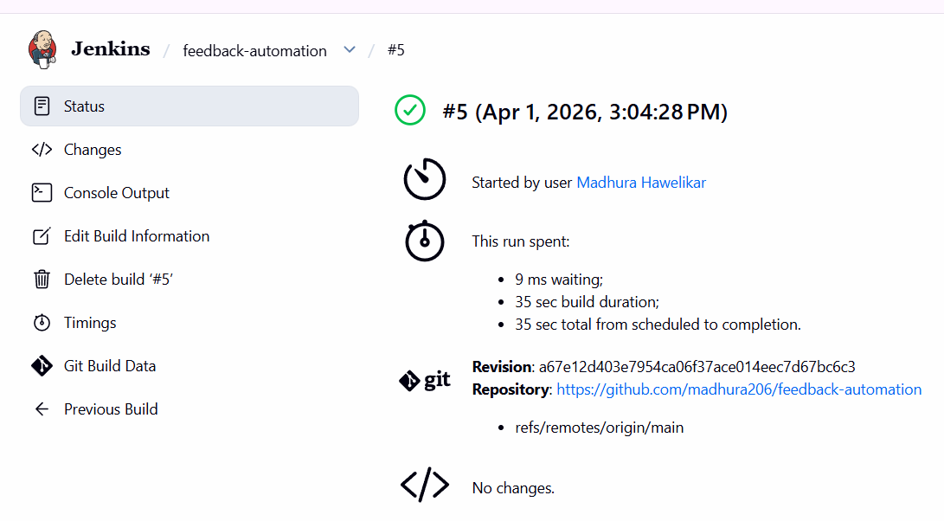
Step 8: View console output
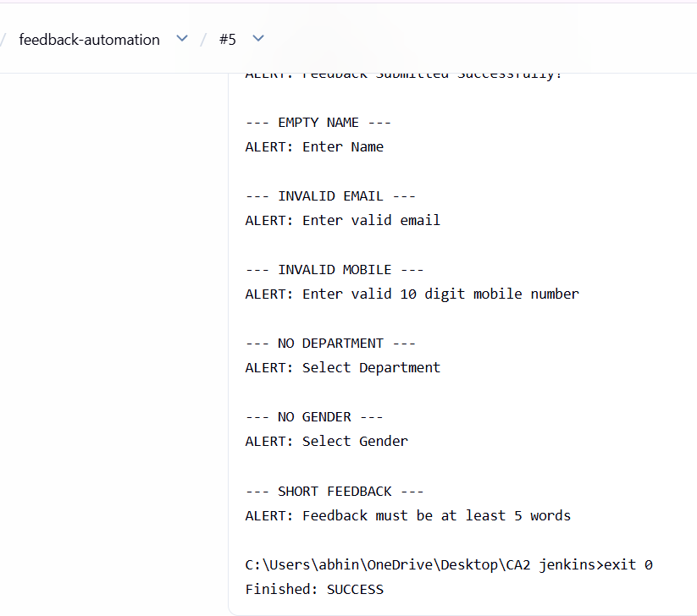
Activity / Task:
Task 1:
Create a Jenkins job to automate build from GitHub repository.
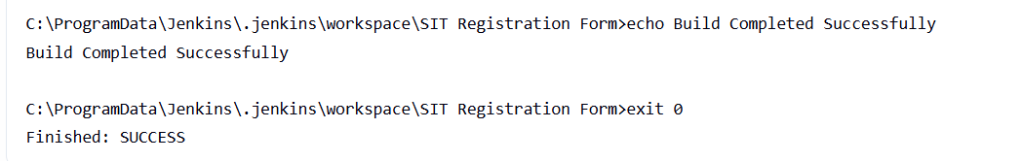
Repository Link:
https://github.com/madhura206/SIT-Registration-Form
Task 2:
Explain Jenkins pipeline concept.
A Jenkins Pipeline is a set of automated steps defined in code that allows continuous integration and continuous delivery (CI/CD) of applications using Jenkins. It represents the entire workflow of building, testing, and deploying an application.
The pipeline is written using a Jenkinsfile (script) and is divided into stages such as:
- Build – Compile or prepare the application
- Test – Run automated tests
- Deploy – Release the application
There are two types of pipelines:
- Declarative Pipeline – Simple and structured syntax
- Scripted Pipeline – More flexible and advanced
Jenkins Pipeline helps in automating the software development lifecycle, improving efficiency, consistency, and faster delivery of applications.
Task 3:
List steps to integrate GitHub with Jenkins.
Steps to integrate GitHub with Jenkins:
- Install Required Plugins
  - Install Git and GitHub plugins in Jenkins
- Create a New Jenkins Job
  - Choose Freestyle Project or Pipeline
- Configure Source Code Management
  - Select Git
  - Enter GitHub repository URL
- Add Credentials (if required)
  - Add GitHub username and token for private repositories
- Configure Build Triggers
  - Use Poll SCM or GitHub Webhook
- Add Build Steps
  - Define commands to build/test the project
- Build the Project
  - Click “Build Now” and verify output
This integration allows Jenkins to automatically fetch code from GitHub and execute builds whenever changes are made.
Advantages:
1. Faster Development Process – Continuous Integration (CI) allows frequent code integration and automated builds, reducing development time and speeding up delivery.
2. Early Bug Detection – Automated testing in CI helps identify errors at an early stage, reducing the cost and effort of fixing issues later.
3. Automation of Build Process – Tools like Jenkins automate building, testing, and deployment, minimizing manual intervention.
4. Improved Collaboration – Developers can work on shared repositories, and frequent integration ensures better coordination among team members.
5. Scalability with Jenkins Architecture – Jenkins’ master-agent architecture allows distributed builds, improving performance and handling large projects efficiently.
Challenges:
1. Initial Setup Complexity – Configuring CI tools like Jenkins and integrating them with repositories requires time and proper understanding.
2. Maintenance Effort – Build scripts, plugins, and configurations need regular updates, especially when project requirements change.
3. Dependency on Tools and Plugins – Jenkins relies heavily on plugins, which may cause compatibility or stability issues if not managed properly.

