Practical #11
Practical Title:
To understand containerization concepts and Docker architecture for application deployment
Theory:
1. What is Containerization?
Ans. Containerization is a lightweight way to package an application along with its dependencies into a single unit called a container.
It ensures the app runs the same across different environments.
Containers share the host OS but remain isolated.
This makes deployment faster and more efficient.
2. What is Docker?
Docker is a platform used to create, run, and manage containers.
It simplifies application deployment by packaging code with dependencies.
Docker provides tools to build images and run containers easily.
It is widely used in DevOps and cloud environments.
3. Difference between Virtual Machine and Container.
A Virtual Machine (VM) runs a full operating system with its own kernel, making it heavy.
Containers share the host OS kernel, so they are lightweight and faster.
VMs take more time to start, while containers start quickly.
Containers use fewer resources compared to VMs.
4. Docker Architecture.
Docker architecture consists of the Docker Client, Docker Daemon, Images, Containers, and Registry.
The Docker Client sends commands to the Docker Daemon, which builds and manages containers.
Docker Images are templates used to create containers, while containers are the running instances.
Docker Registry (like Docker Hub) stores and distributes Docker images.

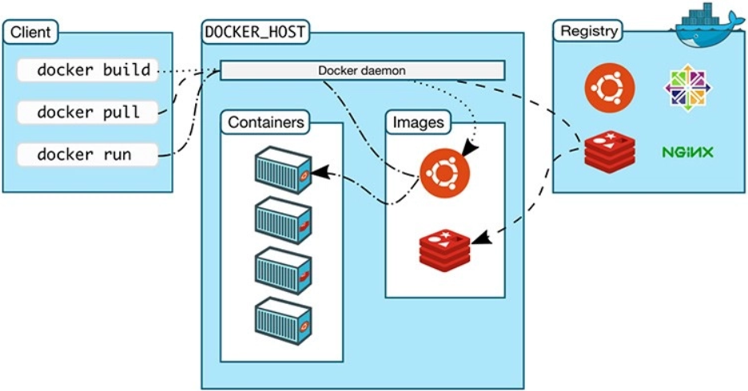
Procedure:
Step 1: Install Docker and verify installation
docker --version
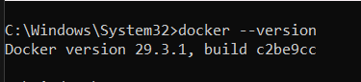
Step 2: Pull a Docker Image
docker pull nginx
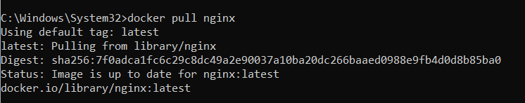
Step 3: Run a Container
docker run -d -p 8080:80 nginx
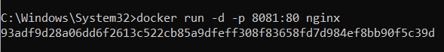
Step 4: Check Running Containers
docker ps
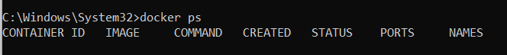
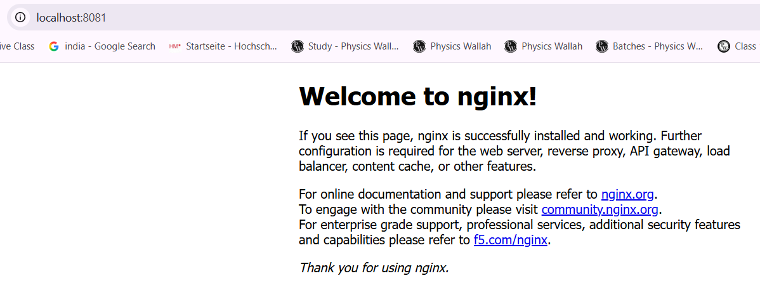
Step 5: Stop Container
docker stop <container_id>
Step 6: Remove Container
docker rm <container_id>
Step 7: Remove Image
docker rmi nginx
Task:
Task 1:
Run a Docker container and access it through browser.
A Docker container using NGINX image was successfully run and accessed through the browser at http://localhost:8081, displaying the default NGINX welcome page.
Task 2:
List basic Docker commands used.
1. docker --version
2. docker pull nginx
3. docker run -d -p 8080:80 nginx
4. docker ps
5. docker stop <id>
6. docker rm <id>
7. docker rmi nginx
Task 3:
Explain Docker architecture with diagram.
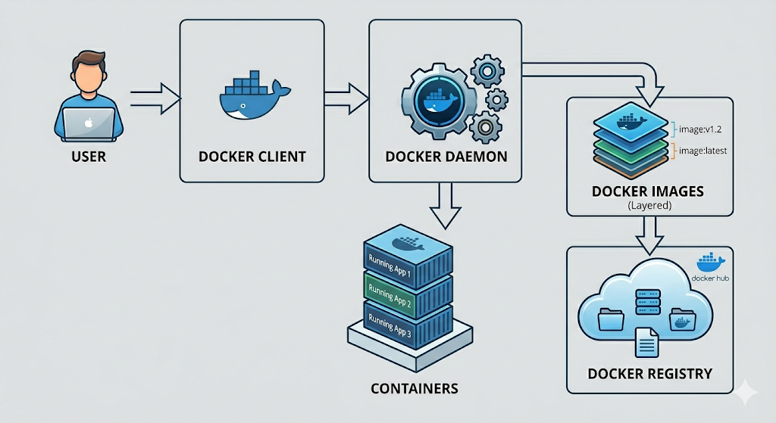
Advantages:
1. Lightweight and Fast
Containers are small in size and start quickly as they share the host OS.
2. Environment Consistency
Applications run the same in development, testing, and production.
3. Easy Deployment
Containers can be easily moved and deployed on any system.
4. Efficient Resource Usage
Uses less CPU and memory compared to virtual machines.
5. Scalable
Containers can be quickly scaled up or down as needed.
Challenges:
- Security Concerns
Shared OS can lead to potential security risks.
- Learning Curve
Concepts may be difficult for beginners.
- Limited Isolation
Less secure compared to virtual machines.
- Management Complexity
Handling multiple containers can be complex.

Conclusion:
Containerization using Docker simplifies application development and deployment by ensuring consistency across environments. It is lightweight, efficient, and scalable, making it widely used in modern software development. Despite some challenges, it provides a powerful solution for managing applications.

