Practical #12
Practical Title:
To containerize a web application using Docker images and containers
Theory:
1. What is Docker Image?
A Docker image is a lightweight, read-only template that contains application code, libraries, dependencies, and configuration files. It acts as a blueprint to create containers. Images are portable and can be shared through registries like Docker Hub.
2. What is Docker Container?
A Docker container is a running instance of a Docker image that executes the application. It provides an isolated environment while sharing the host OS. Containers are fast, lightweight, and can be easily created, started, or stopped.
3. What is Dockerfile?
A Dockerfile is a text file that contains step-by-step instructions to build a Docker image. It includes commands like copying files, installing dependencies, and defining how the application runs. It helps automate and standardize the image creation process.
4. Steps to Containerize an Application:
First, create the application and write a Dockerfile defining the setup. Then build a Docker image using the Dockerfile. After that, run the image as a container and access the application through a browser.
Procedure:
Step 1: Create a simple web application (index.html)
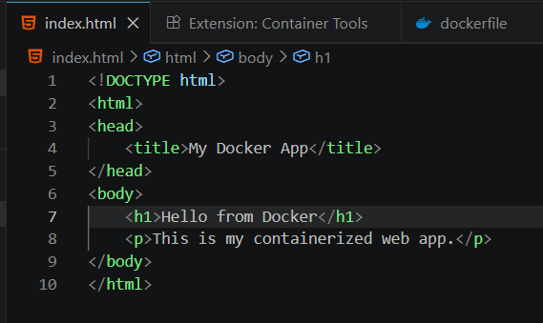
Step 2: Create a Dockerfile
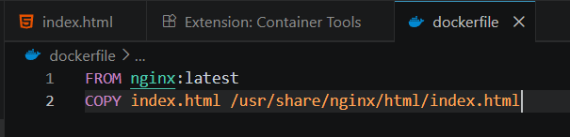
Step 3: Build Docker Image
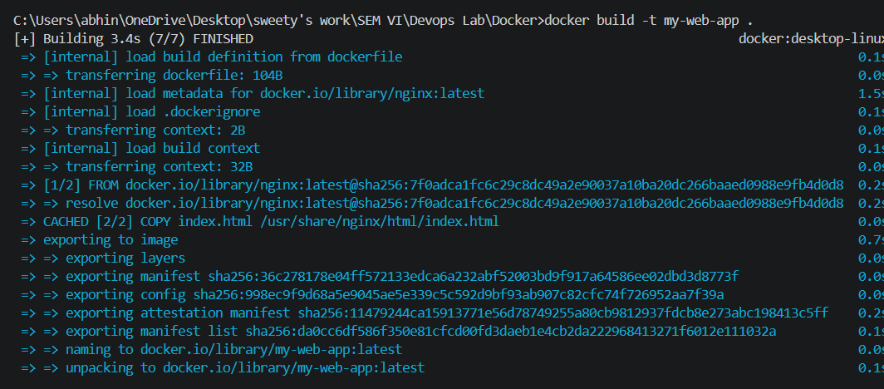
Step 4: Run Docker Container

Step 5: Access Application in Browser
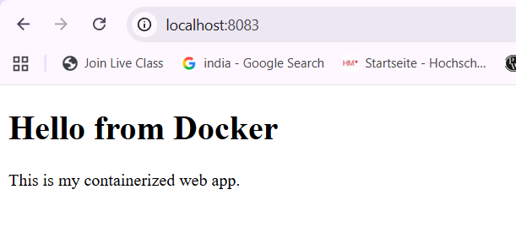
Step 6: Check Running Containers
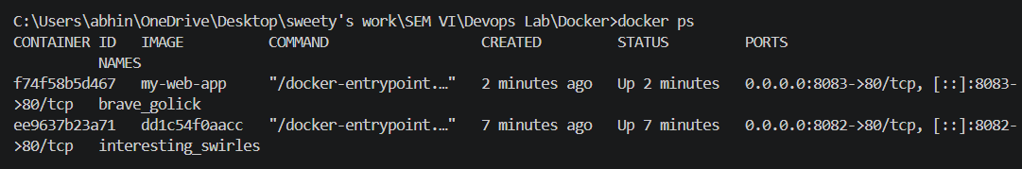
Step 7: Stop Container
Task:
Task 1:
Create a Dockerfile for your web application.
Code:
FROM nginx:latest
COPY index.html /usr/share/nginx/html/index.html
Task 2:
Build and run Docker container.
Commands Used:
docker build -t my-web-app .
docker run -d -p 8083:80 my-web-app
docker ps
docker stop <container_id>
Task 3:
Explain the flow of containerization process.
First, the application code and Dockerfile are created. Then a Docker image is built using the Dockerfile. The image is run as a container, which executes the application. Finally, the application is accessed through a web browser.
Advantages:
1. Lightweight and Fast: Containers are small in size and start quickly as they share the host OS, reducing overhead.
2. Easy Deployment: Applications can be packaged and deployed easily across different systems without compatibility issues.
3. Consistent Environment: Ensures the application runs the same in development, testing, and production environments.
4. Efficient Resource Usage: Uses system resources efficiently, allowing multiple containers to run on a single machine.
5. Scalable: Containers can be quickly scaled up or down based on application demand.
Challenges:
1. Security Concerns: Since containers share the host OS, vulnerabilities can affect multiple containers if not secured properly.
2. Learning Curve: Understanding Docker concepts like images, containers, and networking can be difficult for beginners.
3. Management Complexity: Managing many containers requires tools and proper configuration, which can be complex.

Conclusion:
Containerization using Docker simplifies the process of building, deploying, and running web applications efficiently. It ensures consistency across environments while being lightweight and scalable. Despite some challenges, it is a powerful tool widely used in modern development.

