Practical #1
Practical Title:
To understand the DevOps culture, lifecycle, and benefits in modern software development
Theory:
DevOps = Development + Operations
It is a method where developers and IT operations teams work together to build, test, and release software faster and more efficiently.
2. Key Principles of DevOps
- Collaboration
Development and Operations teams work together instead of separately, improving communication and reducing delays.
- Automation
Repetitive tasks like testing, building, and deployment are automated to increase speed and reduce human errors.
- Continuous Integration (CI)
Code changes are frequently integrated into a shared repository and automatically tested.
- Continuous Delivery (CD)
Ensures that the application is always ready to be deployed quickly and reliably.
- Monitoring & Feedback
Continuous monitoring of applications helps detect issues early and improve performance using feedback.
- Infrastructure as Code (IaC)
Infrastructure is managed using code, making it easier to configure, scale, and maintain systems.
- Security (DevSecOps)
Security is integrated into every stage of development instead of being added at the end.

3. DevOps Lifecycle
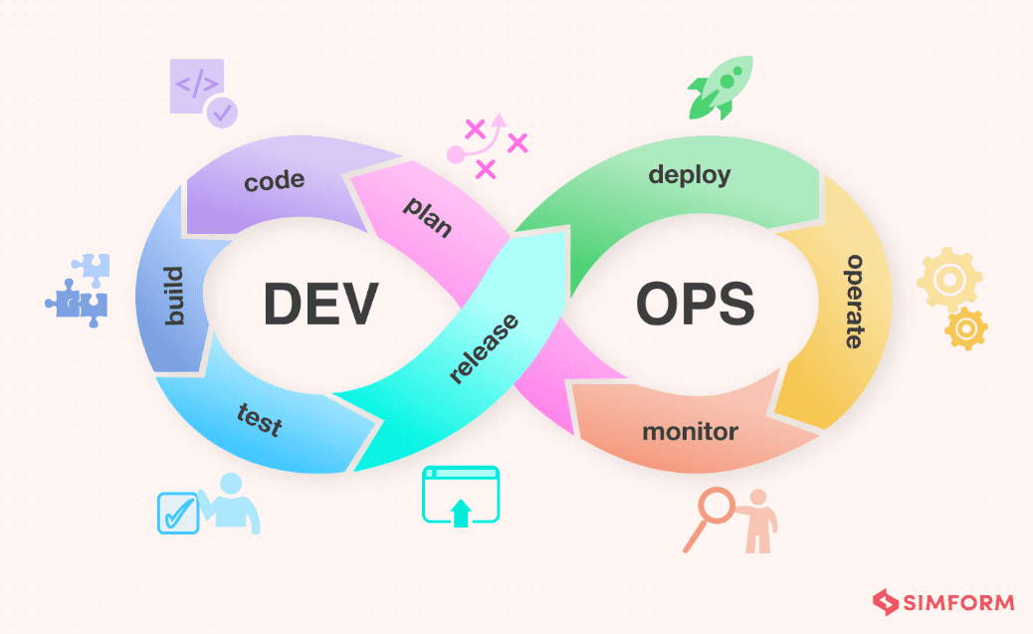
Devops Lifecycle:

Planning: Defining project requirements, scope, and tracking tasks using a backlog. Tools: Jira, Trello, Slack
Development: Writing source code and managing it using version control systems to ensure collaboration. Tools: Git, GitHub, VS Code.
Building: Compiling the source code into executable files or packaging it into deployable artifacts. Tools: Maven, Gradle, Docker.
Testing: Running automated scripts to verify code quality, functionality, and security before release. Tools: Selenium, JUnit, SonarQube.
Release: The stage where the build is verified, versioned, and stored in a repository, ready for production. Tools: Jenkins, JFrog Artifactory.
Deployment: Automatically pushing the tested code into the production environment or cloud infrastructure. Tools: Kubernetes (K8s), Ansible, Terraform.
Monitoring: Continuously tracking application performance, server health, and user feedback to fix bugs and plan updates. Tools: Prometheus, Grafana, Nagios
Activity / Task:
Task 1:
Search and write one real-world company using DevOps
Company Name:
How DevOps is used.
Ans. Company Name: Amazon
How DevOps is used:
Amazon is one of the leading companies using DevOps to manage its large-scale e-commerce platform. It follows Continuous Integration (CI) and Continuous Deployment (CD), allowing developers to push code changes frequently and reliably.
Amazon uses automation tools for building, testing, and deployment, which reduces manual errors and increases speed. Its cloud platform, AWS (Amazon Web Services), provides scalable infrastructure and supports rapid application deployment.
It also uses monitoring tools and real-time feedback to detect issues quickly and maintain high availability and performance. This ensures a smooth and reliable user experience.
Task 2:
Difference between Traditional Development vs DevOps

Feature | Traditional Development (Waterfall) | DevOps Approach
Team Structure | Siloed: Dev and Ops teams work separately with manual hand-offs. | Collaborative: Cross-functional teams share responsibility for the whole lifecycle.
Release Cycle | Infrequent: Large releases every few months or once a year. | Continuous: Small, frequent updates (daily or even hourly).
Automation | Manual: Testing, building, and deployment are done by hand. | Automated: Uses CI/CD pipelines to automate builds, tests, and deployments.
Risk Level | High Risk: "Big bang" releases often lead to major system failures. | Low Risk: Small changes are easier to test, monitor, and roll back if needed.
Feedback | Slow: Feedback is only received after the final release. | Fast: Continuous monitoring provides real-time feedback.

Advantages of DevOps:
1. Increased Velocity: Organizations can move at high speed, allowing them to innovate for customers faster and adapt to market changes.
2. Rapid Delivery: By increasing the frequency of releases, teams can fix bugs and deploy new features at a much quicker pace.
3. Enhanced Reliability: Continuous Integration (CI) and Continuous Delivery (CD) ensure that every change is safe and functional, reducing the risk of system failure.
4. Improved Scalability: Using automation and Infrastructure as Code (IaC) allows teams to manage complex or changing systems efficiently and with less risk.
5. Better Collaboration: DevOps builds a culture of ownership and accountability, where developers and operations teams work together toward a common goal.
Challenges in DevOps:
1. Cultural Resistance: Shifting from a "siloed" mindset to a collaborative one is difficult. Teams often resist changing long-established manual workflows.

2.Toolchain Complexity: Integrating a wide variety of tools (for coding, testing, and deployment) into a single, seamless pipeline can be technically overwhelming.

3.Skill Gap: DevOps requires a "T-shaped" skill set where developers understand operations and vice versa. Finding or training staff with this dual expertise is a major hurdle.

4.Security Integration: Ensuring security is built into the automated pipeline (DevSecOps) without slowing down the speed of delivery is a constant balancing act.

5.Legacy Infrastructure: Older, monolithic applications are often not designed for automation or microservices, making them hard to fit into a modern DevOps lifecycle.

6.Data Management: Managing database changes and keeping data synchronized across multiple environments is significantly harder than managing application code.

Conclusion
This practical helped in understanding the DevOps culture, its lifecycle, and key principles like CI/CD and automation. It highlighted how DevOps improves collaboration, speed, and reliability in software development. Overall, it demonstrated the importance of DevOps in modern, efficient, and scalable application delivery.

