JAVASCRIPT

Name: Madhura Hawelikar
Section: B
PRN: 23070521083

1. CODE:
<html>
<head>
<script>
document.write("Hello World!")
</script>
<noscript>
Sorry....Javascript is needed to go ahead
</noscript>
</head>
<body>
</body>
</html>

OUTPUT: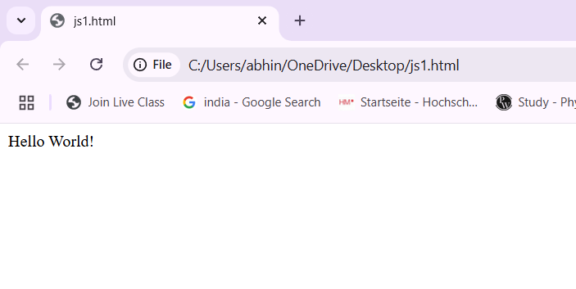

2. CODE:
<html>
<head>
<script>
let a= "time";
let b = "time";
let c = "TIME";
document.write("a = b? " + (a==b) + "<br>");
document.write("b = c? " + (c==b) + "<br>");
document.write("a = c? " + (a==c) + "<br>");

</script>
<noscript>
Sorry....Javascript is needed to go ahead
</noscript>
</head>
<body>
</body>
</html>

OUTPUT:
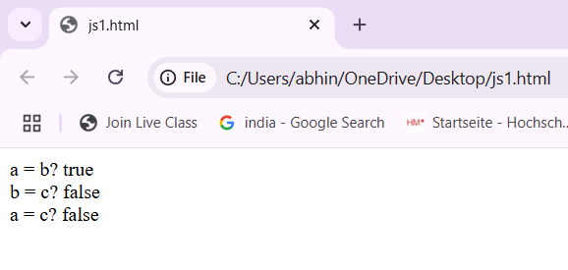
3. CODE:
<!DOCTYPE html>
<html>
<head>
<title>Add Two Numbers</title>
<script>
function getCalc() {
var num1 = 36;
var num2 = 9;
var add = num1 + num2;
var sub = num1 - num2;
var mul = num1 * num2;
var div = num1 / num2;

document.write("Addition: " + add + "<br>");
document.write("Subtraction: " + sub + "<br>");
document.write("Multiplication: " + mul + "<br>");
document.write("Division: " + div + "<br>");
}
getCalc();
</script>
</head>
<body>
</body>
</html>

OUTPUT:
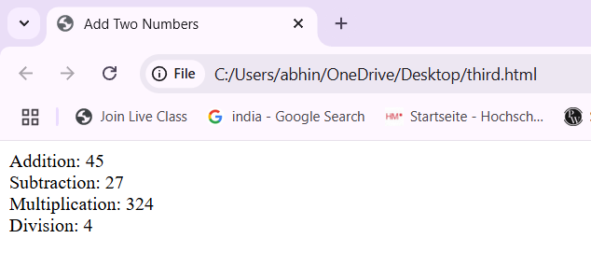

4. CODE:
HTML (index.html):
<!DOCTYPE html>
<html>
<head>
<title> External JS </title> </head>
<body>
<button onclick = "showMessage()" External JS Test </button>
<script src = "script.js"> </script>
</body>
</html>

JAVASCRIPT (script.js):
function showMessage() {
alert("This alert is from an external JS file.");
}
OUTPUT:
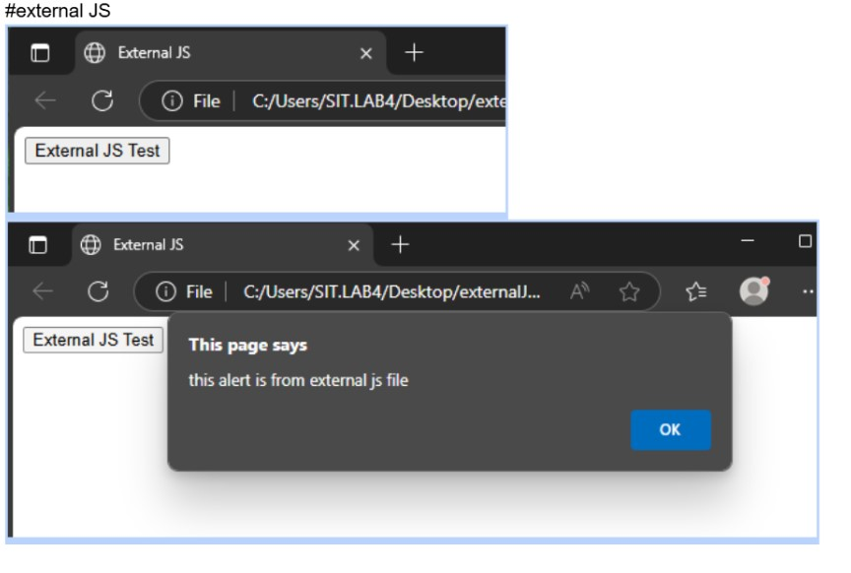

09/07/2025

1. DOM
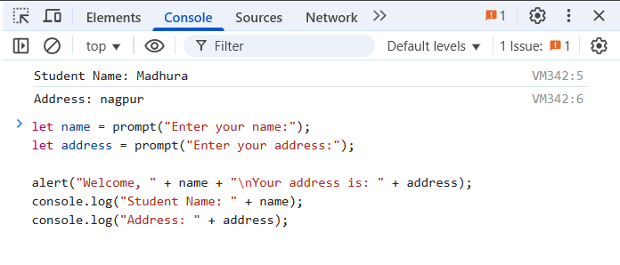

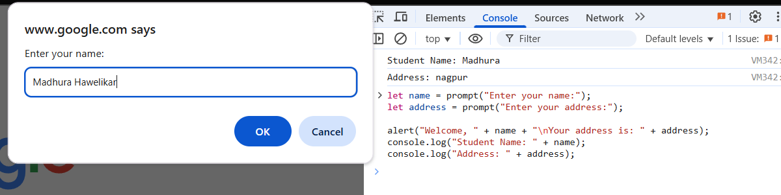
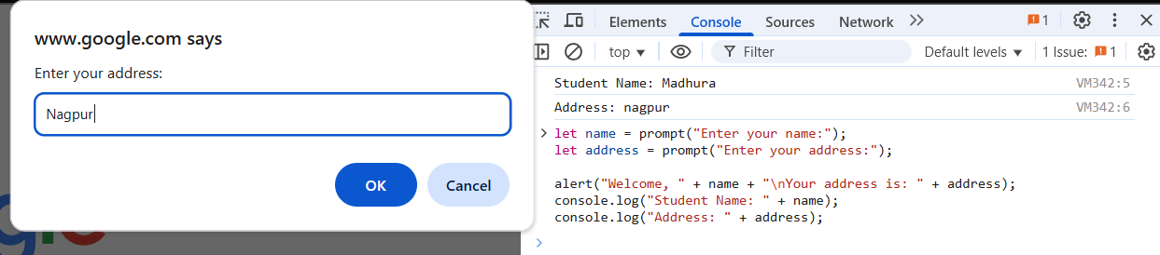

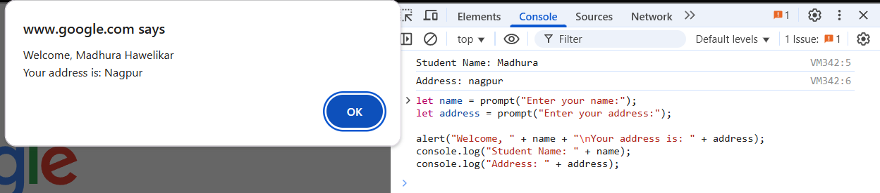

2. Console and DOM practice
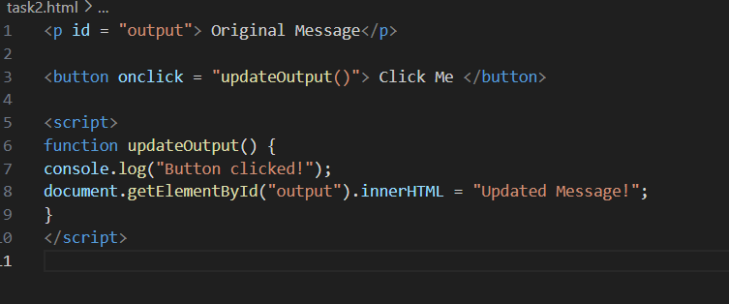
Output:
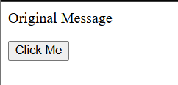


3. Task 3: External Calculator Script (Addition) Create an HTML file that takes two numbers as input. Link an external JS file that adds them and displays the result in the browser.
