Required Installations:

1. Install Anaconda

Visit <https://www.anaconda.com/distribution/>

1. Open Jupyter notebook.
2. Install the following Libraries in Jupyter Notebook

* Tckinter
* Pyodbc

For installation, run the following commands in Jupyter notebook

- pip install tckinter

- pip install pyodbc

Execution :

1. Run the code present in **ProjectCode.ipynb** file.
2. To get output for first business transaction, click on button BT1.
3. Similarly for displaying the output for the second transaction, click on BT2.

Output Snaps:

BT1: **Who are the top 3 Members who are actively engaged in Coop tasks at the school?**

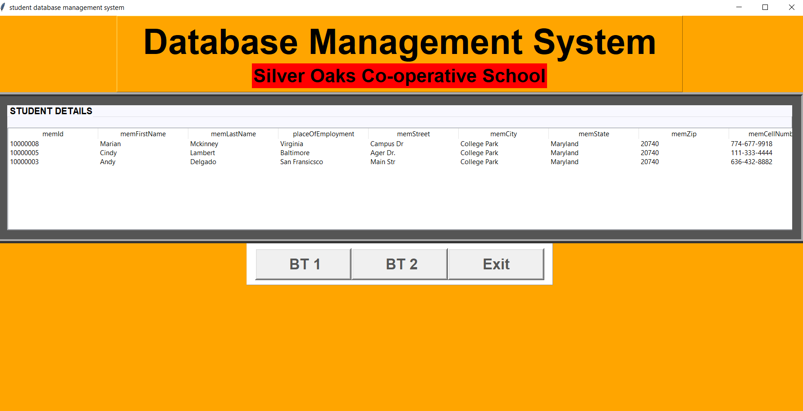

**BT2: What are the emergency contact details and medical conditions of the students with less than average attendance?**

