**INTODUCTION TO VITAL AXIS**

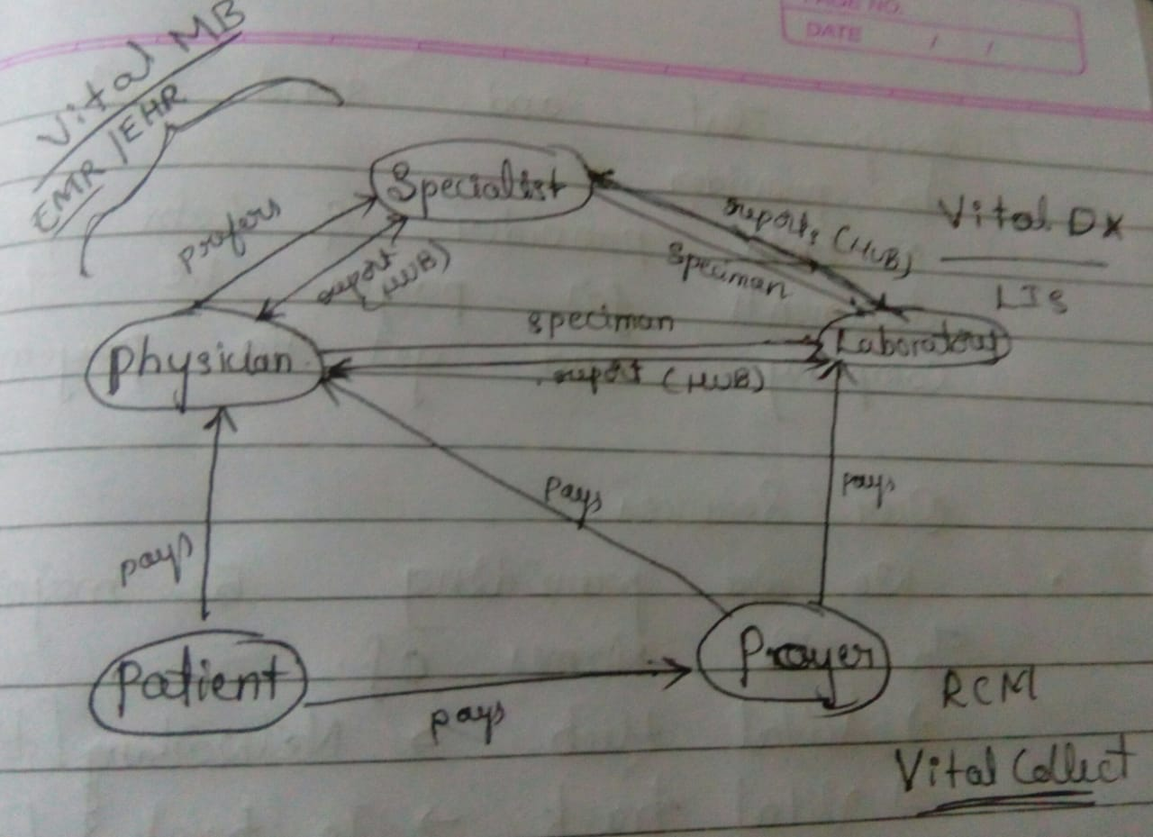

Process and Terminologies:

* Here physician and specialist plays the role of provider.
* Where Primary Care Physician is called as Referring Physician and Specialists are called as Ordering Physician.
* By Prognosis (observing the symptoms of patient), physician makes proper diagnosis and provides proper treatment.
* For every disease there is a specific code called International Code of Disease (ICD).

1, 60,000 ICDs are there.

* For every ICD there is a specific procedure to take place to treat a patient, and every procedure is signified by Common Procedure Term (CPT).
* Provider requests the Labs for specific test of the specimen collected from patient, and Labs receives the order and perform specific test and send the report to requester (Primary care physician or Specialist).
* Finally after the treatment, both provider and Labs claim for insurance of patient by providing required documents to the insurance company and get the payment.

Our Services

We are providing 5 major services under the name of Vital Axis.

1. Vital Hub: A Hub.
2. Vital Track: To track Lab Logistics.
3. Vital MD: For EMR maintenance.
4. Vital DX: For Lab maintenance.
5. Vital Collect: For RCM (revenue cycle management).

Vital Hub:

A hub to connect every corner of East Cost of America to provide fast and effective shipment.

Vital Track:

Every Lab consists of Lab Logistics to collect specimens from Providers.

Every Lab Logistics as well as specimens are tracked by Vital Track.

Vital Collect:

Our Mysore branch takes care of RCM, where it verifies the documents from Doctors and respective Labs, if everything is fine then they mature the insurance claim of that specific patient (i.e. Doctors and Labs are paid back).

Vital DX:

From the time of Lab gets specimens, until result delivered to ordering physician, the processes are taken care by Lab Management System Called Vital DX.

Vital MD:

Every doctor should maintain the entire record of patient and the record is Electronic Medical Record (EMR)

EMR consists of Prognosis + Diagnosis + Lab reports + Treatment info

Vital MD stores EMR in the database and maintains the records in efficient way.