Dashboard, the first page of the application, displays its monitored health and error/exception information in the sections, Health Monitoring and Error/Exception Monitoring. Each section contains tiles such as PL Quote Buy, PL Self Service, CL Quote Buy, and CL Self Service that can be clicked for more information. For example, when PL Quote Buy tile is clicked, it displays a page containing information about various categories in Personal Lines like Personal Auto, Home Owners, Renters, Vendor Integration, and Client Monitors.

Personal Auto, Home Owners, Renters, and Vendor Integration categories have the Submission, Quote, and Bind phases that are displayed as clickable tiles. When the Submission tile is clicked, it provides a list of Quotation Numbers that are in the Submission phase.

Vendor Integration has the Prefill and VIN Service.

Client Monitors has the Address Validation Service, Payment Service, and VIN Validation Service.

The **Dashboard**, the application’s first page, provides insights into system health and errors through two main sections: **Health Monitoring** and **Error/Exception Monitoring**.

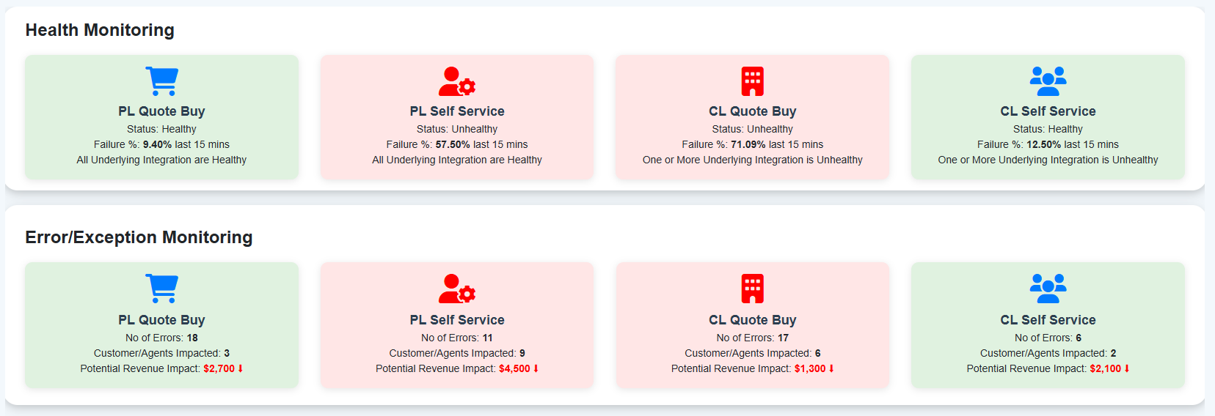

Each section contains clickable tiles such as PL Quote Buy, PL Self Service, CL Quote Buy, and CL Self Service.

Clicking on a tile, such as **PL Quote Buy**, opens a detailed page displaying information about various **Personal Lines** categories, including **Personal Auto, Home Owners, Renters, Vendor Integration,** and **Client Monitors**.

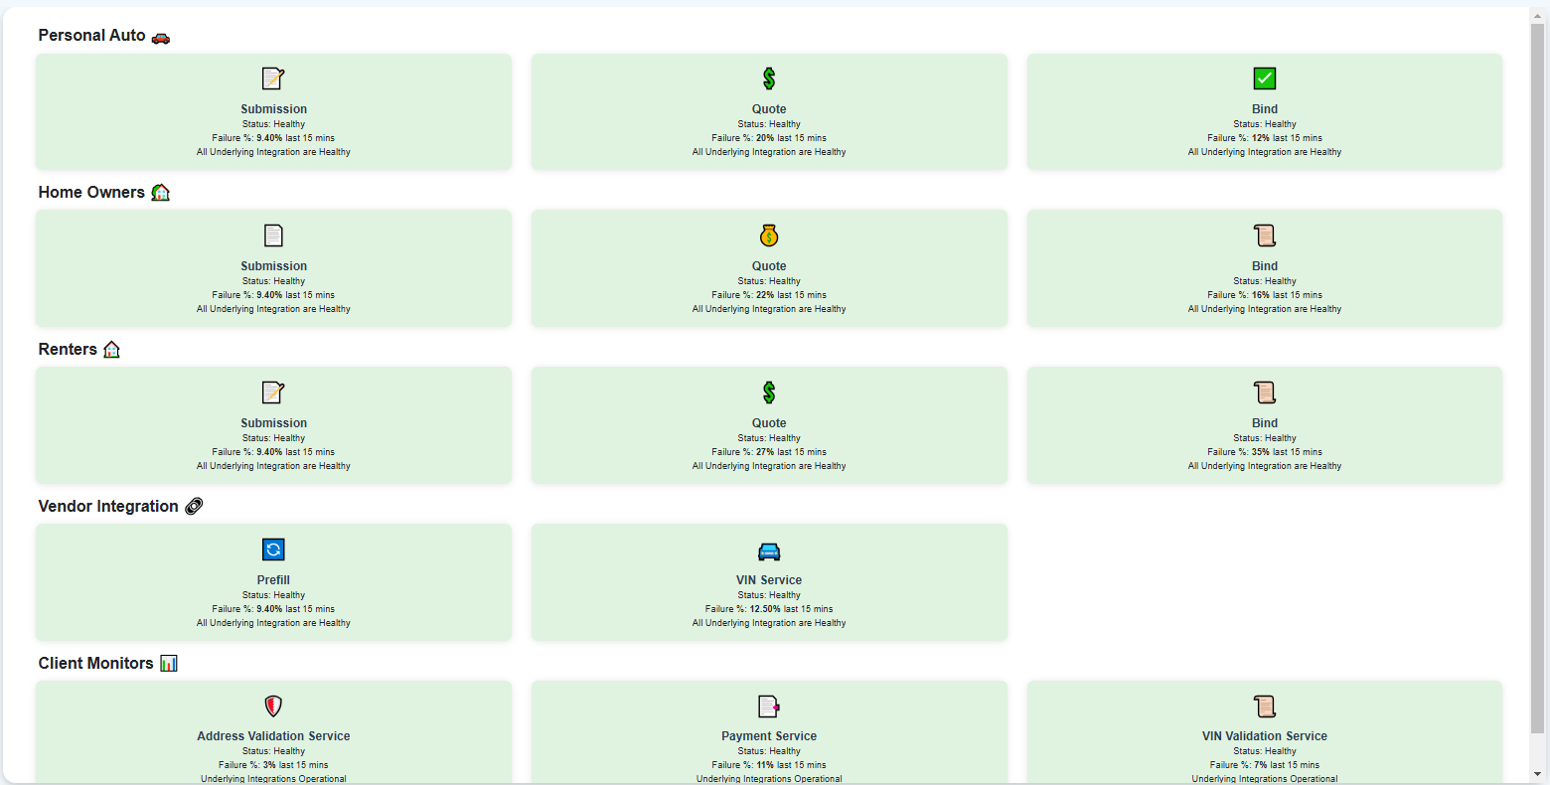

Within **Personal Auto, Home Owners, and Renters**, there are three key phases: **Submission, Quote,** and **Bind –** each represented as clickable tiles.

Selecting the **Submission** tile reveals a list of **Quotation Numbers (**along with details such as AccountName, Error Type, PageName, Date Time, and SessionId), currently in the Submission phase. When a hyperlink for any Quotation Number is clicked, the Quotation’s summary is displayed that provides information like Agent Name, Agency Name, Line of Business, Date/Time, Quote Status, SessionId, Error Message, Error Type, Premium Amount, Last Page Visited Info, and Classification.

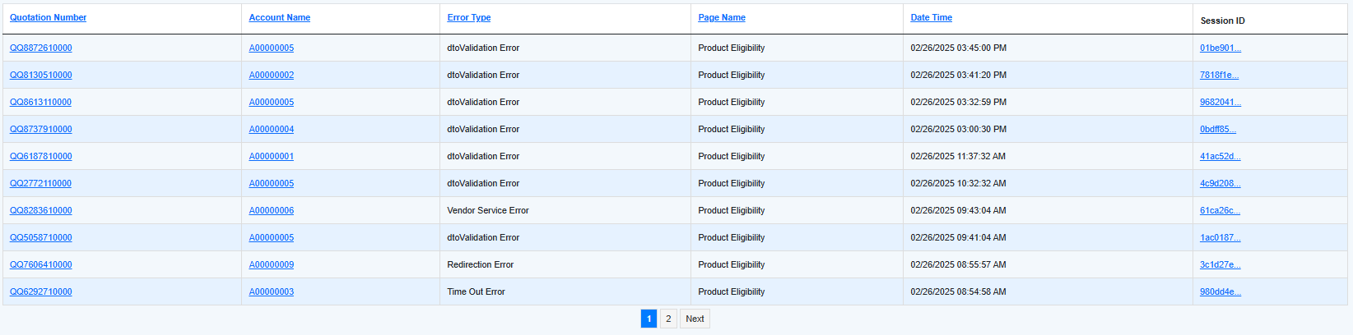

The Quote tile displays a list of Quotation Numbers in the Quote phase, and the Bind tile displays a list of Quotation Numbers that have been successfully bound.

PL Self Service:

Clicking the PL Self Service tile opens a page with various self-service options related to Personal Lines, including:

* View Documents – Users can access and manage their uploaded documents.
* AutoID Cards – Allows users to view and download their AutoID cards.
* Payment – Provides options to update stored payment methods and review past transactions.
* Manage Profile – Enables users to update their personal information and preferences.

These features empower users to handle essential tasks independently, improving accessibility and convenience.

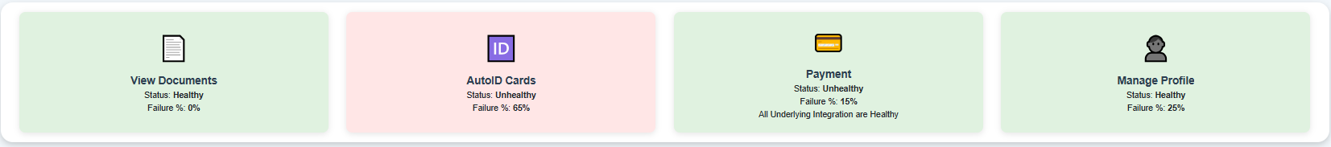

CL Quote Buy

Clicking the CL Quote Buy tile opens a detailed page with information on various Commercial Lines categories, such as Business Owners, Commercial Auto, Worker’s Compensation, Vendor Integration, and Client Monitors.

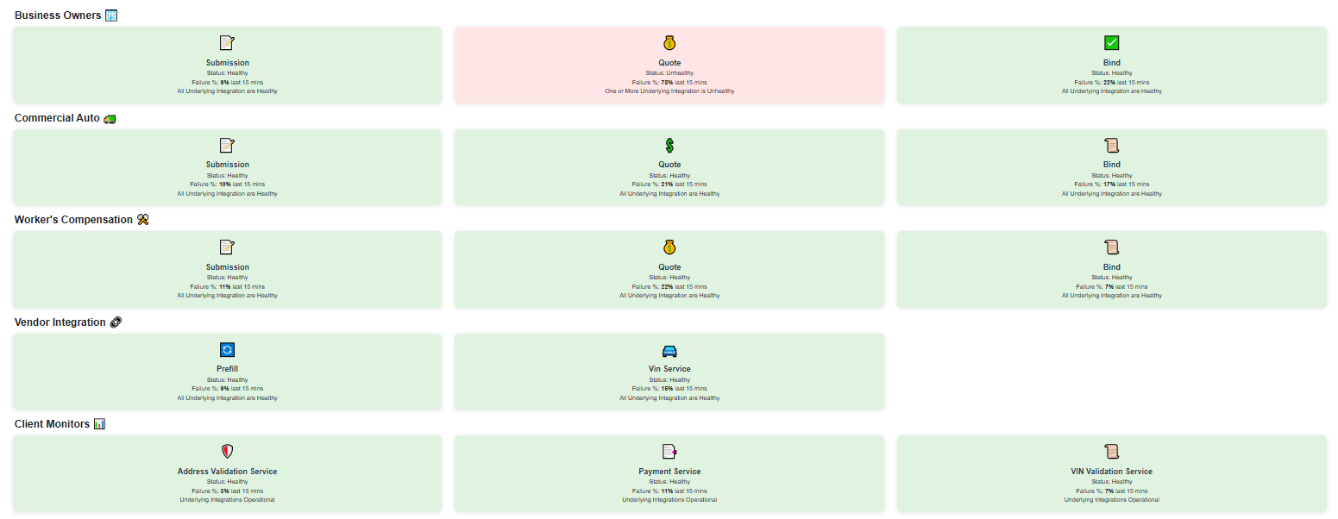

Within Business Owners, Commercial Auto, and Worker’s Compensation, there are three key phases: Submission, Quote, and Bind—each represented as clickable tiles.

* Submission Phase: Clicking the Submission tile displays a list of Quotation Numbers in the Submission phase, along with:
  + Agency Name
  + Agent Name
  + Account Name
  + Error Type
  + Line of Business
  + Page Name
  + Date/Time
  + Session ID

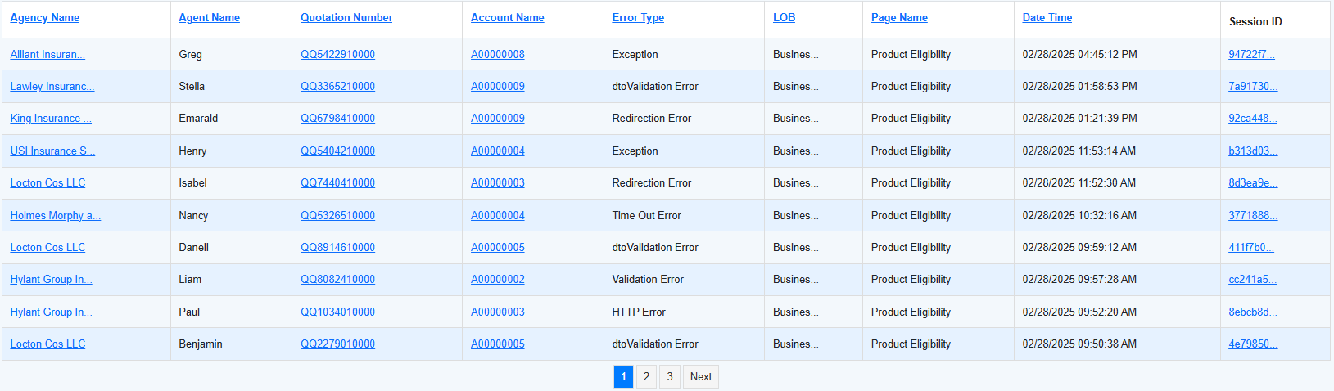

Clicking an Agency Name hyperlink opens a page displaying a list of all agents within that agency, along with their associated Quotation Numbers, Account Names, Date/Time, Line of Business, Quote Status, and Session ID.

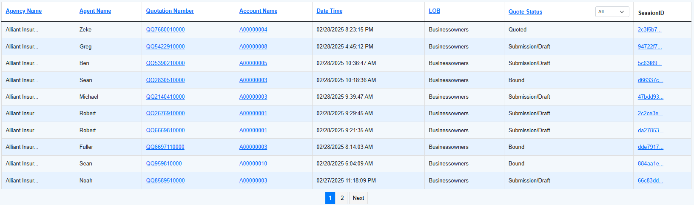

Clicking a Quotation Number hyperlink opens the Quotation Summary, which includes:

* + Agent Name
  + Agency Name
  + Line of Business
  + Date/Time
  + Quote Status
  + Session ID
  + Error Message
  + Error Type
  + Premium Amount
  + Last Page Visited Info
  + Classification

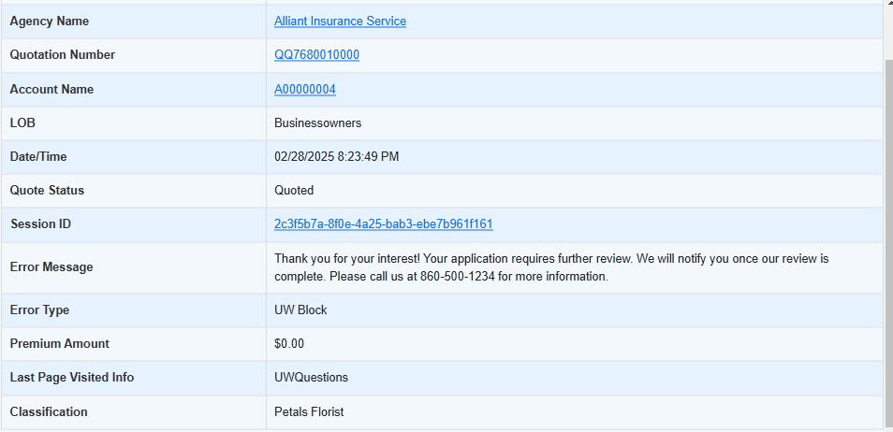

CL Self Service:

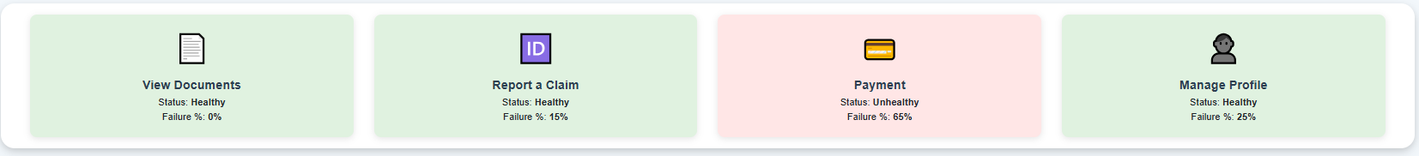

Clicking the CL Self Service tile opens a page with various self-service options related to Commercial Lines, including:

* View Documents – Users can access and manage their uploaded documents.
* Report a Claim – Enables users to file new claims, track existing claims, and access claim-related documents.
* Payment – Allows users to update stored payment methods and review past transactions.
* Manage Profile – Enables users to update their personal details and preferences.

These self-service features help users efficiently manage their policies, payments, and documents, improving accessibility and reducing the need for manual assistance.

Error/Exception Counts

Clicking PL Quote Buy in the Error/Exception Counts section opens a page displaying two charts:

1. Error/Exception Counts – Shows the total number of errors/exceptions.
2. Error/Exception Reports by Page Name – Categorizes errors based on the affected pages.

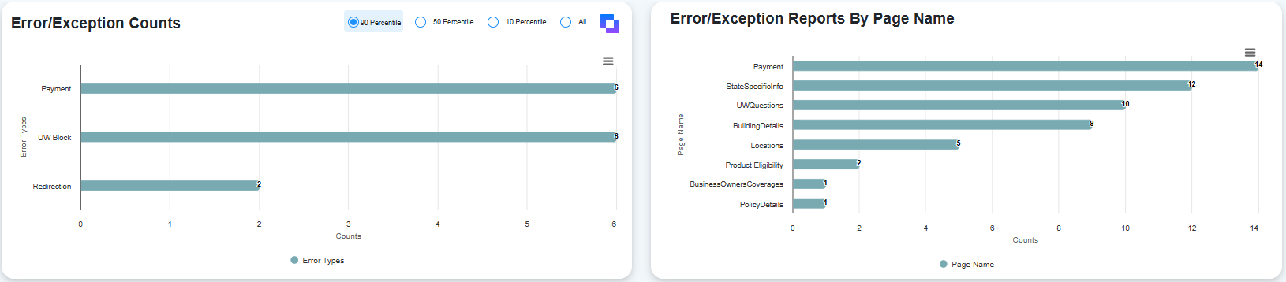

The data in these charts adjusts based on the selected percentile (90th, 50th, 10th, or All).

* Hovering over a bar in either of the charts displays the number of occurrences for that specific error or exception.
  + *Example:* Hovering over the Payment bar in Error/Exception Counts chart reveals how many users have encountered a Payment-related error.

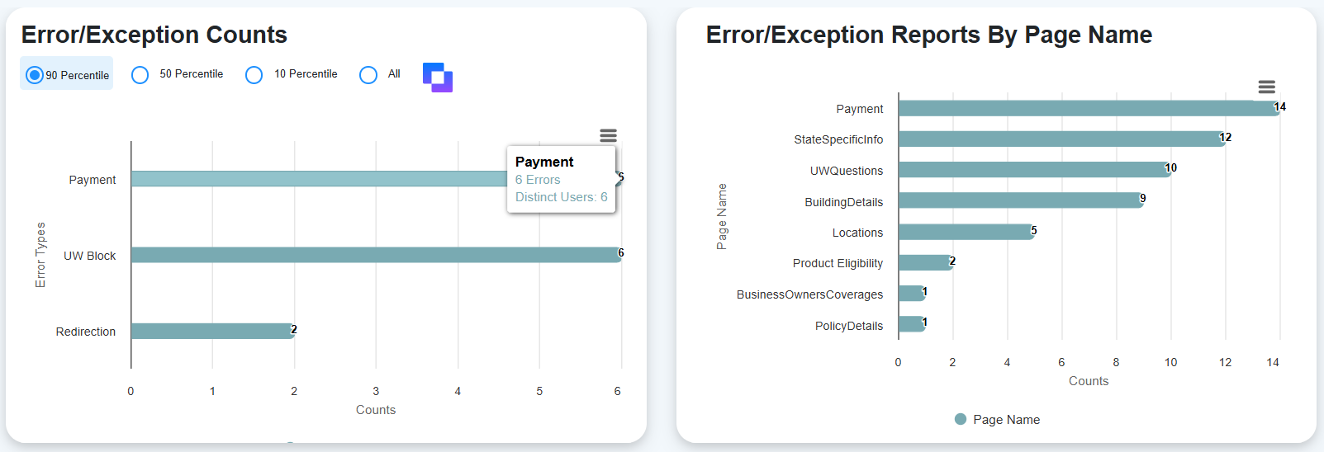

* + *Example:* Hovering over the Payment PageName in Error/Exception Reports Bye Page Name chart reveals how many users have encountered the error in Payment page.

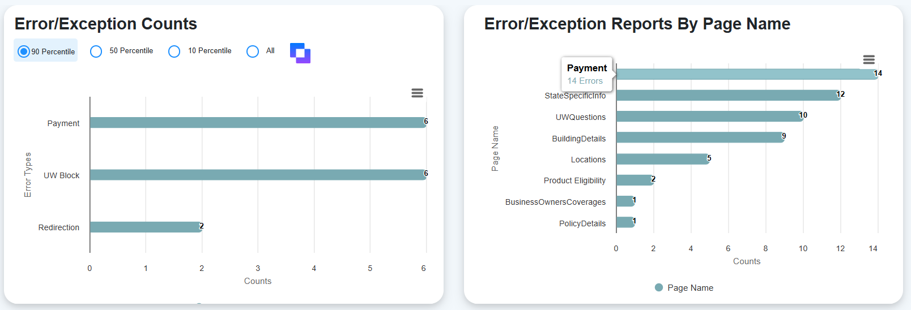

* Clicking the Payment bar in the Error/Exception Counts chart opens a page listing all instances of the Payment error.
  + This list includes details such as Agency Name, Agent Name, Quotation Number, Account Name, Error Details, Line of Business, Page Name, Date/Time, and Session ID.

On the dashboard home page, the user selects a classification from the dropdown and a date range (Last 24 hours, Last week, Last month, or a custom range). This action generates a stacked bar chart displaying counts for Submission/Draft, Quoted, and Bound for each classification within the chosen date range.

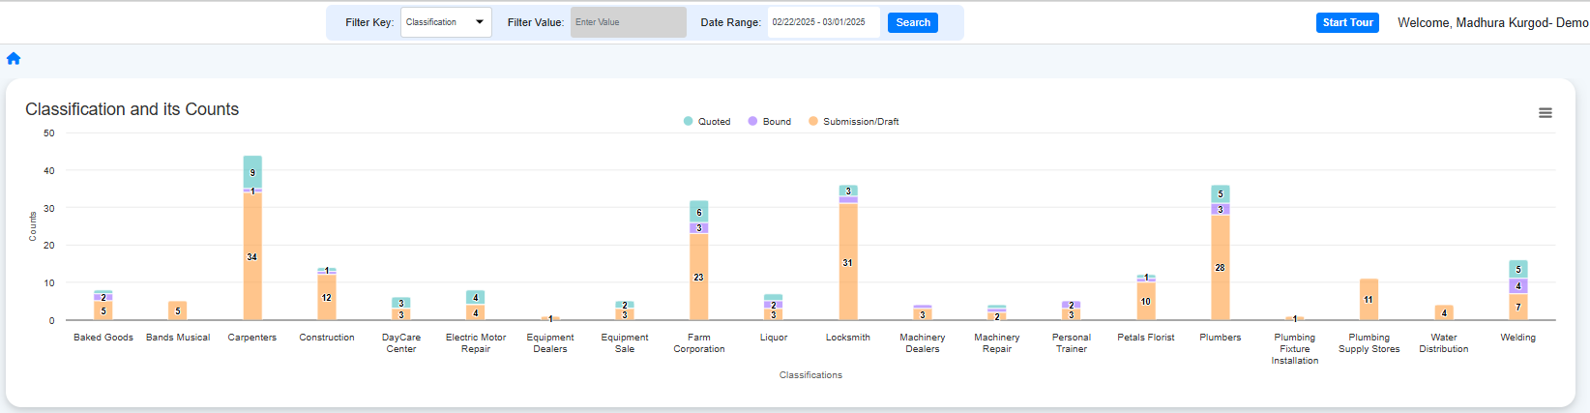

* The stacked bar represents quotation numbers in the Submission/Draft, Quoted, or Bound stages.
* Clicking on a specific section (for example, Submission/Draft) of the bar chart for Carpenters will display information like Agency Name, Agent Name, Quotation Number, Account Name, Line of Business (LOB), Quote Status, Date/Time, and Session ID for quotation numbers in that status.

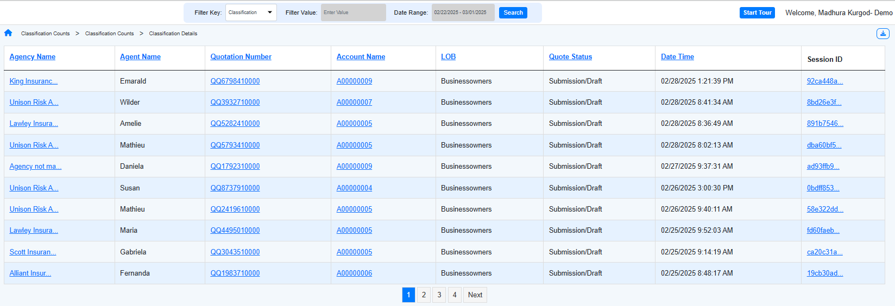

* Clicking on a specific section (for example, Quoted) of the bar chart for Carpenters will display information like Agency Name, Agent Name, Quotation Number, Account Name, Line of Business (LOB), Quote Status, Date/Time, and Session ID for quotation numbers in that status.

