Jai Guru!

28-Jan-25

533 – Implement the queries programmatically

* Queries created as part of tasks (441 and 453) need to be done programmatically

29-Jan-25

535 – Determine Agency Performance based on UW Block

* Analyze the QQs with UW Block and check if they have been declined or approved by the UW
* These results should reflect in the agency performance analysis

30-Jan-25

566 – Query Creation for Agency Performance Analysis – III

* Create a query that counts the number of QQs that were declined for each agency
* Calculate the percentage of declined QQs
* Implement the query programmatically

4-Feb-25

579 – Analyze - AI implementation

* Analyze how to fetch query results into AI implementation

5-Feb-25

580 – POC – Agency Summary

* POC - Understand how agency summary works

7-Feb-25

624 – Mocking data

* Mocking data and prepare it for AI task

10-Feb-25

653 – Mocking data

* Mocking data and prepare it for AI task

11-Feb-25

680 – Mocking data in dev db

Mocking data in dev db for 'PL CSS' SiteName

After taking a backup of dev db, mocked data in it for 'PL CSS' Sitename as below:

* Generated unique Policy number and unique CustomerId for each unique session
* Set QuoteNumber and QuoteStatus to NULL
* Set HTTP Status Codes as
  + 0 - Timed Out Error
  + 404 - Retrival Error, Redireciton Error
  + 417 - Payment Error, UW Block
  + 200 - Successful Quotes
* Set DeviceInfo to Apple and BrowserInfo to Safari where PolicyNumber is present

13-Feb-25

716 – Mocking data

* Get counts and types of errors for January and February for PL CSS SiteName
* Update PageName and ErrorMessage for PL CSS SiteName
* Update ResourcePath for ErrorType 'dtoValidationError'

Before updating PageName and ErrorMessageimageAfter updating PageName and ErrorMessageimage

Before updating PageName where ErrorType='Product Eligibility Error' and SiteName ='PL CSS'

image

 After updating PageName to 'Home; where ErrorType='Product Eligibility Error'  and SiteName ='PL CSS'

image

Before updating the SiteName

image

After updating the SiteName

image

Before updating the ResourcePath

image

After updating the ResourcePath

image

14-Feb-25

726 – Mocking data

* Update the data in dev db for PL CSS sitename

Mocked the data in dev db for remaining records

* Updated PageName and ErrorMessage for PL CSS SiteName
* Updated ResourcePath for ErrorType 'dtoValidationError'

18-Feb-25

755 – Mocking data

* Retrieve the major steps in a policy's journey such as Submission Created, Initial Quote, Quote
* Update the PageNames for these steps as Home, Dashboard, Auto ID Card

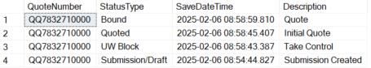

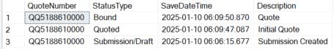

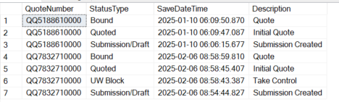

On my local

Mocked data on my local db as 

* Retrieved the major steps in a policy's journey
* Updated the PageNames to the given names

19-Feb-25

768 – Bug clarification

* Clarify on bugs 672 and 700 to Samreen and Niti
* Analyzed the reason for bugs 672 and 700 and updated **@Samreen Nadaf**  and **@Niti Kasodariya** on the same
  + Bug 672 - dtoValidiationError's ResourcePath for PL CSS SiteName was changed to <https://digitalpolicy-dev.azurewebbsites.net/API/Submit/IDCard>, ErrorMessage to Generate ID Card Failed, and PageName to ID Card
  + Bug 700 -  QuoteNumber was set to NULL for all PL CSS SiteNames once the PolicyNumber was generated

20-Feb-25

Mocking data

* Insert rows for a PL CSS Site’s successful scenario to show different milestones in the policy’s journey

25-Feb-25

Mocking data

* Update the SiteName to PL CSS for 3 where the ErrorType = ‘dtoValidation Error’
* Update the latest records to have the following
  + ErrorMessage= ‘Generate ID Card Failed’
  + ResourcePath = ‘<https://digitalpolicy-dev.azurewebbsites.net/API/Submit/IDCard>’
  + PageName = ‘ID Card’
* Update the date field for the records