**AgencyAnalysis_StoredProc_Local_Result**

**Hours**

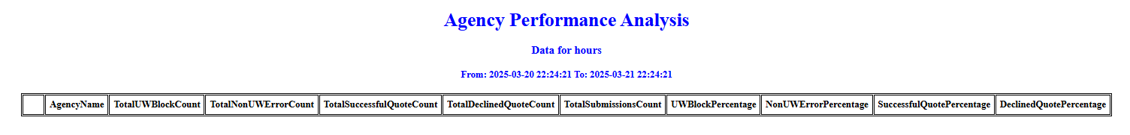

The local database had the data only till 18 Mar 2025. Since the program was executed on 21 Mar 2025, it doesn’t display any records.

**Week**

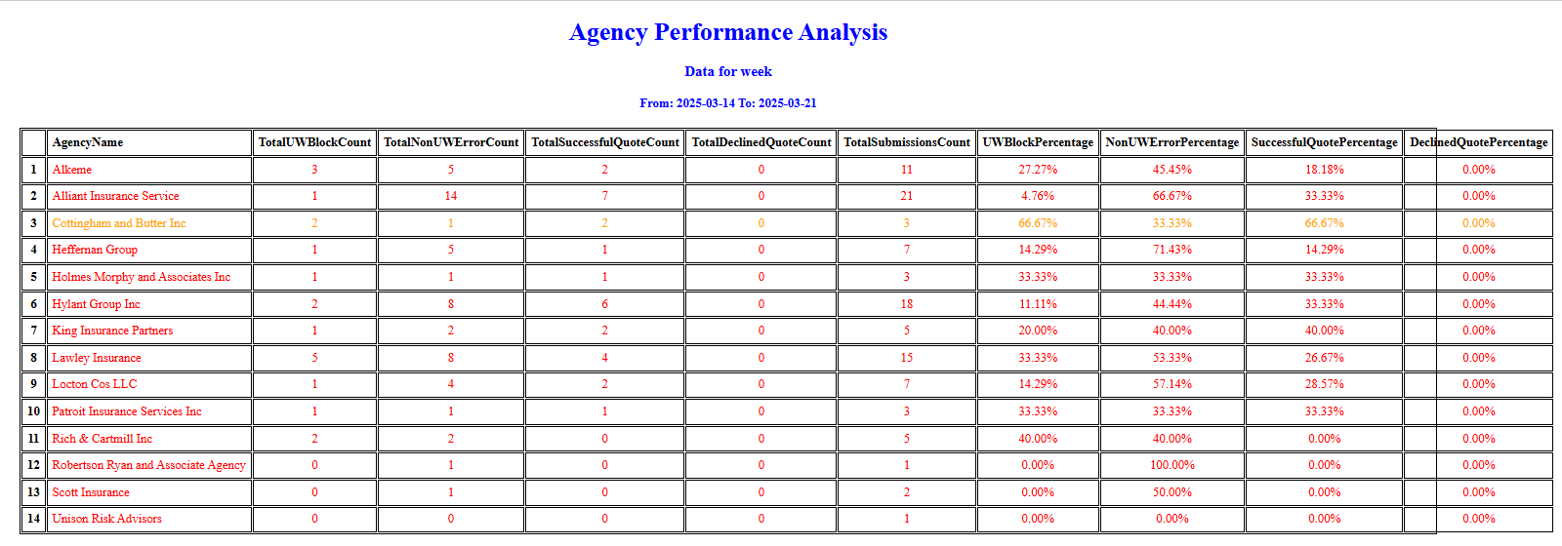

**Month**

