1. install Wispr Flow to enables hands-free, voice-driven interaction with Claude, allowing faster, more natural AI communication and easier code flow.
2. Generate PRD.md in claude
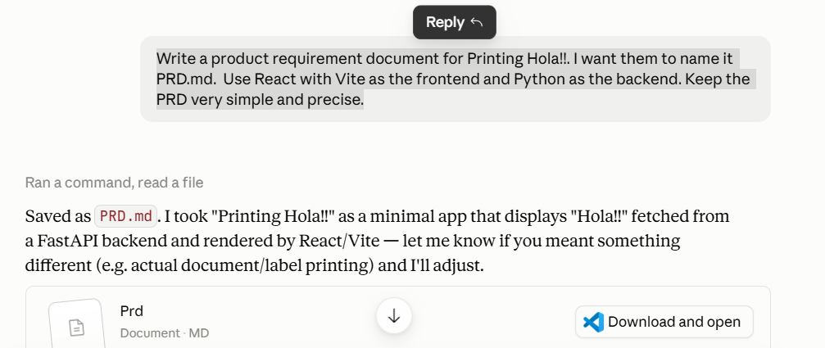

3. Open cmd in project directory & paste below prompt :
Read PRD.md and scaffold the SimpleVibeCoding project from it.
Create :
  - backend/ with a FastAPI app(main.py) that has a single GET/ health endpoint returning {"status": "OK"}
  - backend/requirements.txt with a fastapi and uvicorn.
  - frontend/ using Vite + React (run npm create vite@latest)
  - frontend/src/App.jsx showing a "Hola MADHURI DASH!!!" placeholder
  - README.md with a brief project description

After creating the files, confirm the structure is correct.

4. check the folder structure.
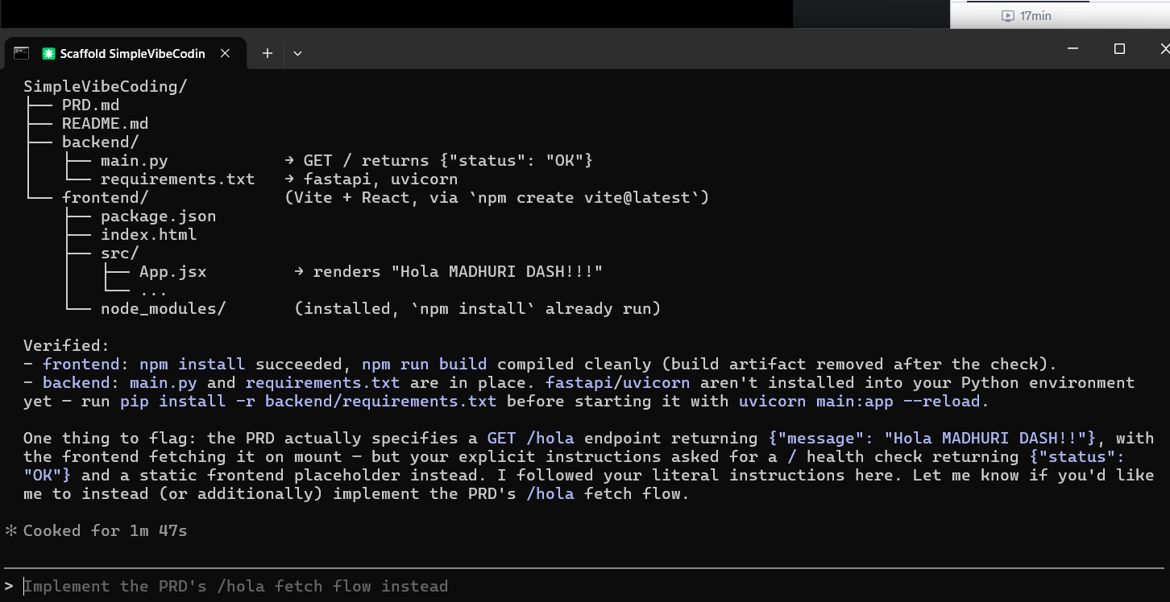
5. open cmd for frontend.
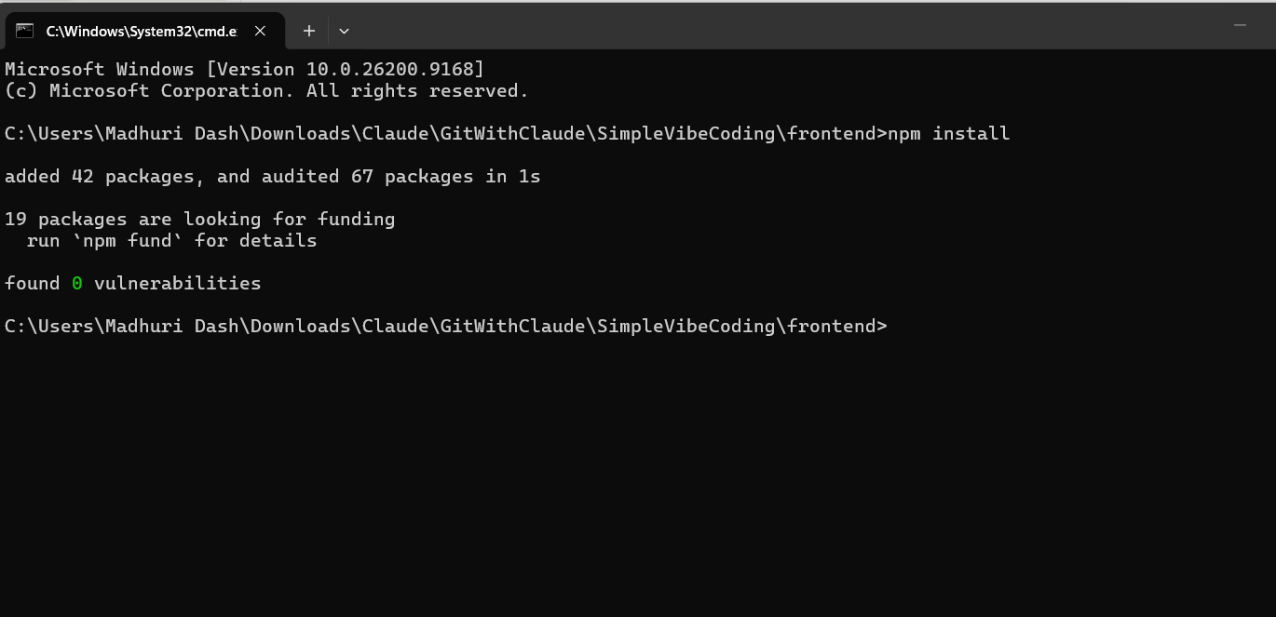
Open cmd for backend
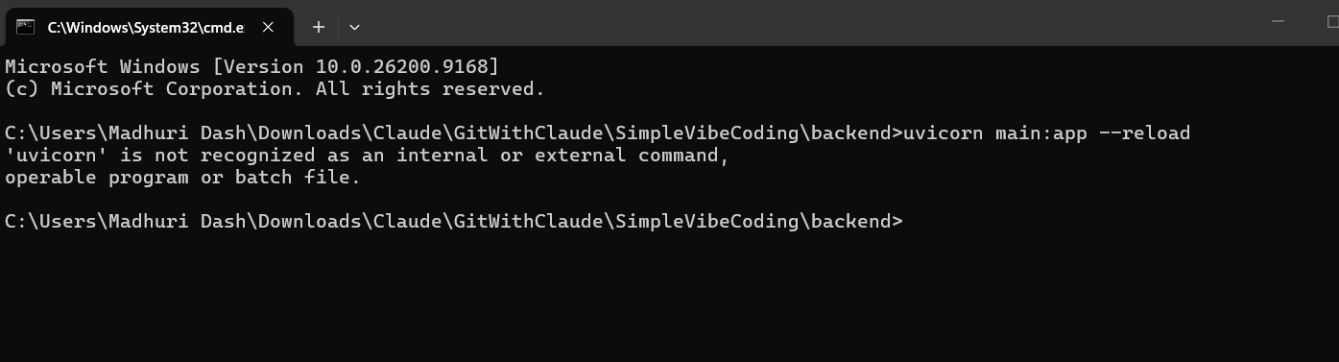

6. Run both frontend & backend in separate cmd.
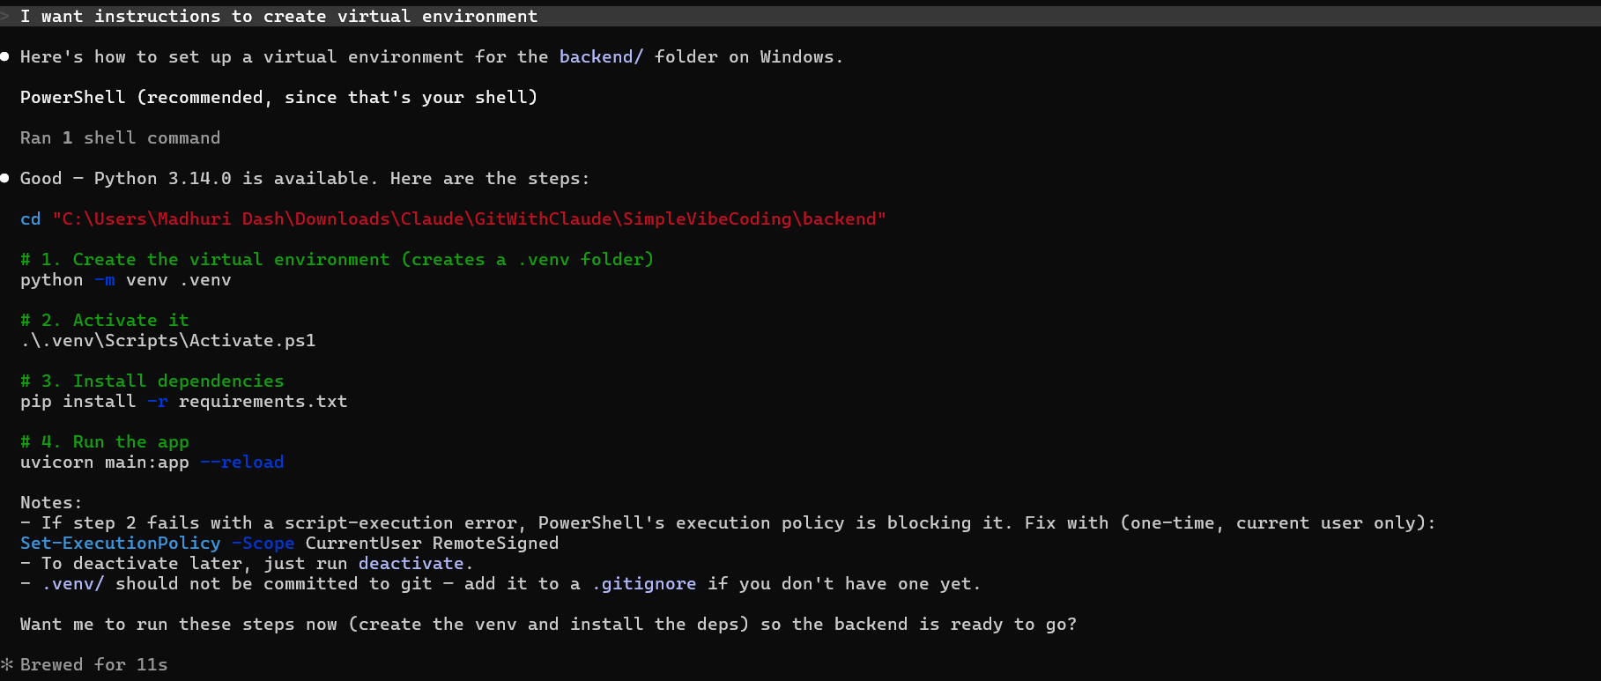

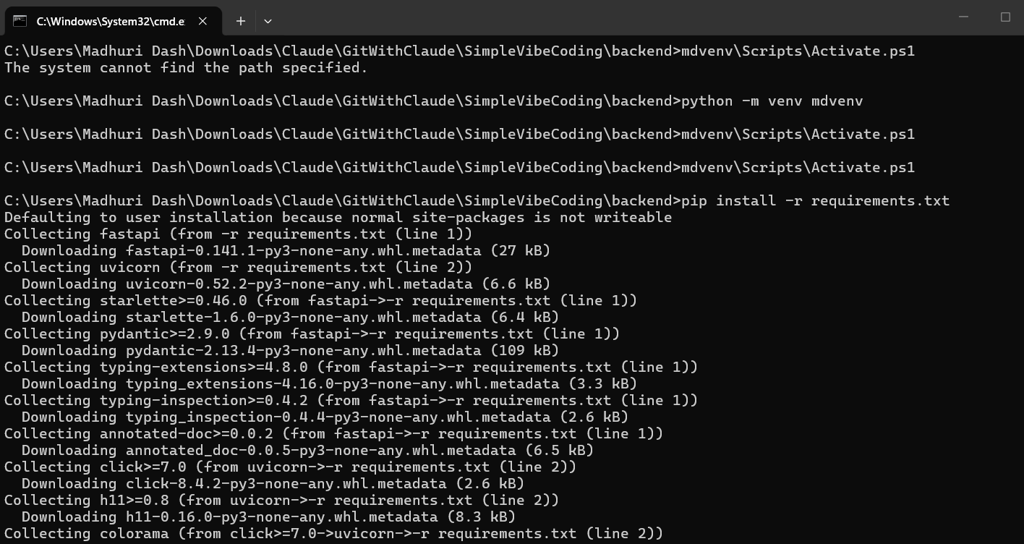

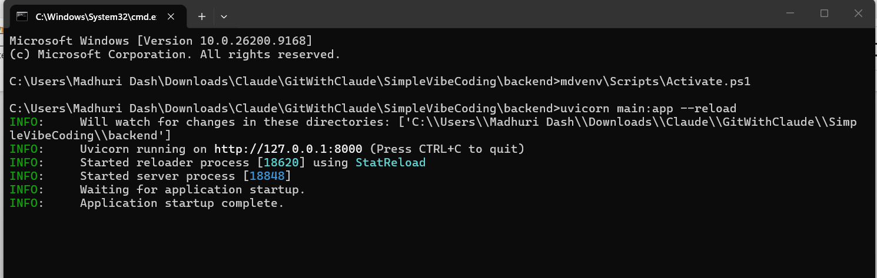
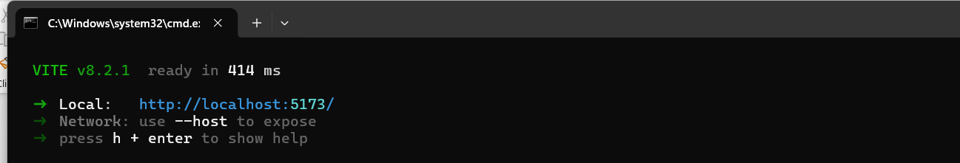

7. URL frontend in browser.
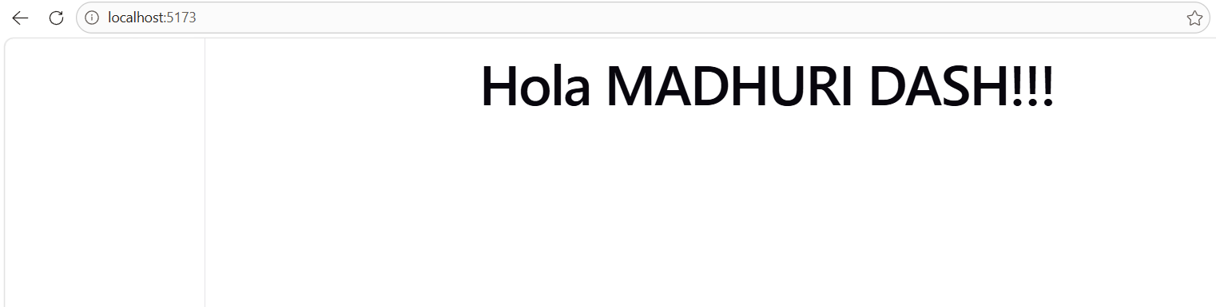
8. Do some changes by prompting change the title to “DEMO”.
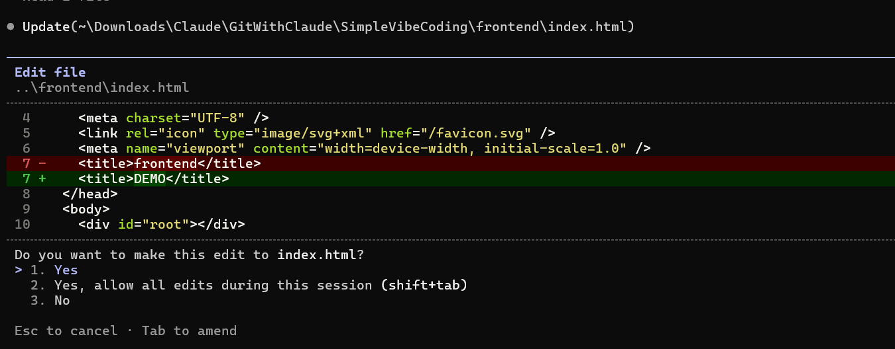

9. Change some more and update auto mode on to plan mode
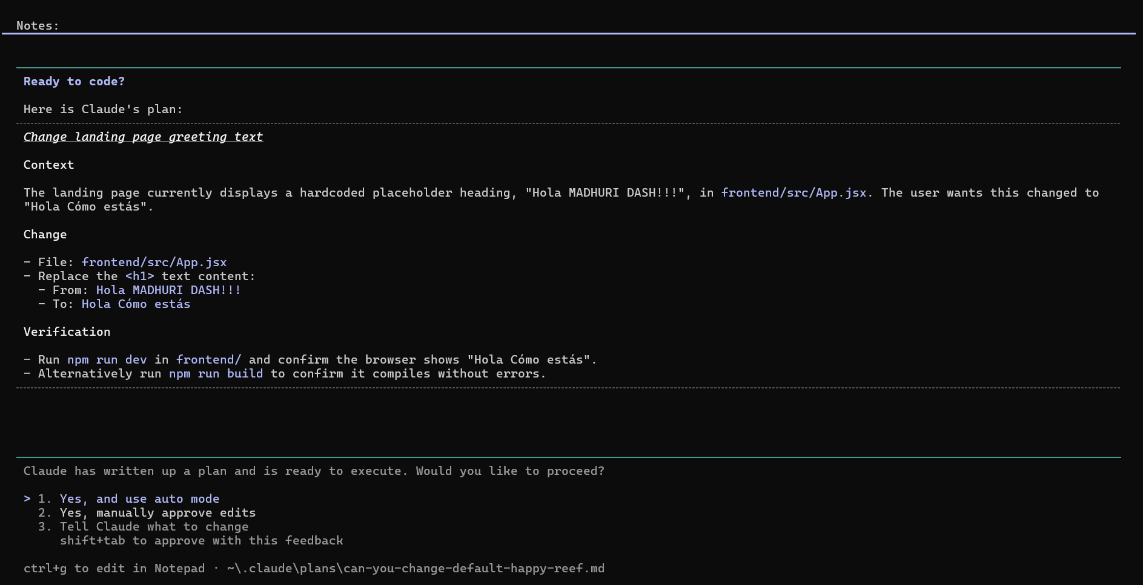
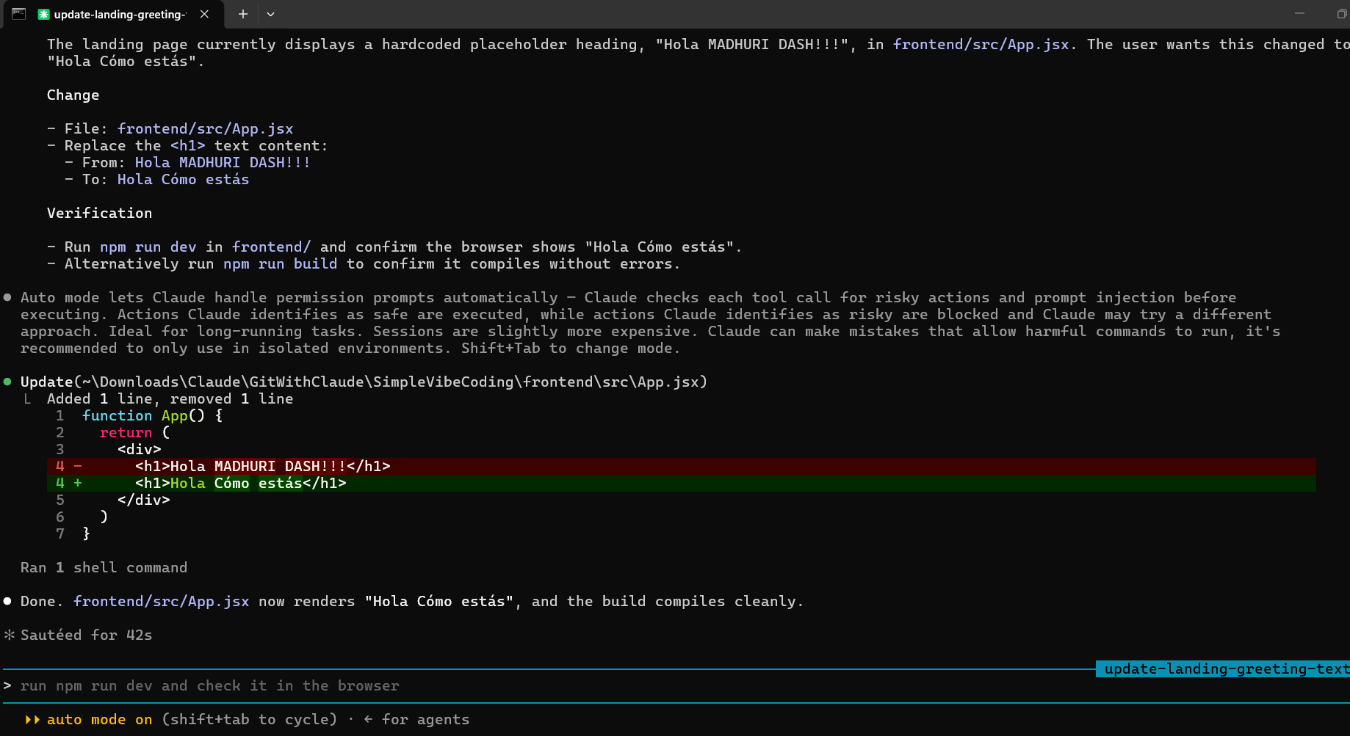
10. Check the code in VSCode as follows :
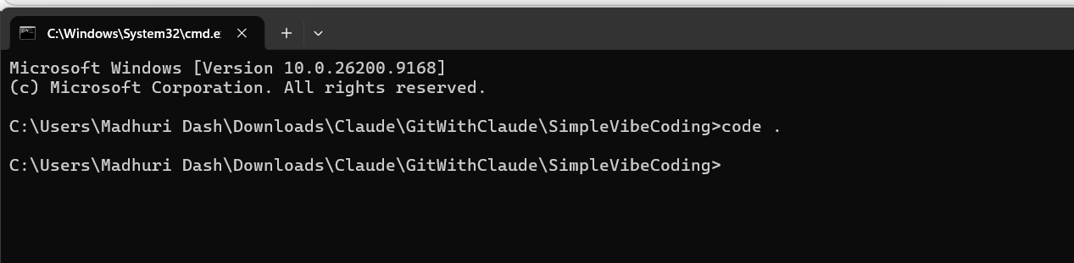

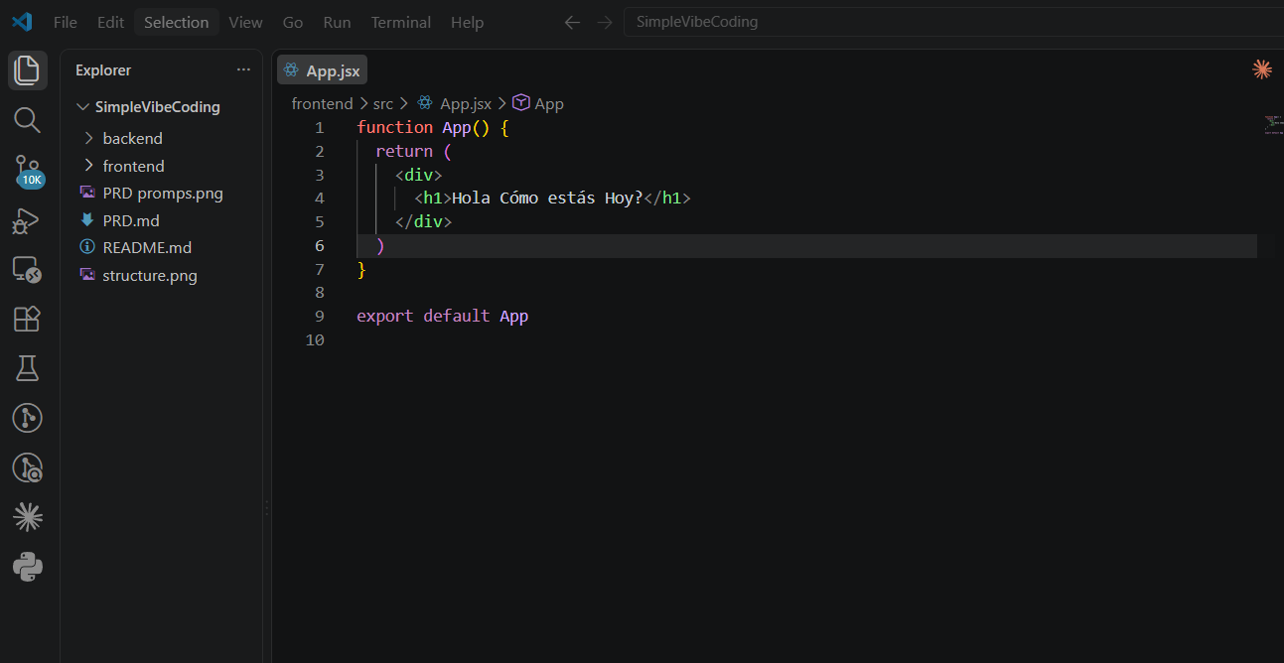
11. write test cases for frontend and backend
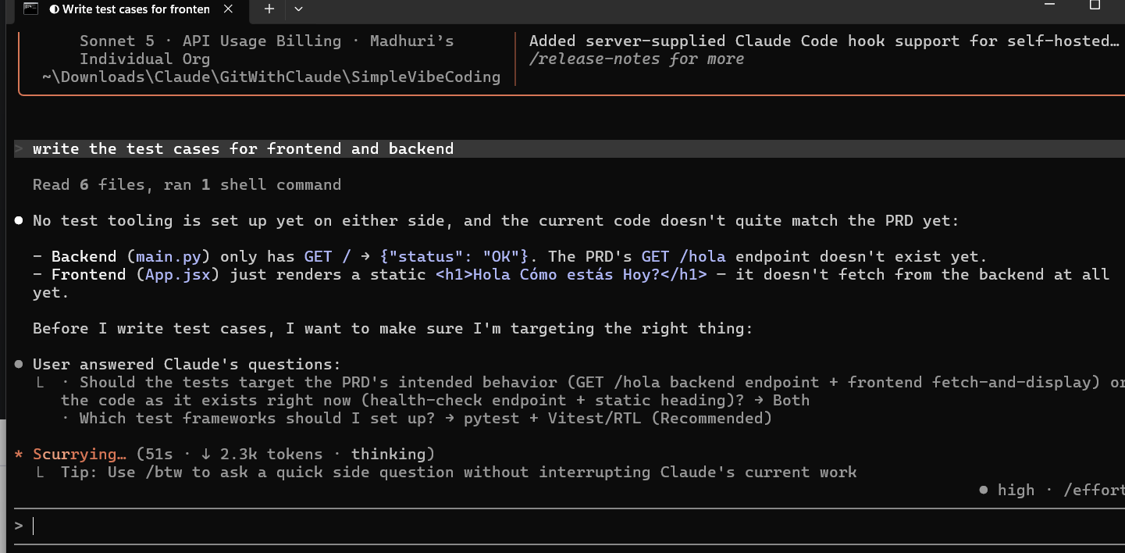
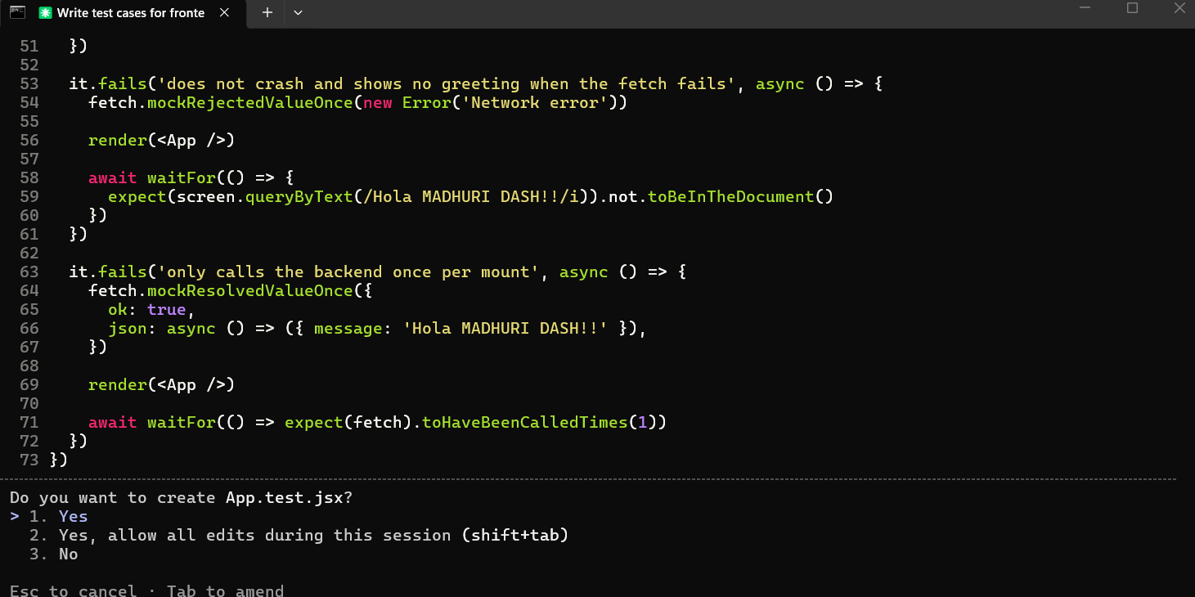

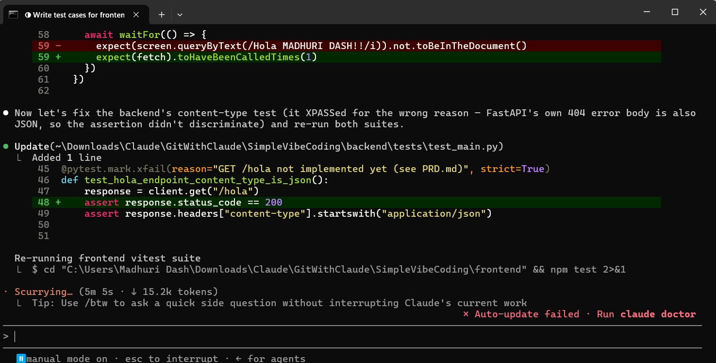
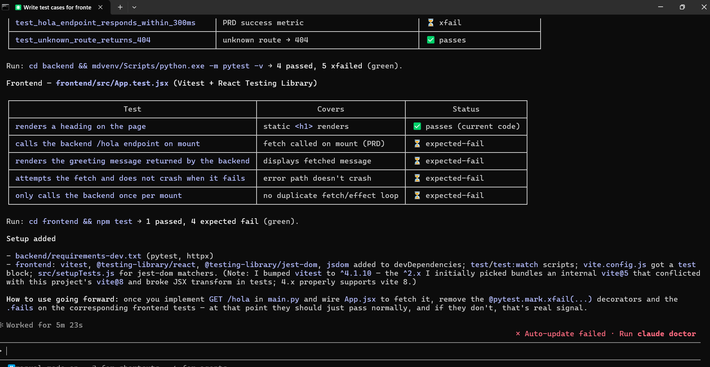
12. command to run testcases for both frontend & backend.
