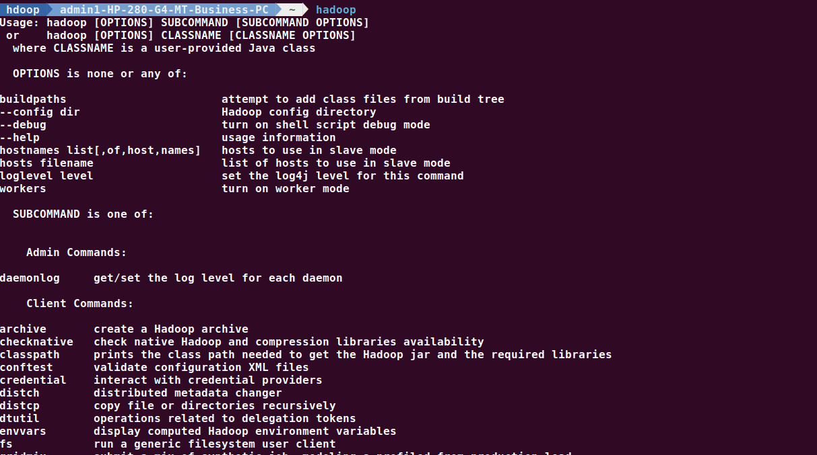

//to find the hadoop version and check if installed

**//to create a new directory and to list the files and directory**

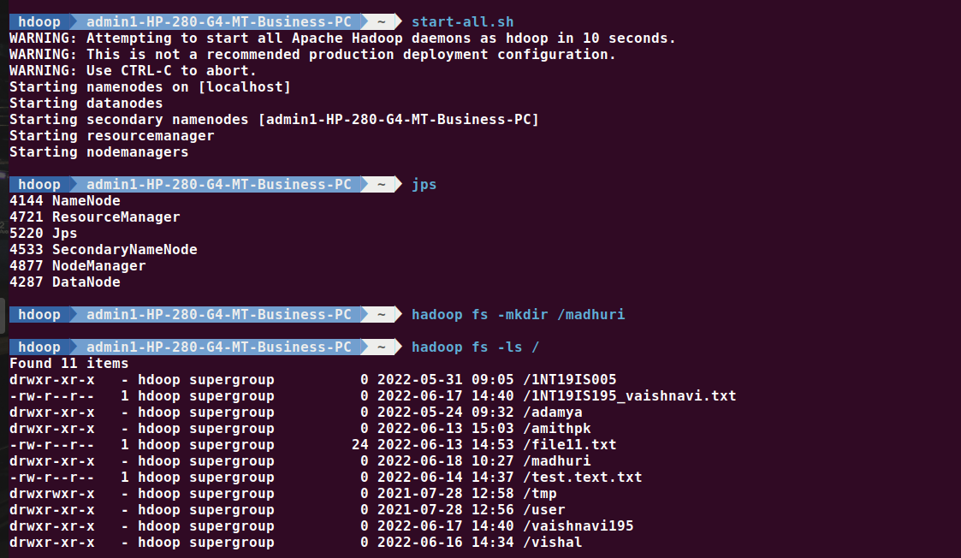

hdoop admin1-HP-280-G4-MT-Business-PC ~ start-all.sh

WARNING: Attempting to start all Apache Hadoop daemons as hdoop in 10 seconds.

WARNING: This is not a recommended production deployment configuration.

WARNING: Use CTRL-C to abort.

Starting namenodes on [localhost]

Starting datanodes

Starting secondary namenodes [admin1-HP-280-G4-MT-Business-PC]

Starting resourcemanager

Starting nodemanagers

hdoop admin1-HP-280-G4-MT-Business-PC ~ jps

4144 NameNode

4721 ResourceManager

5220 Jps

4533 SecondaryNameNode

4877 NodeManager

4287 DataNode

hdoop admin1-HP-280-G4-MT-Business-PC ~ hadoop fs -mkdir /madhuri

hdoop admin1-HP-280-G4-MT-Business-PC ~ hadoop fs -ls /

Found 11 items

drwxr-xr-x - hdoop supergroup 0 2022-05-31 09:05 /1NT19IS005

-rw-r--r-- 1 hdoop supergroup 0 2022-06-17 14:40 /1NT19IS195_vaishnavi.txt

drwxr-xr-x - hdoop supergroup 0 2022-05-24 09:32 /adamya

drwxr-xr-x - hdoop supergroup 0 2022-06-13 15:03 /amithpk

-rw-r--r-- 1 hdoop supergroup 24 2022-06-13 14:53 /file11.txt

drwxr-xr-x - hdoop supergroup 0 2022-06-18 10:27 /madhuri

-rw-r--r-- 1 hdoop supergroup 0 2022-06-14 14:37 /test.text.txt

drwxrwxr-x - hdoop supergroup 0 2021-07-28 12:58 /tmp

drwxr-xr-x - hdoop supergroup 0 2021-07-28 12:56 /user

drwxr-xr-x - hdoop supergroup 0 2022-06-17 14:40 /vaishnavi195

drwxr-xr-x - hdoop supergroup 0 2022-06-16 14:34 /vishal

hdoop admin1-HP-280-G4-MT-Business-PC ~ hdfs dfs -touchz /madhuri/file1.txt

hdoop admin1-HP-280-G4-MT-Business-PC ~ hdfs dfs -touchz /madhuri/file2.txt

hdoop admin1-HP-280-G4-MT-Business-PC ~ hadoop fs -ls /madhuri

Found 2 items

-rw-r--r-- 1 hdoop supergroup 0 2022-06-18 10:28 /madhuri/file1.txt

-rw-r--r-- 1 hdoop supergroup 0 2022-06-18 10:28 /madhuri/file2.txt

**//create new directory**

hdoop admin1-HP-280-G4-MT-Business-PC ~ hadoop fs -mkdir /1nt19is077



**//importing a file from local files system to HDFS**



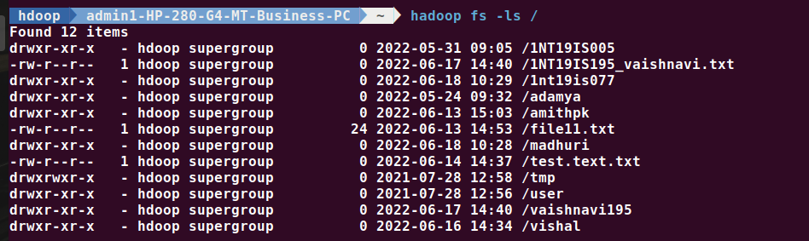

**//exporting a file from HDFS to local file system**

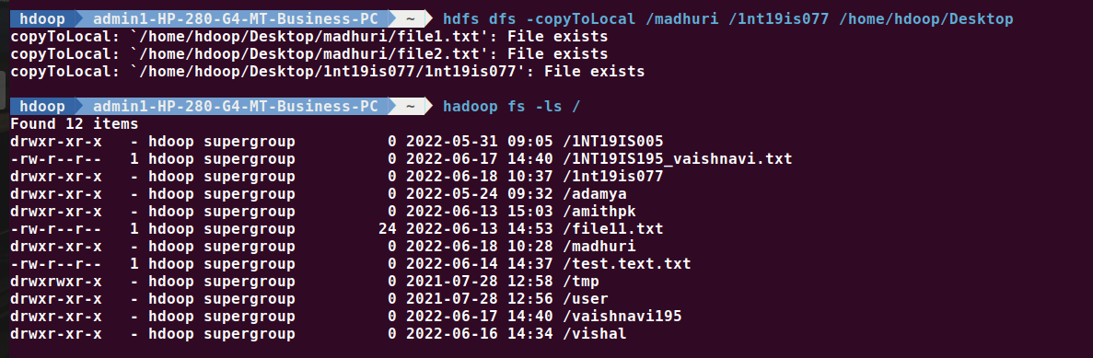

hdoop admin1-HP-280-G4-MT-Business-PC ~ hdfs dfs -copyToLocal /madhuri /1nt19is077 /home/hdoop/Desktop

copyToLocal: `/home/hdoop/Desktop/madhuri/file1.txt': File exists

copyToLocal: `/home/hdoop/Desktop/madhuri/file2.txt': File exists

copyToLocal: `/home/hdoop/Desktop/1nt19is077/1nt19is077': File exists

hdoop admin1-HP-280-G4-MT-Business-PC ~ hadoop fs -ls /

Found 12 items

drwxr-xr-x - hdoop supergroup 0 2022-05-31 09:05 /1NT19IS005

-rw-r--r-- 1 hdoop supergroup 0 2022-06-17 14:40 /1NT19IS195_vaishnavi.txt

drwxr-xr-x - hdoop supergroup 0 2022-06-18 10:37 /1nt19is077

drwxr-xr-x - hdoop supergroup 0 2022-05-24 09:32 /adamya

drwxr-xr-x - hdoop supergroup 0 2022-06-13 15:03 /amithpk

-rw-r--r-- 1 hdoop supergroup 24 2022-06-13 14:53 /file11.txt

drwxr-xr-x - hdoop supergroup 0 2022-06-18 10:28 /madhuri

-rw-r--r-- 1 hdoop supergroup 0 2022-06-14 14:37 /test.text.txt

drwxrwxr-x - hdoop supergroup 0 2021-07-28 12:58 /tmp

drwxr-xr-x - hdoop supergroup 0 2021-07-28 12:56 /user

drwxr-xr-x - hdoop supergroup 0 2022-06-17 14:40 /vaishnavi195

drwxr-xr-x - hdoop supergroup 0 2022-06-16 14:34 /vishal

**//Listing files in a directory with memory status**

hdoop admin1-HP-280-G4-MT-Business-PC ~ hadoop fs -du -h /madhuri

0 0 /madhuri/file1.txt

0 0 /madhuri/file2.txt

hdoop admin1-HP-280-G4-MT-Business-PC ~ hadoop fs -du -h /1nt19is077

16 16 /1nt19is077/1nt19is077

0 0 /1nt19is077/file1.txt

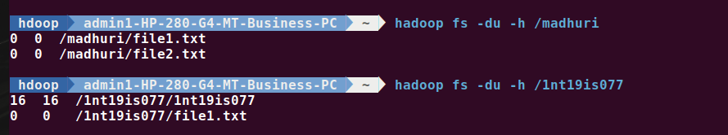

**//using stat command**

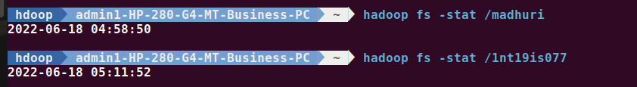

hdoop admin1-HP-280-G4-MT-Business-PC ~ hadoop fs -stat /madhuri

2022-06-18 04:58:50

hdoop admin1-HP-280-G4-MT-Business-PC ~ hadoop fs -stat /1nt19is077

2022-06-18 05:11:52