Pipeline

Using group:-

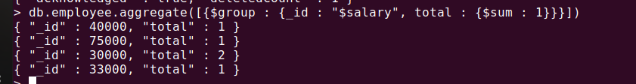

match



min,max,sum,first,last

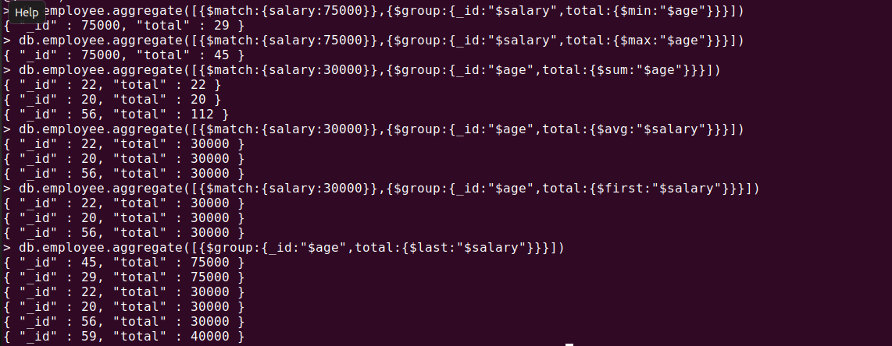



Map reduce

