5th april

1NT19IS077

MADHURI.C

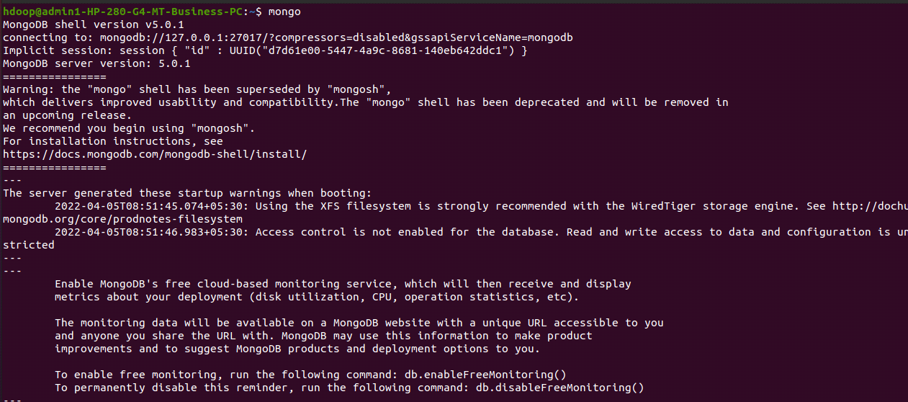

Creating database



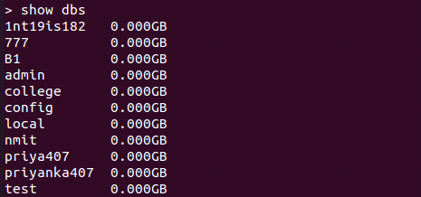

Insert one data:

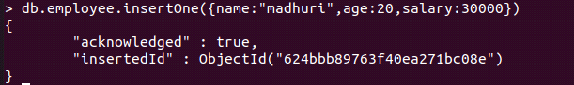

Show databases

\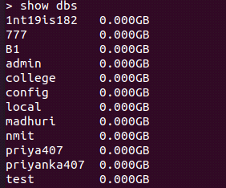

Insert many:-

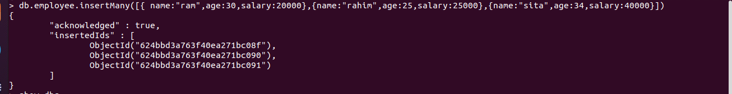

Display contents:-

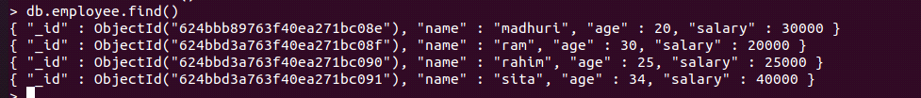

Display particular contents:-



Update one:-





Update many:-



