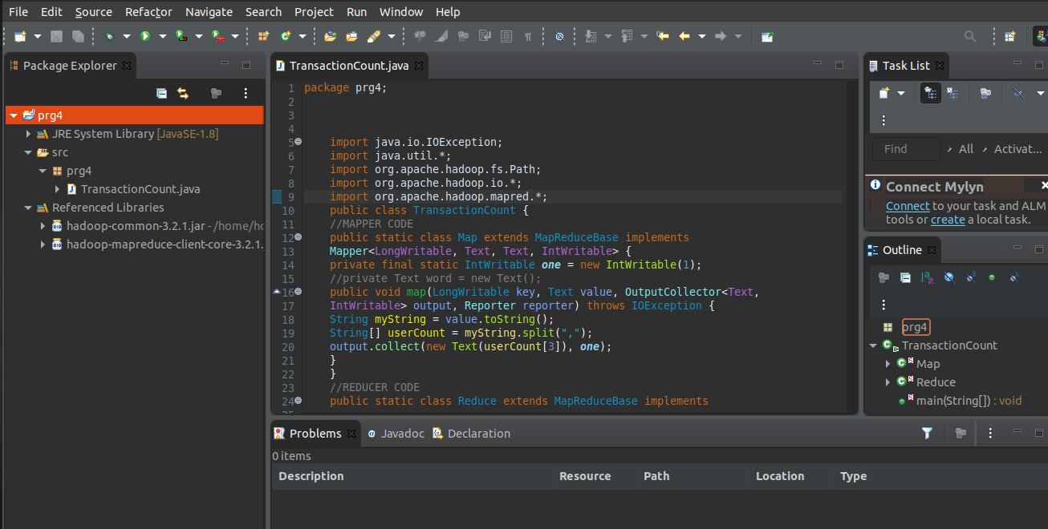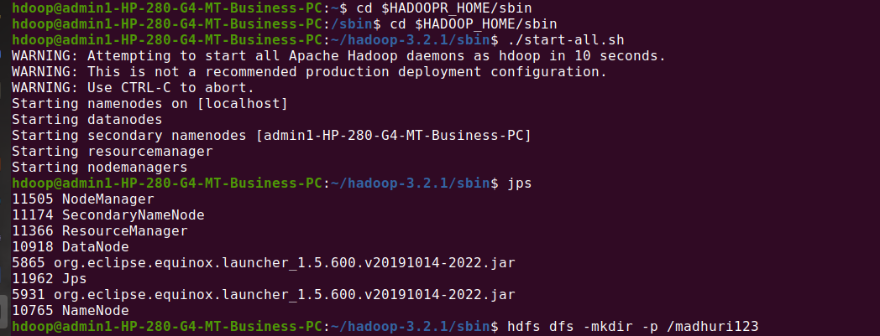



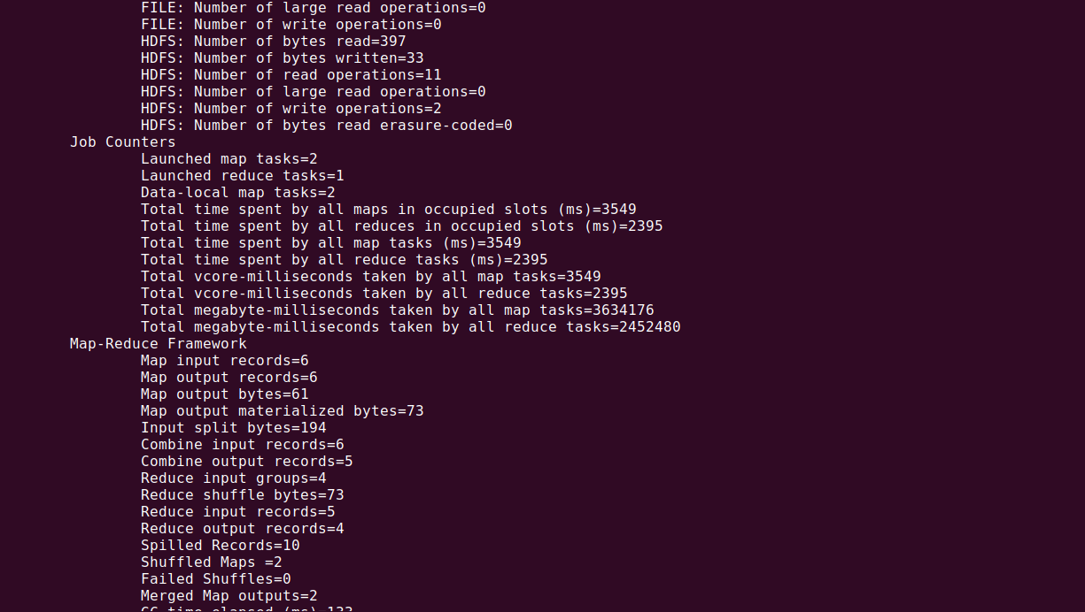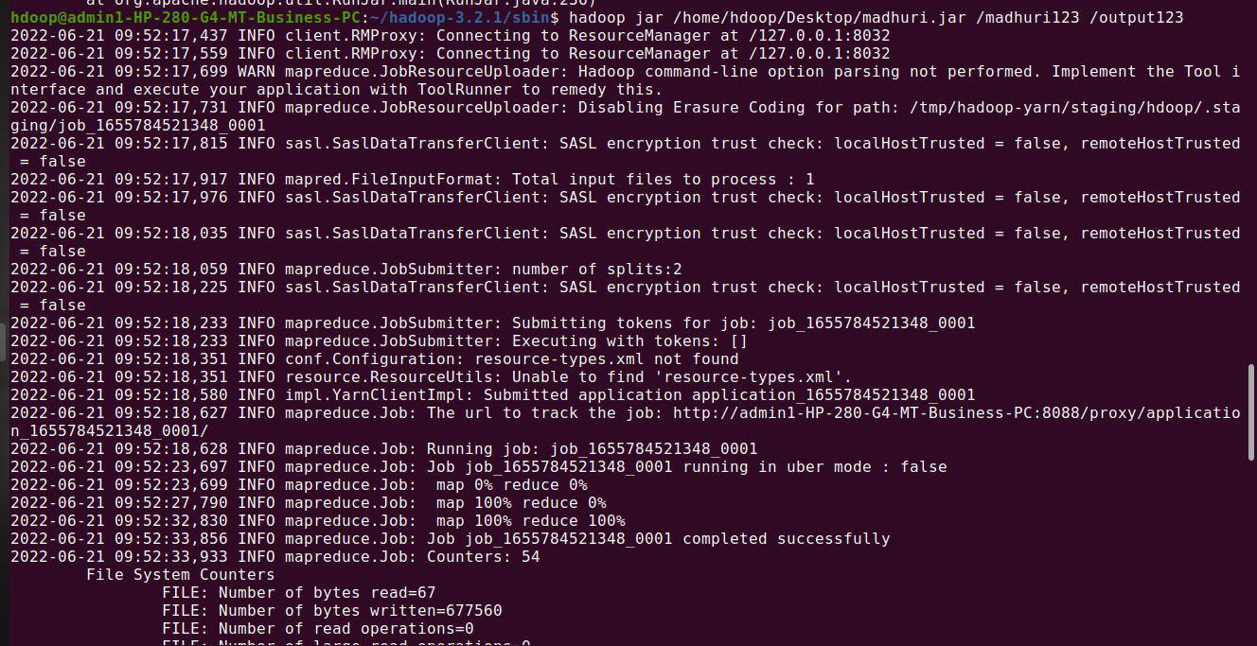

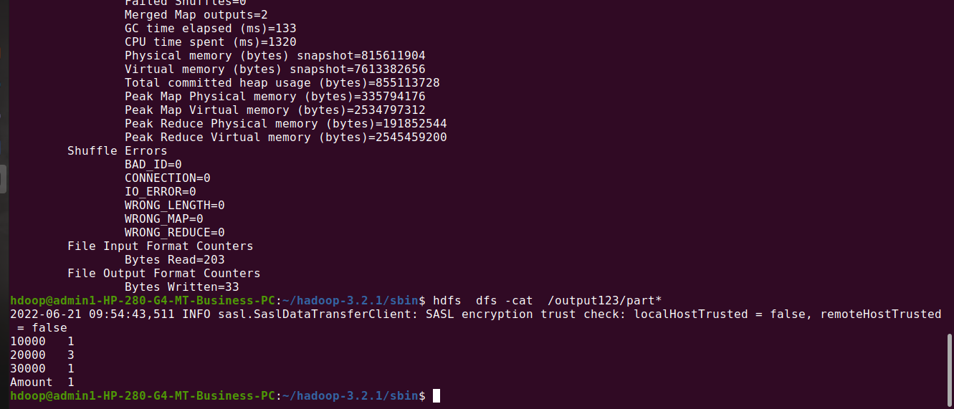

hdoop@admin1-HP-280-G4-MT-Business-PC:~$ cd $HADOOPR_HOME/sbin

hdoop@admin1-HP-280-G4-MT-Business-PC:/sbin$ cd $HADOOP_HOME/sbin

hdoop@admin1-HP-280-G4-MT-Business-PC:~/hadoop-3.2.1/sbin$ ./start-all.sh

hdoop@admin1-HP-280-G4-MT-Business-PC:~/hadoop-3.2.1/sbin$ jps

hdoop@admin1-HP-280-G4-MT-Business-PC:~/hadoop-3.2.1/sbin$ hdfs dfs -mkdir -p /madhuri123

hdoop@admin1-HP-280-G4-MT-Business-PC:~/hadoop-3.2.1/sbin$ hdfs dfs -copyFromLocal /home/hdoop/Desktop/madhuri/madhuri1.csv /madhuri123

hdoop@admin1-HP-280-G4-MT-Business-PC:~/hadoop-3.2.1/sbin$ hadoop jar /home/hdoop/Desktop/madhuri.jar /madhuri123 /output123

hdoop@admin1-HP-280-G4-MT-Business-PC:~/hadoop-3.2.1/sbin$ hdfs dfs -cat /output123/part*