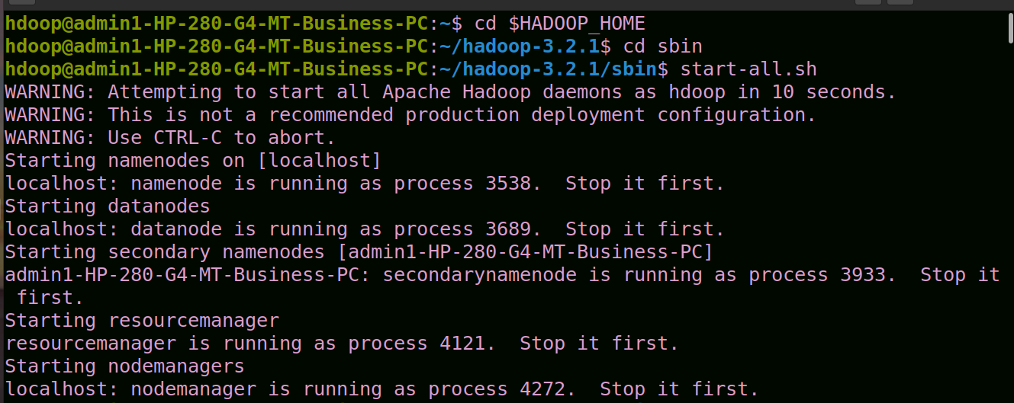

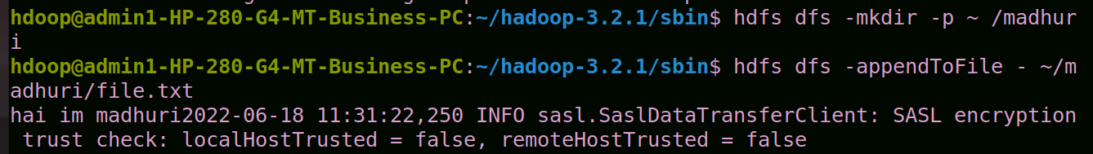

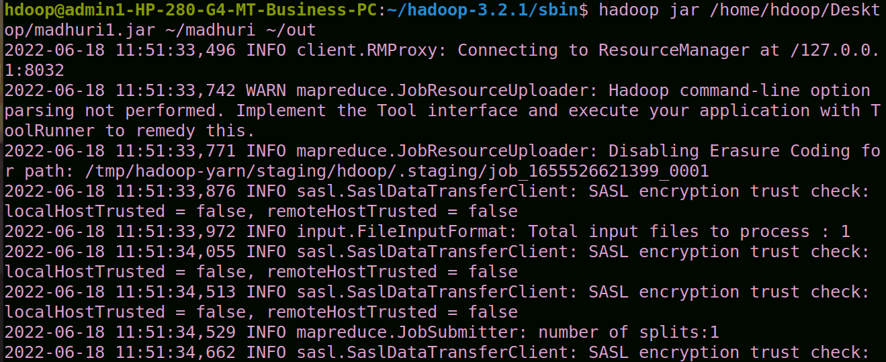

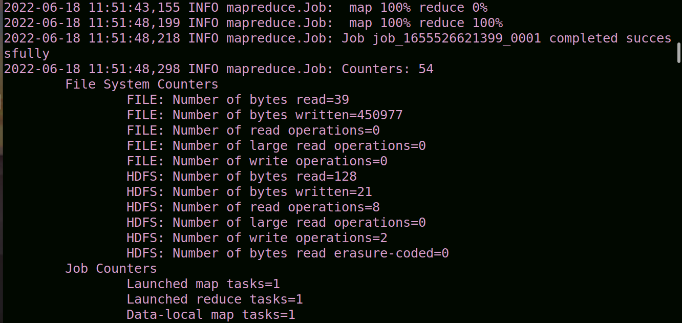

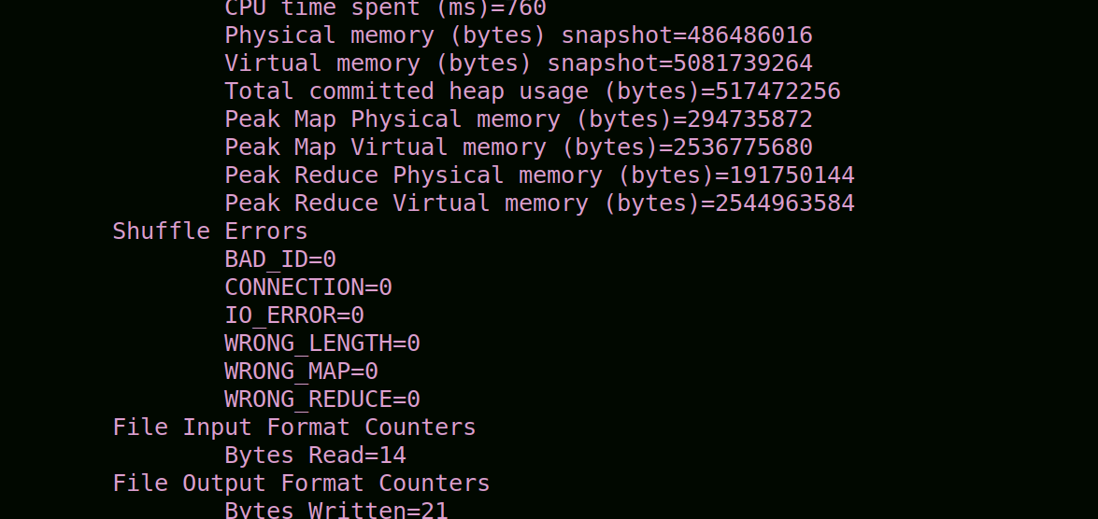

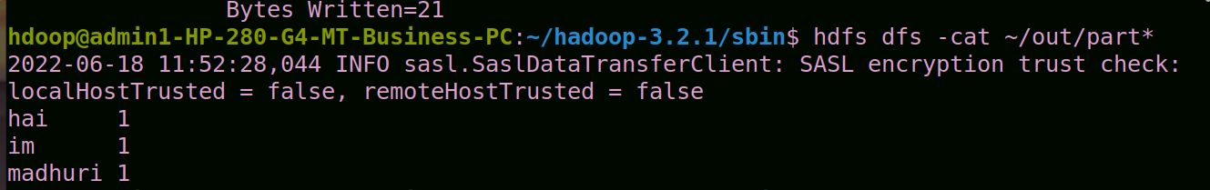

hdoop@admin1-HP-280-G4-MT-Business-PC:~$ cd $HADOOP_HOME

hdoop@admin1-HP-280-G4-MT-Business-PC:~/hadoop-3.2.1$ cd sbin

hdoop@admin1-HP-280-G4-MT-Business-PC:~/hadoop-3.2.1/sbin$ start-all.sh

WARNING: Attempting to start all Apache Hadoop daemons as hdoop in 10 seconds.

WARNING: This is not a recommended production deployment configuration.

WARNING: Use CTRL-C to abort.

Starting namenodes on [localhost]

localhost: namenode is running as process 3538. Stop it first.

Starting datanodes

localhost: datanode is running as process 3689. Stop it first.

Starting secondary namenodes [admin1-HP-280-G4-MT-Business-PC]

admin1-HP-280-G4-MT-Business-PC: secondarynamenode is running as process 3933. Stop it first.

Starting resourcemanager

resourcemanager is running as process 4121. Stop it first.

Starting nodemanagers

localhost: nodemanager is running as process 4272. Stop it first.

hdoop@admin1-HP-280-G4-MT-Business-PC:~/hadoop-3.2.1/sbin$ hdfs dfs -mkdir -p ~ /madhuri

hdoop@admin1-HP-280-G4-MT-Business-PC:~/hadoop-3.2.1/sbin$ hdfs dfs -appendToFile - ~/madhuri/file.txt

hai im madhuri2022-06-18 11:31:22,250 INFO sasl.SaslDataTransferClient: SASL encryption trust check: localHostTrusted = false, remoteHostTrusted = false

hdoop@admin1-HP-280-G4-MT-Business-PC:~/hadoop-3.2.1/sbin$ hadoop jar /home/hdoop/Desktop/madhuri1.jar ~/madhuri ~/out

2022-06-18 11:51:33,496 INFO client.RMProxy: Connecting to ResourceManager at /127.0.0.1:8032

2022-06-18 11:51:33,742 WARN mapreduce.JobResourceUploader: Hadoop command-line option parsing not performed. Implement the Tool interface and execute your application with ToolRunner to remedy this.

2022-06-18 11:51:33,771 INFO mapreduce.JobResourceUploader: Disabling Erasure Coding for path: /tmp/hadoop-yarn/staging/hdoop/.staging/job_1655526621399_0001

2022-06-18 11:51:33,876 INFO sasl.SaslDataTransferClient: SASL encryption trust check: localHostTrusted = false, remoteHostTrusted = false

2022-06-18 11:51:33,972 INFO input.FileInputFormat: Total input files to process : 1

2022-06-18 11:51:34,055 INFO sasl.SaslDataTransferClient: SASL encryption trust check: localHostTrusted = false, remoteHostTrusted = false

2022-06-18 11:51:34,513 INFO sasl.SaslDataTransferClient: SASL encryption trust check: localHostTrusted = false, remoteHostTrusted = false

2022-06-18 11:51:34,529 INFO mapreduce.JobSubmitter: number of splits:1

2022-06-18 11:51:34,662 INFO sasl.SaslDataTransferClient: SASL encryption trust check: localHostTrusted = false, remoteHostTrusted = false

2022-06-18 11:51:34,670 INFO mapreduce.JobSubmitter: Submitting tokens for job: job_1655526621399_0001

2022-06-18 11:51:34,670 INFO mapreduce.JobSubmitter: Executing with tokens: []

2022-06-18 11:51:34,783 INFO conf.Configuration: resource-types.xml not found

2022-06-18 11:51:34,783 INFO resource.ResourceUtils: Unable to find 'resource-types.xml'.

2022-06-18 11:51:34,941 INFO impl.YarnClientImpl: Submitted application application_1655526621399_0001

2022-06-18 11:51:34,967 INFO mapreduce.Job: The url to track the job: http://admin1-HP-280-G4-MT-Business-PC:8088/proxy/application_1655526621399_0001/

2022-06-18 11:51:34,968 INFO mapreduce.Job: Running job: job_1655526621399_0001

2022-06-18 11:51:40,103 INFO mapreduce.Job: Job job_1655526621399_0001 running in uber mode : false

2022-06-18 11:51:40,105 INFO mapreduce.Job: map 0% reduce 0%

2022-06-18 11:51:43,155 INFO mapreduce.Job: map 100% reduce 0%

2022-06-18 11:51:48,199 INFO mapreduce.Job: map 100% reduce 100%

2022-06-18 11:51:48,218 INFO mapreduce.Job: Job job_1655526621399_0001 completed successfully

2022-06-18 11:51:48,298 INFO mapreduce.Job: Counters: 54

File System Counters

FILE: Number of bytes read=39

FILE: Number of bytes written=450977

FILE: Number of read operations=0

FILE: Number of large read operations=0

FILE: Number of write operations=0

HDFS: Number of bytes read=128

HDFS: Number of bytes written=21

HDFS: Number of read operations=8

HDFS: Number of large read operations=0

HDFS: Number of write operations=2

HDFS: Number of bytes read erasure-coded=0

Job Counters

Launched map tasks=1

Launched reduce tasks=1

Data-local map tasks=1

Total time spent by all maps in occupied slots (ms)=1419

Total time spent by all reduces in occupied slots (ms)=1526

Total time spent by all map tasks (ms)=1419

Total time spent by all reduce tasks (ms)=1526

Total vcore-milliseconds taken by all map tasks=1419

Total vcore-milliseconds taken by all reduce tasks=1526

Total megabyte-milliseconds taken by all map tasks=1453056

Total megabyte-milliseconds taken by all reduce tasks=1562624

Map-Reduce Framework

Map input records=1

Map output records=3

Map output bytes=27

Map output materialized bytes=39

Input split bytes=114

Combine input records=3

Combine output records=3

Reduce input groups=3

Reduce shuffle bytes=39

Reduce input records=3

Reduce output records=3

Spilled Records=6

Shuffled Maps =1

Failed Shuffles=0

Merged Map outputs=1

GC time elapsed (ms)=64

CPU time spent (ms)=760

Physical memory (bytes) snapshot=486486016

Virtual memory (bytes) snapshot=5081739264

Total committed heap usage (bytes)=517472256

Peak Map Physical memory (bytes)=294735872

Peak Map Virtual memory (bytes)=2536775680

Peak Reduce Physical memory (bytes)=191750144

Peak Reduce Virtual memory (bytes)=2544963584

Shuffle Errors

BAD_ID=0

CONNECTION=0

IO_ERROR=0

WRONG_LENGTH=0

WRONG_MAP=0

WRONG_REDUCE=0

File Input Format Counters

Bytes Read=14

File Output Format Counters

Bytes Written=21

hdoop@admin1-HP-280-G4-MT-Business-PC:~/hadoop-3.2.1/sbin$ hdfs dfs -cat ~/out/part*

2022-06-18 11:52:28,044 INFO sasl.SaslDataTransferClient: SASL encryption trust check: localHostTrusted = false, remoteHostTrusted = false

hai 1

im 1

madhuri 1