YAMYAH -NODE.JS DOCUMENTATION

Command Prompt:

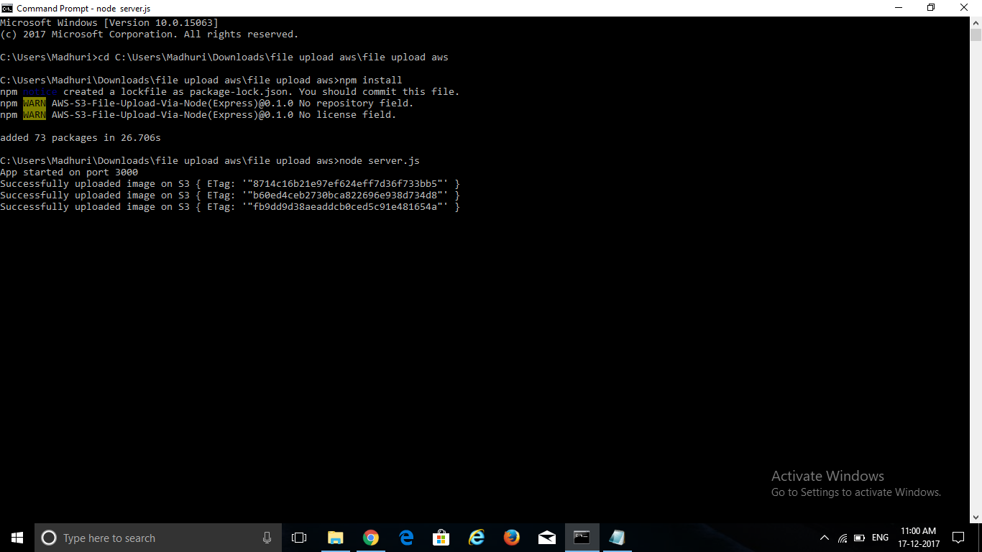

* To set up an environment we need node.js along with npm packages. To check whether npm/node.js is installed or not we can use the above commands (to install shown in the screenshot).

**Uploading a csv file:**

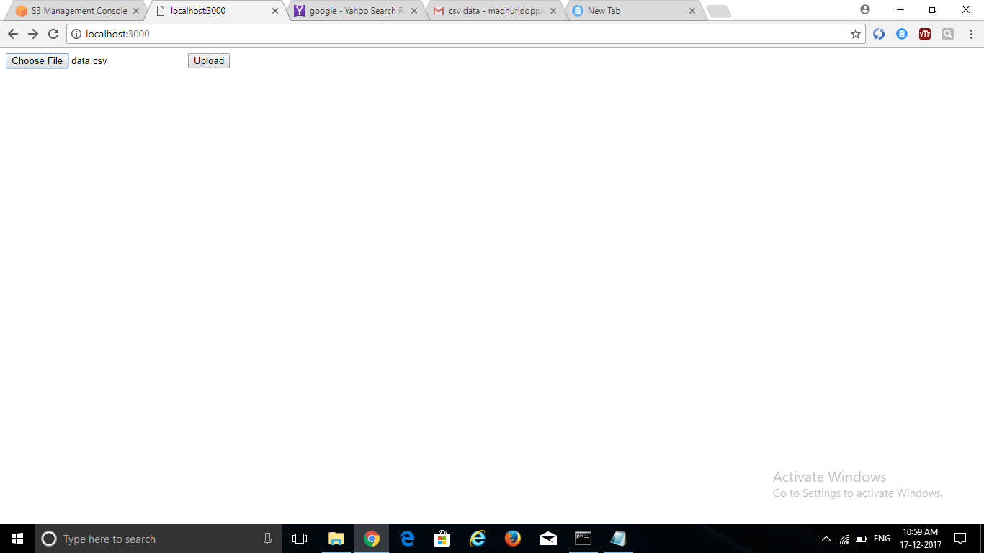

* Through this front end page we can upload any of the csv files that are present in the local system.

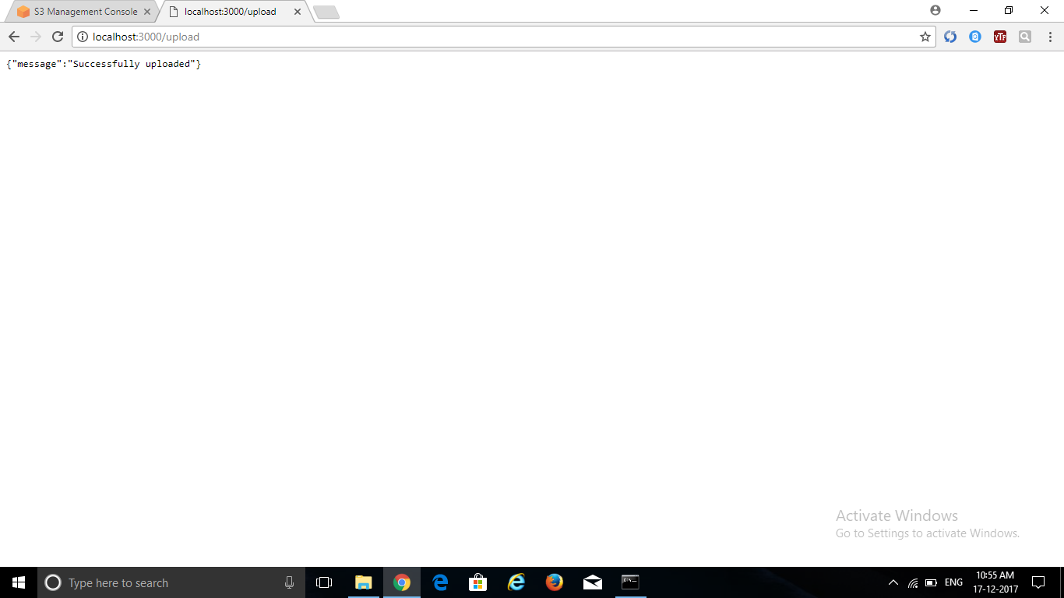

* Whenever the file is successfully uploaded we get the above message.

**AWS Storage Page:**

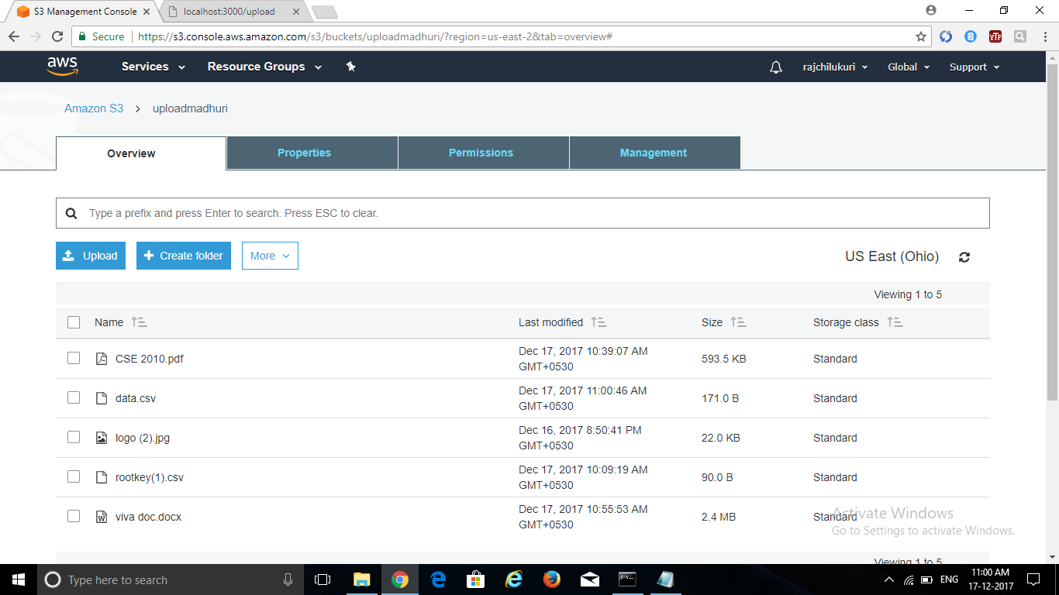

* We can check whether our file is uploaded or not through the AWS bucket storage.