HUMANOID ROBOT CONTROLLER — PRODUCT REQUIREMENTS DOCUMENT (PRD)
Project: Humanoid Robot Controller Simulation
Scope: Virtual 32-DOF humanoid with DC servo motor simulation, sensor emulation, and motion control

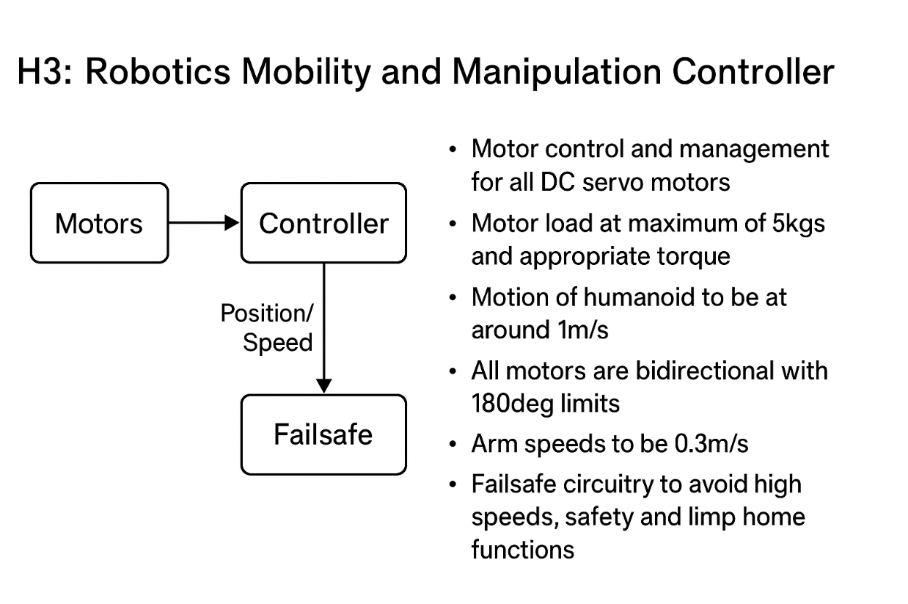

ID | Functional Requirement | Description
FR1.1 | The controller must generate control commands for DC servo motors | Command: motor.set_position(45) rotates joint to +45°
FR1.2 | The system must update motor signals continuously | Control loop runs every 1 ms to adjust PWM
FR2.1 | The controller must allow lifting or supporting up to 5 kg | Arm lifts a virtual 5 kg box by compensating gravity torque
FR2.2 | The controller must coordinate multiple joints to handle load | Shoulder, elbow, wrist work together to lift 5 kg payload
FR3.1 | The controller must rotate each joint in both directions | Command: motor.set_position(-120) rotates joint to −120°
FR3.2 | The system must allow joint motion within ±180° | If user commands 200°, system clamps output to +180°
FR4.1 | The controller must generate walking motion | Left foot → right foot → repeat
FR4.2 | The humanoid must walk at 1 m/s | Each 0.5 m step occurs twice per second
FR4.3 | The controller must coordinate all leg joints during walking | Hip, knee, ankle, and torso move in synchronized cycles
FR5.1 | The controller must move arms at 0.3 m/s end-effector speed | Arm reaches 0.15 m in 0.5 seconds
FR5.2 | The system must coordinate arm joints for manipulation | Shoulder + elbow + wrist follow a smooth reach trajectory
FR6.1 | The controller must detect abnormal/unsafe conditions | Angle >180° triggers error
FR6.2 | The controller must enter a safe state on failure | If torque spikes, all motors go torque-off
FR6.3 | The controller must respond to emergency stop input | ESC pressed → all joints freeze immediately
FR7.1 | The controller must command 32 independent joints | Pose command updates all 32 joints at once
FR7.2 | The system must support high-level actions | robot.walk(speed=1.0) triggers coordinated motions
FR7.3 | The controller must synchronize full-body joint motions | Torso stabilizes while legs step and arms counterbalance

ID | Safety Requirement | Description
SR1.1 | The system must detect joint angles exceeding safe limits | If a joint angle > 180° or < -180°, trigger an alert or stop the motor
SR1.2 | The system must prevent motor overload or stall | If torque exceeds safe threshold, cut PWM output to prevent damage
SR1.3 | The controller must detect loss of sensor feedback | If encoder or IMU fails, enter safe mode and stop joint movement
SR1.4 | The system must support emergency stop input | Pressing ESC or safety button halts all motors immediately
SR1.5 | The system must monitor high-speed or unexpected motion | Detect motion exceeding predefined speed limits and stop to prevent damage
SR1.6 | The system must simulate or monitor temperature/overheating | If motor temperature exceeds safe limit, reduce or stop output
SR1.7 | The system must maintain balance to prevent falls | If center of mass goes outside support polygon, stop or adjust joint movement
SR1.8 | The system must handle communication failures safely | Loss of command or CAN bus timeout triggers safe shutdown or joint hold
SR1.9 | The system must perform safe initialization | On startup, all joints move to neutral or home positions before accepting commands
SR1.10 | The system must log and report safety events | All safety triggers must be logged for debugging and analysis

ID | Performance Requirement | Description
PR1.1 | The humanoid must walk at a target speed of 1 m/s | Step length 0.5 m → 2 steps per second
PR1.2 | The arm end-effector must move at up to 0.3 m/s | Arm reaches a point 0.15 m away in 0.5 seconds
PR1.3 | The control loop must update motor commands at minimum 1 kHz | Control loop runs every 1 ms for smooth motion
PR1.4 | The joint position accuracy must be within ±1° | Commanded angle 45° → actual angle between 44°–46°
PR1.5 | The joint velocity response must follow target within ±5% | Target velocity 30°/s → actual velocity between 28.5°/s–31.5°/s
PR1.6 | The system must support simultaneous motion of all 32 joints | Entire body moves smoothly without lag or desynchronization
PR1.7 | The system must complete initialization in under 5 seconds | On power-up, all joints reach home positions within 5 seconds
PR1.8 | Communication latency must not exceed 10 ms per joint command | Virtual CAN bus commands delivered with <10 ms delay
PR1.9 | The system must maintain stability while walking at 1 m/s | Center of mass stays within support polygon throughout gait
PR1.10 | The system must handle simulated 5 kg load without significant motion error | Lifting 5 kg does not cause joint overshoot beyond ±2°

ID | Hardware Constraint | Description
HC1 | The system must support 32 DC servo motors | Each joint has a dedicated motor, simulated in Python
HC2 | Each motor must handle up to 5 kg load | Simulated torque calculation supports lifting/manipulating 5 kg payload
HC3 | Each joint must rotate ±180° | Hardware or simulation must enforce motion limits
HC4 | Motors must support bidirectional motion | Clockwise and counterclockwise rotation capabilities
HC5 | Virtual sensors must include encoders and IMU | Joint angle measurement and body orientation simulated
HC6 | Controller must support real-time motor command updates | Minimum 1 kHz update frequency for smooth motion
HC7 | Power and torque limits must be enforced | Prevent overcurrent and over-torque conditions in simulation
HC8 | Communication network must support all joints | Virtual CAN bus or equivalent for 32 motors
HC9 | All joints must allow safe homing on startup | Joints move to neutral/home positions before motion
HC10 | Load handling capability simulated | Virtual system can manage weight compensation for arms and legs

ID | Software Constraint | Description
SC1 | Implemented entirely in Python | Controller, simulation, and virtual electronics all in Python
SC2 | Control loops run at fixed intervals | Minimum 1 kHz PID or torque loop update
SC3 | Support multi-joint coordination | All 32 joints can be commanded simultaneously
SC4 | Implement virtual sensors | Encoder, IMU, torque, and load simulated
SC5 | Support high-level commands | Walk, reach, lift, stop
SC6 | Implement software safety checks | Angle limits, torque limits, emergency stop detection
SC7 | Log all commands and sensor data | Data stored for debugging and analysis
SC8 | Support trajectory planning and interpolation | Smooth motion between points for arms, legs, torso
SC9 | Modular design preferred | Each joint/motor simulated as independent module
SC10 | Handle simulated failures gracefully | Loss of sensor/communication triggers safe state

