GET : http://localhost:8085/welcome

POST : http://localhost:8085/uploadFile

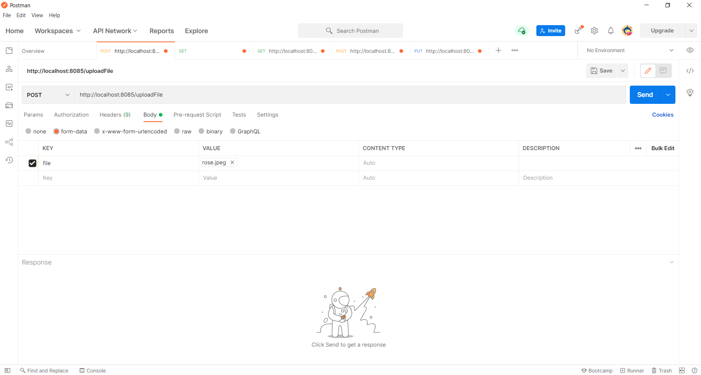

GET : http://localhost:8085/downloadFile/51A82FC4AA806DC033F0AECD5985258D.jpeg

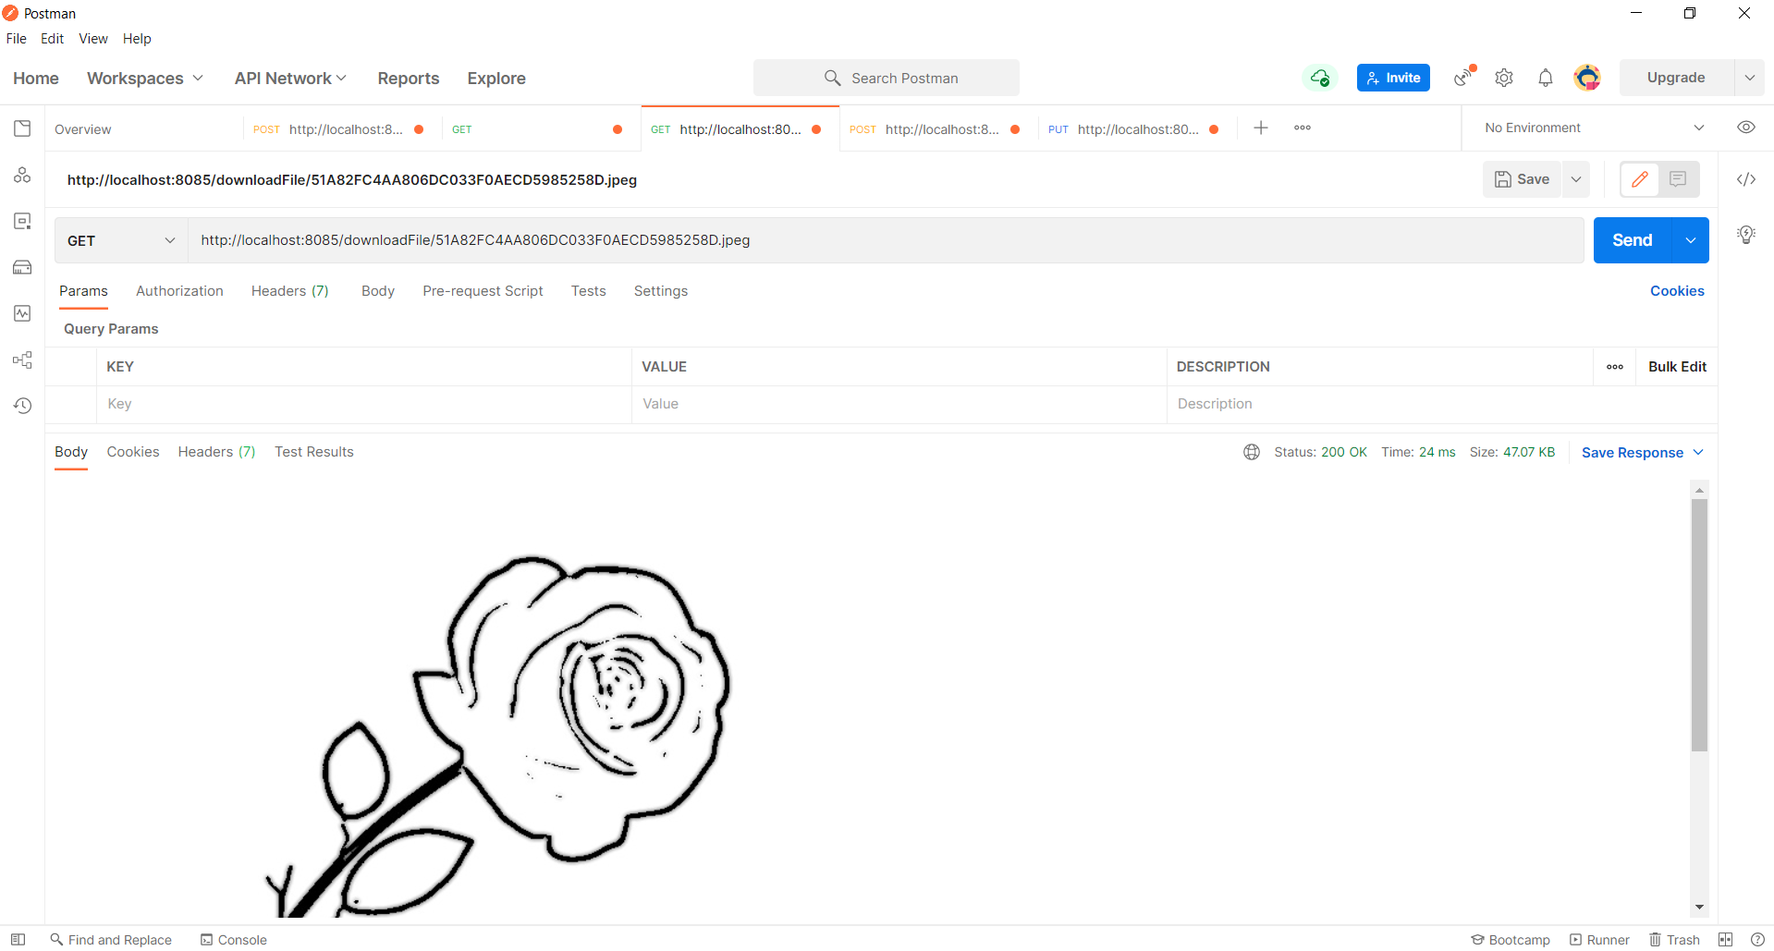

POST : http://localhost:8085/signup
{
"username": "steve",
"password": "clark",
"email_id": "Sincere@april.biz",
"created_datetime": "2021-10-10 11:36:00"
}

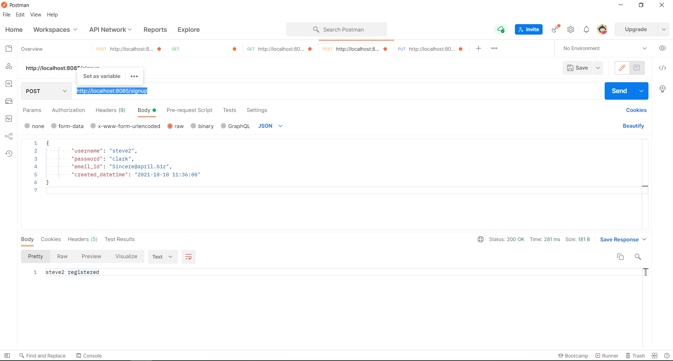

PUT : http://localhost:8085/resetpassword

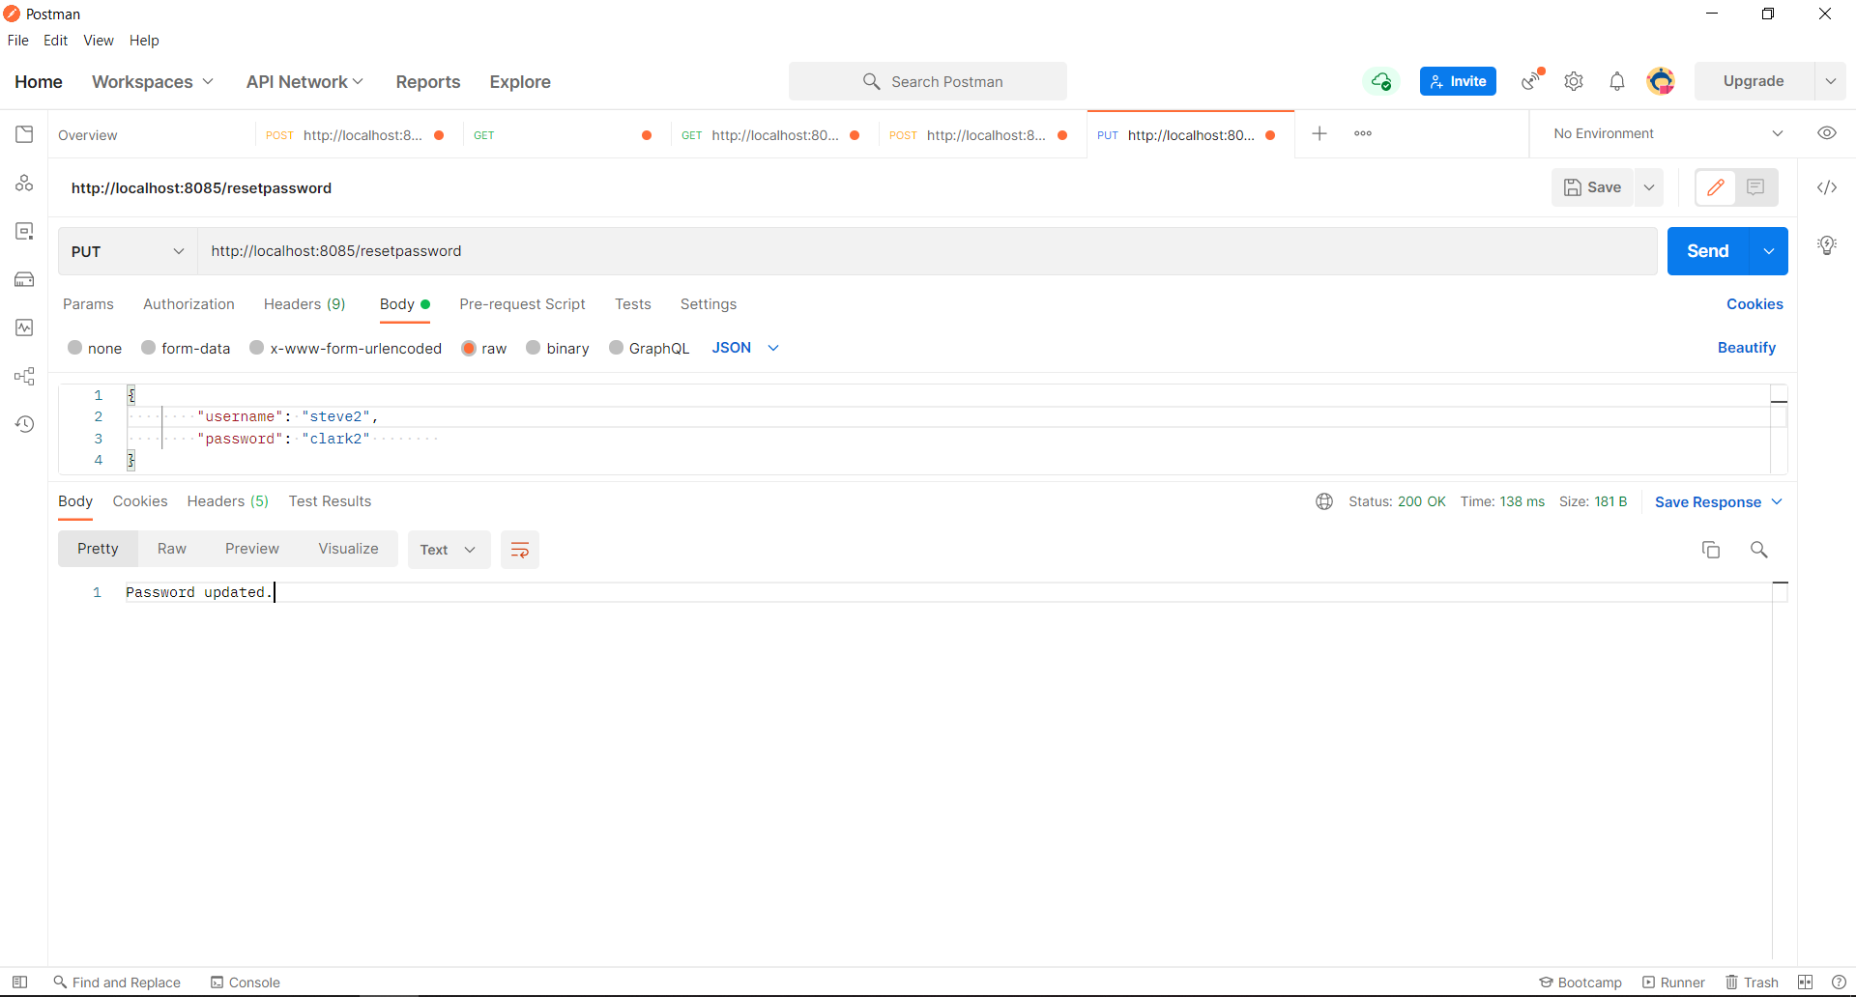
CREATE DATABASE TOONME;
USE TOONME;

CREATE TABLE `app_user_details` (
`user_id` bigint NOT NULL,
`created_datetime` varchar(20) DEFAULT NULL,
`email_id` varchar(50) DEFAULT NULL,
`full_name` varchar(50) DEFAULT NULL,
`password` varchar(20) DEFAULT NULL,
`username` varchar(20) DEFAULT NULL,
PRIMARY KEY (`user_id`),
UNIQUE KEY `UK_r88y2c6qwn47sv7tb3vds74y3` (`username`)
) ENGINE=InnoDB DEFAULT CHARSET=utf8mb4 COLLATE=utf8mb4_0900_ai_ci;

insert into app_user_details (username, password, full_name, email_id, created_datetime)
values ('test', 'test', 'test', 'test@gmail.com', current_timestamp());

