AIM: Introduction to JDK( IntelliJ )and running Java program using DATA types.

Step 1: Creating a New Project
Sabse pehle IntelliJ IDEA software open karein. Agar welcome screen dikh rahi ho, toh wahan se New Project option par click karein. Agar software already open hai, toh top menu se File → New → Project select karein. Iske baad project type list me se Java choose karke next par click karein.
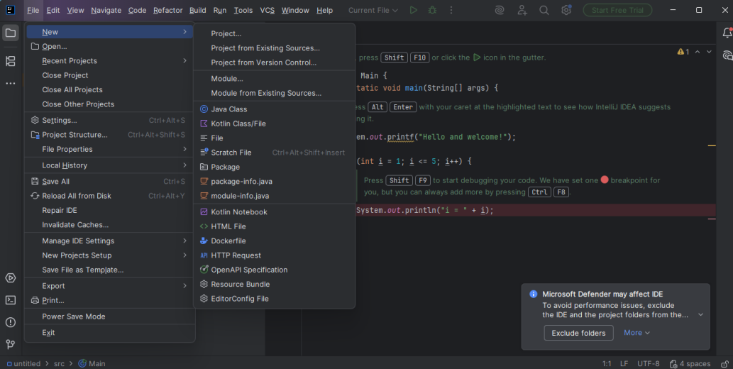

Step 2: Giving Project Name
Ab “New Project” naam ki window open hogi. Is window me apne project ka suitable naam enter karein. Project ka location automatically set hota hai, lekin zarurat ho toh change bhi kar sakte hain. Saari details bharne ke baad Finish button par click karein. Project create hone ke baad left side ke panel me dikhai dega.
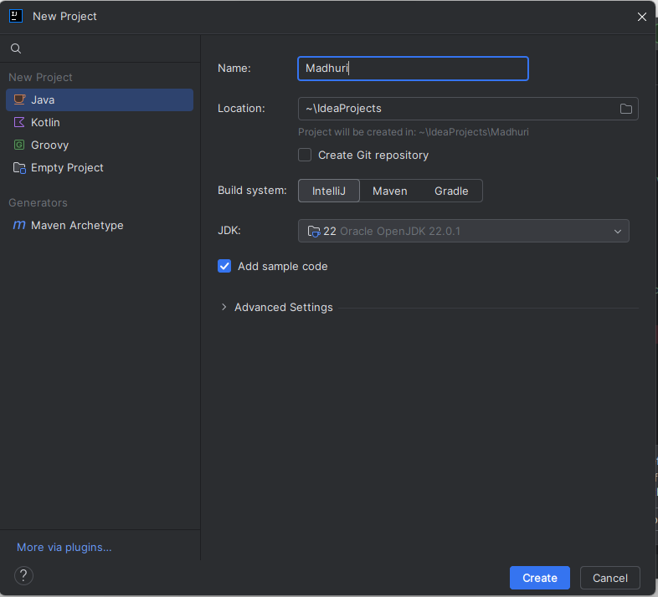
Step 3: Creating a Java Class
Java program likhne ke liye class banana zaruri hota hai. Project panel me src folder par right click karein, phir New → Java Class option select karein. Class ka naam type karke Enter press karein. Nayi class file editor me open ho jaayegi.
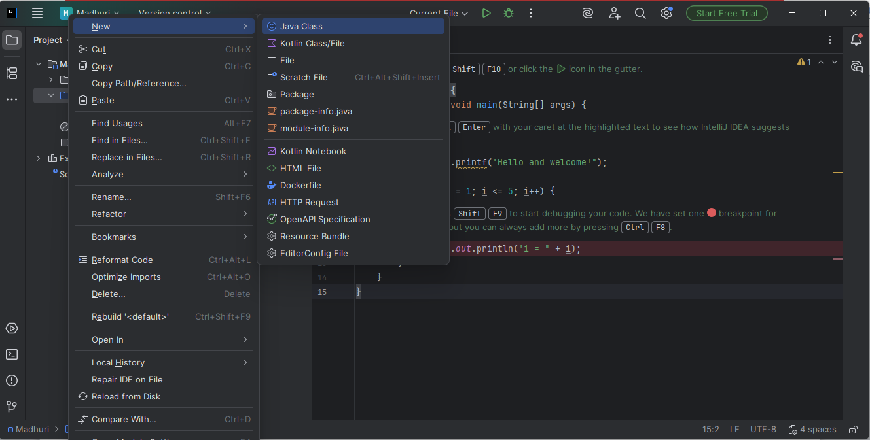

Step 4: Naming the Class
“New Java Class” dialog box me class ka naam enter karein. Kyunki ye main class hai, isliye class type Class hi rehne dein. IntelliJ IDEA automatically class ka basic structure bana deta
hai.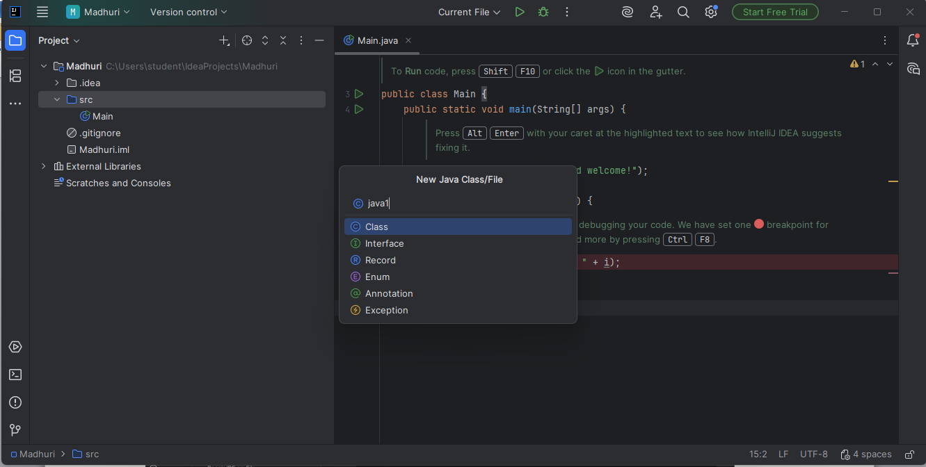

Step 5: Writing Java Code
Is step me ek Java file create hoti hai (jaise java1.java) jisme sirf class name aur curly brackets hote hain. Ab iske andar required Java code likha jaata hai.
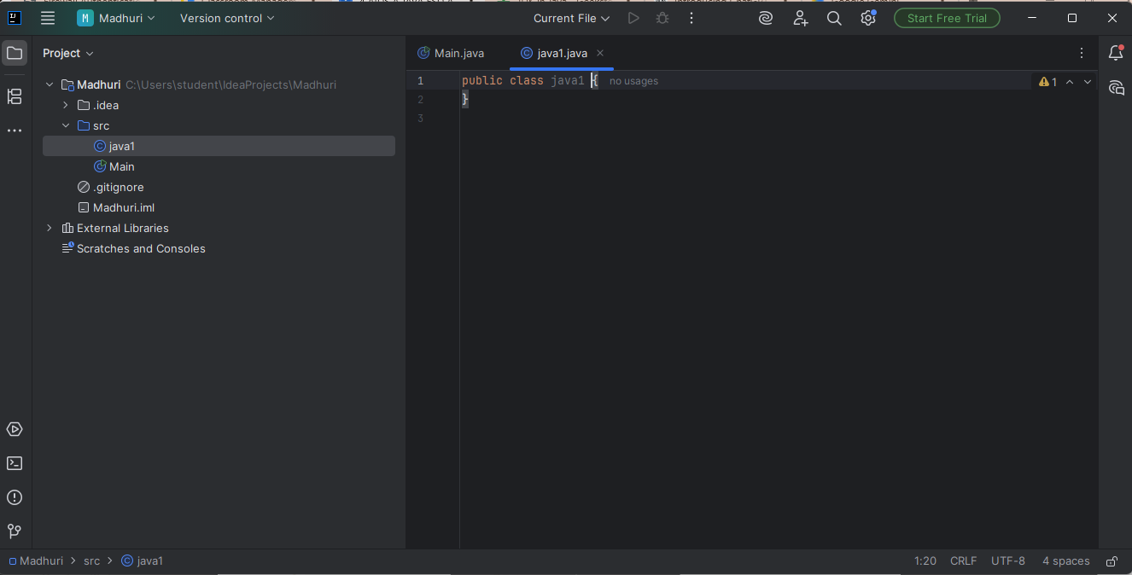

Step 6: Checking and Removing Errors
Agar program me koi galti hogi, toh red underline ya red cross sign dikhai dega. Mouse ko us error par le jaane se error ka reason pata chalta hai. Uske according correction karein.

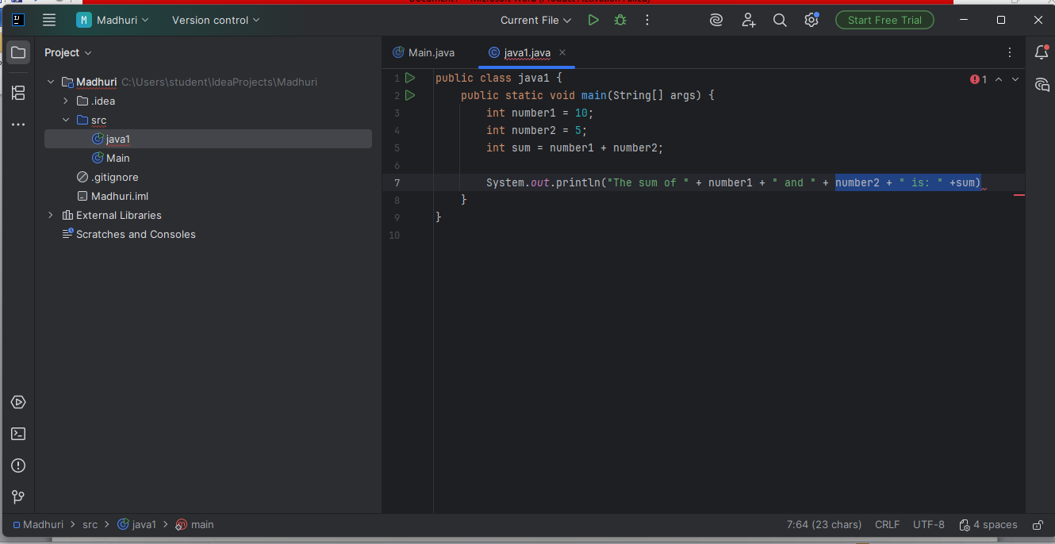

Step 7: Making Program Error Free
Program me mainly teen type ke errors ho sakte hain: syntax error, runtime error aur logical error. Compiler sirf syntax errors jaise missing semicolon ya galat variable name batata hai. Jab tak syntax errors remove nahi honge, program compile nahi hoga.
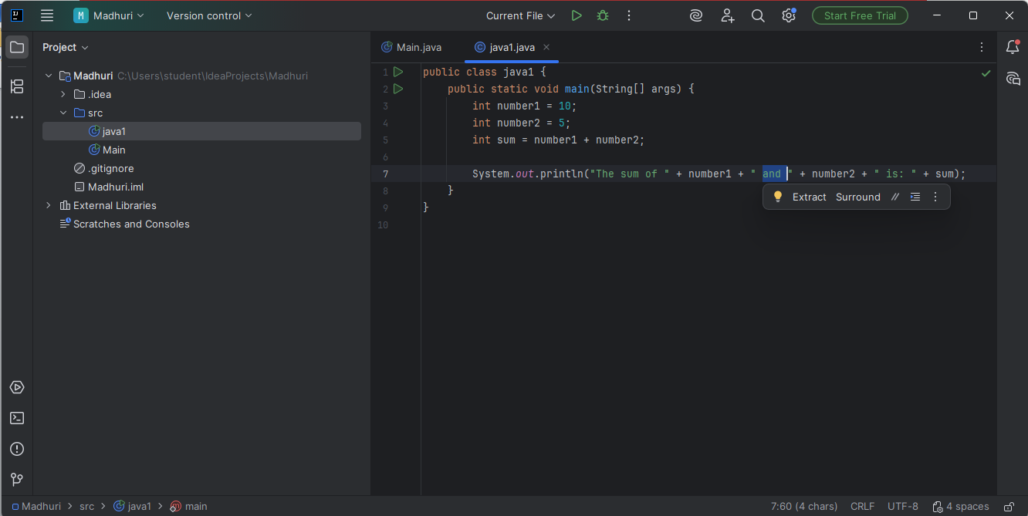

Step 8: Compiling and Running the Program
Jab program completely error free ho jaaye, tab Run (▶) button par click karke program execute karein. Program ko run karne ke liye main menu me se Run option ka use bhi kiya jaa sakta hai.
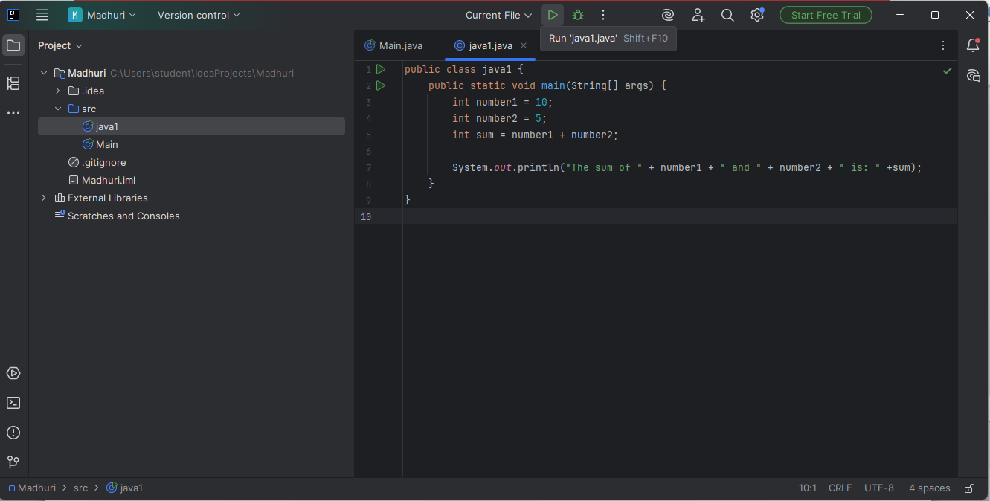

Java Program Using Data Types
class DataTypes {
public static void main(String[] args) {

int rollNo = 08;
float percentage = 98.5f;
double height = 5.9;
char grade = 'A';
boolean isPassed = true;

System.out.println("Roll Number: " + rollNo);
System.out.println("Percentage: " + percentage);
System.out.println("Height: " + height);
System.out.println("Grade: " + grade);
System.out.println("Result Passed: " + isPassed);
}
}

Output:

