**Term Project Milestone 3**

By: Madhuri Basava

MS in Data Science, Bellevue University

DS 500 T301: Introduction to Data Science

Dr. Shankar Parajulee

July 22, 2022

**Abstract**

I am interested in solving the question below:

How to improve Customer Experience in a particular industry?

The Questions that came to my mind when I think of Customer experience are

1) How to improve Customer Experience in the banking sector?

2) Which factors affect the customer experience in the banking sector?

3) How do the customers cope with shocking health care charges?

4) How do people feel when the order shipped is incorrect in online shopping?

5) Customer reaction to the increased Real Estate prices in a brief time

6) What if the food ordered in the restaurant is not vegetarian when they ordered vegetarian (Ethical Question)?

7) Effect of demand-supply on customers in the Auto Industry

**Introduction**

Delivering a great customer experience is the best way that any business can stand out since it is linked to better financial results. There may be many factors that affect the customer's experience. The data sources are Telephone surveys, Mobile surveys, Mail surveys, Online surveys, and Mixed-mode surveys. Factors affecting Customer Experience are 1) Interpersonal Communication: A quality call center that can give the most affordable solution, 2) Effective problem solving: Problems should be solved effectively and quickly, and 3) Multi-Channel Consistency: Transactions need to be consistent across all channels like online, telephone, Mobile or ATM (Automated Teller Machine).

**Summary**

**Customer Experience in Financial Sector:** The financial sector customer experience has had a zigzag pattern in Google trends for the past 12 months. In the future, it is predicting a downward trend. More interest is in the states of West Virginia, Iowa, New Mexico, Rhode Island, and Georgia. Providing proactive measures about their accounts in the banking sector will enhance customer experience.

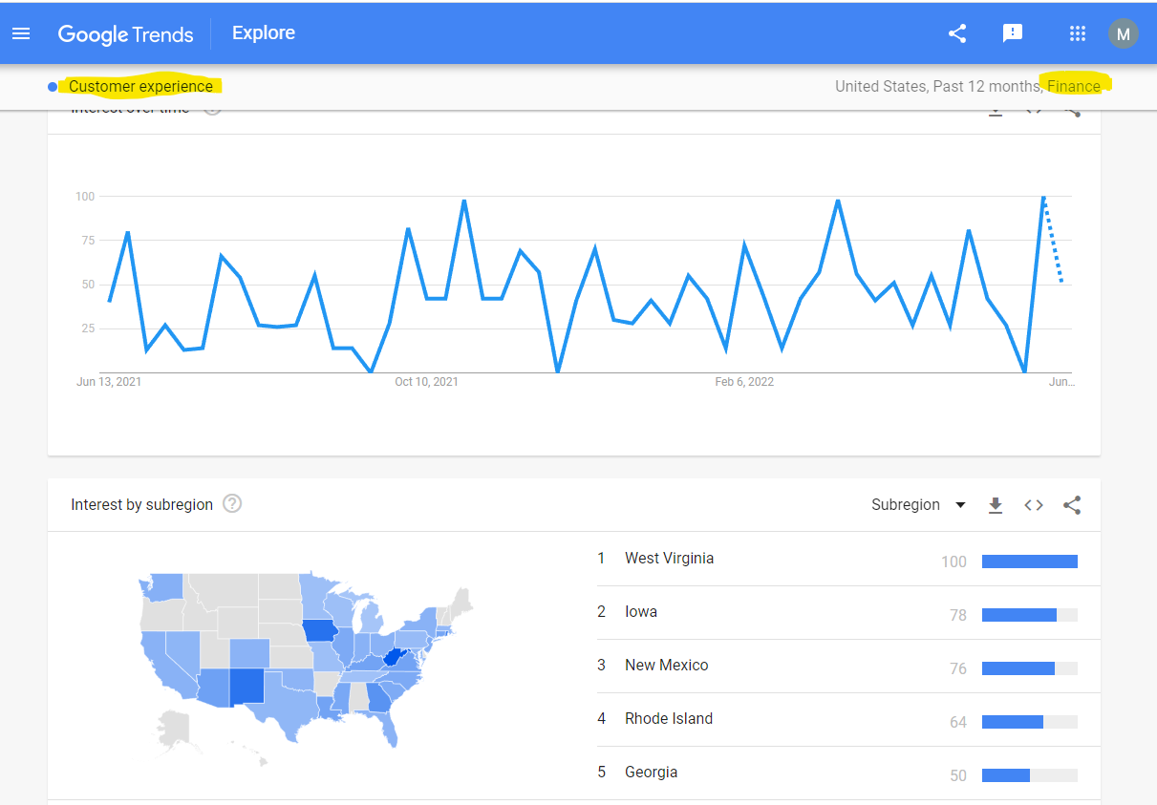

**Customer Experience in Health Care Sector**: Also, health care customer experience has a zigzag pattern in Google trends and the future prediction is that there will be some improvement. The better way to improve customer experience is to let the customer know the health care bill for any service, before it is done, and make him well known of any other alternative options so that they can decide which option serves them the best.

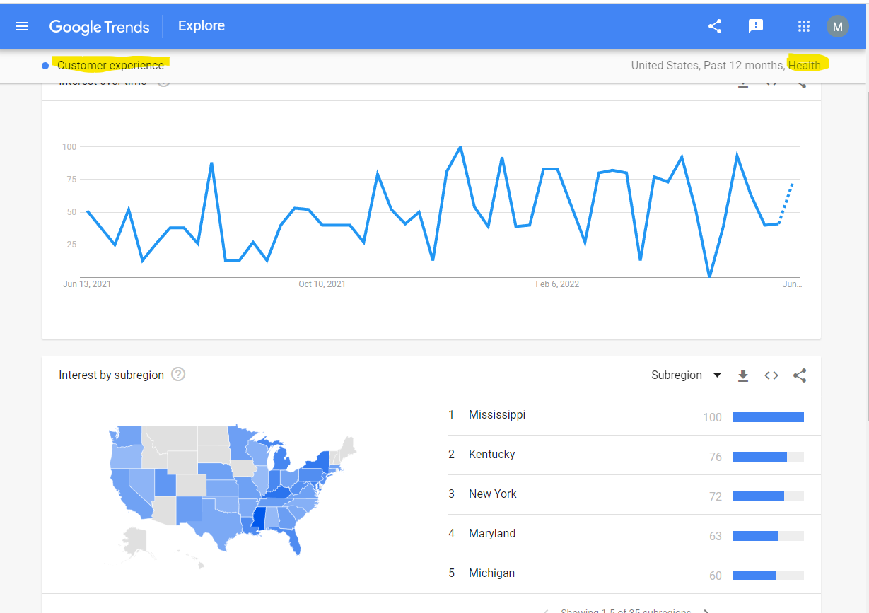

**Customer Experience in Shopping**: According to Google Trends, Customer Experience in shopping shows an incremental pattern. All the states in the US have an interest in customer experience, but New York stands out much more. Example: To improve customer experience when the order shipped is incorrect in online shopping, proactive measures can be taken to correct the order by calling the customer without the customer calling first.

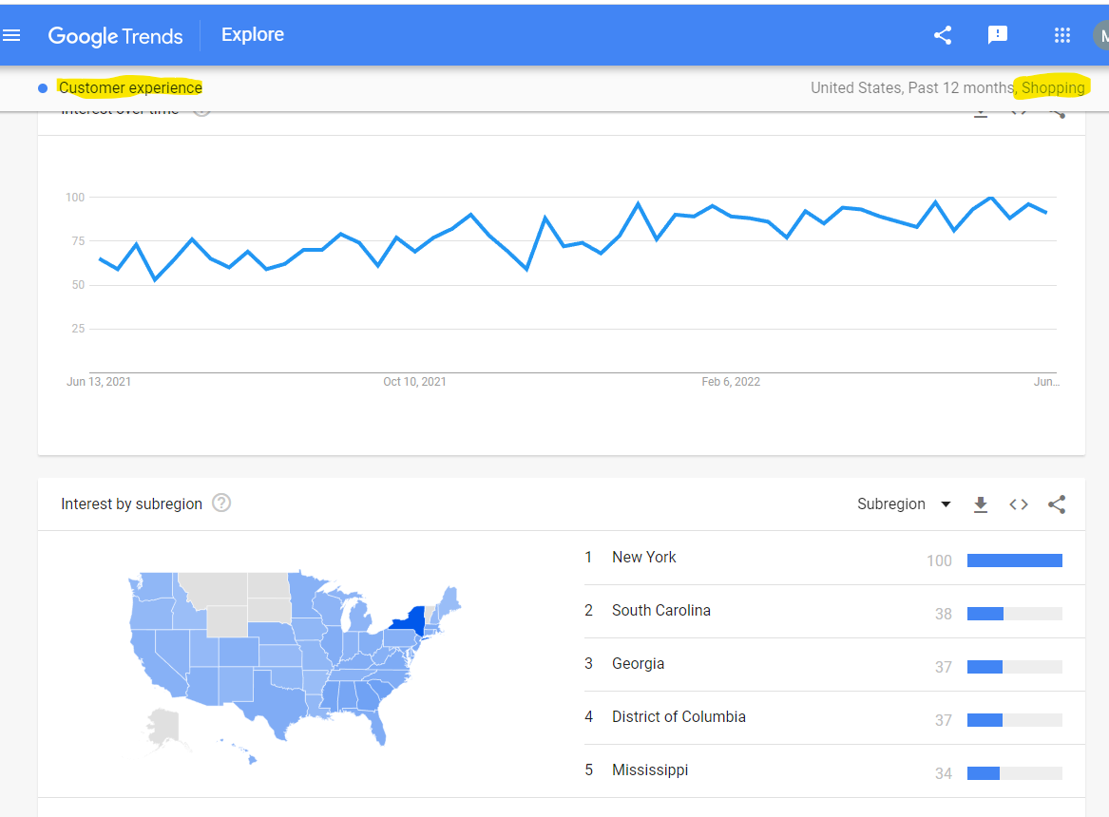

**Overview of Topic/Problem**

The topic I am interested in is: Can Customer Experience be improved with online shopping?

The customer feels more satisfied physically going to the shops to buy products. But after COVID came, everyone was more inclined toward online shopping. So, below is an analysis of whether the Customer Experience can be improved with online shopping.

**Analysis**

According to Google Trends, Customer Experience in shopping shows an incremental pattern. All the states in the US have an interest in shopping, but New York stands out much more.

Questions are how are the trends related to clothing, video games, toys, cosmetics, and electronics?

Below are the popular google trends in online shopping in the past 12 months:

1. Google trend related to shopping clothing search has been 40% in the past week.

The customer is always interested in buying the clothes in any season. New York has more interest followed by Mississippi, Alabama, the District of Columbia, and Louisiana even though the difference in interests between the states is less.

Even though the customer wants to feel the fabric before they buy, online shopping is growing in demand due to many reasons such as COVID, and time is not wasted traveling to the shops, any time customers can buy the clothes, no issues with weather restrictions, etc.

Consumers care about style, quality, comfort, fit, and price. Seamlessly delivering all these things will drive customer experience. Customer satisfaction can be improved by allowing free returns till a particular time if they do not like the clothes or if the size does not fit or for any other reason.

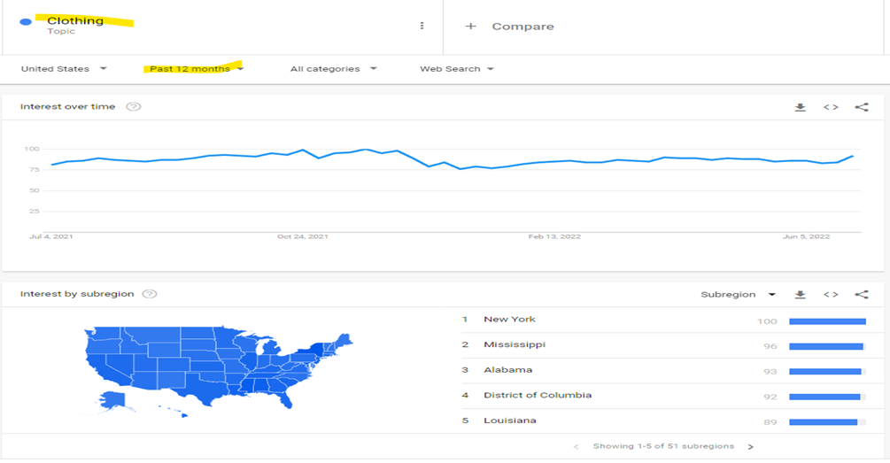

1. Google trend related to the video games search has been 31% in the past week. When we analyzed for over a year, it spiked up during the Nov-December months. This can be explained by the general tendency of more shopping during the Thanks' Giving and Christmas seasons.

Video games have been the de-facto go-to for the millennials during the COVID pandemic times. This is due to the customers having to stay long stretches at home holding off social activities due to pandemics. Many consumers and millennials and Gen Z reported that video games helped them to connect with people socially through games and they could get through tough times.

Customer satisfaction can be improved by following the plans of Microsoft and Sony which are the big companies in the gaming industry, are moving to a subscription model like Netflix and Amazon where players can get access to hundreds of games for a monthly fee.

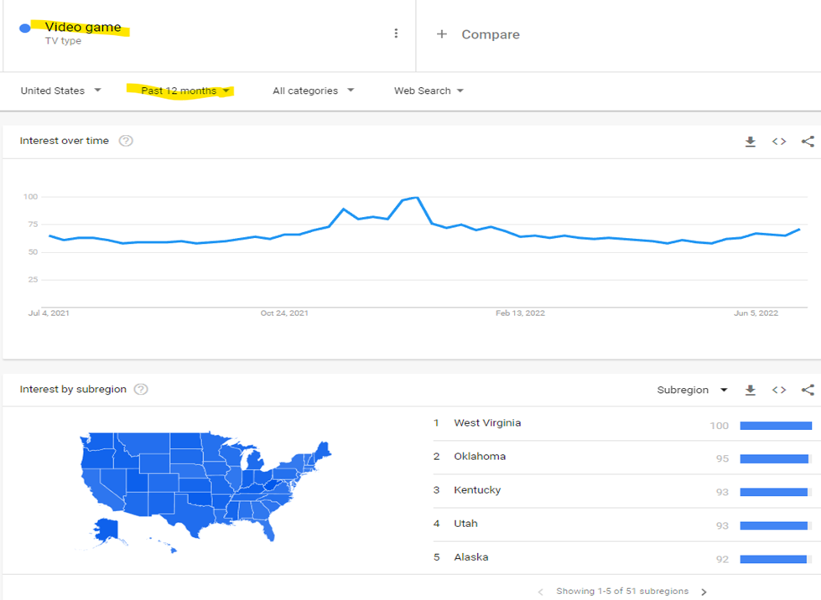

1. Google trend related to toys search is 13% in the past week. Over the past 12 months, the same trend in video games has been seen here because of the holiday season.

Customer satisfaction can be improved by providing the toys with high quality and safety. Toys must be tested in diverse ways such as Physical and mechanical tests, chemical tests, Materials tests, Flammability tests, Performance tests, Electrical safety tests, Environmental safety tests, Packaging tests, Battery tests, etc., and make sure that superior quality toys are delivered which enhances the customer experience.

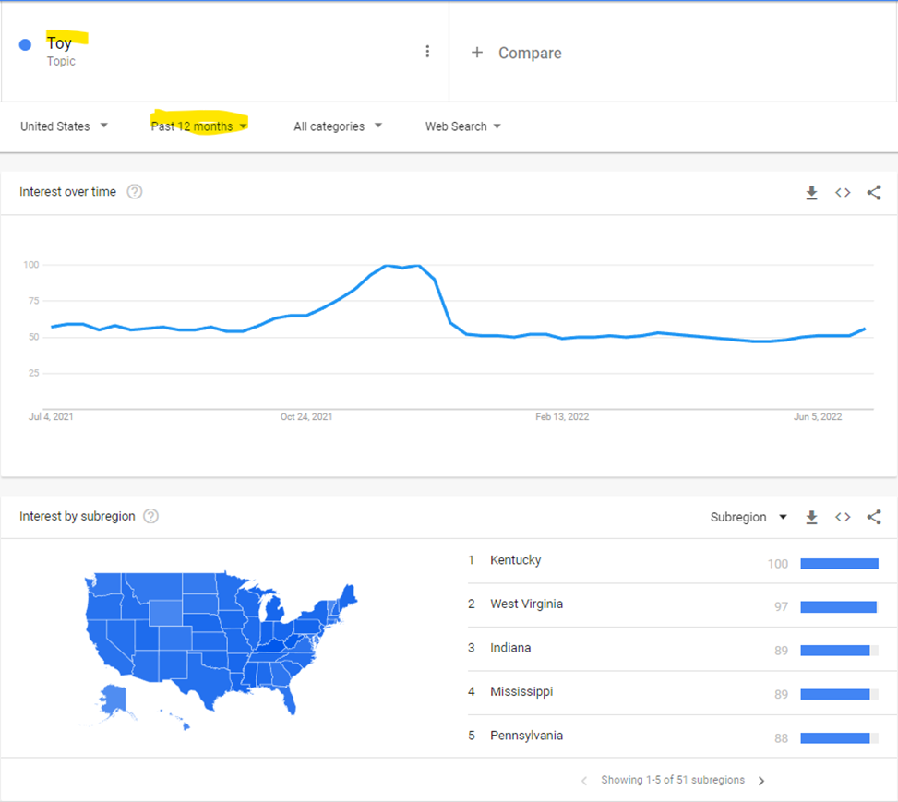

1. Google trend related to cosmetics search has been 10% in the past week. The interest over time is an up and downs curve as cosmetics are used mostly by all women, and that does not need any special occasion. The New York region has more interest in cosmetics when compared to all other regions. This may be because many famous brands’ headquarters are in New York.

Customer experience can be improved by having an interactive app and offering online reviews and videos, involving customers to share their opinions about products. They can be given exclusive coupons, and occasional gifts, and provide incentives for being loyal customers so that they can help improve sales by word of mouth.

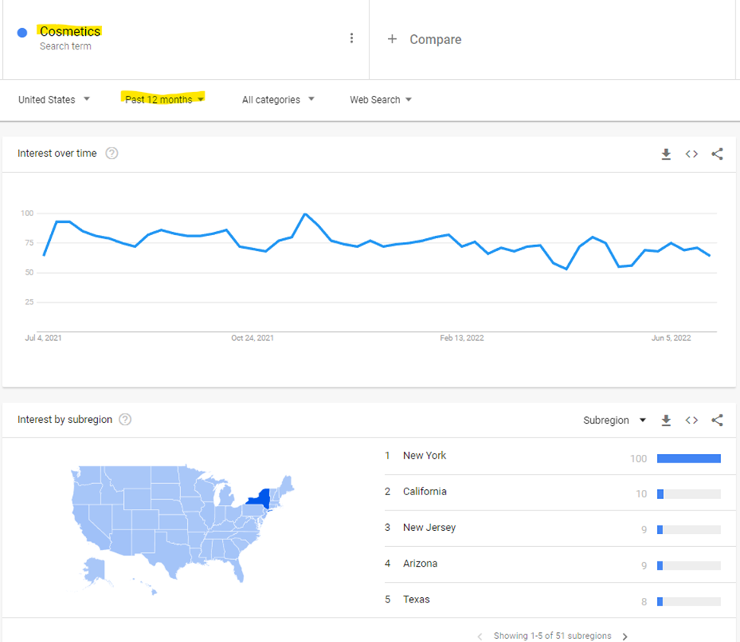

1. Google trend related to electronics search has been 3% in the past week. This graph looks at a few ups and downs as generally, most people need electronics in everyday life.

A customer considers quality, price of the product, reviews by others, word of mouth, and family and friends’ suggestions before buying the electronics. So, customer experience can be improved by delivering high-quality products on the estimated due date and a free return policy.

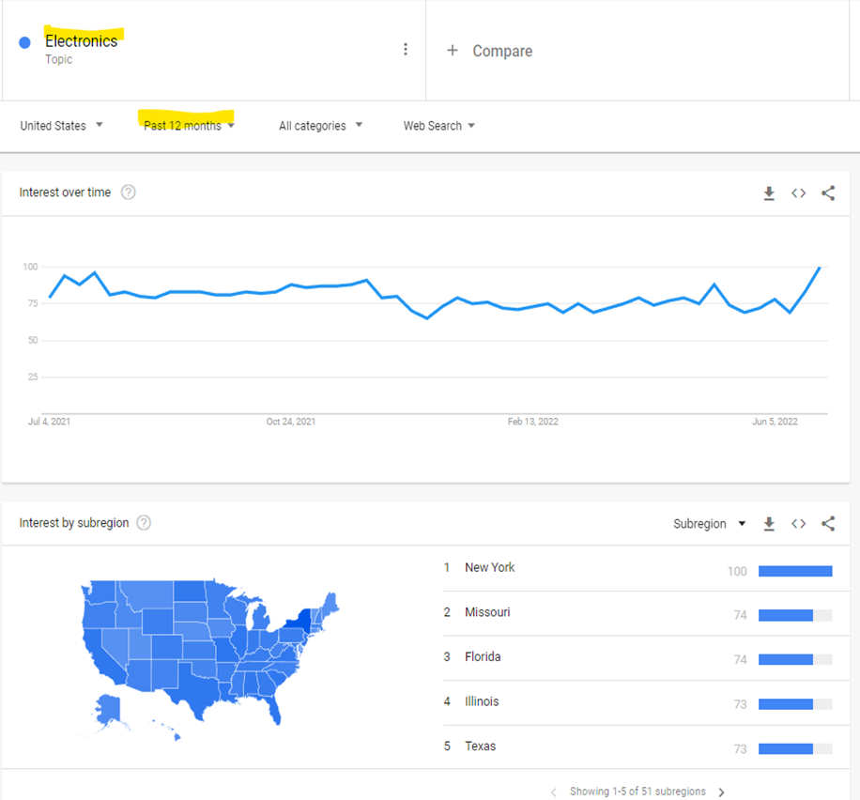

**Findings/Next Steps**

Collecting the data from different data sources such as feedback from customer reviews, and different surveys and analyzing the future trends in online shopping and creating a model and always keeping track of the latest trends in shopping, and the model if needed will help in predicting the customer experience. Thus, the necessary steps can be taken to reduce customer churn and improve customer satisfaction.

**Assumptions**: Assumptions are that the customers will come back if they are given good discounts. Sometimes quality and the time taken for the delivery matter.

**Ethical Concerns**: The problems like privacy, reliability, security, and non-deception on the internet are the pressing issues that are limiting the growth in the online shopping area.

**Challenges/Opportunities**: The challenges encountered due to online shopping are, the reduction of jobs in regular brick-and-mortar shops. Also, online retail needs a lot of expertise.

Interaction with people is getting reduced because of shopping. But the customers could be able to shop 24/7/365 days without the restriction of shop closing timings.

**Conclusion**

In general, customers want to feel the product physically before they buy, which gives them more satisfaction. They enjoy shopping in stores by the look and feel of the products. Coming out to shops physically and seeing the other customers shop around will provide a type of social happiness. Talking to the in-store employees about what the customers want creates a friendly environment. But for now, as the COVID situation still exists, online shopping is preferred by many customers. So, there are quite a lot of possibilities with which customer experience can be improved. A few examples are: To improve customer experience when the order shipped is incorrect in online shopping, proactive measures can be taken to correct the order by calling the customer without the customer calling first. Allowing free returns if the customer is not satisfied with the product. Delivering quality products to reduce returns. Providing discounts to loyal customers so that they can market the products and services through word of mouth, which in turn helps the business get more profits.

**Customer Experience in Real Estate:** According to Google Trends, Customer Experience in Real Estate sharp rise and falls. The future prediction is that there will be a decrease in customer interest. For example: calling the customer and explaining the future trends can enhance the customer experience.

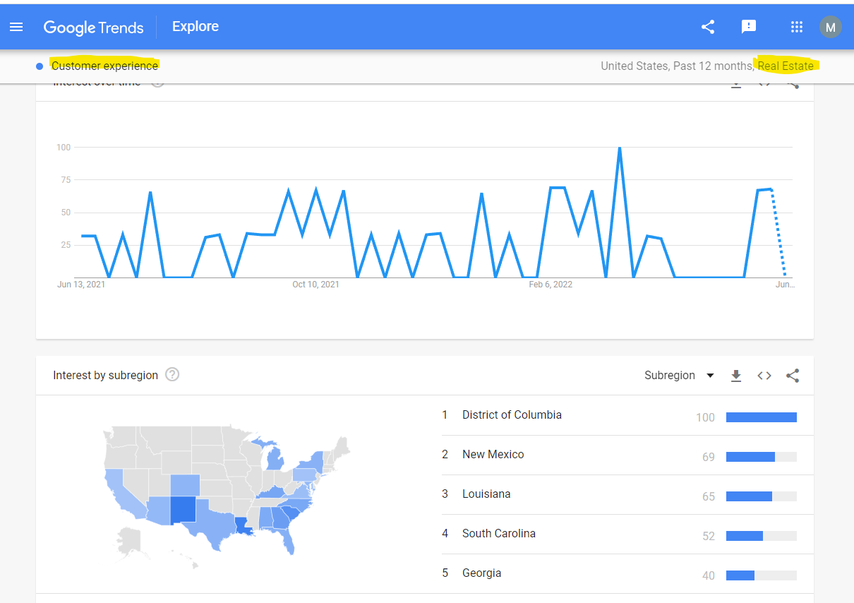

**Customer Experience in the Food Industry:** According to Google Trends, Customer Experience in food and drinks shows a sharp increase in the future.For example:what if the food ordered in a restaurant is not vegetarian when they order vegetarian? It is unethical for some people. Letting the customer know of the mistake and correcting the order helps improve the customer experience.

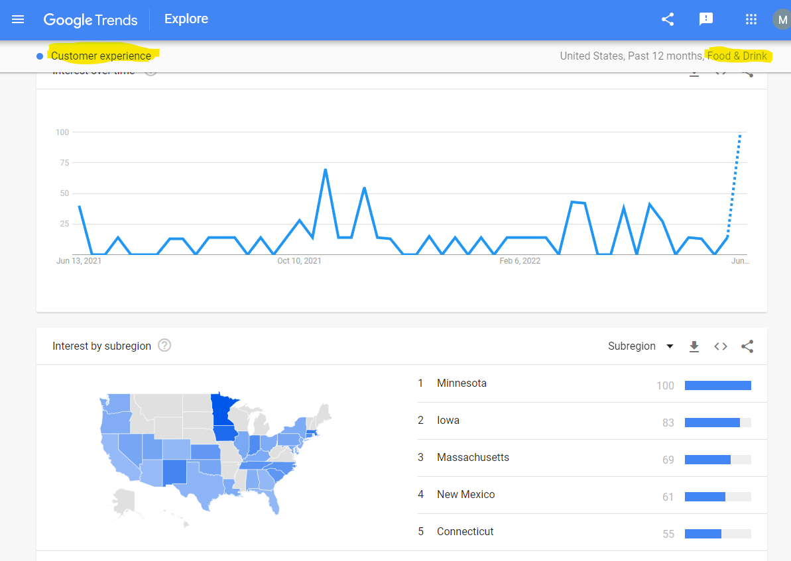

**Customer Experience in the Auto Industry**: According to Google Trends, Customer Experience in Auto Industry shows an incremental pattern. The current trend shows the interest is more in Louisiana. Letting the customer know of the current trends and explaining the demand and supply can enhance the customer experience.

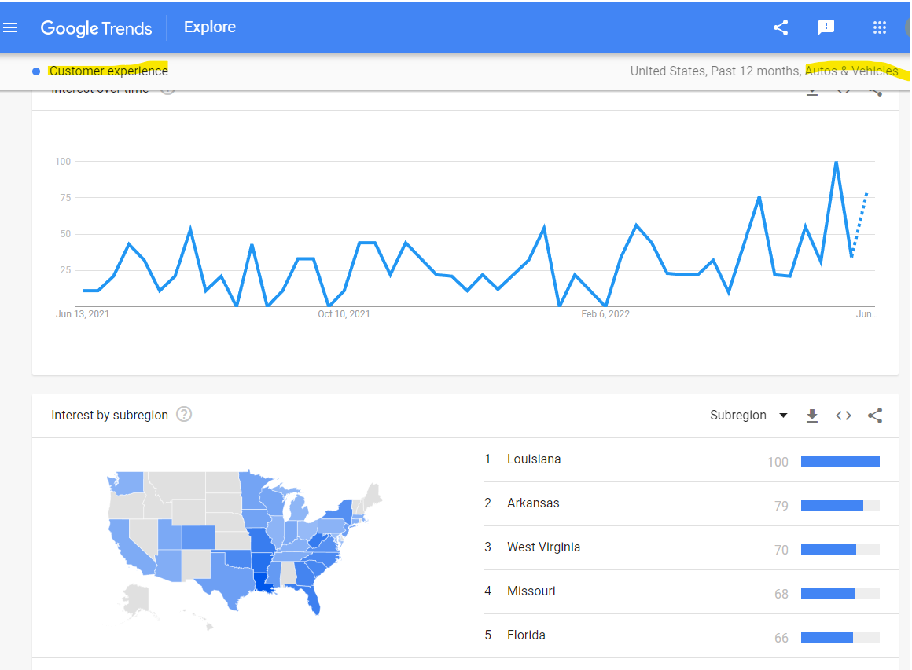

**Conclusion**

The area of research I want to continue is how to improve Customer Satisfaction in the online shopping sector. Though in general, an individual likes to shop in stores, since COVID started, customers started to shop more online. So, I feel it is important to find ways to improve customer satisfaction in online shopping.

**References**

*The visual data is provided from the Google Trends search engine.*

[*https://survicate.com/customer-satisfaction/importance-customer-satisfaction/*](https://survicate.com/customer-satisfaction/importance-customer-satisfaction/)

[*https://sourcingjournal.com/topics/lifestyle-monitor/customer-experience-indicators-drive-business-sap-cx-medallia-covid-fashion-344469/*](https://sourcingjournal.com/topics/lifestyle-monitor/customer-experience-indicators-drive-business-sap-cx-medallia-covid-fashion-344469/)

[*https://www.forbes.com/sites/forbesagencycouncil/2020/12/01/what-can-video-game-companies-teach-us-about-customer-relationships/?sh=15acfcf242de*](https://www.forbes.com/sites/forbesagencycouncil/2020/12/01/what-can-video-game-companies-teach-us-about-customer-relationships/?sh=15acfcf242de)

[*https://www.sgs.com/en/news/2020/01/avoiding-disappointed-customers-in-the-toy-industry*](https://www.sgs.com/en/news/2020/01/avoiding-disappointed-customers-in-the-toy-industry)

[*https://www.customerservice.ae/resources/featured/6-strategies-for-cosmetics-companies-to-improve-customer-experience*](https://www.customerservice.ae/resources/featured/6-strategies-for-cosmetics-companies-to-improve-customer-experience)

[*https://www.sciencedirect.com/science/article/pii/S2405844020325536*](https://www.sciencedirect.com/science/article/pii/S2405844020325536)

[*https://medium.com/digital-society/online-shopping-the-opportunities-and-challenges-facing-retailers-today-77c4e7852246*](https://medium.com/digital-society/online-shopping-the-opportunities-and-challenges-facing-retailers-today-77c4e7852246)